
BTI S2
WEST FARGO PUBLIC SCHOOL DISTRIC
COURSE OUTLINE

INSTRUCTOR: LAINE WHITE

STUDENT COMPETENCIES AND GOALS:
To provide a sound program of Building Trades, clear and realistic goals are essential.
The following core values come from industry:
Safety: View co-workers/classmates with respect and strive to ensure safety for all.
Integrity: Follow through and keep your word while being open, honest, ethical, and fair.
Trust: Promote growth and long-term success by making wise decisions with trust as an essential component.
Respect: Unleash creative talents by treating each other with respect.
Teamwork: People achieve more by working together.
Humility: Recognize and appreciate strengths and contributions beyond oneself.

As we continue to foster a supportive community, I believe it’s essential to uphold our professionalism in all interactions. I appreciate your efforts in maintaining a respectful atmosphere

As we all navigate our professional paths, it's crucial to remember that every encounter is a potential connection that may help you in the future. How we present ourselves during these interactions can significantly impact whether these connections develop positively or negatively.

Additionally, I believe it's worth noting that I truly believe cursing can often be perceived as a sign of a fragile character and Immature vocabulary. Maintaining professionalism in our communication not only reflects our values and maturity but also strengthens our network.

BUILDING TRADES POLICY STATEMENT / CLASSROOM EXPECTATIONS:
- Students will be on time, in your seat, quiet, respectful, and ready to learn and work. Classroom disruptions are not accepted.
- Respect in the Classroom:
Students will always treat classmates and instructors with professionalism and respect. Appropriate language, behavior, and attitudes are expected. Disrespect, arguing, or disruptive behavior will not be tolerated.
- Respect for Classroom & Jobsite Visitors:
Students will demonstrate professional behavior when administrators, substitute teachers, guest speakers, business partners, or community members visit the classroom or jobsite. Remain on task, use appropriate language, and represent the Building Trades program in a positive manner.
- Cell phones are not permitted and will be turned in at the beginning of each class. Earbuds and headphones are not permitted.
- Lab/jobsite and shop must be kept clean and safe. The shop and work site will be cleaned after each class. This is the responsibility of the BTII students to make sure this gets done at the end of every class.
- Tools must be kept in good working order and returned to the proper storage area.
- Students must wear a pair of ANSI Z87 approved safety glasses. One pair is provided by the school. If lost or damaged, the student must purchase replacements before the next class period. You cannot participate in LAB without safety glasses.
- BTII will have a team of BTI students they manage. Do not let your teammates work in the lab without the correct PPE.
- Students will not leave the classroom or building site without permission. I do not make passes to leave the classroom, plan accordingly.
- Students must wear appropriate clothing and PPE for work and the environment. This includes but is not limited to closed-toed shoes, hearing protection, and cold-weather clothing. Failure to do so will result in the student not being able to work in the lab and loss of daily points.
- Report all accidents and damage immediately.
- Follow school rules and policies.
- Students will adhere to the West Fargo Public Schools Core Values and the SkillsUSA Framework.
- SkillsUSA Conduct & Competition Eligibility:
Students who are members of SkillsUSA are expected to always act as model citizens. Participation in competitions, conferences, and leadership events is a privilege. Students must demonstrate strong character, respect, responsibility, academic effort, and safe behavior in both the classroom and lab to be eligible to compete. Failure to meet classroom, school, or program expectations may result in removal from competitions or leadership opportunities.
- Willful damage or careless use of tools or equipment will result in financial responsibility.
- Carelessness and horseplay are not permitted in Building Trades and will result in the student not being able to work in the lab and loss of daily points.
- Sitting in the classroom is not permitted when the class is working in the lab. You will be marked unverified if you are not in the lab with the class.
- BTII students are looked at as leaders of the class and are expected to model strong work ethic, professionalism, and safety both in the classroom and in the lab.

Building Trades I
Grade: 10 - 11
Credit/Length: 2 Elective credits, 2 Semesters 36 weeks

Recommended Prerequisites: Advance woods, Intro to Construction, or Instructors Permission

Course Description:
Learn basic and advanced carpentry building skills by incorporating knowledge acquired of print reading, measurement, materials, and tool application. Power tools, both hand and stationery, are used extensively by students in an open lab setting. Students will exit this class with a strong knowledge of fundamental carpentry techniques and jobsite experience in this hands-on course.

Course Objectives:
- Acquire knowledge of:
  - Basic Blueprint reading
  - Layout, measurement.
  - Rough and Finish carpentry
  - Hand and power tool operation and safety
  - Collaboration with others
- Students who demonstrate they can work safely and respectfully in the construction lab will have the opportunity to complete an 1,800 square foot rambler style house. Their readiness for this project will be evaluated using the CRP rubric.
- Investigate possible career choices in the construction field.
- Learning safe and innovative operating techniques of power tools.
- Gain appreciation for quality carpentry skills and techniques.
Grading:
- Weekly Bell Ringers / Exit Slip: due by 3:36 pm on the last day of that week. If you are absent one day, make note of that in the work log, No late work will be accepted.
- Lab Grade: 5 points each day. PPE = 1pt, Work #1 & Work #2 = 3pts, and Clean up =1pt
- Career Ready Practice (CRP): This is tied in with your Lab grade.
- Tests: weighted the same as the other grades
- If you miss a day, you are responsible for getting any missing work or notes turned in. You get one day for a missed day; assignments are due the day after you get back.
Miss a day / get a day.

Classroom Expectations: At Proficient/Advanced Level
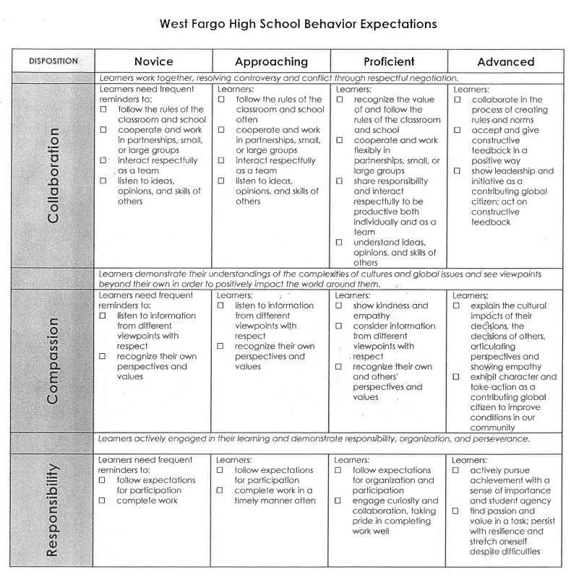

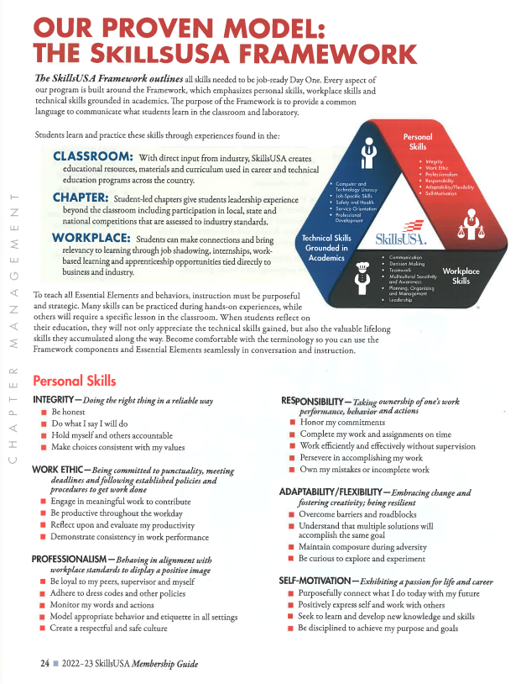
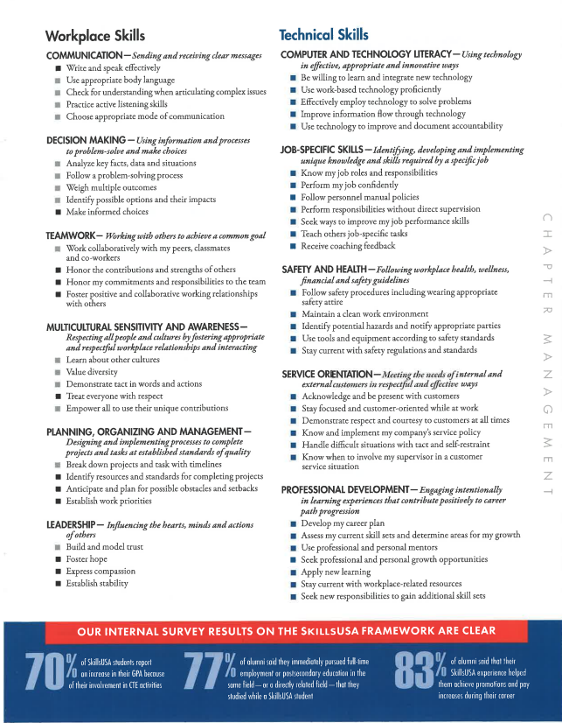
Hybrid/Virtual Learning: (This portion will be updated if hybrid or virtual learning happens)
- Be prepared by keeping your iPad firmware up to date and charged.
- Check Schoology and Email
- TEAMS Etiquette:
  - Keep Microphone off unless speaking.
  - Turn Camera On.
  - Locate yourself in a quiet space.
  - Use Chat as a source of communication.
  - Make sure you have proper dress attire.
  - All work is due that day unless otherwise noted.

Grading:
- Daily work, tests, and Lab points are weighted the same.
- Students are accountable for getting makeup work when gone.
- Late work will be accepted until the end of that unit. Work from previous units will result in loss of points.
- Career Ready Rubrics will be used to assess a student’s career skills.
- Final grades will be calculated: Semester 1: Q1 50% and Q2 50%, Semester 2: Q3 50% and Q4 50%

Communication:
- Email: lwhite@west-fargo.k12.nd.us
- Teacher will respond to emails during school hours.
- Check PowerSchool grades often to make sure students work is completed and correct.

