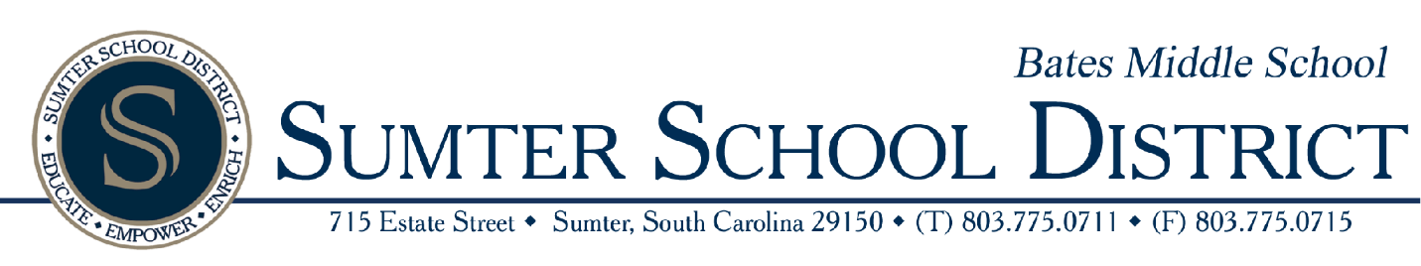

Bates Middle School Title I Home and School Compact 2026-2027
A school-home compact is a written agreement outlining how the schools, families and students will share responsibilities in the academic success and well-being of the student. Bates Middle School under Title I have developed a home and school compact outlining how our teachers, administrators, support staff and families will work together in a joint effort to support the academic success, achievements and well-being of our students.
Bates Middle School will:
- Provide high- quality instruction in a safe learning environment
- Hold every student at Bates Middle School to high expectations.
- Provide instruction with an interesting and challenging curriculum that will motivate students to learn and promotes academic achievements.
- Staff will allow for reasonable availability for conferences, via in person, emails, phone calls or any other means of reasonable communication.
- Communicate regularly regarding the student’s progress and/or areas of needs improvement.
- Provide opportunities for meaningful family engagement, and volunteer opportunities.
- Be available to discuss and develop plans to address student and/or community issues
As the family/guardian I will:
- Ensure my child attends school every day and on time.
- Monitor my child’s progress
- Attend parent-teach conferences and school events
- Support learning by encouraging homework and reading
- Providing a supportive learning environment at home
- Encourage positive behavior and responsibility, and making sure my child adheres to school policies.
As a student I will:
- Come to school with a positive attitude prepared to learn.
- Respect others, myself and school property.
- Complete all assignments and homework.
- Adhere to school policies
- Ask for help when needed and DO MY BEST!
Student Name | Date:
Student Signature | Date:
Parent/Guardian Signature | Date
Principal/Teacher Signature | Date:

