What is a School-parent Compact?  A School-Parent Compact for Achievement is an agreement that students, parents, and teachers develop together. It explains how parents and teachers will work together to make sure our students reach grade-level standards.  Callaway Elementary School’s Parent Compact meeting will be scheduled for the month of September. At this meeting, parents will get a chance to express their views regarding information within the Compact. All suggestions will be forwarded to the Principal, Dr. Dawn Watkins.  Do you have questions about your child’s progress? Contact your child’s teacher by phone at (678) 479-2600 or by email. Email addresses are on the school website at:  http://133.clayton.k12.ga.us/  Achievement at Home  Callaway Elementary School is committed to supporting every student. Parents are encouraged to assist in learning at home. Listed below are methods that parents can use to assist their children at home:  Communicate with your child regarding their day by asking questions and engaging them.  Assist your child with their daily homework in math, reading, and writing.  Read with your child nightly for at least 30 minutes.  Ask friends and family to encourage your child to read different types of reading materials to them.  Allow your child to actively participate in helping you in routine activities. | CALLAWAY ELEMENTARY SCHOOL  Jointly Developed  The school staff, parents, students, and community stakeholders of Callaway Elementary School collectively came together in developing Callaway Elementary School-Parent Compact for Achievement.  - Teachers provide various opportunities for parent input via virtual platforms  - Parents added their input and students provided feedback regarding what could help improve their academic experience.  - Parents are encouraged to attend annual virtual/face-to-face revision meetings which are held in the Spring and Fall each year to review the Compact and Parent and Family Engagement Plan and make changes based on student needs and school improvement goals.  +++++++++++++++++++++++++++++++  SCHOOL HOURS AND RULES  School doors open at 7:00 a.m. and class starts at 7:45 a.m. – 2:15 p.m. All late students must be signed in by an Adult. Early check-outs must be done before 1:30 p.m. Please ensure that the school has at all times, updated contact/information. School doors will be locked for mandatory security between 7:45 a.m.-3:00 p.m. All transportation changes must be made in writing.  SCHOOL UNIFORMS  Uniform Tops: Navy Blue, Grey, or White  Uniform Bottoms: Khaki, Black or Navy Blue  Uniform Code: Belts are worn with bottom attire with belt loops, and Boys' shirts tucked in. | 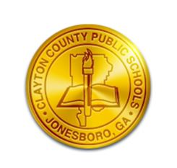  Scho  Clayton County Public Schools  School-Parent Compact  For Achievement  2026-2027  Callaway Elementary Knights  K-5 School-Wide
  ________________________________________
  “callaway knights are armored with greatness!!!”
  “building a better tomorrow, today!”
  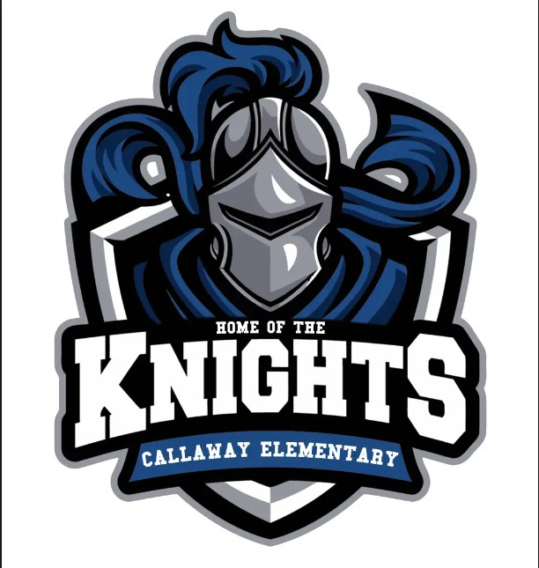
  Callaway Elementary School
  120 Oriole Drive
  Jonesboro, GA. 30236
  (678) 479-2600 (Phone)
  (678) 479-2613 (Fax)
  http://133.clayton.k12.ga.us/
  Principal: Dr. Dawn Watkins
  Asst. Principal: Dr. Tracy Jones
  Asst. Principal: Ms. Chelsia Evans
  Parent Liaison: Mrs. Yvonne Scrubb
  Last Revised: October 5, 2026
our goals for student achievement  MISSION STATEMENT  The mission of Clayton County Public Schools is to empower scholars to achieve academic, professional, and personal goals by providing equitable access and experiences that build skills in literacy, creativity, critical thinking, and collaboration.  VISION/ASPIRATION STATEMENT  The vision of Clayton County Schools is to prepare ALL graduates to have the skills to pursue and accomplish college, post-secondary training, and or career opportunities to live and compete successfully in a global society.  DISTRICT ACADEMIC GOALS  From 2021-2027, Clayton County Public Schools and every school will demonstrate eight percentage points growth each school year for students scoring at the proficient and distinguished levels as evidenced by state and national assessments.  SCHOOL ACADEMIC GOALS  By the end of the 2027 school year, Clayton County Public Schools will increase the percentage of students scoring at the Proficient and/or Distinguished levels on the GMAS by at least 8 percentage points in each content area. | Callaway elementary school focus areas  By May 2027, Callaway Elementary School will show an eight percent point improvement for students scoring at the proficient and distinguished levels on the ELA GMAS from 23% to 31%. By May 2027, Callaway Elementary School will show an eight percent point improvement for students scoring at the proficient and distinguished levels on the Math GMAS from 28% to 36%.  WE WILL MEET THESE GOALS BY:  Implement the five components of reading, which are Phonemic Awareness, Phonics, Vocabulary, Fluency, and Comprehension. Implement rigorous math instruction focused on the Standards for Mathematical Practice.  AS A SCHOOL WE WILL:  Kindergarten: Provide families with grade appropriate sight word lists and simple practice strategies to help students build sight word recognition and fluency at home. 1st Grade: Provide families with ways to help their child explore different topics, practice place value, and write complete sentences. 2nd Grade: Provide families with strategies to help their child express their thoughts in writing, while practicing math, reading, and writing skills. 3rd Grade: Provide strategies to parents to help their child master grade-level math, reading and writing skills. 4th Grade: Provide families with helpful research-based learning resources for extra practice with their child where they need support. 5th grade: Provide families strategies with ways that they can help their child practice solving math problems and explaining their reasoning. DES: Provide resources to help parents to work on social/emotional development at home.  AS STUDENTS WE WILL:  Be present in class daily and on time and pay attention to teachers; be ready to learn and put forth our best effort; complete all assignments/homework on time; ask for help when needed; read 30 minutes daily; practice reading/writing/math skills; utilize, public library, educational websites, check Canvas daily and continue to practice the 4B’s during school hours and at home.  AS PARENTS WE WILL:  Help our child explore different topics, practice place value, and write complete sentences about what they are learning; encourage their child to express their thoughts in writing while practicing vocabulary, sight words, math, reading, and writing skills; continue practicing and mastering grade-level math, reading, and writing skills; and providing our child with extra practice in areas where they need support by using helpful, research-based learning resources. Finally, encouraging our child to practice math skills by math word problems, continue to make sure that homework assignments are done, check ClassDojo and Infinite Campus on a regular basis to stay informed on our child’s behavior, attendance, and academics. | Communication about student learning  Callaway Elementary School is committed to:  Provide frequent reports to parents on their children’s progress  Provide parent-teacher conferences which will be held annually during which the Compact shall be discussed as it relates to the individual child’s achievement  Provide reasonable access to staff, opportunities to participate in their child’s Canvas class, and observation of classroom activities.  Weekly Homework Folders Phone Calls or Notes  Parent-Teacher Conferences Connect Ed Messages  Agendas/Flyers Infinite Campus  School website/Social Media Class Dojo  School Marquee/ Parent Info Board Remind 101  Face-to-Face/Virtual Communication  PBIS (Positive Behavioral Intervention Strategies)  Parent & Family Engagement Center Calendar  Callaway Elementary School Activities to Build Partnerships  Parent and Family Engagement Virtual/ Face-to-Face Workshops  Parent-Teacher Conferences  Parent Academy Workshops  Parent Resource Center  Student Extra-curricular activities  Partnering with Media Specialist  Partnering with the Community  PTA  Open House  Curriculum Night  Parent Involvement Day  Callaway Elementary School  120 Oriole Drive  Jonesboro, GA 30238  Dr. Dawn Watkins, Principal  www.dawn.watkins@clayton.k12.ga.us

