2025-2026 School Year
120 Oriole Drive
Jonesboro, GA. 30236
678-479-2600
678-479-2613 (fax)
http://133.clayton.k12.ga.us
Plan Revision: October 5, 2026
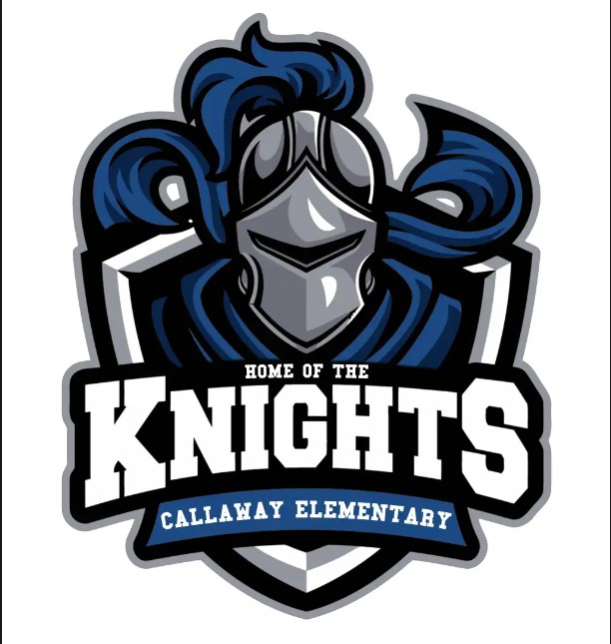

Who is it for?
All students participating in the Title I, Part A program, and their families, are
encouraged and invited to fully participate in the opportunities described in this plan.
Callaway Elementary will provide opportunities for the participation of parents with limited English, parents with disabilities and parents of migratory children.
How is it revised?
Callaway Elementary School invited all parents to attend 2 parent and family engagement plan meetings during the Fall 2026 and in the Spring 2026 to review and revise the parent and family engagement plan as well as the school-wide plan, our school-parent compact and the family engagement 1% budget. Additionally, parent input and comments regarding this plan were welcomed during the school year and a paper copy was available in the front office. All parent feedback received during the year will be used to revise the plan for the next school year. We distributed an annual survey online, also by paper, QR code, and email, and asked parents for their suggestions on the plan and the use of funds for parent and family engagement. Some surveys were completed online via home internet access, in the parent resource room, smartphone, or the paper copy sent home. Parents can also give feedback during parent meetings and activities during the school year including our annual Title I meeting, parent-teacher conferences, curriculum night, and all other meetings/trainings held. This year’s revisions will be done by Google Forms, virtual/face-to-face meetings and surveys.

What is Title I?
Callaway Elementary is identified as a Title I school as part of the “Every Student Succeeds Act” 2015 (ESSA). Title I is designed to support State and local school reform efforts tied to challenging state academic standards to reinforce and enhance efforts to improve teaching and learning for students. Title I programs must be based on an effective mean of improving student achievement and include strategies to support parental engagement. All Title I schools must jointly develop with all written Parent and Family Engagement Input Callaway Elementary held meetings and involved all parents, students, and teachers in the Fall of 2026 and Spring 2026 to acquire their input. However, a copy of the parent and family engagement input form was distributed to all students to take home to their parents. Parents were notified via school messenger, monthly parent and family engagement calendar, class dojo, and the school marquee. Parents were asked to provide input on the parent and family engagement plan. All teachers signed acknowledging that they received and sent home the Parent and Family Engagement Plan.
Where is it available?
At the beginning of the year, the plan is included on our school website, in the parent and Family Engagement center, and front office. A revised copy will be made available on ClassDojo, the PRC room (113) and the school website. All parents will have a paper copy sent home by students.
School Plan for Shared Student Achievement
What is it?
This is a plan that describes how Callaway Elementary will provide opportunities to
improve parent engagement to support student learning. Callaway Elementary values
the contributions and engagement of parents to establish an equal partnership for the common goal of improving student achievement. This plan describes different ways Callaway Elementary will support parent engagement and how parents can help plan and participate in activities and events to promote student learning at school and at home. Callaway Elementary will engage all parents through academic parent academy workshops, local school council committees, and parent and family engagement committees. Parents of Callaway Elementary are asked to provide suggestions throughout the year in the Parent and Family Engagement Center located in Room 113.
CALLAWAY ELEMENTARY SCHOOL
Parent and Family Engagement Plan

1A
7
1B
2C
1A
2B
1A
4A

Open House – July 30, 2026 from 1:00 p.m. – 3:00 p.m.
Meet your child’s teacher, parent liaison, and our friendly and helpful school staff for the year.
Parent and Family Engagement Plan/Compact Input -August 25, 2026 @ 10:00 a.m. & 4:00p; August 28, 2026-QR Code
Annual Title I Meetings (Virtual & face-to-face) – September 3, 2026 @ 4:30pm & September 4, 2026 @ 10:00am
Title I Information-The purpose of the Title I meeting is to inform parents and guardians of how schools receive federal funding to supplement the school’s existing programs, use of Title I funds for instruction and professional development.
Parent-Teacher Conferences – September 21-25, 2026 (Can also be scheduled throughout the School Year)
Discussion about students’ academic progress
Curriculum Night –September 3, 2026 @ 5:00pm-7:00pm
Learn how to make reading and math fun at home
Grandparents & Grits-September 10, 2026 @ 7:00 a.m.-8:00 a.m. in Media Center
Callaway’s Community Fall Festival-November 6, 2026
Red Ribbon Week- Oct. 26-30, 2026
Picture Book Reading Bowl – October 24, 2026 @ MD Roberts Middle School @ 9:00 a.m.
Fall Picture Day- October 7, 2026
Trunk N Treat-October 30, 2026
Fall Book Fair – Nov. 6th – 12th 2026
Thanksgiving Luncheon-November 18 2026
Christmas Luncheon-December 16, 2026
Helen Ruffin Chapter Reading Bowl – January 30, 2027 @ Mundy’s Mill HS @ 9:00 a.m.
Read Across America-March 1-5, 2027
Dads N Donuts-March 4, 2027
Spring Book Fair – March 12-19, 2027
Moms N Muffins- April 22, 2027
GMAS Testing- 3rd-5th grades – April 26th – May 3rd, 2027
Moving on Ceremonies: May 17, 2027- Kd.g & 5th Grade; May 13th-3rd & 4th Awards Day; May 14th-1st & 2nd Awards Day
Parent Academy Workshops – Monthly (Virtual & Face-to-Face)
Parents will gain insight of various topics relating to their child’s academics and how they can help their child succeed.
Callaway Field Day – May 19, 2027- 4th & 5th Grades; May 20, 2027 -2nd & 3rd Grades; May 24, 2027-PreK-Kdg
Catch up with the latest resources to help support your child’s learning.
Career Day – March 24, 2027
Community and School work together to present career topics and relate how academics are intertwined in core content areas. Parent Academy Recognition – TBD

DUE TO UNFORESEEN CIRCUMSTANCES, SOME DATES AND TIMES ARE SUBJECT TO CHANGE!

Connect with the school and community to build a better school and review school plans.

Let’s Get Together!
Callaway Elementary will host the following events to build the capacity for strong parental engagement to support a partnership among the school, parents, and the community to improve student academic achievement. All meetings for parents will be held during the day and some evenings. In addition, parents will have the opportunity to have one on one workshops with our Parent Liaison Mrs. Scrubb.

CALLAWAY ELEMENTARY
2026-2027 School Goals

By May 2027, Callaway Elementary School will show an eight percent point improvement for students scoring at the proficient and distinguished levels on the ELA GMAS from 23% to 31%. By May 2027, Callaway Elementary School will show an eight percent point improvement for students scoring at the proficient and distinguished levels on the Math GMAS from 28% to 36%.

CLAYTON COUNTY PUBLIC SCHOOLS
2026–2027 District Goal

From 2021-2027, Clayton County Public Schools and every school will demonstrate eight percentage points growth each school year for students scoring at the proficient and distinguished levels as evidenced by state and national assessments.

School-Parent Compacts
As part of this plan, Callaway Elementary and our families will jointly develop a school-parent compact, which is an agreement that parents, teachers, and students will develop that explains how parents and teachers will work together to make sure all our students reach grade-level standards. The compacts will be reviewed and updated annually. However, a hardcopy will be available in the parent resource center, the front office, and on our school website.

8A

3
9
8A

Callaway Elementary is committed to
helping our parents attend the parental activities listed in this plan. Please call 678-479-2600 EXT.133131 or email Mrs. Scrubb, yvonne.scrubb@clayton.k12.ga.us if
you have any questions in regard to parental and family engagement.

Callaway Elementary will allow ALL PARENTS the opportunity to provide feedback.

Callaway Elementary Knights are Armored in Greatness!
Callaway Elementary will take the following measures to promote and support parents as an important foundation of the school in order to strengthen the school and reach our school goals. We will:

Ensure that all information related to school and parent programs, meetings, and other activities is published in English, posted on the school website, and included in the monthly school newsletter for all parents.
Provide monthly trainings for staff during their planning periods on strategies to improve communication with parents and ideas to increase family engagement. Staff will also share best practices during regularly scheduled faculty meetings.
Share information in English/Spanish in the school newsletter for parents to understand the school’s academic standards and assessments as well as the ways parents can monitor their child’s progress and work with educators; We also have a district newsletter in English and Spanish.
Communicate with all families and the community on a regular basis regarding school-wide events and activities, through school calling posts, marquee, flyers, workshops, Class Dojo, social media, PTA, Connect Ed, school website, Parent and Family Information Board, and virtual/face-to-face meetings.
Work with our parents to develop relevant trainings and helpful presentations to educate our staff on the importance of parental and family engagement.
Provide necessary materials and handouts for parents at conferences, meetings, and activities to help parents work with their child to improve their child’s achievement.
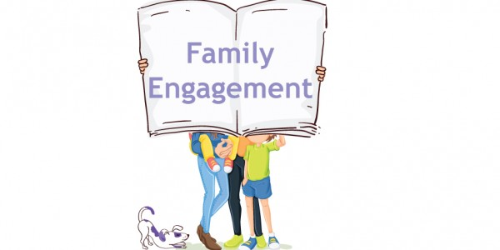
Parental Engagement
Callaway Elementary believes that parent and family
engagement means the participation of parents in regular two-way, and meaningful communications,
involving student academic learning and other school activities, including ensuring that:
Parent Resource Center
Come visit the Parent Resource Center to check out books, study materials, and activities to use at home with your child. Computers are available for parents to explore the Infinite Campus Parent Portal, job searches, and educational resources.
Monday – Friday, 8:00 am – 3:00 pm
Extended hours available upon request

Parents play an integral role in assisting in their child’s learning.
•

•
Parents are encouraged to be actively
engaged in their child’s education at school.
Parents are full partners in their child’s
education and are included, as appropriate, in decision-making and on advisory committees to assist in the education of their child.

•

The carrying out of other activities as
described in this plan.
•

8E
8D
8B
8A
2B

Callaway Elementary invites all parents to share ideas and ways to engage other parents to build partnerships with school, families, and the community. Parents can also submit their ideas or suggestions at school activities and meetings, as well as through our parent survey.
“WE ARE ARMORED IN GREATNESS!”
Parent and Family Engagement Standards
Callaway Elementary and our parents have adopted Joyce Epstein’s 6 types of parental engagement standards as the school’s model in engaging parents, students, and the community. These standards are:

Date: ______________________________________________________________
Comment: __________________________________________________________
Callaway Elementary Parents Share Your Thoughts!
Become a part of the Parent & Family Engagement Team. If you are interested in helping with clerical work, volunteering at school events, etc. please let me know. If you have any concerns about the Plan or School-Parent Compact, please provide us with your comments in the space provided and cut and return this portion to your child’s teacher or Mrs. Scrubb.

Parenting
Effective Communication
Learning at Home
Making Decisions
Volunteering
Collaborating with Community

Telephone Number & Email: (optional)
Print – First and Last Name :)

1.
2.
3.
4.
5.
6.
2A

