

IT’S ALL ABOUT YOU!

“You are never too old to set a new dream or to dream a new dream." — C. S. Lewis

Newsletter for the Clearview Adult Education Center Students August 2026 Volume 14, Issue 1
Everyone has dreams. Some people dream of earning a GED, getting a better job, starting a business, or helping their family. Others dream of going to college or learning new skills. No matter what your goal is, every big achievement begins with a dream. Dreaming big means believing your future can be better than your present. It means having hope, even when life is difficult. Many ESOL and GED students have already shown courage by returning to school and continuing their education. Learning a new language or preparing for a GED takes hard work, patience, and determination. These are the same qualities that help people reach their dreams. Sometimes a dream may seem too large or too far away. You may feel unsure of yourself or worry that you are not ready. However, every successful person started with a first step. A dream does not become reality overnight. It grows through small actions, such as attending class, studying for a test, reading a book, or asking for help when needed. Soon we will display new pictures of graduates who were just like you in the beginning. Your success can show others that positive change is possible. By believing in yourself, you help create a community of learners who support one another. Displaying your dreams and goals on the dream wall will remind you to keep working and will also inspire others to do the same. It is important to remember that mistakes are a normal part of learning. Challenges and setbacks do not mean you have failed. They are opportunities to learn and become stronger. When you keep going despite obstacles, you build confidence and resilience. Dream big, work hard, and never stop learning. Your dreams matter, and with dedication and perseverance, you can achieve more than you ever imagined.

Important Dates

9/7/26 Labor Day Holiday – Schools Closed – No Classes

10/12/26 Non-Student Day – No Classes

11/11/26 Non-Student Day – No Classes

11/23/26-11/27/26
Thanksgiving Holiday Break
Schools Closed – No Classes

11/30/26 Schools Reopen – Classes Resume


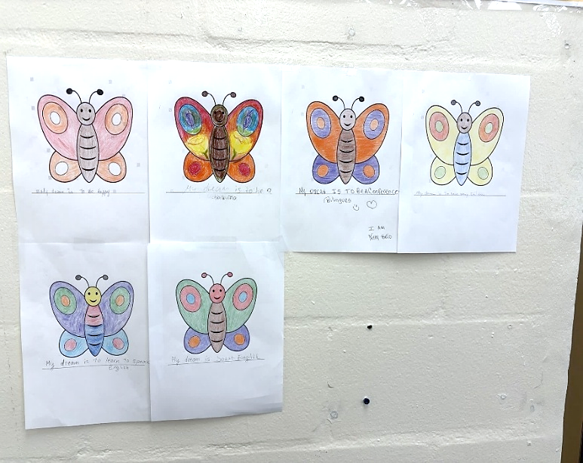
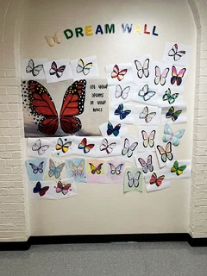

CVAEC Teacher
Ms. Tanja’s Level 1/2 ESOL Students’ “Dream” Butterflies.

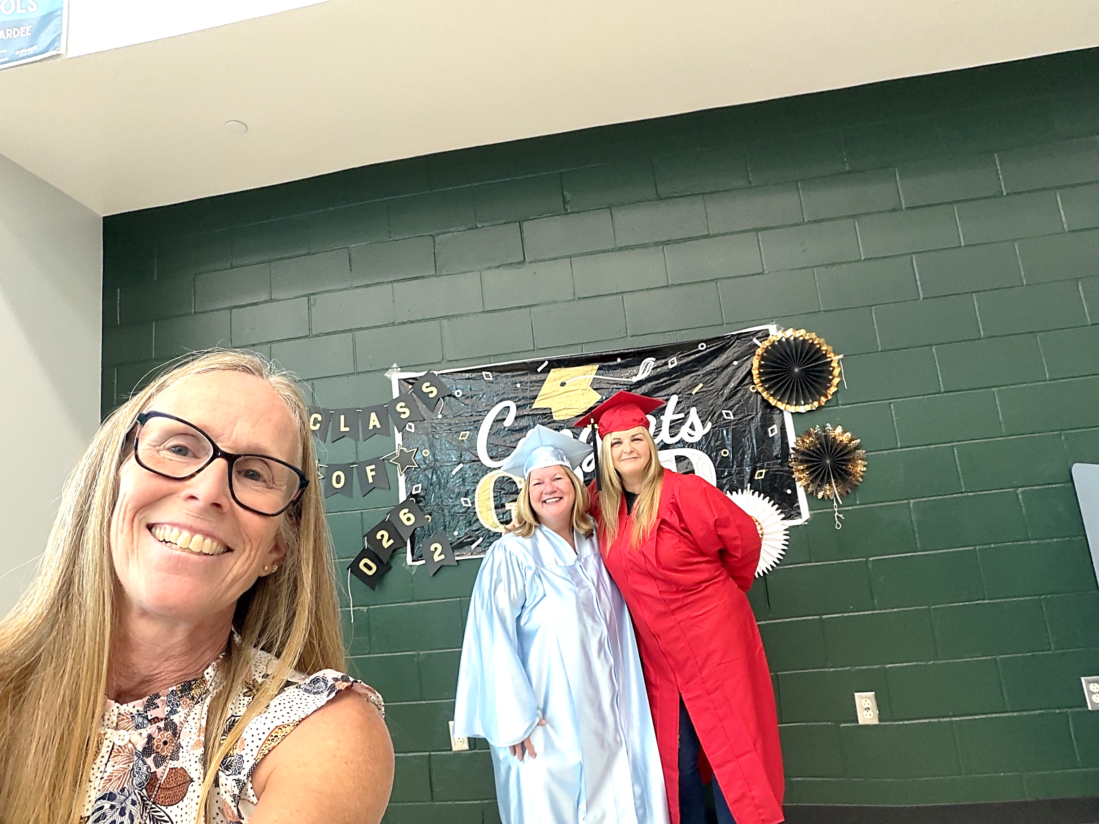
August Graduate of the Month from Clearview
Cheri

“Cheri's journey to earning her GED is a true testament to perseverance, determination, and resilience. Throughout her educational journey, she faced many challenges and obstacles outside the classroom, yet she never allowed them to stand in the way of her goal. No matter what life threw at her, Cheri continued to show up ready to learn, work hard, and move forward. She brought a positive spirit to class each day, greeting everyone with a warm smile and often a heartfelt hug that brightened the room. Her strength in overcoming adversity has led her to this proud accomplishment. I was honored to celebrate Cheri's success at our August 20th GED Ceremony and look forward to all she will achieve in the future.” Nominated by CVAEC GED/AHS Teacher Ms. Jet.

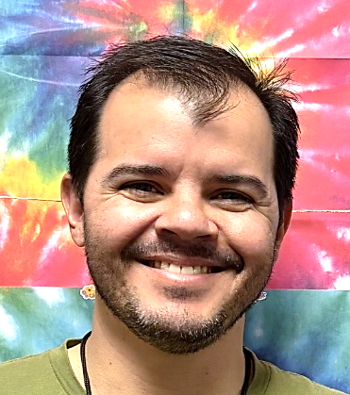
August ESOL Student of the Month from Clearview
Douglas De Oliveira Jr.

“I am nominating Douglas De Oliveira Jr. as an ESOL Student of the Month! Douglas is a newer student at Clearview and is very committed. He participates in every class and is not shy about asking questions. All questions are good, and Douglas’ always help others as well as himself. Douglas is also a good sport. I have mistaken him as a Spanish speaker a number of times, but in fact, he is from Brazil and speaks Portuguese. I think I have finally started to remember that. Our school is fortunate to have such a dedicated and enjoyable student. I think Douglas will progress nicely with these attributes. Welcome to Clearview, Douglas!” Nominated by CVAEC ESOL Teacher Ms. Brenda.

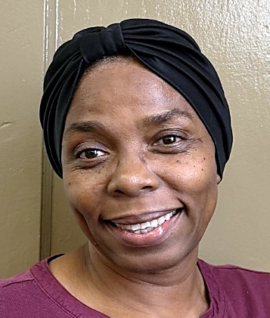
August ESOL Student of the Month from Clearview
Marie Chantale Laurore

“I am nominating Marie Chantale Laurore as an ESOL Student of the Month. Chantale has been my student for a long time and is wonderful to have in class. Marie completed a Phlebotomy program here and is now working on getting her state certification. Marie also attends ESOL classes almost every day. On her most recent reading test her score went up and was only a few points away from the next level. Chantale is not only a good student, but also a good person who always shows kindness to her teachers and classmates. Congratulations Chantale. I am very proud of you. Keep up the good work!” Nominated by CVAEC Lead ESOL Teacher Ms. Magen.

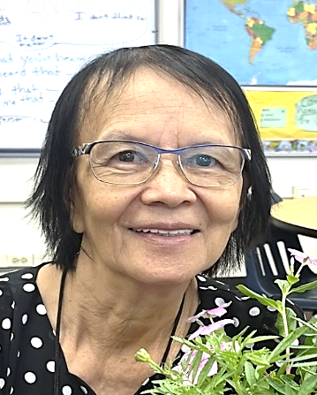
August ESOL Student of the Month from Clearview
Thuy Hoa Thi Lam

“Our newest ESOL Student of the Month is Thuy Hoa Thi Lam. Originally from Vietnam, Thuy came to Florida 25 years ago and has always worked in nail salons. A few months ago, she decided to study English because she wanted to communicate more easily with her daughter-in-law and three grandchildren. Thuy is curious and eager to learn, always asking questions and sharing ideas and experiences with others. She has a kindhearted spirit and often shares food with classmates and teachers. Her determination to learn, her generosity and the smiles she brings to those around her make her truly special.” Congratulations Thuy!” Nominated by CVAEC ESOL Teacher Ms. Paige.

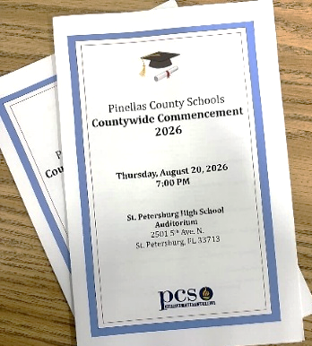
On Thursday, August 20th, Pinellas County Schools held its 2025-2026 Adult Graduation Ceremony. Over 100 students had the opportunity to walk across the stage, shake hands with our PCSB Leaders, and prove to themselves that they could accomplish this goal. Each diploma represents countless hours of hard work, overcoming challenges, balancing responsibilities, and staying committed to their educational goals. Through their resilience and effort, they have achieved an important milestone that opens the door to new opportunities for higher education, career advancement, and personal growth. We celebrate not only their academic accomplishment but also the strength, courage, and commitment they showed along the way. Their success is a testament to the belief that it is never too late to achieve a dream. CONGRATULATIONS to our graduates on this well-earned achievement and the bright future that lies ahead. Submitted by CVAEC ABE/GED/AHS Teacher Ms. Jet.

Congratulations to our graduates on this well-earned achievement and the bright future that lies ahead.

https://www.wfla.com/news/pinellas-county/i-knew-i-had-to-do-it-43-year-old-mother-graduates-pinellas-county-schools-with-ged/

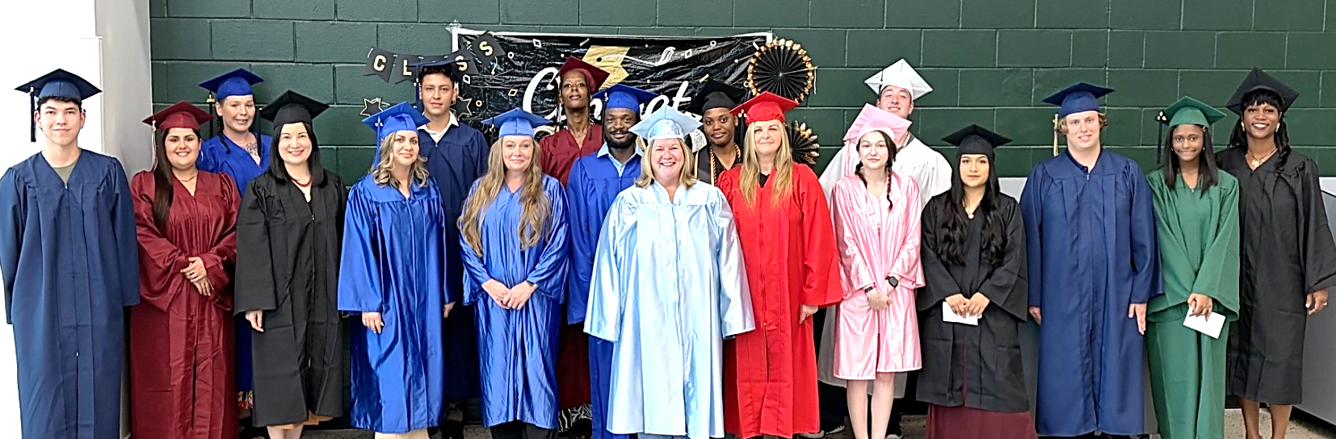

2026 CVAEC Graduates Tanner, Breyona, Stephanie, Qi, Yudilien, Alexis, Sarah, Cassandra, Thomas, Jennifer, Kivina, Cheri, Ashlynn, Noah, Riley, Surriyah and Niarobe (not pictured Rebecca, Teema and Sheena).

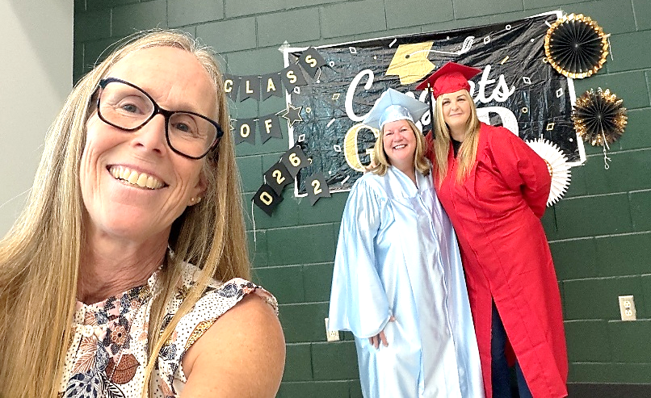


CVAEC Graduate Kaleia.

CVAEC GED Teacher Ms. Jet, and
CVAEC Graduates Jennifer and Cheri.

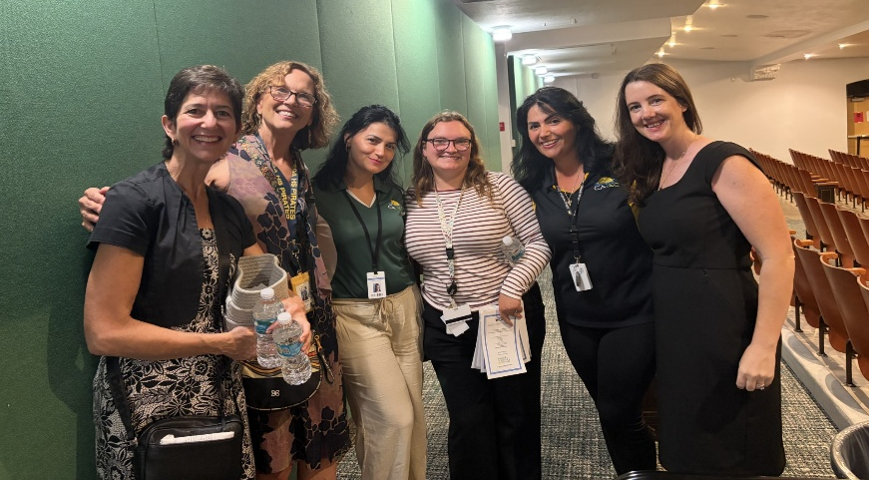
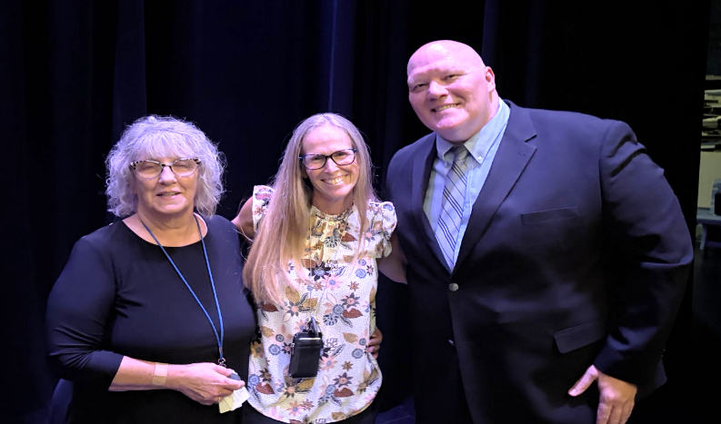

CTEA Secretary Ms. Nancy, CVAEC GED Teacher
Ms. Jet and CTEA Managing Officer Mr. Andy.

CVAEC ESOL Teacher Ms. Naki and Counselor Ms. Linda, CAEC Staff Ms. Ledina, Ms. Mirela and Ms. Katie.


To celebrate America's 250th Fourth of July, the Level 5 ESOL class did a timeline activity with important events in US History. It included a range of events from the signing of the Declaration of Independence to the moon landing to the creation of the internet and AI. Students first had to work together to put the events in what they believed was the right order. Then the correct order was revealed after which they learned a little bit about each event. It was a wonderful activity that allowed them to learn a lot about the country they now call home. Submitted by CVAEC Lead ESOL Teacher Ms. Magen.

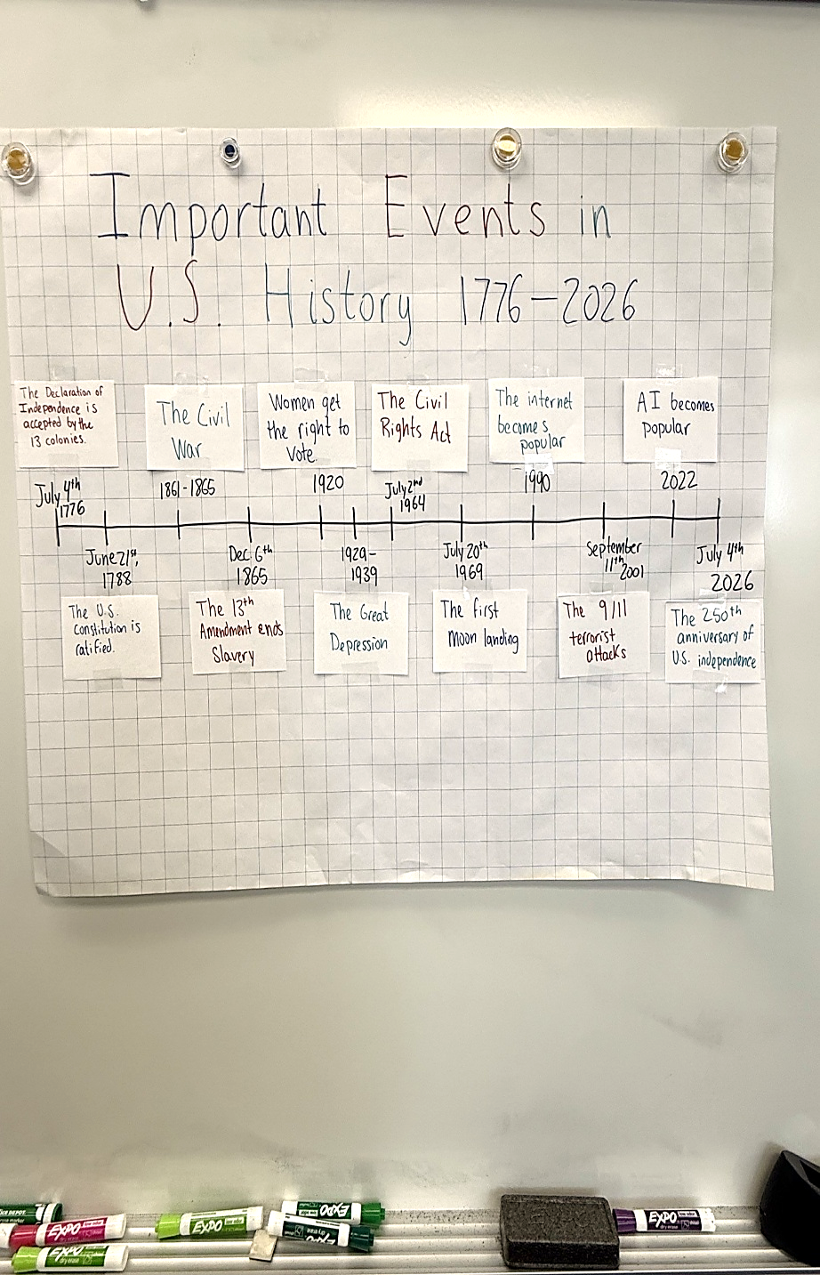
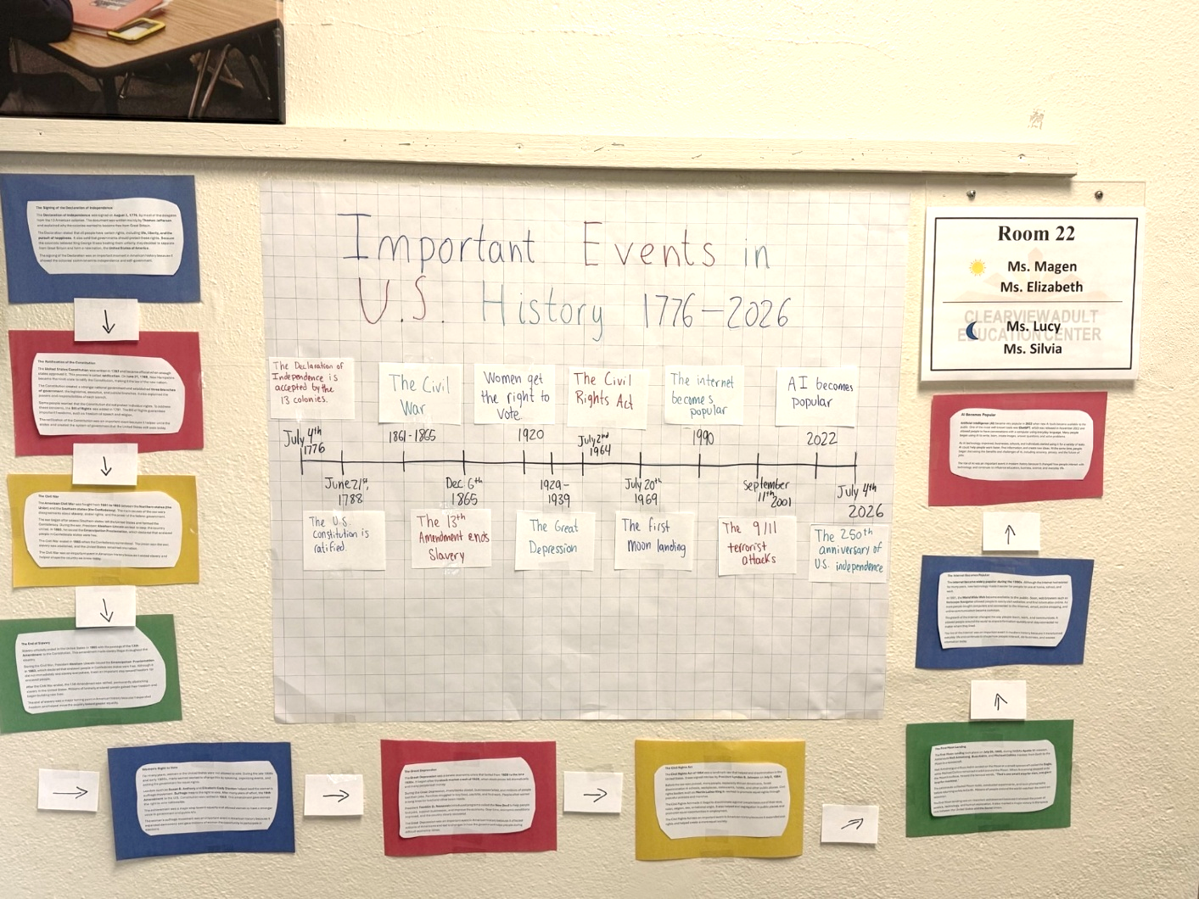

ESOL students at Feeding Pinellas Northwest Church “colored” their butterfly dreams. The students looked at a “blank” butterfly and were asked, “What do you see?”. Each student transformed it into a lesson connecting language learning, science, personal growth, and their dreams. As a class, we came to an important conclusion: learning English is a dream that can come true. Just like the butterfly, transformation happens little by little, one step at a time. Submitted by CVAEC Feeding Pinellas Northwest Church ESOL Teacher Ms. Patricia.
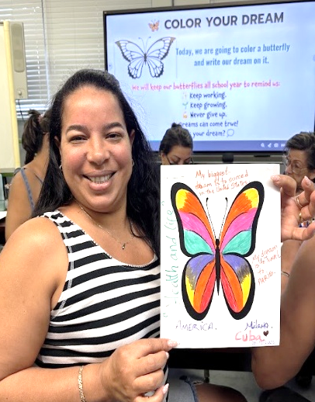
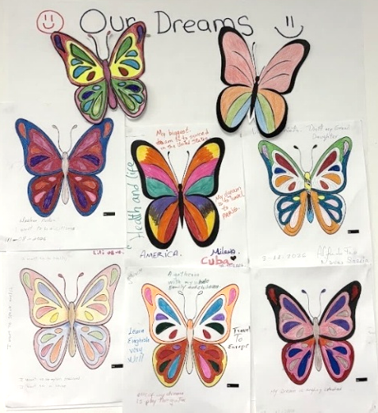
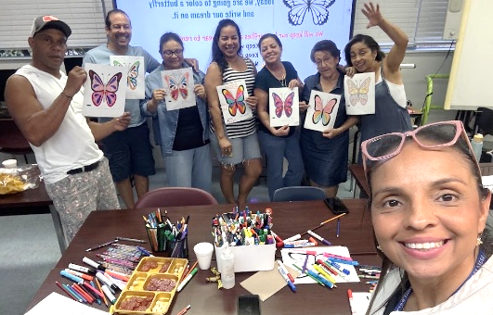

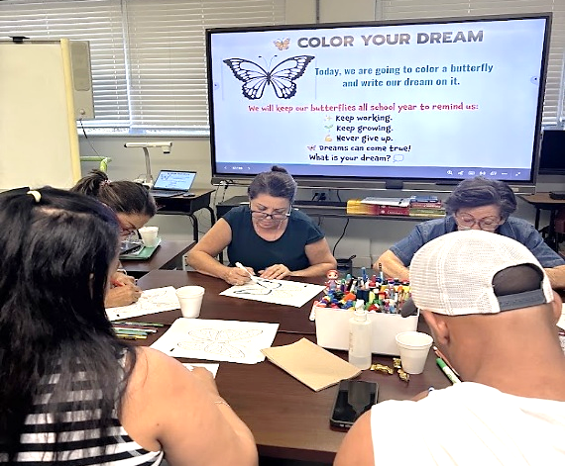
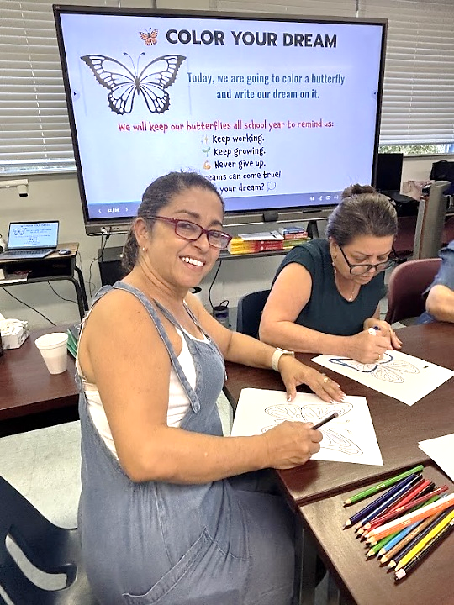
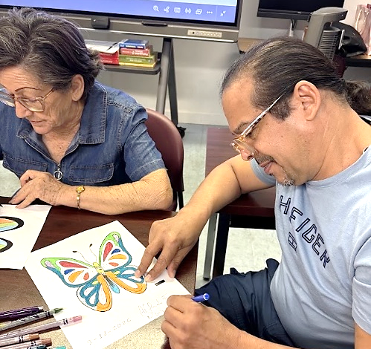

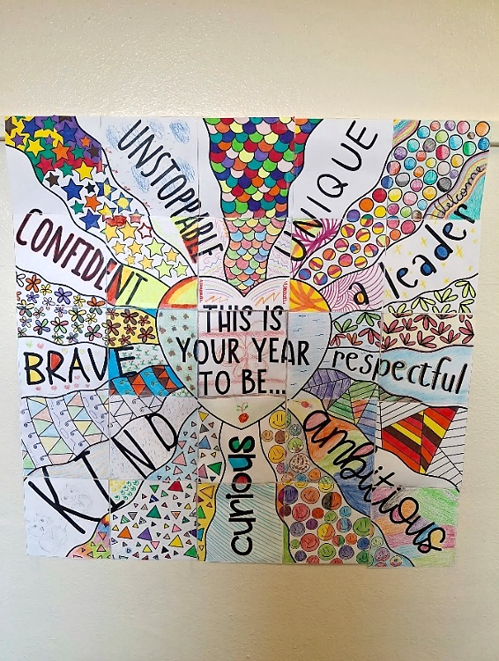

On the first day of school, intermediate and advanced ESOL students were asked to discuss their personal, educational, and career goals. They were also invited to review all the school rules and watch the school safety video. We also talked about all the opportunities Clearview offers like counseling, online and GOALS classes, the CSIT program, food/clothing assistance, and other support. While all the discussions were going on, each student colored one piece of the back-to-school puzzle pictured. The result is an amazing and very colorful motivational poster. Come and see it on the wall near room 20! Submitted by CVAEC ESOL Teacher Ms. Inguna.

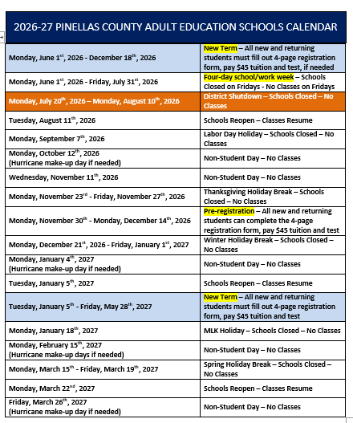

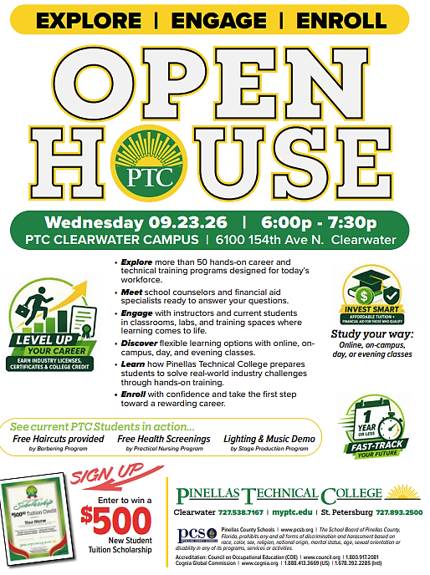
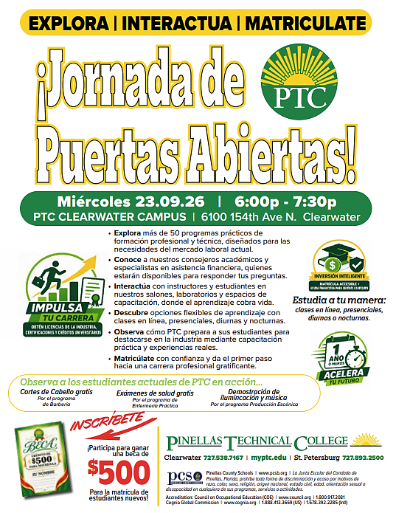

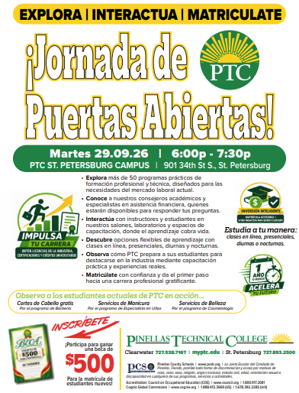
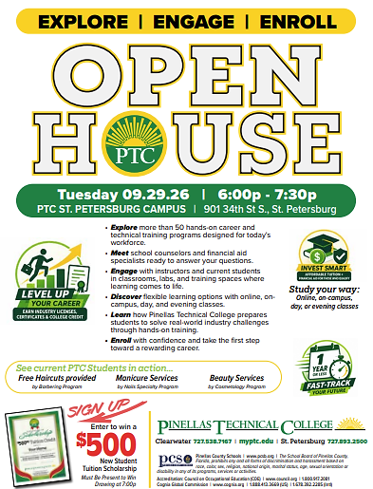

The Florida Department of Health in Pinellas County (DOH-Pinellas) has shared important information regarding two confirmed dengue fever cases in the community. We are sharing the attached information with families in both English and Spanish to help you stay informed about dengue fever, including steps you can take to help prevent mosquito bites and reduce the risk of mosquito-borne illness. Thank you, Pinellas County Schools.

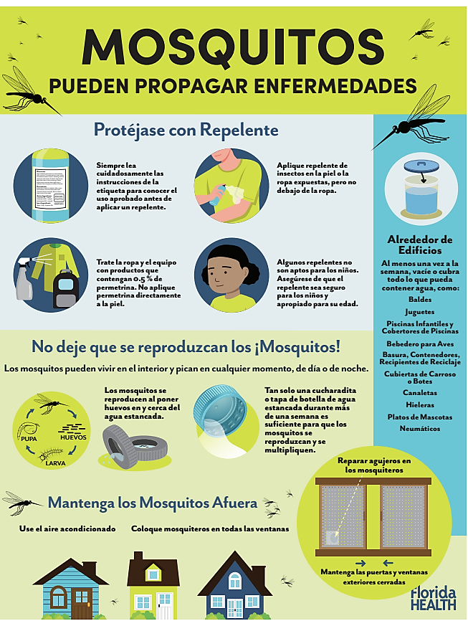
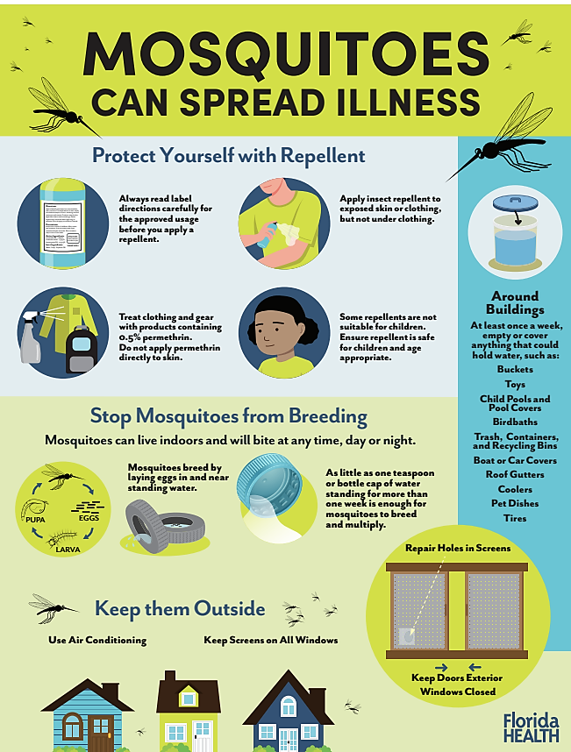

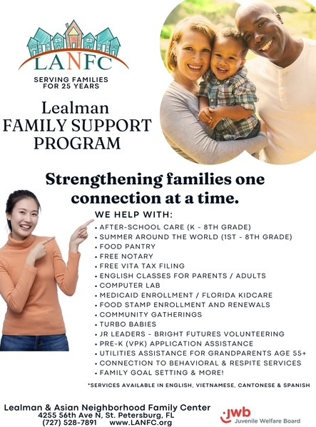
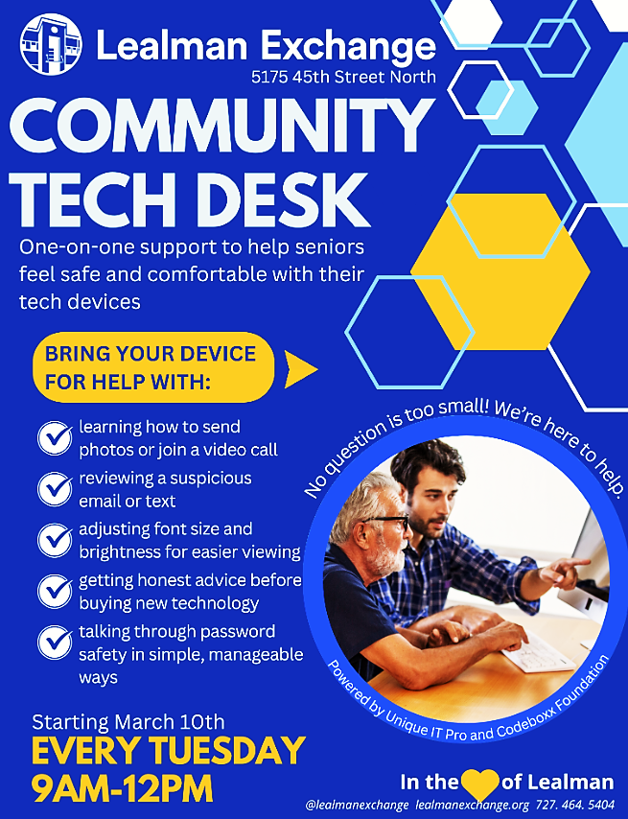

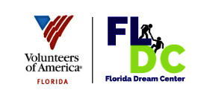

Florida Dream Center
4017 56th Ave. North, St. Petersburg, FL
727-851-9074
Tuesdays – Fridays 8:00 am – 4:00 pm
Saturdays 6:00 am – 1:00 pm

We can assist with registering for:
Food stamps
Medicaid
Blue card (health care for uninsured residents ages 18 to 64 who are not eligible for Medicaid, Medicare, or other health programs)
Social Security Disability (first time only)

We can help with:
Safe shelter
Emergency food
Clothing
Hygiene products
Household goods
Affordable housing
Legal Aid referrals
Workforce training programs
Referrals to other social services (vocational rehab, mental health, substance abuse, etc.)

To schedule an appointment with a case manager please call 727-851-9074.

Other Florida Dream Center locations:
53rd Ave. North & Haines Rd. (behind Boardwalk Tavern), St. Petersburg, and Clearview United Methodist Church,
4515 38th Ave. North, St. Petersburg.

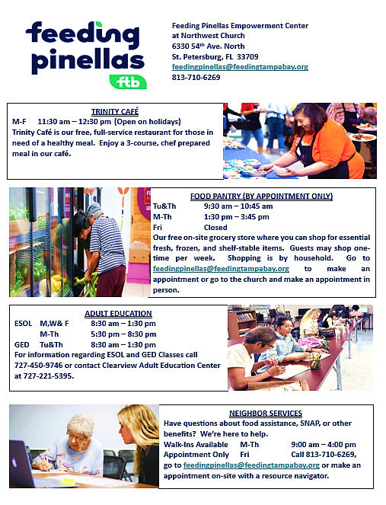

727-824-6900
www.Pinellas.FloridaHealth.gov

There are six Department of Health (DOH-Pinellas) locations in Pinellas County offering:
Primary Care including breast and cervical cancer screenings.
Maternal and child health programs.
Supplemental Nutrition Program for Women, Infants, and Children (WIC).
Dental healthcare including adult and pediatric care.
School healthcare services including annual and school physicals for children.
Adult and pediatric immunizations.
Disease control prevention and treatment.
Birth and death certificates.
The Florida DOH-Pinellas collaborates with Pinellas County Government to provide care for uninsured residents at no-cost and on a sliding fee scale for those that do not qualify for no-cost services.

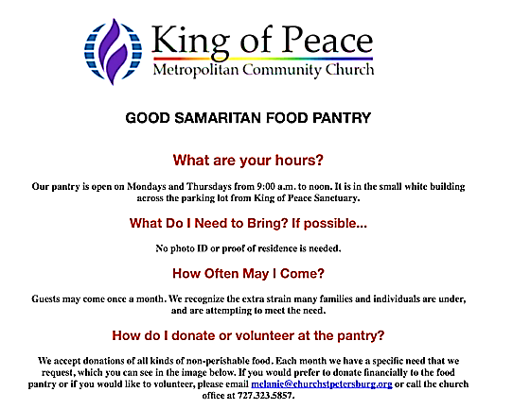
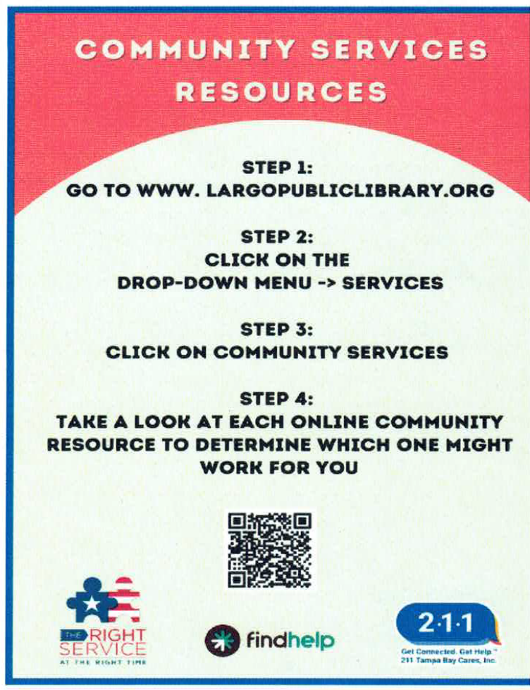

6085 Park Blvd, Pinellas Park, FL 33781


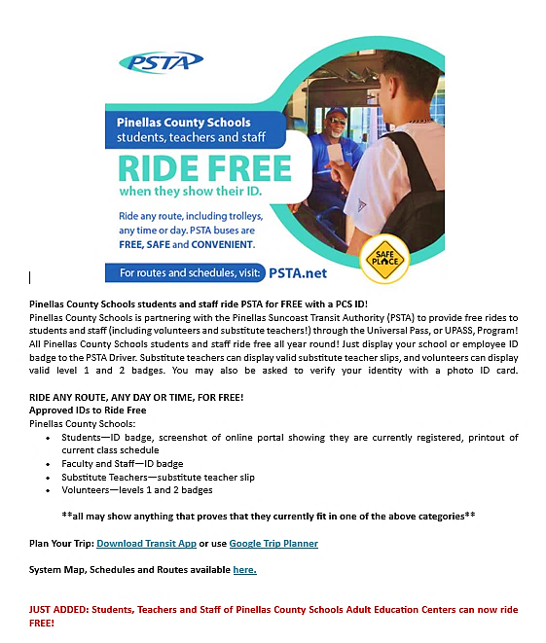
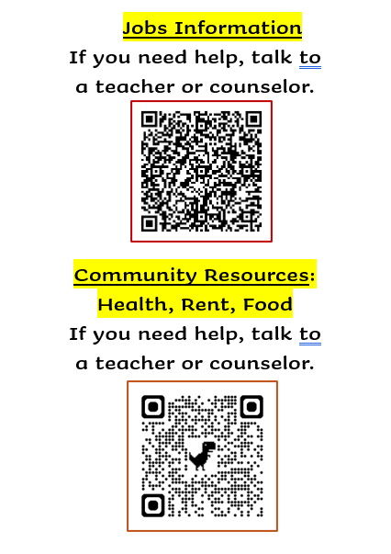

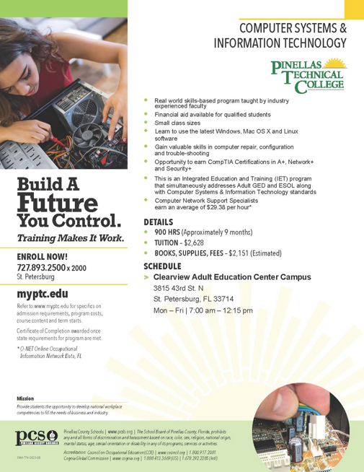
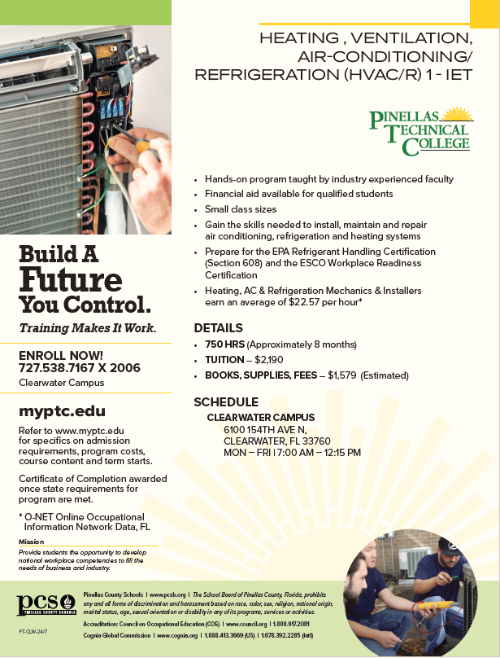



CVAEC Teacher
Ms. Tanja’s Level 1/2 ESOL Students’ Butterflies.

