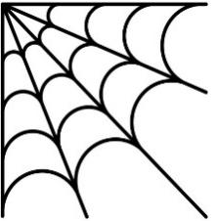
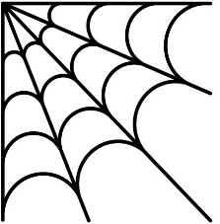
Cochise Elementary School Grades K-8
OCTOBER 2026
Student Lunch $3.00 Extra Milk $.35 Adult Lunch $7.25

MONDAY | TUESDAY | WEDNESDAY | THURSDAY | FRIDAY
 |  |  | 1  Nachos  Churro  Refried Beans  Oranges | 2  Hot Dog  Goldfish Crackers  Carrots  Peaches
5 Chicken Nuggets Mac and Cheese Carrots Fruit Juice | 6  Egg Roll  Fried Rice  Broccoli  Oranges | 7  Chicken Sandwich Goldfish Crackers Vegetable Juice  Apple Sauce | 8  Soft Tacos  Churro  Corn  Mango-Strawberry Cup | 9 Pizza Ranch Dressing Mixed Vegetables Pear
12  NO SCHOOL | 13 | 14 | 15 | 16
19  Chicken Tenders  French Fries  Goldfish Crackers Pears | 20  Ravioli w/Meat Sauce Bread Sticks Mixed Vegetables Peaches | 21  Corn Dog Goldfish Crackers  Green Beans  Fruit Juice | 22  PB&J Sandwich Cookie Carrots Apple Sauce | 23  Taquitos and Tamale  Salsa  Refried Beans  Oranges
26  Swedish Meatballs  Mashed Potatoes  Green Beans Cranberries | 27  Nachos  Churro  Refried Beans  Oranges | 28  Orange Chicken Rice Broccoli Pineapple | 29  Pizza Ranch Dressing Mixed Vegetables Pear | 30  Cheeseburger  Cookie  French Fries  Peaches
Cochise Elementary School Grades K-8
FEBRUARY 2025

MONDAY | TUESDAY | WEDNESDAY | THURSDAY | FRIDAY
 |  | NO SCHOOL
3 | 4 | 5 | 6 | 7
10 | 11 | 12 | 13 | 14
17 | 18 | 19 | 20 | 21
24 | 25 | 26 | 27 | 28

