ONE TEAM • ONE MISSION • CONSISTENCY CREATES EXCELLENCE
WELCOME BACK, UYA FAMILIES!
FROM THE PRINCIPAL'S DESK — MR. HINES
Welcome to another great week at UYA! As we continue moving deeper into instruction, our focus remains on helping every scholar SHOW UP, SHOW OUT, and LEVEL UP. Our routines, procedures, and cultural expectations create the foundation, and now we are using that foundation to drive stronger teaching, learning, and academic achievement.
I am excited to share our Spring 2026 M-STEP results with our families. In Math, every tested grade increased in proficiency from Spring 2025 to Spring 2026. In ELA, Grades 3, 4, and 7 increased. These results give us something to celebrate while also reminding us that our work continues. The M-STEP charts included in this newsletter show our grade-by-grade results and progress over time.
This week, NWEA testing begins September 22 and continues through September 30. NWEA gives us another important measure of where scholars are now so we can identify strengths, respond to needs, and continue pushing academic growth. Families can help by making sure scholars are at school every day, on time, well-rested, and ready to give their best effort.
Our goal is not simply improvement one time. We want consistent growth. That is why our theme remains One Team, One Mission — Consistency Creates Excellence. When our school, scholars, and families stay connected and consistent, we create the conditions for every scholar to succeed.
Let’s continue to be 1% better every day. Let’s SHOW UP, SHOW OUT, and LEVEL UP!
UPCOMING SEPTEMBER DATES
SEPT. 22–30
NWEA Testing
Testing window
THIS WEEK AT UYA — ATTENDANCE & DATA
ATTENDANCE MATTERS — SHOW UP  UYA Attendance Goal: 95% ADA  Week of 9/8 coded attendance: 93.42%  Class Attendance Celebration: Comer 6a and Vinluan 6b 100% Attendance last week  Family Challenge: Have your scholar in school Monday, Tuesday, Wednesday, Thursday, and Friday for 100% attendance this week. | NWEA TESTING  September 22–30  Our NWEA testing window begins September 15 and continues through September 30. Daily attendance is especially important so scholars are present and ready to do their best.
CULTURE CORNER — CHARACTER CAMP
WHAT SHOULD IT LOOK LIKE, FEEL LIKE & SOUND LIKE?
This week's focus is Character Camp: routines, procedures, and cultural norms.
LOOKS LIKE: Modeling • Practicing • Reteaching
FEELS LIKE: Consistency • Clear expectations • Everyone learning the same expectations
SOUNDS LIKE: Scholars explaining the cultural norm, routine, or procedure — and the WHY behind it.
Family conversation: Ask your scholar, “What are the cultural norms and why are they in place?” and “What is a routine or procedure at UYA, and why is it in place?”

FAMILY CONNECTIONS & WEEKLY ACTIONS
IMPORTANT REMINDERS  • Breakfast ends at 7:55am  • Doors open at 7:30am daily  • Scholars use their regular entry doors.  • Uniform expectations remain the same; shoes must be solid black.  • CurbSmart dismissal will be followed. Returning families will use the same process as last year; new families reviewed the process during orientation.  • If you do not know your scholar's CurbSmart number, you will learn it when you pick up your scholar. | HOMEWORK & LEARNING  READ & RESPOND  This week, scholars should read each night and respond to what they read. Families, please have your scholar read carefully and complete the response connected to the reading.
CONNECTIONS CORNER
SAVE THE DATE — MATH-O-WEEN
October 29 • 5:00–7:00 PM
More information will be shared as the event gets closer.
FAMILY CHALLENGE OF THE WEEK
100% ATTENDANCE CHALLENGE
The challenge is simple: make sure your scholar is at school all Five days this week — Monday, Tuesday, Wednesday, Thursday, and Friday. Our goal is for your scholar to finish Friday with 100% attendance for the week.

M-STEP ELA — HISTORICAL PROFICIENCY
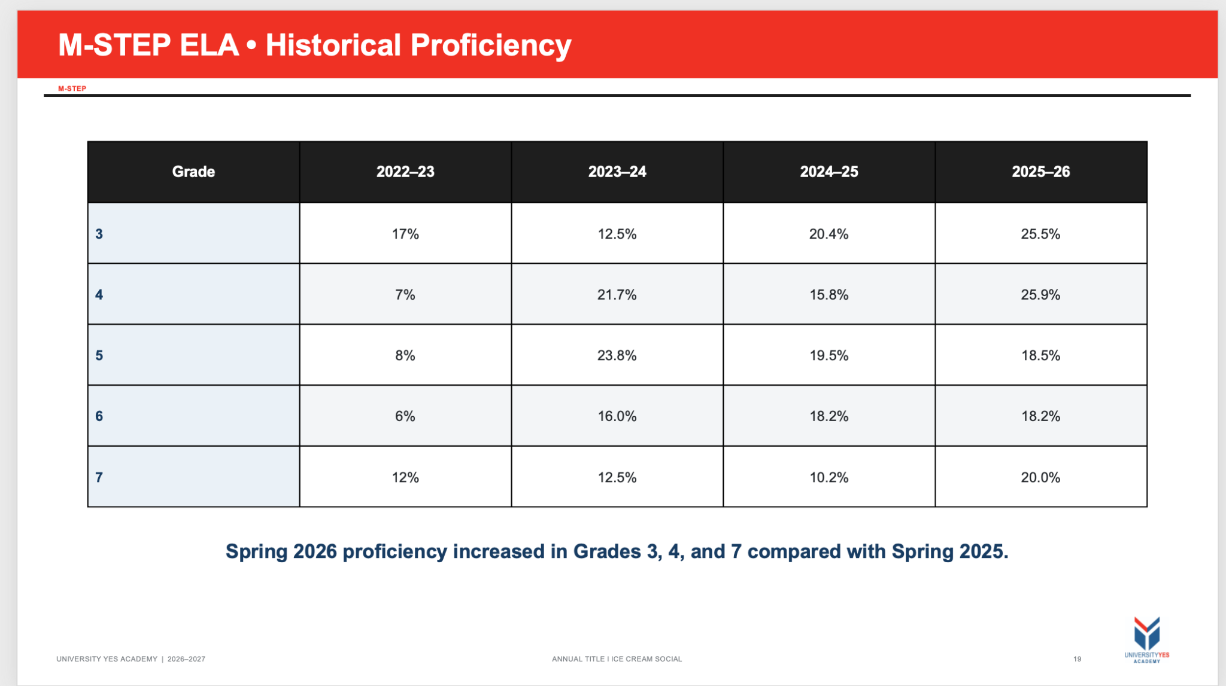
Spring 2026 proficiency increased in Grades 3, 4, and 7 compared with Spring 2025.

M-STEP MATH — HISTORICAL PROFICIENCY
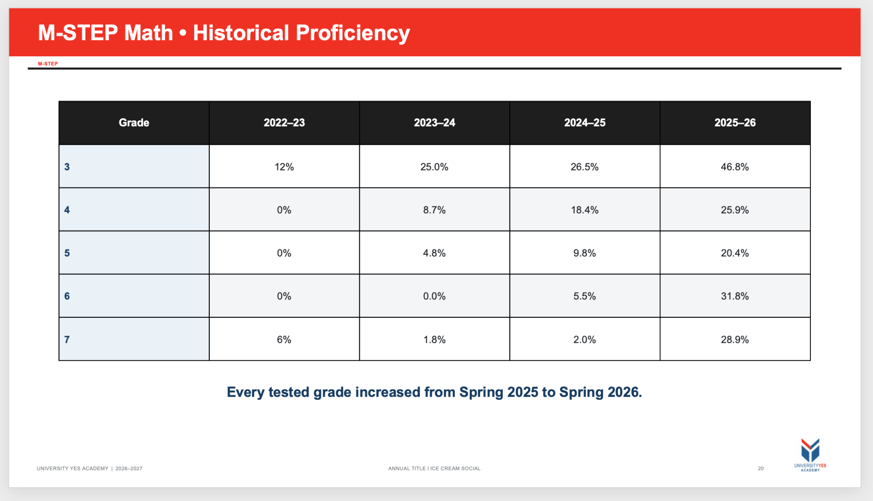
Every tested grade increased from Spring 2025 to Spring 2026.


TRIPLE CROWN OF EXCELLENCE
SHOW UP • SHOW OUT • LEVEL UP

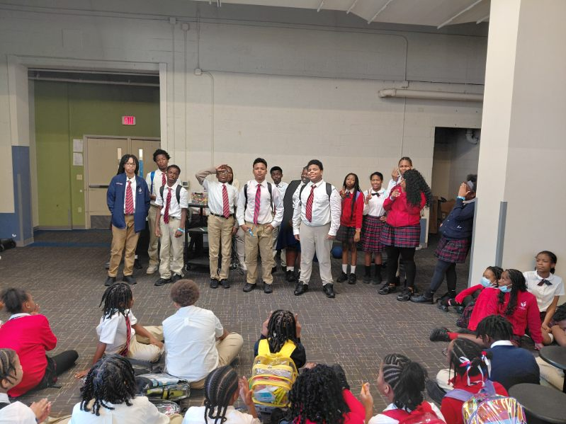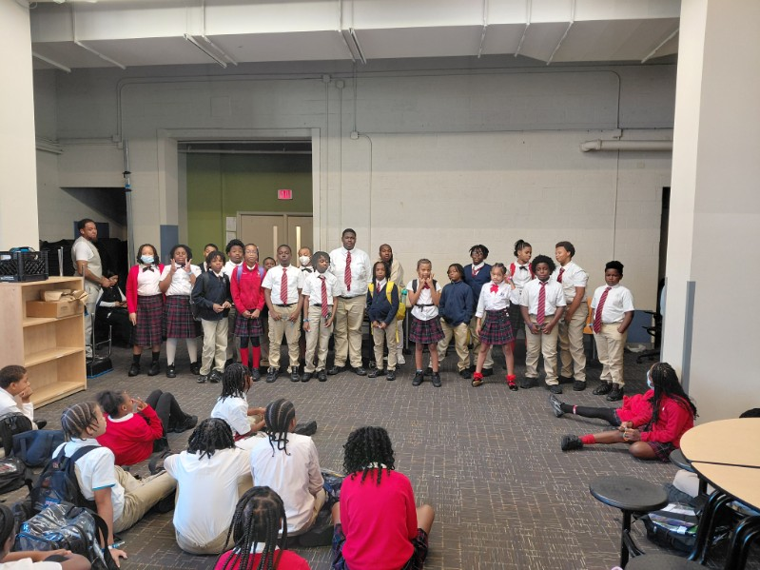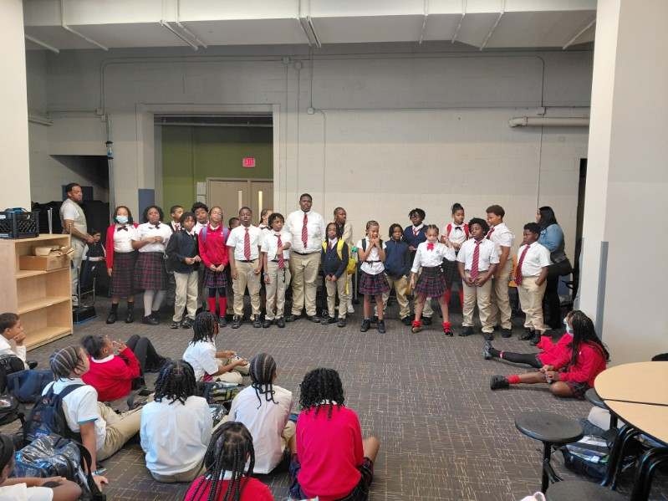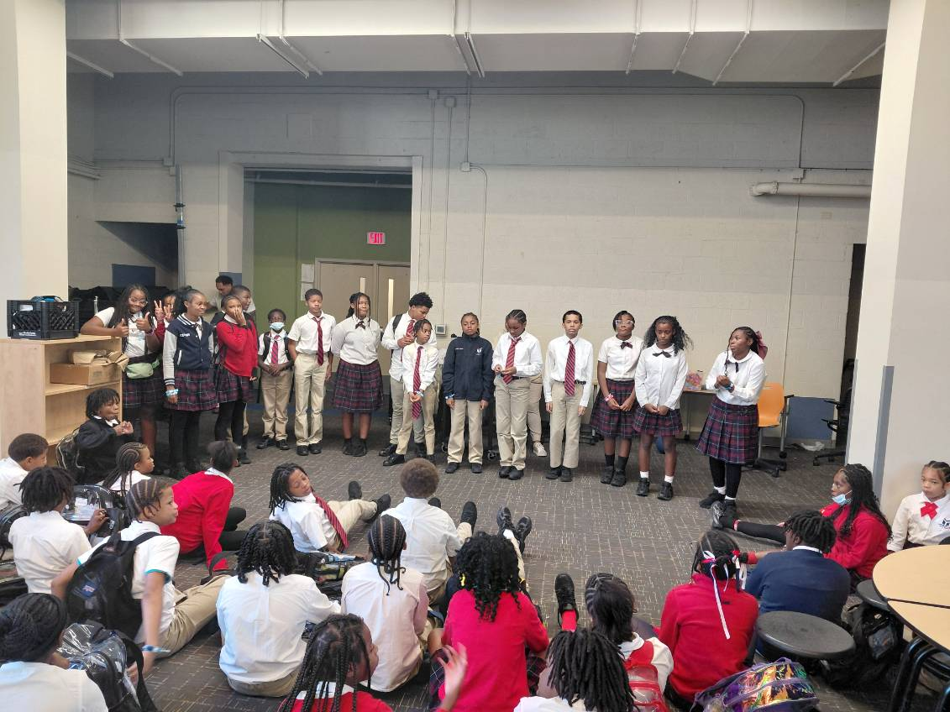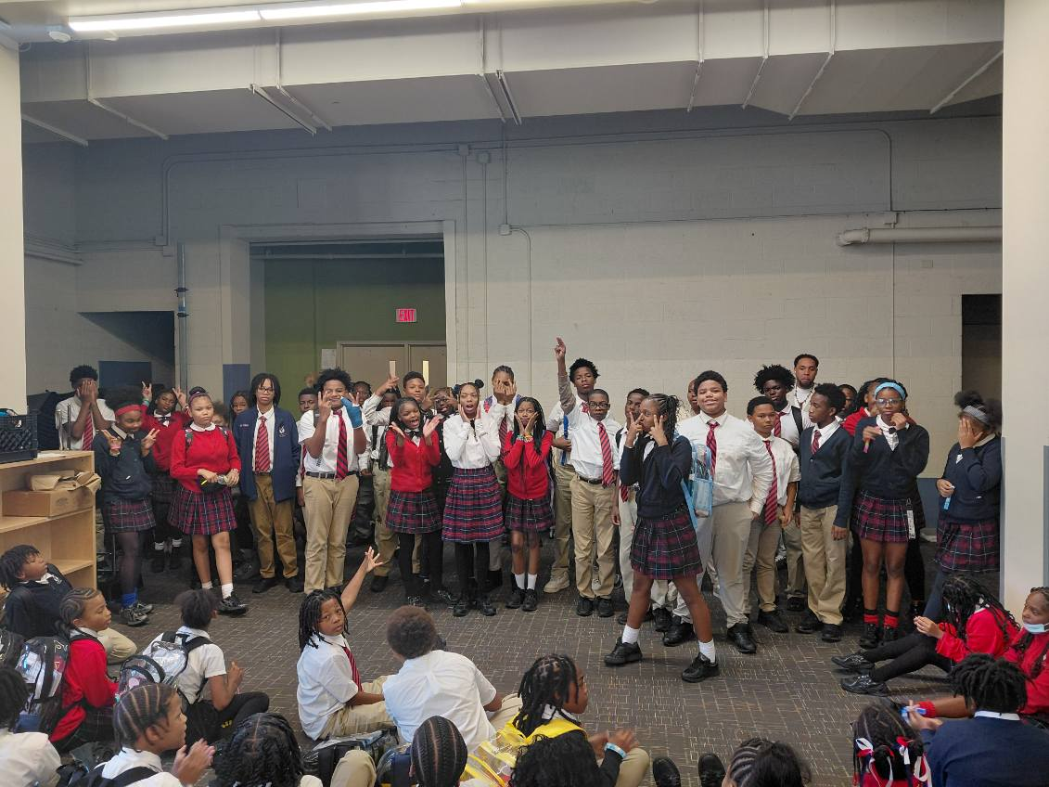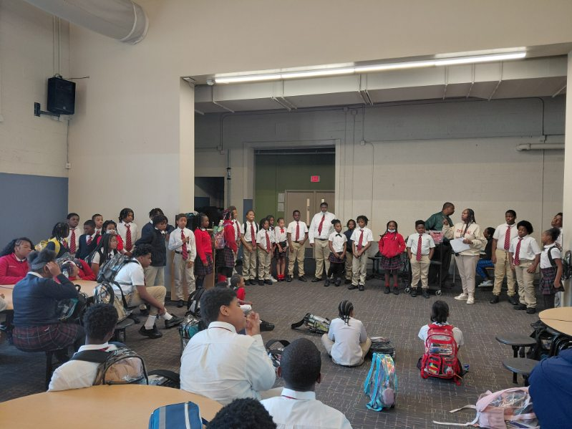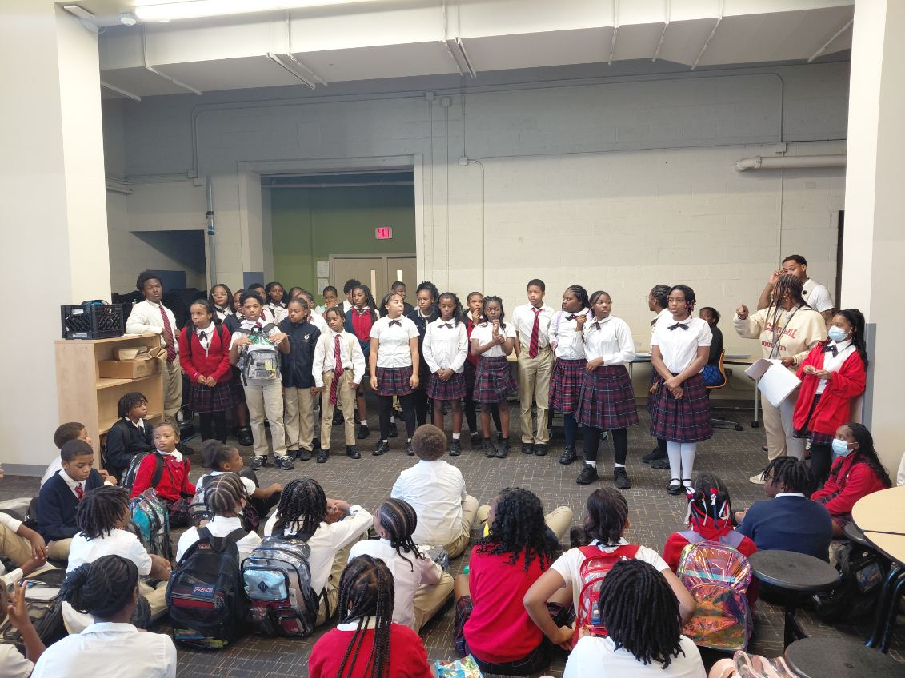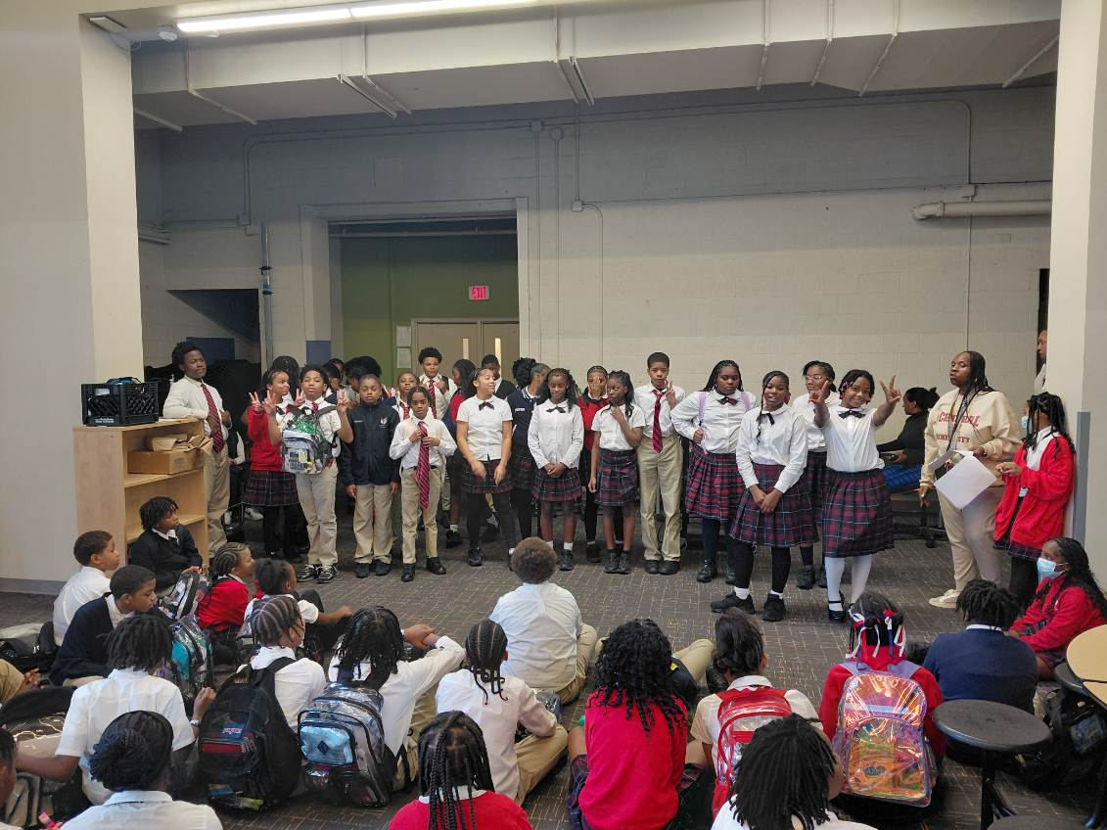

CONTACT UYA STAFF
Use the Dean's List number to TEXT when one is listed. If no Dean's List number was provided, use the staff member's email.
STAFF MEMBER | POSITION | EMAIL | DEAN'S LIST TEXT
Mr. Hines | Principal | rhines@npfeschools.org | (313) 528-0753
Dr. Bland | Chief Officer of Schools | Not provided | Not provided
Ms. Bowie | Student Support Specialist | tbowie@npfeschools.org | (313) 241-0280
Ms. Shelman | SPED Director | nshelman@npfeschools.org | nshelman@npfeschools.org
Ms. Liz | Admin Assistant | eidemudia@npfeschools.org | (313) 757-9638
Mr. Cummings | Student Support Specialist | kcummings@npfeschools.org | (313) 552-3565
Mrs. Gipson | Pre-K | cgipson@npfeschools.org | (313) 241-7152
Ms. Lee | 1st Grade Teacher | dlee@npfeschools.org | (313) 228-2293
Ms. Butio | 2nd Grade Teacher | mbutio@npfeschools.org | (313) 228-2319
Ms. Mariano | 2nd Grade Teacher | tmariano@npfeschools.org | (313) 380-4253
Mr. Apostol | 3rd Grade Teacher | hapostol@npfeschools.org | (313) 524-9938
Mr. Sigmon | 3rd Grade Teacher | Not provided | Not provided
Ms. Chatman | 4th Grade Teacher | dchatman@npfeschools.org | (313) 552-4185
Ms. Mariano | 4th Grade Teacher | mmariano@npfeschools.org | (313) 228-2265
Mr. Mike | 5th Grade Teacher | mmayuga@npfeschools.org | (313) 228-2259
Ms. Doss | ELA | ddoss@npfeschools.org | ddoss@npfeschools.org
Ms. V | 6th, 7th & 8th Science | svinluan@npfeschools.org | (313) 484-0346
Ms. Page | 6th, 7th & 8th Social Studies | npage@npfeschools.org | npage@npfeschools.org
Ms. Jordan | 6th, 7th & 8th Math | ejordan@npfeschools.org | (313) 737-8360
Ms. Dean | ELA | cdean@npfeschools.org | cdean@npfeschools.org
Ms. Lewis | Med Tech | nlewis@npfeschools.org | (313) 524-0728
Ms. Comer | Art | hcomer@npfeschools.org | hcomer@npfeschools.org
Mr. Motley | Gen Ed Social Worker | jmotley@npfeschools.org | (313) 241-0235
Mr. J. Jackson | PE | jjackson@npfeschools.org | jjackson@npfeschools.org
Ms. Momo | Intervention | fmomo@npfeschools.org | (313) 241-0273
Ms. Cuffie | Student Information System | lcuffie@npfeschools.org | lcuffie@npfeschools.org
Mrs. Tucker | Operations | ltucker@npfeschools.org | ltucker@npfeschools.org
Ms. Hopwood | Intervention Reading | chopwood@npfeschools.org | (313) 241-8471
Ms. Williams | JA SPED | lapaigewilliams@npfeschools.org | lapaigewilliams@npfeschools.org
Ms. Dixon | Student Engagement & Support Coordinator | ldixon@npfeschools.org | (313) 228-2243
Mr. Reed | Attendance & Engagement | dreed@npfeschools.org | (313) 380-3629

