Southern Bluffs Elementary
Parent Handbook
2026-2027



Welcome to Southern Bluffs Elementary

In a day and age when families have so many choices when it comes to educating their children, we are humbled and thankful that you have selected us to do this very important work. The staff at Southern Bluffs is highly qualified, compassionate, innovative and student-focused and we look forward to being your partner this school year.

The information in this handbook has been developed in order to provide families with information, policy and procedures at our school. Topics include: attendance policies, health and nutrition services, transportation, Positive Behavior Intervention Supports (PBIS), volunteering and more. I encourage families to go through this handbook together, as well as additional information provided in the school district’s newly revised School District of La Crosse Code of Rights & Responsibilities located on the district website.

We will continue to remain vigilant when it comes to the health and safety of our school community. Safety protocols may evolve and change throughout the school year based on the landscape of the greater La Crosse community. Thank you in advance for your understanding and flexibility if those changes are not reflected or differ from what is currently in the 2025-26 Parent/Guardian Handbook.

You will receive regular communications from the classroom and school throughout the school year. Please be sure to keep your contact information in Skyward Family Access current for more seamless communication. You may also wish to bookmark the Southern Bluffs Web page and “Like” the Southern Bluffs Facebook page for day-to-day updates. To reach the main office, call 608.789.7020 with any questions or if you need additional information.

Go Bobcats!
Amanda Durnen
Amanda Durnen, Principal


Home-School Communications
A weekly school-wide Parent Square update will be sent to families. Our website, https://southern-bluffs.lacrosseschools.org, has information on current and upcoming events, classroom sites, supply lists, access to district information and much more.
Parent Square: Periodically, you will receive a text or email message from the principal or main office with important information or reminders. Parent Square is the School District’s main communication platform and will be used regularly.

How to Be a Bobcat
POSITIVE BEHAVIORAL INTERVENTIONS AND SUPPORTS (PBIS)

Southern Bluffs has implemented PBIS to benefit our entire student and staff population. We have three clearly defined expectations:
- Be Respectful
- Be Responsible
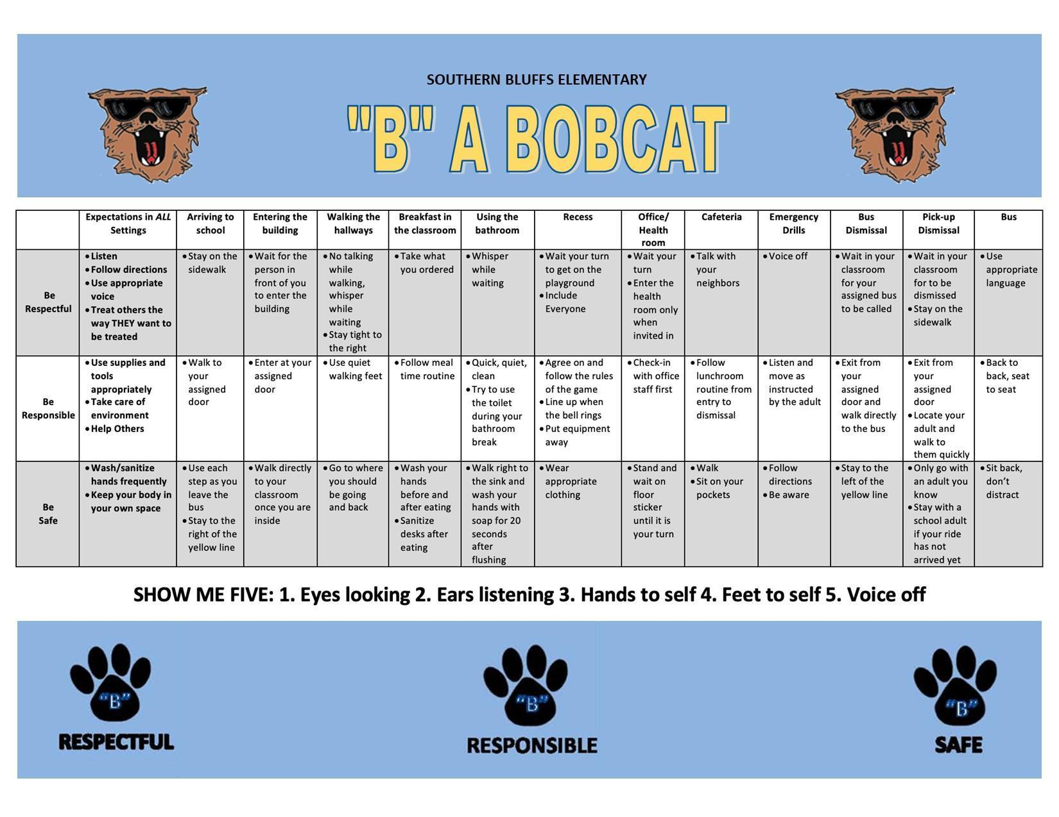
- Be Safe
Students will be taught these three expectations in multiple settings throughout the school. They will be instructed as to what the expectations look and sound like. We will continually self-evaluate our culture to effectively meet the social, emotional, behavioral, and academic needs of all students. We do this to create a more positive culture in our learning community.
On the following page you will find our PBIS matrix that defines the expectations of respectful, responsible, and safe behaviors in multiple areas of our school setting. Any opportunity you have to reinforce these expectations with your child will be appreciated.

Academics
HOMEWORK
Homework is assigned at all grade levels and is expected to be completed. Homework is an opportunity for students to independently practice skills or demonstrate learning. It is also an opportunity to teach student responsibility. A general guideline would be 10 minutes per grade. If your child consistently needs to spend an excessive amount of time and effort on homework, parents should notify the teacher. Parents with questions or concerns about homework assignments should contact the child’s teacher. Nightly reading is always encouraged. HOMEWORK IS NOT CONNECTED TO GRADING.

PROGRESS REPORTS TO PARENTS
Information regarding pupil progress occurs throughout the school year. The staff is encouraged to contact parents as soon as possible when concerns develop or when positive growth/development changes occur. In the fall and spring families will receive progress reports during parent teacher conferences. Report cards will be sent after the 2nd and 4th quarters. Parents are encouraged to contact a child’s teacher whenever a concern arises.

FIELD TRIPS
Field trips are an extension of classroom learning. Whether a field trip is a walking trip or a transported trip, students are expected to conduct themselves appropriately. Behavioral expectations will be taught prior to each field trip.

Health
MEDICINE IN SCHOOL
Over-the-counter medication is dispensed at school with the written consent of the parent. Prescription medication will be dispensed when the Pink Medication form is completed by the parent and a physician. Medication forms are available at any school office, local clinic, or on the District Web Page. All medications (over the counter and prescription) must arrive at school in the original container. Adults are encouraged to bring medication to school instead of sending it with a student. Medication will not be sent home from the school with a student.

LATEX-CONTROLLED ENVIRONMENT
Southern Bluffs is a latex-controlled school. Materials that contain high concentrations of latex, such as most balloons, are prohibited. Contact the school office if there are questions regarding latex materials.

ILLNESSES
If your child has been ill the night before school or is complaining of illness, please keep the child home. When a child becomes ill or seriously injured at school, we will make the child as comfortable as possible while we attempt to contact a parent. If we are unable to reach the parent, we will contact the adults listed as emergency contacts. Children with a temperature of 100.4°or more will be sent home. Other student health guidelines can be found on the District Web Page (lacrosseschools.org >Programs & Services >School Health Services >Parents Health Guide). All health-related questions should be directed to the school nurse or health assistant.

INSURANCE
The School District of La Crosse does not carry insurance covering student accidents occurring on the way to school, at school, or on the way home from school. Families interested in purchasing an insurance policy through the school district may contact the school office.

Attendance Policy
Each year, the School District of La Crosse makes a special effort to ensure that all students fully benefit from their education by attending school regularly. Research shows that missing 10 or more days of school can have a significant impact on student achievement.
After 10 student absences, all absences will require a doctor’s note and/or principal approval. If neither is provided, the absence will be marked unexcused.

Parents are required to call the school (608-789-7020), email us at southernbluffs@lacrossesd.org or submit the “Attendance Form” on our website before 8:00 a.m. if a child will be late or absent from school that day. Any message left on the school voice mail should include the reason for the child’s absence. When a child is absent and notification is not received from a parent/guardian, an automated call will go out to families at approximately 8:45 a.m. If a reason for the absence is not determined, it will be considered unexcused.
Unexcused absences can lead to truancy proceedings. There are various people in our building prepared to help if you or your student face challenges in getting to school. We promise to work collaboratively with you to identify barriers and provide support to overcome challenges you may face in helping your student attend school. Additional information regarding policies of the School District of La Crosse can be found at www.lacrosseschools.org.

**The Southern Bluffs Elementary School Day is from 7:45 am – 2:25 pm **

Winter Behavior Expectations
While the snowy, winter season provides many fun recess activities for our students at Southern Bluffs Elementary, we do have the following expectations that everyone needs to understand and follow. These are for the safety and well-being of all.

Students need to wear snow pants, coats, hat, gloves, and boots at every recess, walking to and from school and when riding the bus. Without the proper winter clothing your child may be asked to stand near the doorway or wear our “loaner” clothes at recess. (We only have a limited supply of these, so it is important that your son/daughter brings their own.)
-Throwing snow or snowballs is not permitted.
-Students will follow directions from staff/adults regarding equipment use or accessible areas to play on, when ice is present.
The following sledding guidelines are for the safety of our students.
Students must be seated feet first on sleds.
One person on each sled unless two can fit sitting correctly with feet forward.
Get on a sled safely.
Sledding only along the fence line.
Keep arms and legs inside of sleds to avoid injuries.
Avoid making contact with others.
Wait until the hill is clear of sleds in assigned area before going down.
At the bottom of the hill, get off sled immediately and walk up the side of the hill.
Students may slide feet first on their bottoms, down the snow banks formed by plowing.
Please slide towards the field area only.
Return and stack sleds neatly when finished.
Last recess students bring sleds to the designated area indoors.

Nutrition
LUNCH
If you would like to join your child for a school lunch, contact the office by 8:30 to make a lunch choice. Families are discouraged from bringing fast food or take-out lunches into the student cafeteria, and state guidelines prohibit soda in school cafeterias.

SCHOOL MEALS
Both breakfast and lunch are served at school, and monthly menus are available at the school or on the district website. Breakfast will be served in the cafeteria from 7:20-7:40am. Adult breakfast costs $2.95. Lunch is served from 10:40 until 12:10. A la carte milk is $0.50, and the price of an adult lunch is $5.00. Families may apply for free or reduced status at any time during the school year.
Elementary Student Meal Prices
Breakfast | $1.90
Reduced Breakfast | $0.30
Lunch | $3.15
Reduced Lunch | $0.40

TREATS/SNACKS

ALL CLASSROOM TREATS AND SNACKS MUST BE STORE BOUGHT AND INDIVIDUALLY PACKAGED. HOMEMADE SNACKS AND TREATS ARE NO LONGER ACCEPTED DUE TO STUDENT MEDICAL AND ALLERGY NEEDS. Classroom treats are permissible if enough treats are provided for the entire class. All families are asked to send healthy snacks or treats. Classroom teachers will inform families of food allergies that may pose problems for any student in a class. When bringing a treat/snack for the entire class students will not be permitted to share with others outside of their classroom (due to health/safety concerns).
HEALTHY AND EASY SNACK IDEAS
-Single-serve fruit cups
-Granola bars
-Fresh fruit (bananas, oranges, apples)
-Dried fruit, raisins, apricots, apples, cherries, or cranberries
-Cereal bars low in fat and added sugar (less than 5g sugar)
-Yogurt or low-fat cheese sticks
-Air-popped popcorn

School Expectations
AFTER SCHOOL ACTIVITIES

-SCHOOL SPONSORED CLUBS
Students participating in a school sponsored club are expected to follow the same school day expectations.

-NON-SCHOOL ACTIVITIES (e.g., Park & Rec, YMCA, Scouts, LCBA)
Students participating in after school activities are expected to stay with the supervisor of that particular program. The office staff will not assume responsibility for supervising students waiting for an activity to begin. Parents are asked to be on time to pick up students when the activity is over.

ADDRESSING CLASSROOM CONCERNS
During the first week of school, routines and expectations are taught by the classroom teacher. This includes community agreements amongst classroom members, along with school-wide expectations following the school’s PBIS implementation plan. When differences or challenges arise, it’s important that these questions or concerns be directed to the classroom teacher first. Additional or unresolved concerns can be directed to the school administrator.

For more details, see Administrative Policy 8700 at La Crosse Schools Administrative Policies

STUDENT DRESS POLICY
Students have the right to choose their manner of dress and personal grooming and hygiene unless it presents a clear danger to the student’s health or safety, causes an interference with schoolwork or creates classroom or school disorder.

Students are responsible for wearing clothes that are appropriate for school. To maintain a safe learning environment, student dress cannot be a health and/or safety hazard, obscene, sexually explicit or discriminatory. Clothing that displays words or images that communicate a message that is racist, sexist, or otherwise derogatory is not permitted. Clothing that displays references to alcohol, chemicals, tobacco or other products that are illegal for use by minors is not permitted.

For more details, see Administrative Policy 4430.1 at La Crosse Schools Administrative Policies

TECHNOLOGY - PERSONAL DEVICES
Personal electronic devices (cellphones), walkie talkies, tablets, e-Readers, iPods/iPads, or other hand-held media devices should remain at home. Should a SMART communication device be brought to school, it will remain in a child’s backpack/locker during the school day. The school is not responsible for student-owned electronics. State laws prohibit the use of laser pointers and laser lights on buses, in school, and at school functions.

MOVIES IN THE CLASSROOM
From time to time, students may view movies or video clips that support classroom instruction or are part of a special school activity. All movies shown during the school day must align with district curriculum, be approved by the principal, and comply with district licensing requirements. Movies for special events that are celebratory in nature, are not required to align to district curriculum but do require principal approval. If a PG-rated movie is approved for classroom use, families will be notified in advance through ParentSquare or a classroom communication and will have the opportunity to opt their child out. Movies rated PG-13 or higher will not be shown to elementary students. Full-length movies are used sparingly and are not intended to replace regular classroom instruction.

DISCIPLINE

The Student Code of Rights and Responsibilities is the guiding document for all disciplinary concerns. Students are expected to treat each other and the adults in the building with respect, dignity, tolerance and understanding. Students who disrupt learning or behave in an inappropriate manner may be subject to one or more of the following consequences:
- reteaching of expectations
- conflict resolution
- restorative practices
- verbal warning
- lunch and/or recess detention
- after-school detention
- in-school or out-of-school suspension
- loss of privileges
- natural consequences
- police involvement
In general, school incidents are handled within the school setting. Parents will be notified and asked to partner with the school to resolve behavioral concerns.

EQUITY IN EDUCATION

I. | The School District of La Crosse is committed to the success of each and every student in our schools. We believe every student has the potential to achieve, and it is the responsibility of school district personnel to give each student the opportunity and support to meet their highest potential. Every School District of La Crosse employee is responsible for the success and achievement of each and every student. Closing the achievement gap – while raising the achievement for each and every student – is a top priority for our Superintendent and all district personnel.
II. | Student achievement data from school districts across Wisconsin (and across the country) reveal similar achievement patterns; we are aware that complex societal and historical factors contribute to the inequities our students face. Nonetheless, rather than perpetuate disparities, School District of La Crosse personnel will strive to address inequities and institutional marginalization, providing each student with support and opportunities to succeed.
III. | The School District of La Crosse will continually examine marginalization and change practices as appropriate in order to achieve and maintain equity in education. Educational equity in La Crosse means raising the achievement of each student - and addressing the marginalization experienced by students of differing social locations at all academic levels - while:  - eliminating the gaps between the lowest and highest performing students; and  - eliminating the predictability and disproportionality of which student groups occupy the highest and lowest achievement categories.
 | Social Location. A unique social position that reflects the intersections of socially defined differences often used to group individuals including, for example, gender identity/gender expression, race/ethnicity, sexuality, socioeconomic status, and ability status.

GENDER IDENTITY
The concept of educational equity goes beyond formal equality – where all students are treated the same – to fostering a barrier-free environment where each and every student has the opportunity to benefit regardless of their race, ethnicity, religion, national origin, ancestry, creed, socioeconomic status, marital or parental status, pregnancy, sex, sexuality, gender identity/gender expression, physical, mental, emotional, or learning disability, citizenship, political affiliation, genetic information, or any other factor prohibited by state or federal law. Educational equity benefits all our students, and our entire community. Students shall graduate from the School District of La Crosse ready to succeed in a diverse local, national, and global community. In order to achieve equity for each and every one of our students, we establish the following assurances:
- Each and every staff member shall understand – and each and every student will have the opportunity to understand – identity development, and the impact of their own social location on themselves and others.
- The District shall provide every student with equitable access to high quality and inclusive curriculum, instruction, support, facilities, and other educational resources, even when this means differentiating resources to accomplish this goal.
- The District shall create multiple pathways to success to meet the needs of our diverse student body, and shall actively encourage, support, and expect high academic achievement for each and every student. Additionally, we will renew on a continuing basis the commitment from our administrators, faculty, and staff to support positive self-esteem and self-efficacy in each and every student.
- The District shall recruit, employ, support, and retain diverse and culturally competent administrative, instructional, and support personnel; employment will include professional development to strengthen employees’ knowledge and skills to address social inequalities in education, including eliminating disparities in achievement. Additionally, the District shall actively strive to have our workforce reflect the diversity of our student body.
- The District shall address marginalization by continuously examining and improving practices leading to proportional representation of students across the spectrum of course and programming options.
- The District shall welcome, include, and empower students and families, including underrepresented and diverse families, as essential partners in their student’s education, school planning, and District decision-making. The District shall create welcoming, inclusive, and safe environments that reflect and support the racial and ethnic diversity of our student population and community. In addition, the District shall include partners who have demonstrated expertise – including government agencies, nonprofit organizations, businesses, and the community in general – in meeting our educational outcomes.
- All District staff shall be responsible for creating equity through active engagement in district/school designated improvement systems and individual practices.

REPORTING DATA DIRECTORY CONCERNS
We have a responsibility to protect our students' personally identifiable information, and we take that responsibility seriously. As parent(s)/guardian(s), if at any time you believe information about your student has been shared that conflicts with your designated preferences – as documented on the annual Release of Student Directory Data Information – please notify the school principal to discuss the circumstances.

FAMILY ACCESS (https://skyward.iscorp.com/scripts/wsisa.dll/WService=wsedulacrossewi/seplog01.w)
With a Family Access password, you can log on at the School District website and update/view your child’s Enrollment Information, Lunch Account, Attendance, Health and Immunization Records, Emergency Contacts, and other general information. Contact information can also be updated on this website. Call the office to get your login information or if you have questions.

You may also want to take advantage of the online Lunch Account payment service available through Family Access. This easy service allows you to add to your child’s lunch account without sending cash or checks to school. If you have questions about the online payments, please call the School Nutrition office at 789-7625.

FINANCIAL ASSISTANCE
From time to time, families may experience some form of financial hardship. The school may be able to provide some type of financial assistance during such times. Families may inquire about financial assistance by contacting the classroom teacher, school counselor or the school office. All inquiries are confidential. Please contact Ryan Schmidt, Southern Bluffs Guidance Counselor, at 789-5128 for more information.

FUNDRAISING
District Administrative Regulation IGDG states:
All fundraising is to be purely voluntary. Any intimidation (perceived or real) no matter how small is not to be tolerated. Both students and parents have the right to appeal all fundraising. To do this they should discuss their concerns with:
- The teacher or advisor in charge of the fundraiser
- The building principal
- The District Business Manager
- The Superintendent
- The Board of Education
This is the appeal process for these concerns.

LOST AND FOUND
Families are encouraged to label all personal items (e.g. coats, hats, gloves, backpacks, lunchboxes, folders) with the child’s name. Items found on the playground, in the halls or in the classroom are placed on the lost and found rack near the office. Families and students are encouraged to regularly check the lost and found rack. Small items such as earrings, rings, or money are kept in a drawer in the office. Items remaining in the lost and found for more than nine weeks are donated to local charitable organizations or kept in-house for student use.

MONEY AT SCHOOL
Students should have little reason to bring money to school except to pay for nutrition accounts (which we encourage families to do online), field trips, or book orders. Money sent to school should be placed in a sealed envelope and labeled with the child's name, the teacher’s name, the dollar amount enclosed, and the purpose of the money (i.e., lunch, field trip, etc.). Students should be instructed to keep money in their backpacks until it can be handed to their teacher.

PERSONAL ITEMS, TOYS AND GAMES
Toys, trading cards, skateboards, roller blades, video games, and playground equipment are among the items that should not be brought to school. These items easily become a distraction, safety concern, and a target for theft and/or misuse. The staff may confiscate any item that is threatening or disruptive to the school setting. Most confiscated items will be returned only to a parent/guardian. Items may be brought to school for sharing activities with the consent of the teacher.

ANIMALS IN THE CLASSROOM
To provide for the safety and welfare of all children in our schools, family pets are not allowed to be brought to school.
The district identifies four types of animals used in instructional activities: service animals, therapy dogs, emotional support animals, and classroom animals. For more information, please contact the building principal.

RECESS
Recess is an opportunity for students to play and socialize in a supervised setting. All students are expected to be respectful, responsible, and safe. Play that becomes hurtful, aggressive or offensive will not be tolerated. Students will go outside for recess except in inclement weather, when the temperature is 0F or below, or when the wind chill is -5F degrees or below.

STUDENT ARRIVAL
For safety purposes, students should not be dropped off at school prior to 7:20 a.m. unless they are attending Surround Care. Parents/Guardians should anticipate a call from the school office if a child is dropped off too early. Students not riding the bus should be dropped off at the main entrance, Door A.
SCHOOL CLOSINGS
Families are asked to complete an Unexpected Early Release Plan (sent home in September) and return it to the classroom teachers. All family members should be aware of plans in the event that school closes early. Emergency closings will be announced in the media and on the district web page as soon as decisions are made. Surround Care is not available when schools close early, open late, or are not in session.

SECURITY GUIDELINES
In an effort to provide a safe environment for learning, Southern Bluffs has implemented the following District approved guidelines:
- Public entry to the school is through the doors near the office. All other doors require key access.
- Visitors to the school must use the call box/security camera on the right-hand side of the front entrance, Door A, to gain entrance.
- All visitors to Southern Bluffs must register in the office.
- Between the hours of 7:40 and 2:25 (student day), visitors to the building are required to wear an ID badge. Any visitor who is not wearing an ID badge will be asked to return to the office to check in.
- Surveillance cameras are located in all hallways and foyers.
- Parents picking up students at the end of the day should wait outside by the flagpole.
- Hallways to back classrooms and the LLC will be locked after 4:00 p.m. daily.
- Students will be released only to adults listed on the student enrollment forms. In the event that your child is to be released to someone other than those listed on the enrollment form, a parent must notify the office. The building principal will make any final decisions related to the release of children.
- Staff and students will participate in at least one safety drill each month. Such drills will include fire drills, severe weather drills, and lockdown drills.
- Weapons and weapon look-alike toys are prohibited on school grounds.
- All visitors will need to check in at the main office and follow the La Crosse School District procedures for providing a driver’s license and signing in, and then wearing a corresponding badge during the 2023-24 school year.

iPads

Use of District Technology and Student Assigned Devices
Our partnership between home and school in a digital learning environment is necessary to guide students to be a productive online learner and digital community member. We encourage parents/guardians to monitor the use of any iPad/Macbook Air that may come home for completing school activities.

Students are issued a district iPad (K-8 grade/middle school) or Macbook Air (high school) as an integral part of their education. This means that the student has a responsibility to use the iPad/Macbook Air appropriately for educational purposes and to secure it from damage or loss. Doing so ensures the student has the necessary access to digital resources to be successful in all classes. In addition, shared iPad and computers are available for student use while at school. District policy 3630.2 – Internet Safety and Acceptable Use explains all responsibilities and privileges of the internet and digital tools. You will find this on the district webpage or may ask for a copy in the building office. The District Student Handbook summarizes this policy.

Student Expectations
- Students shall follow all district policy and school/classroom rules and expectations as described by principals, classroom teachers, or other adults in the building. Building administrators work with each student at the time of the infraction to determine a course of corrective behavior, compensation to the district, or legal action.
- Students will not share their district username and password with any other person except when asked by a school employee or by their parents/guardians. All information on the district issued iPad/Macbook Air is not private information and students should expect adults to review their work and files as necessary.
- By using personal email or other personal social media/gaming/online accounts students should expect these to be accessed if necessary with reasonable cause as identified by the building principal and/or the School Resource Officer.
- iPads are monitored through internet usage logs and web-content filters.
- Students should not install non-district approved apps or services on iPad/Macbook Air devices. If this is done, students should expect these to be removed at any time by district personnel. Students should be aware of their actions while online so that malware and viruses are not brought into the district network.
- Students should not ‘sync’ the iPad/Macbook Air to any personal phones, iPods, other laptops, etc.
- Students should use online ‘cloud’ storage to backup any/all files that a student does not want to lose. Devices do fail and if this happens, any data/files stored on the iPad/Macbook Air may not be recoverable and all data can be lost. Students have access to iCloud, OneDrive, and Google Drive for backing up any/all school-related files.
- Students are issued a district-managed Apple ID and email to allow for access to many online resources and storage as well as to communicate with teachers, administration, and each other.
- District issued cases are to be kept on the iPad/Macbook Air. If a student removes the case and it breaks, new cases can be purchased in the school office or school store depending on the school. iPad/Macbook Airs must be used with a case at all times.
- Students who take the iPad/Macbook Air home are to only use district provided cords.Lost/damaged cords can be replaced in the school office. Non-district provided cords are not to be used and will not be accepted during hand-in.
- Students are to refrain from entering their first and last name, birthdate, address, or any other personal information on any online services. Teachers requesting students to use online services will ensure that the online site is appropriate for the age of the student and will not request the use of personal information unless the site is approved by the district technology department and has a partnership agreement for use of data with the approved vendor of the online service.

Hand-out of iPad/Macbook Air
Schools will be issued an iPad/Macbook Air based on a schedule either within the school day, at registration, or after school. See the Voluntary Insurance section.

Hand-in of iPad/Macbook Air
Schools will collect the iPad/Macbook Air based on a schedule either within the school day, at the end of the school year or when the student withdraws from the district. Any iPad/Macbook Air that is not returned during that time will be considered stolen public property and treated as such.

Insurance

Insurance Coverage

iPads
- Voluntary insurance covers accidental damage to the iPad
- Each device component will be replaced one time (e.g. cracked screen, audio port damaged, etc.).
- Subsequent breakage of the same item is the responsibility of the Parent/Guardian.
- Repairs/loss due to negligence are not covered by insurance.
- Accidental damage includes walking down the hall with the device in the student’s arms and someone bumps into the student and the iPad is dropped; student has iPad in backpack and someone grabs the backpack and tosses it down the hall.
- Negligent damage includes liquid in iPad of any amount; iPads in backpacks or cases that are thrown down or sat on by the student; iPads on floor in traffic areas resulting in being stepped on by students or others; iPads left unsecured in areas such as lockers or cars.
- In middle school and high school device accessories (cases, power brick, power cord, Logitech Crayon) are not covered by insurance. Students/parents/guardians must purchase Apple brand power cords or power bricks from the school office or from Apple/Apple Resellers. Other brands may not be the correct wattage or manufactured properly to support the district supplied iPad and will be considered ‘missing’ at hand-in. Cases and Logitech Crayons must be purchased from the school office.
- In elementary schools, power bricks, cases, and crayons are classroom sets and not assigned to the student and are the responsibility of the school. The iPad case is the responsibility of the student and is not covered by the insurance. Replacement cases can be purchased in the school office.
- Lost or stolen devices are not covered by insurance.
- Failure to return any iPad including all accessories upon leaving the district or when requested will be considered theft of public property. This will result in a charge to the student for the full replacement cost of the device. Non-payment may result in the charge being sent to collections.

Laptops
- Voluntary insurance covers accidental damage to the laptop; each device component will be replaced one time (e.g. cracked screen, audio port damaged, etc.). Subsequent breakage of the same item is the responsibility of the Parent/Guardian. Repairs/loss due to negligence are not covered by insurance. The following are only examples of accidental or negligent damage. See Building Student Handbook for additional examples.
- Accidental damage includes walking down the hall with the device in the student’s arms and someone bumps into the student and the laptop is dropped; student has laptop in backpack and someone grabs the backpack and tosses it down the hall.
- Negligent damage includes liquid in laptop of any amount; items placed between keyboard and cover resulting in screen breakage or hinge damage; grabbing the laptop by the screen with fingers instead of picking up laptop from the bottom near the track pad; laptops in backpacks or cases that are thrown down or sat on by the student; laptops/backpacks on floor in traffic areas resulting in being stepped on by student or others; laptops/backpacks left unsecured in areas such as lockers or cars.
- Cases, power supplies, power cords, or electrical connectors (duckheads) are not covered by voluntary self-insurance. Students/parents/guardians must purchase Apple brand power supplies, power cords, or duck heads from the school office or from Apple/Apple Resellers. Other brands may not be the correct wattage or manufactured properly to support the district supplied laptop voiding the voluntary self-insurance and will be considered ‘missing’ at hand-in. Cases must be purchased in the school office.
- Lost or stolen devices are not covered by insurance.
- Failure to return any laptop including all accessories upon leaving the district or when requested will be considered theft of public property. This will result in a charge to the student for the full replacement cost of the device.

Insurance Time Frames

Traditional Year Schools
- The insurance purchasing period is from August 1st to October 1st.
- If purchased, insurance is valid for a period of 1 year from August 1st to July 31st.
- Families new to the district have 2 weeks from enrollment date (if outside of normal purchasing period) to either purchase the insurance
- If payment is not received by October 1st, it is assumed that the family does not want the insurance.

Year-Round Schools
- The insurance purchasing period is from August 1st to October 1st.
- If purchased, insurance is valid for a period of 1 year from July 1st to June 30th.
- Families new to the district have 2 weeks from enrollment date (if outside of normal purchasing period) to either purchase the insurance
- If payment is not received by October 1st, it is assumed that the family does not want the insurance.

Insurance Process for Families
- During the enrollment and Skyward info update period, families will be asked if they want to purchase insurance for their student’s device.
- Families choose to opt in or out to the insurance and choose their payment method. Cash, Check, or Credit Card via Skyward.
- During the process, families are informed on what insurance covers and costs for repairs. Families are also asked to read and sign the Student Expectations and Acceptable Use Handbook.

Opting Out of Insurance
- Any family that opts out of insurance is responsible for all repair costs, including total loss of device.

Lost/Stolen Devices

School Process
- Students must notify the building principal or associate principal immediately if their device is lost or stolen. Or, if notifying a teacher, ask that the teacher notify the principal immediately.
- For stolen devices, it is highly recommended that families file a police report for the device.
- The device will be placed into lost mode. Lost mode prevents the device from being used and for iPads may provide us with its last known location. Location data is not 100% accurate and relies on the device being powered on and connected to WiFi.

Fees
- Lost/stolen devices are not covered under insurance.
- Charges for the lost/stolen device will be assessed in Skyward by the Tech Dept..
- The fee is the full cost of replacement for the device. Refer to the fee schedule below.

Damaged Devices

School Process
- Office is notified of a damaged, lost, or stolen device.
- Principal, assistant principal, or other designee speaks with the student regarding the incident.
- Building administrative assistant will create a help desk ticket for the repair.
- Damaged devices are labeled and sent to tech services for repair.

Tech Dept Process
- Tech Services receives help tickets, diagnoses problems, and repairs on site if possible.
- If unable to repair in the district, the device is sent out for repairs. Repairs may take up to 5 school days to complete depending on the severity of the issue and/or availability of parts.
- Repaired device is sent back to the school admin.
- Charges are added in Skyward by the tech dept if applicable.
- Principals will receive email from tech if a repair fee is incurred.

Fees
- If the device part has been damaged more than once and no longer covered under insurance, the fee will be assessed in Skyward
- Refer to the fee schedule below for parts cost.

Withdrawals
- Tech dept receives withdrawal notification and places the device into lost mode.
- If the device is not received by tech services, lost/stolen device fee is assessed on the student's account.
- Failure to return any device upon leaving the district or when requested will be considered theft of public property.
- Schools notify the family of unreturned equipment. If unable to reach the family directly, a request should be made to the new school for assistance with device collection and/or contacting the family.

Communication
- Families are automatically sent a statement for device fees at the end of each semester.
- Technology Services will communicate with the principal regarding billing.

Student Expectations and Acceptable Use Handbook
- When families sign up for insurance they are prompted to review and sign the Student Expectations and Acceptable Use Handbook.
- A copy can be found through the tech support webpage on the district website.

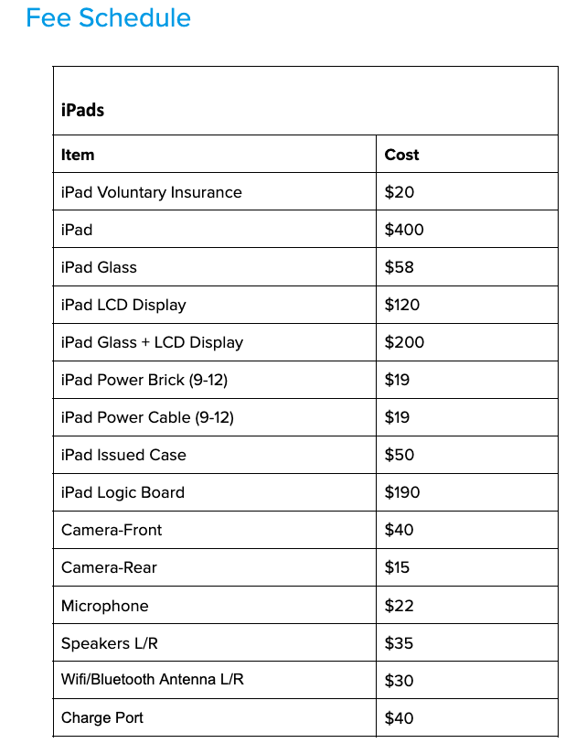

Transportation
BUS RIDERS
Parent concerns regarding bus transportation should be referred directly to GoRiteway Bus Company (608) 881-6370. All transportation in the School District of La Crosse is under the authority of Jeff Elsen at Hogan Administrative Center (608-789-7600). According to state law, students who are eligible to ride the bus are to be transported to and from their home/home area.

STOPFINDER APP
The Stopfinder app is available in the App Store and Google Play, and is free to download. It allows families to view and share student transportation schedules. Stopfinder allows parents, guardians, and caretakers to view student transportation schedules, receive real-time updates on busing, set up GeoAlerts & receive announcements from the local GO Riteway Terminal.

Parents of students who are eligible for busing need to visit the district website and request transportation or indicate transportation isn’t needed. (This is true for all students who are eligible for busing except for those special education students whose IEPs call for busing. The Special Education Office is scheduling busing for these special education students. 4K transportation will be set up through the Preschool Office.)

We realize many people work and have baby-sitters. When possible, we are happy to make arrangements to accommodate these needs. These alternating schedules must remain the same on specific days. Alternate arrangements can take up to a week; therefore, we ask that you follow these procedures:

- It is possible to have an "alternating day" schedule (for example, have your child picked up at one address on Monday and Wednesday, and picked up at another address on Tuesday, Thursday, and Friday as long as it is always the same). You may have one pickup address and a different drop-off address as long as it always occurs on the same day of the week.
- Only students eligible to ride a bus to and from school will be allowed on buses (for example, it is not possible for a non-eligible bus rider to ride the bus home with a friend after school).
Bus Rules and Regulations:
Please read and discuss the bus rules with your child(ren). They are sent home with your child on the first day of school. Rules include, but are not limited to the following:
1) Be at the bus stop on time.
2) Wait until the bus comes to a complete stop before entering. Do not push to get on the bus.
3) Keep hands and heads inside the bus at all times.
4) Remain in the bus in case of emergency, unless told to do differently by the bus driver.
5) Remain in seat while the bus is in motion.
6) Be courteous to anyone on and around the bus.
7) The driver is responsible for each student - students must obey the driver.

If students have difficulty following bus rules the driver will write up an incident report and send it to the school principal who will meet with the child. When a child receives a third bus incident report they can be suspended from the school bus for up to 3 days or longer depending on the concern. We will make every attempt to work with families if this occurs. However, we do understand the need to keep all students safe on the school bus.

ARRIVING TO SCHOOL — OTHER THAN ON A BUS
MORNING ROUTINE
- Students will no longer be going to their classroom directly upon arrival this year. Students will now have 2 choices each morning:
  - Go to breakfast (starts at 7:20am)
  - Go to the playground for morning recess (starts at 7:20am)
- IF YOU DROP OFF IN THE MORNING (NO drop off prior to 7:20am unless attending YMCA Surround Care)
  - Students will walk around to the side of the building and go to the playground through the side gate
  - ONLY students who will be eating breakfast (or arrive after 7:35am) will enter through the front main doors.
  - All students will still need to walk around to the playground prior to the 7:35am bell ringing and join their class at the back doors.
- IF YOUR STUDENT RIDES A BUS IN THE MORNING
  - Students will exit the bus and either go to the playground through the gate by bus drop off OR go to breakfast by entering Door B by bus drop off
- School Bell will ring at 7:35am for students on the playground to signal line up time
- Inform your student’s teachers at Open House what your child’s before and after school routines will be to help ensure that those needing to eat breakfast are able to do so
  - If you are dropping your child off at school and they will be eating breakfast here, make sure to have them at school by 7:20am so they have sufficient time to eat.
- Please say your good-byes by the flag pole
  - We ask parents not to walk their kids all the way to the fence as we want students to develop their self-confidence and independence
- Please do not walk students across the bus lane
  - Although this option is convenient, walk down the sidewalk and around to the drop off area and have your child follow the sidewalk on the school side

CONES
- There will be a cone placed by the flag pole each morning, either GREEN or RED.
  - Green means we are outside for recess or eating breakfast
  - Red means all students will come inside and either go to breakfast or their classroom
    - Red would be for inclement weather

Students who arrive at school in a vehicle other than a school bus should exit the vehicle on the curb side of the vehicle only at the student drop off area and walk on the sidewalk to their designated grade level door. Vehicles should not be left unattended in the student drop off area and should not use the bus lane for drop off or pick up. Please leave pets in the vehicle if traveling with a pet.

STREET PARKING
Parents parking along the street should NOT impede the arrival or departure of buses by parking too close to the bus entrance/exit.

WALKERS
Students who walk to and from school are to use designated crosswalks in front of the school. Students are not to cross from the school campus to the Hwy 35 trail at the intersection of Hwy 35 and Sunnyside Drive. Please cross at the pedestrian crosswalk with lights.
BICYCLES
Students riding bicycles must walk their bikes to and from the bike racks while on school property.
DISMISSAL TIME PICK-UP
Students will not be allowed to leave the school building and walk to a waiting car in the parking lot prior to dismissal. Parents who park in the lot are to meet their child by the flagpole and escort him/her to the car. Parents parking on the street are asked to leave the car and escort the student across the street. Staff assigned to supervise dismissal will not escort children to a waiting car. Vehicles should not be left unattended in the student pick up area. Walkers should follow the sidewalk and cross at the indicated crosswalk. For safety reasons, please do not walk or drive through the bus lane.

Visitors and Volunteers
VISITOR AT SCHOOL
Parents who would like to visit their child’s classroom during the school day are asked to make arrangements in advance with the teacher. Teachers have the option to limit classroom visits if the presence of additional adults becomes disruptive to student learning. For the safety of students and staff, all school doors will be locked. Parents and visitors should use the door buzzer system to enter the building and must report to the school office to sign in and receive a badge to wear during their visit to Southern Bluffs to clearly identify all authorized visitors to our school. The school district does not assume responsibility for students from other schools visiting our staff or students during the school day. Southern Bluffs has a safety plan with emergency procedures in place to ensure student safety, as well as a camera surveillance system. All Southern Bluffs staff will wear a photo ID badge clearly identifying them as staff to students and parents. Cell phones should only be used for emergency purposes and should not be used to take pictures or videos. All visitors will need to check in at the main office and follow the La Crosse School District procedures for providing a driver’s license and signing in, and then wearing a corresponding badge during the 2025-26 school year.

VOLUNTEERS
Southern Bluffs is frequently in need of volunteers. Teachers and staff members may solicit volunteers as needed and will be responsible for guiding the involvement of the volunteers in the building.
- All volunteers are expected to follow the direction of the supervising staff member and are to follow the same conduct expectations of employed staff.
- District policy requires that volunteers "sign in" and "sign out" in the office.
- All volunteers must wear a “visitor” badge while in the building.
- All volunteers working directly with students must complete a Volunteer Service Form (online) and be approved before volunteering (good for 3 years and at all schools).
- Once approved, the volunteer must complete/sign the Volunteer and Confidentiality Agreement form.
- Volunteers are expected to be able to devote full attention to a class when volunteering. It is expected that preschool-age siblings do not accompany a parent when the parent is volunteering.
- Cell phones are to be used only in an emergency.
- Any student information or staff information that is incidentally observed or determined in the course of volunteer efforts is considered confidential and should not be shared in the community. Volunteers unable to adhere to the expectations for confidentiality can be restricted from additional volunteer opportunities.

Off-Site Evacuation & Reunification
In the event students and staff need to evacuate the building due to a safety concern, our primary evacuation site is
Waterview Apartments. Our secondary evacuation site is Mt. LaCrosse.

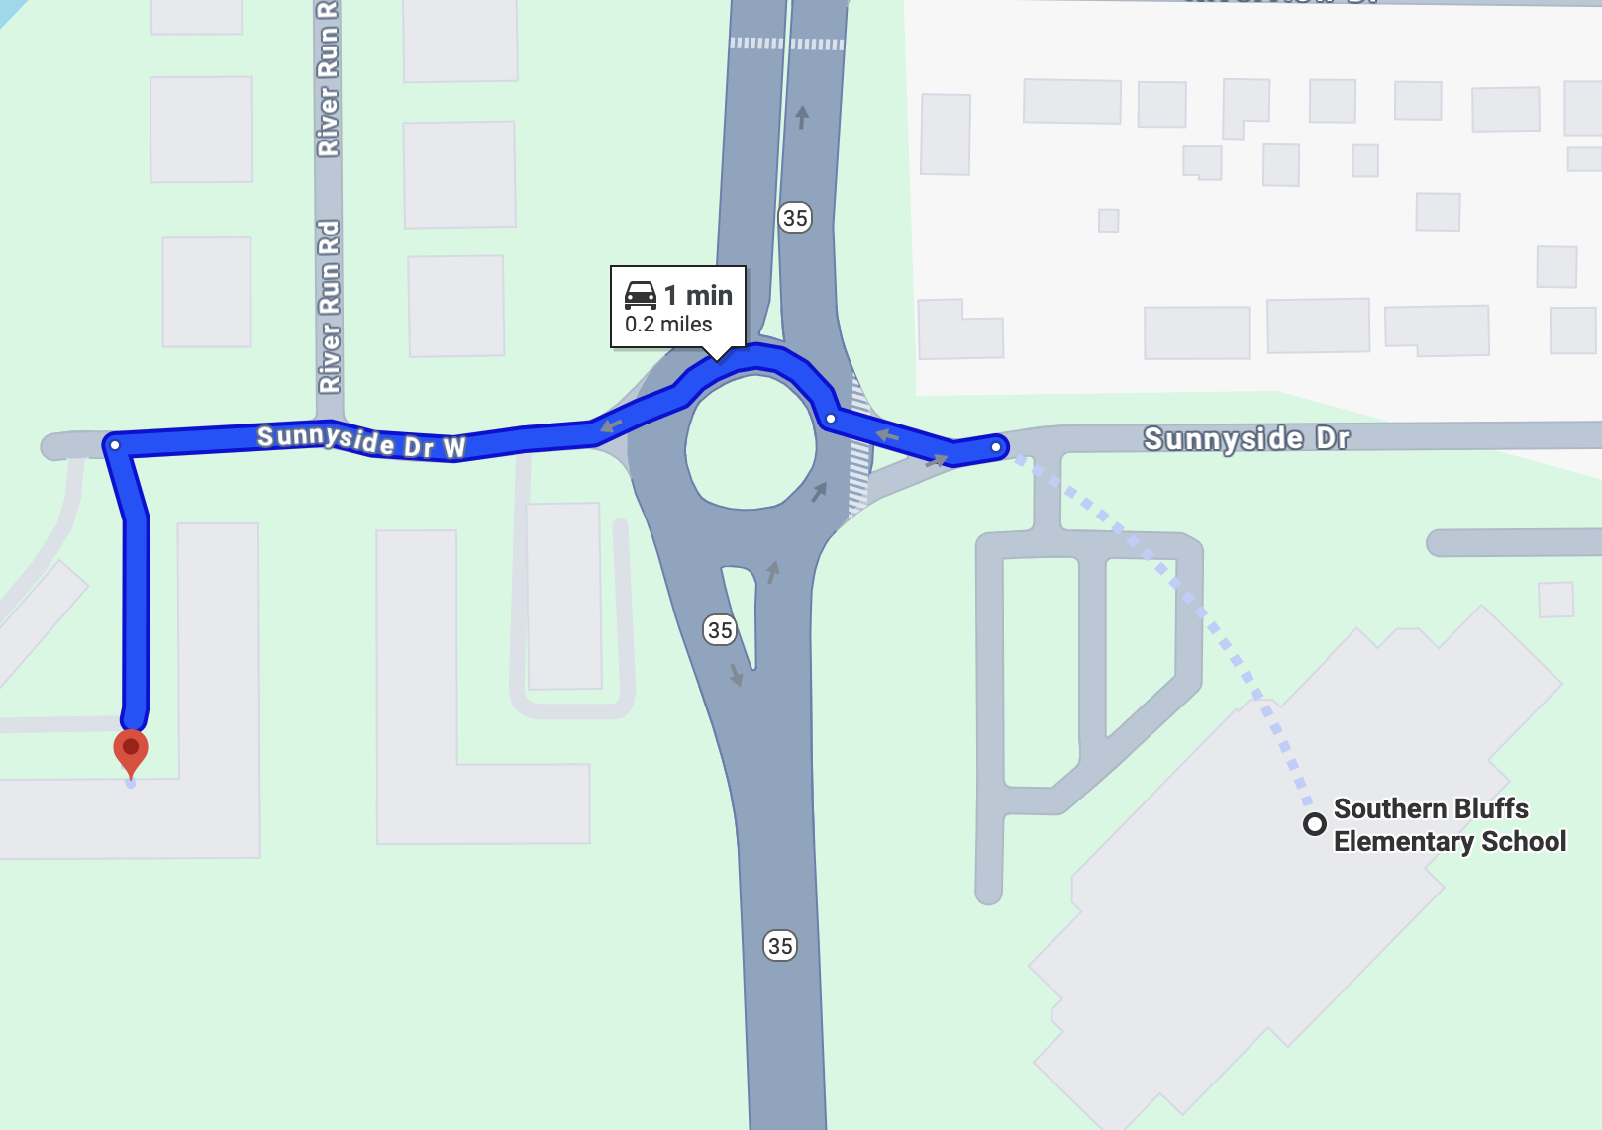

Site 1: Waterview Apartments
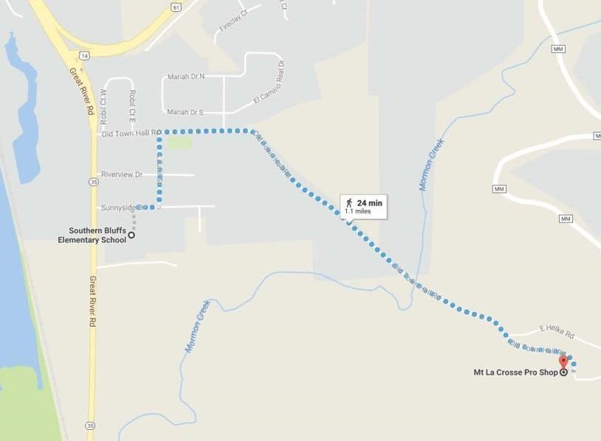
Site 2: Mt. La Crosse

Student safety and parent reunification is our primary goal. Upon arriving at the evacuation site Parent/Guardians will check in with designated school staff. Children may be released to Parent/Guardian 1, Parent/Guardian 2, or listed Emergency Contacts upon presentation of a picture I.D.

PUPIL NON-DISCRIMINATION POLICY
It is the policy of the School District of La Crosse, pursuant to s. 118.13 Wisconsin Statutes and PI 9 that no person on the basis of sex, race, religion, national origin, ancestry, creed, pregnancy, marital or parental status, sexual orientation or physical, mental, emotional, or learning disability, may be denied admission to any public school in this district or be denied participation in, be denied the benefits of, or be discriminated against in any curricular, co/extra-curricular, pupil services, recreational, or other program or activity.

