
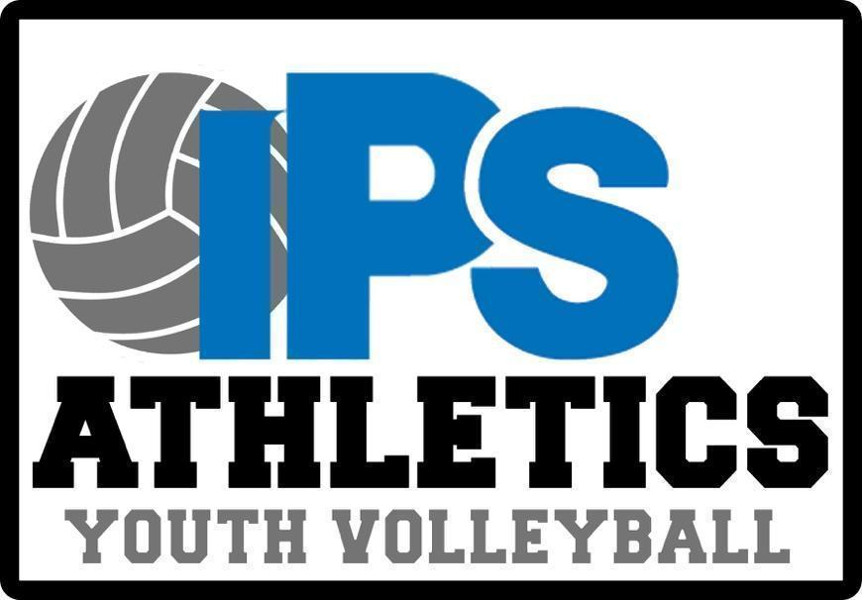

Boys 2026 IPS Elementary 4-5 Volleyball Schedule

Teams
Butler Lab 55 | Robert Lee Frost 106
Butler Lab 60 | McClellan 91
Carl Wilde 79 | Thomas Gregg 15
CFI 84 | Washington Irving 14
Charles Fairbanks 105 | William McKinley 39
Christian Park 82 | Ernie Pyle 90
Clarence Farrington 61 | Frederick Douglass 19
Daniel Webster 46 | James Riley 43
 | Jonathan Jennings 109
Ralph Emerson 58 (Red and Blue)

Date | Away Team | Home Team |  | Time
Thur. 8/27 | Butler Lab 55 | William McKinley 39 | 6pm
Thur. 8/27 | Butler Lab 60 | Washington Irving 14 | 6pm
Thur. 8/27 | Carl Wilde 79 | Thomas Gregg 15 | 6pm
Thur. 8/27 | CFI 84 | McClellan 91 | 6pm
Thur. 8/27 | Charles Fairbanks 105 | Robert Lee Frost 106 | 6pm
Thur. 8/27 | Christian Park 82 | Ralph Emerson 58 Red  Ralph Emerson 58 Blue | 6pm  7pm
Thur. 8/27 | BYE | Clarence Farrington 61 | 6pm
Thur. 8/27 | Daniel Webster 46 | Jonathan Jennings 109 | 6pm
Thur. 8/27 | BYE | James Riley 43 | 6pm
Thur. 8/27 | Ernie Pyle 90 | Frederick Douglass 19 | 6pm

Date | Away Team | Home Team |  | Time
Thur. 9/3 | William McKinley 39 | Butler Lab 60 | 6pm
Thur. 9/3 | Carl Wilde 79 | Butler Lab 55 | 6pm
Thur. 9/3 | Washington Irving 14 | CFI 84 | 6pm
Thur. 9/3 | Thomas Gregg 15 | Charles Fairbanks 105 | 6pm
Thur. 9/3 | McClellan 91 | Christian Park 82 | 6pm
Thur. 9/3 | Robert Lee Frost 106 | Clarence Farrington 61 | 6pm
Thur. 9/3 | Ralph Emerson 58 Blue  Ralph Emerson 58 Red | Daniel Webster 46 | 6pm  7pm
Thur. 9/3 | Ernie Pyle 90 | Jonathan Jennings 109 | 6pm
Thur. 9/3 | Frederick Douglass 19 | James Riley 43 | 6pm

Date | Away Team | Home Team |  | Time
Thur. 9/10 | Carl Wilde 79 | William McKinley 39 | 6pm
Thur. 9/10 | CFI 84 | Butler Lab 60 | 6pm
Thur. 9/10 | Charles Fairbanks 105 | Butler Lab 55 | 6pm
Thur. 9/10 | Washington Irving 14 | Christian Park 82 | 6pm
Thur. 9/10 | Thomas Gregg 15 | Clarence Farrington 61 | 6pm
Thur. 9/10 | McClellan 91 | Daniel Webster 46 | 6pm
Thur. 9/10 | Ernie Pyle 90 | Ralph Emerson 58 Red  Ralph Emerson 58 Blue | 6pm  7pm
Thur. 9/10 | Robert Lee Frost 106 | Frederick Douglass 19 | 6pm
Thur. 9/10 | James Riley 43 | Jonathan Jennings 109 | 6pm

Date | Volleyball Clinic @ Shortridge High School |  | Time
Sat. 9/12 | CFI 84 | William McKinley 39 | 10:15-11:30
Sat. 9/12 | Charles Fairbanks 105 | Carl Wilde 79 | 10:15-11:30
Sat. 9/12 | Christian Park 82 | Butler Lab 60 | 10:15-11:30
Sat. 9/12 | Clarence Farrington 61 | Butler Lab 55 | 10:15-11:30
Sat. 9/12 | Daniel Webster 46 | Washington Irving 14 | 10:15-11:30
Sat. 9/12 | Eleanor Skillen 34 | Thomas Gregg 15 | 11:45-1:00
Sat. 9/12 | Ernie Pyle 90 | McClellan 91 | 11:45-1:00
Sat. 9/12 | Frederick Douglass 19 | Robert Lee Frost 106 | 11:45-1:00
Sat. 9/12 | James Riley 43 | Ralph Emerson 58 (Red and Blue) | 11:45-1:00
Sat. 9/12 | Jonathan Jennings 109 |  | 11:45-1:00

Date | Away Team | Home Team | Time
Thur. 9/17 | William McKinley 39 | Charles Fairbanks 105 | 6pm
Thur. 9/17 | Christian Park 82 | CFI 84 | 6pm
Thur. 9/17 | Clarence Farrington 61 | Carl Wilde 79 | 6pm
Thur. 9/17 | Butler Lab 60 | Daniel Webster 46 | 6pm
Thur. 9/17 | Washington Irving 14 | Ernie Pyle 90 | 6pm
Thur. 9/17 | Thomas Gregg 15 | Frederick Douglass 19 | 6pm
Thur. 9/17 | McClellan 91 | James Riley 43 | 6pm
Thur. 9/17 | Jonathan Jennings 109 | Robert Lee Frost 106 | 6pm
Thur. 9/17 | Butler Lab 55 | Ralph Emerson 58 Blue  Ralph Emerson 58 Red | 6pm  7pm

Date | Away Team | Home Team | Time
Thur. 9/24 | Christian Park 82 | William McKinley 39 | 6pm
Thur. 9/24 | Clarence Farrington 61 | Charles Fairbanks 105 | 6pm
Thur. 9/24 | Daniel Webster 46 | CFI 84 | 6pm
Thur. 9/24 | McClellan 91 | Carl Wilde 79 | 6pm
Thur. 9/24 | Butler Lab 60 | Ernie Pyle 90 | 6pm
Thur. 9/24 | Butler Lab 55 | Frederick Douglass 19 | 6pm
Thur. 9/24 | James Riley 43 | Washington Irving 14 | 6pm
Thur. 9/24 | Jonathan Jennings 109 | Thomas Gregg 15 | 6pm
Thur. 9/24 | Ralph Emerson 58 Red  Ralph Emerson 58 Blue | Robert Lee Frost 106 | 6pm  7pm

Date | Away Team | Home Team | Time
Thur. 10/8 | William McKinley 39 | Clarence Farrington 61 | 6pm
Thur. 10/8 | Daniel Webster 46 | Christian Park 82 | 6pm
Thur. 10/8 | CFI 84 | Ernie Pyle 90 | 6pm
Thur. 10/8 | Frederick Douglass 19 | Carl Wilde 79 | 6pm
Thur. 10/8 | James Riley 43 | Butler Lab 60 | 6pm
Thur. 10/8 | Jonathan Jennings 109 | Butler Lab 55 | 6pm
Thur. 10/8 | Charles Fairbanks 105 | Washington Irving 14 | 6pm
Thur. 10/8 | Ralph Emerson 58 Blue  Ralph Emerson 58 Red | Thomas Gregg 15 | 6pm  7pm
Thur. 10/8 | Robert Lee Frost 106 | McClellan 91 | 6pm

