La Vega Independent School District BM03 – Strategic Partners Department of Special Programs Last Edit: 1/13/2026

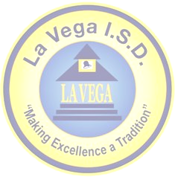
La Vega High School
Pathways in Technology Early College High School Academy
555 North Loop 340 • Waco, TX
Phone: 254-299-6820 • Fax: 254-799-0720

Vocational Studies Strategic Partners

Name | Organization | Title | Role
Dr. Sharon Shields | La Vega ISD | Superintendent | Lead the district and support P-TECH initiatives.
Chris Ward | La Vega ISD | Dean of Vocational Studies | P-TECH leadership
Jeanne Gravitt | La Vega ISD | Dean of Advanced Studies | Provide academic recommendations for DC core classes and TSIA.
Sandra Gibson | La Vega ISD | Assistant Superintendent, Curriculum and Instruction | Provide academic recommendations and support for core classes and EOC testing.
Corey McAdams | La Vega ISD | LVHS Principal | Lead LVHS comprehensive building and programs.
Diane Walters | Lochridge  Priest | Business Development | Advise and provide support for work based learning opportunities
John Nickell | Nickell Metalsmiths | Owner | WBL, Facility Tours, Job Shadowing
Santiago Morales | TSTC | Manager, Dual Credit | Coordinate the collaboration between the LEA and IHE.
Cory Dickman | Triple Win Waco | Program Director | Manage summer student internship program with local high schools.
Clay Springer | Sturdistell | Project Manager | WBL, Facility Tours, Job Shadowing
James Langlotz | La Vega ISD | Director of Maintenance | WBL, Facility Tours, Job Shadowing

