La Vega Independent School District 1.7 Leadership Roles
Department of Special Programs Last Edit: 1/13/2026

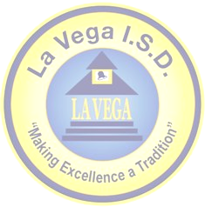
La Vega High School
Pathways in Technology Early College High School Academy
555 North Loop 340 • Waco, TX
Phone: 254-299-6820 • Fax: 254-799-0720

P-TECH Leadership Team

Name | Organization | Title | Role
Dr. Sharon Shields | La Vega ISD | Superintendent | Lead the district and support P-TECH initiatives.
Chris Ward | La Vega ISD | Dean of Vocational Studies | P-TECH leadership
Jeanne Gravitt | La Vega ISD | Dean of Advanced Studies | Provide academic recommendations for DC core classes and TSIA.
Sandra Gibson | La Vega ISD | Assistant Superintendent, Curriculum and Instruction | Provide academic recommendations and support for core classes and EOC testing.
Corey McAdams | La Vega ISD | LVHS Principal | Lead LVHS comprehensive building and programs.
John Nickell | Nickell Metalsmiths | Owner | WBL, Facility Tours, Job Shadowing  Welding and Precision Machining
Zaire Alvarez | TSTC | Manager, Dual Credit | Coordinate the collaboration between the LEA and IHE.
Courtney Copas | LaVega ISD | PTECH/CTE Counselor | Coordinate dual credit with TSTC.

