Regular Bell Schedule


CAMP ROAD MIDDLE SCHOOL BELL SCHEDULE
2026 - 2027

Period | 6th Grade | 7th Grade | 8th Grade
Homeroom | 8:25 - 8:45 | 8:25 - 8:47 | 8:25 - 8:47
1st Period | 8:49 - 9:34  AM Related Arts (45) | 8:50 - 9:50  Core 1 (55) | 8:50 - 9:50  Core 1 (60)
2nd Period | 9:38 - 10:38  Core 1 (60) | 9:53 - 10:38  AM Related Arts (45) | 9:53 - 10:53  Core 2 (60)
3rd Period | 10:41 - 11:26  Lunch/Flex (45) | 10:42 - 11:42  Core 2 (60) | 10:56 - 11:41  AM Related Arts (45)
4th Period | 11:29 - 12:29  Core 2 (60) | 11:45 - 12:30  Lunch/Flex (45) | 11:45 - 12:45  Core 3 (60)
5th Period | 12:33 - 1:18  PM Related Arts (45) | 12:33 - 1:33  Core 3 (60) | 12:48 - 1:33  Lunch/Flex (45)
6th Period | 1:22 - 2:22  Core 3 (60) | 1:37 - 2:23  PM Related Arts (45) | 1:36 - 2:36  Core 4 (60)
7th Period | 2:25 - 3:25  Core 4 (60) | 2:25 - 3:25  Core 4 (55) | 2:40 - 3:25  PM Related Arts (45)
Dismissal | 3:25 - 3:30 | 3:25 - 3:30 | 3:25 - 3:30

Early Release (Regular Homeroom)
CAMP ROAD MIDDLE SCHOOL EARLY RELEASE
BELL SCHEDULE
2026 - 2027 (Friday, 09/04/26 & Friday, 02/12/27, Friday, 03/12/27, Thursday 05/27/27)

Period | 6th Grade | 7th Grade | 8th Grade
Homeroom | 8:25 - 8:40 | 8:25 - 8:42 | 8:25 - 8:42
1st Period | 8:44 - 9:14  AM Related Arts (30) | 8:45 - 9:25  Core 1 (40) | 8:45 - 9:25  Core 1 (40)
2nd Period | 9:17 - 9:57  Core 1 (40) | 9:29 - 9:59  AM Related Arts (30) | 9:28 - 10:08  Core 2 (40)
3rd Period | 10:00 - 10:42  Lunch/Flex (42) | 10:02 - 10:42  Core 2 (40) | 10:12 - 10:42  AM Related Arts (30)
4th Period | 10:45 - 11:25  Core 2 (40) | 10:45 - 11:25  Lunch/Flex (40) | 10:45 - 11:25  Core 3 (40)
5th Period | 11:29 - 11:59  PM Related Arts (30) | 11:28 - 12:08  Core 3 (40) | 11:28 - 12:08  Lunch/Flex (40)
6th Period | 12:02 - 12:42  Core 3 (40) | 12:12 - 12:42  PM Related Arts (30) | 12:11 - 12:51  Core 4 (40)
7th Period | 12:45 - 1:25  Core 4 (40) | 12:45 - 1:25  Core 4 (40) | 12:55 - 1:25  PM Related Arts (30)
Dismissal | 1:25 - 1:30 | 1:25 - 1:30 | 1:25 - 1:30

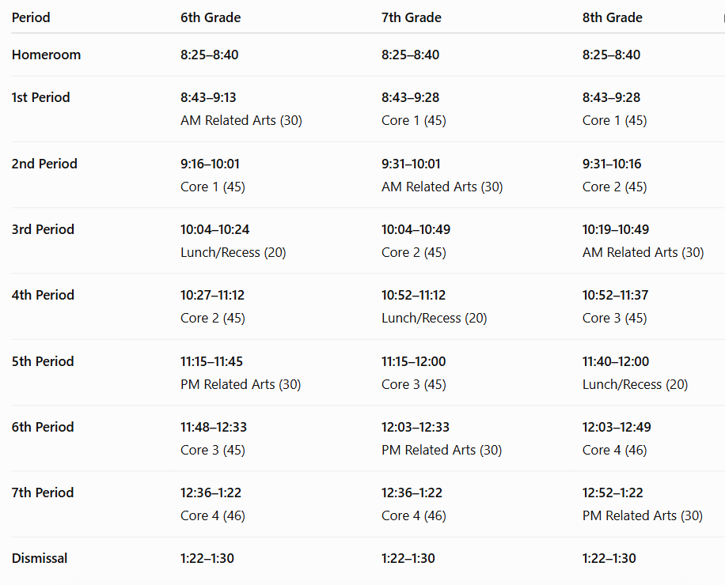

Half Day (Regular Homeroom)
CAMP ROAD MIDDLE SCHOOL HALF DAY
BELL SCHEDULE
2026 - 2027 (Friday, 10/09/26 & Friday 12/18/26)
(All grades have 3 minute transitions with the exception of 6th grade 1st period with 4 minutes - students report to first period; no homeroom)

Period | 6th Grade | 7th Grade | 8th Grade
Homeroom | Report to 1st period | Report to 1st period | Report to 1st period
1st Period | 8:25 - 9:01  AM Related Arts (36) | 8:25 - 9:01  Core 1 (36) | 8:25 - 9:01  Core 1 (36)
2nd Period | 9:04 - 9:40  Core 1 (36) | 9:04 - 9:40  AM Related Arts (36) | 9:04 - 9:40  Core 2 (36)
3rd Period | NO LUNCH/FLEX | 9:43 - 10:19  Core 2 (36) | 9:43 - 10:19  AM Related Arts (36)
4th Period | 9:43 - 10:19  Core 2 (36) | NO LUNCH/FLEX | 10:22 - 10:58  Core 3 (36)
5th Period | 11:26 - 11:56  PM Related Arts (30) | 10:22 - 10:58  Core 3 (36) | NO LUNCH/FLEX
6th Period | 10:22 - 10:58  Core 3 (36) | 12:09 - 12:39  PM Related Arts (30) | 11:01 - 11:37  Core 4 (36)
7th Period | 11:01: - 11:37  Core 4 (36) | 11:01 - 11:37  Core 4 (36) | 12:52 - 1:22  PM Related Arts (30)
Dismissal | 11:37 - 11:45 | 11:37 - 11:45 | 11:37 - 11:45

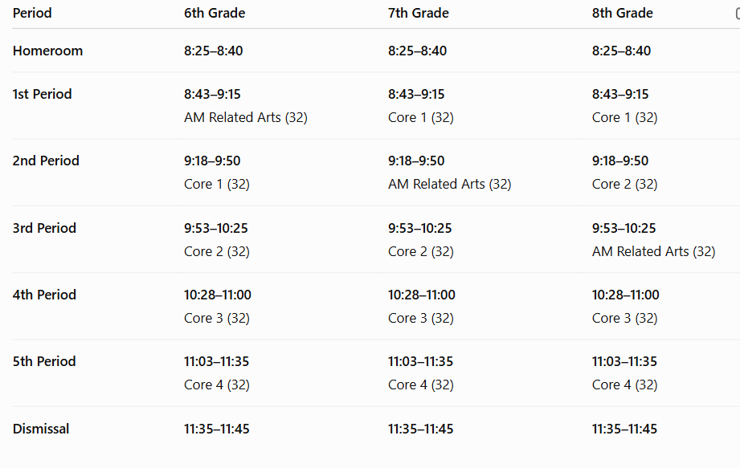

Extended Homeroom
CAMP ROAD MIDDLE SCHOOL EXTENDED HR
BELL SCHEDULE
2026 - 2027 (TBD)
(difference between 6th and 7th and 8th = 8th has only 3 minute transitions all day and 6th gets 4 minutes to get to their related arts)

Period | 6th Grade | 7th Grade | 8th Grade
Homeroom | 8:25 - 9:05 | 8:25 - 9:07 | 8:25 - 9:07
1st Period | 9:09 - 9:59  AM Related Arts (50) | 9:10 - 10:03  Core 1 (53) | 9:10 - 10:03  Core 1 (53)
2nd Period | 10:02 - 10:55  Core 1 (53) | 10:06 - 10:56  AM Related Arts (50) | 10:06 - 10:59  Core 2 (53)
3rd Period | 10:58 - 11:43  Lunch/Flex (45) | 10:59 - 11:52  Core 2 (53) | 11:02 - 11:52  AM Related Arts (50)
4th Period | 11:46 - 12:39  Core 2 (53) | 11:55 - 12:40  Lunch/Flex (45) | 11:55 - 12:48  Core 3 (53)
5th Period | 12:43 - 1:33  PM Related Arts (50) | 12:43 - 1:36  Core 3 (53) | 12:51 - 1:36  Lunch/Flex (45)
6th Period | 1:36 - 2:29  Core 3 (53) | 1:39 - 2:29  PM Related Arts (50) | 1:39 - 2:32  Core 4 (53)
7th Period | 2:32 - 3:25  Core 4 (53) | 2:32 - 3:25  Core 4 (53) | 2:35 - 3:25  PM Related Arts (50)
Dismissal | 3:25 - 3:30 | 3:25 - 3:30 | 3:25 - 3:30

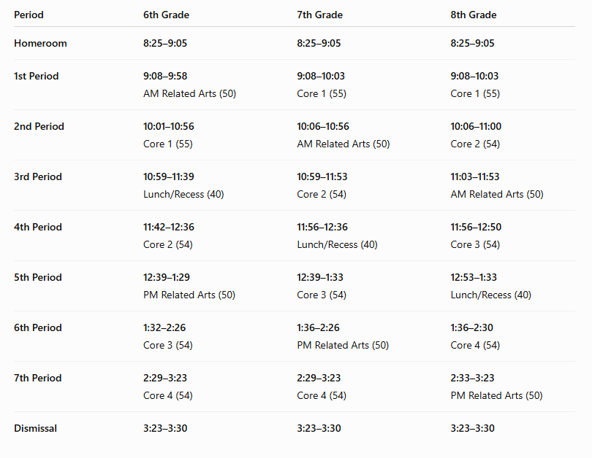

iReady Schedule (120 minutes)
CAMP ROAD MIDDLE SCHOOL iReady Test
BELL SCHEDULE
2026 - 2027 Wednesday & Thursday August 19 & 20, Wednesday and Thursday December 9 & 10, & Wednesday and Thursday April 7 & 8

Period | 6th Grade | Period | 7th Grade | Period | 8th Grade
Homeroom | 8:25 - 8:40 | Homeroom | 8:25 - 8:40 | Homeroom | 8:25 - 8:40
iReady | 8:45 - 10:45  Testing (120) | iReady | 8:45 - 10:45  Testing (120) | iReady | 8:45 - 10:45  Testing (120)
1st Period | 10:49 - 11:19  AM Related Arts (30) | 1st Period | 10:48 - 11:27  Core 1 (39) | 1st Period | 10:48 - 11:27  Core 1 (39)
3rd Period | 11:22 - 12:03  Lunch/Flex (41) | 2nd Period | 11:31 - 12:01  AM Related Arts (30) | 2nd Period | 11:30 - 12:09  Core 2 (39)
2nd Period | 12:06 - 12:45  Core 1 (39) | 4th Period | 12:04 - 12:45  Lunch/Flex (41) | 3rd Period | 12:13 - 12:43  AM Related Arts (30)
4th Period | 12:48 - 1:27  Core 2 (39) | 3rd Period | 12:48 - 1:27  Core 2 (39) | 5th Period | 12:46 - 1:27  Lunch/Flex (41)
5th Period | 1:31 - 2:01  PM Related Arts (30) | 5th Period | 1:30 - 2:09  Core 3 (39) | 4th Period | 1:30 - 2:09  Core 3 (39)
6th Period | 2:04 - 2:43  Core 3 (39) | 6th Period | 2:13 - 2:43  PM Related Arts (30) | 6th Period | 2:12 - 2:51  Core 4 (39)
7th Period | 2:46 - 3:25  Core 4 (39) | 7th Period | 2:46 - 3:25  Core 4 (39) | 7th Period | 2:55 - 3:25  PM Related Arts (30)
Dismissal | 3:25 - 3:30 | Dismissal | 3:25 - 3:30 | Dismissal | 3:25 - 3:30

2 Hour Delay
CAMP ROAD MIDDLE SCHOOL 2-HOUR DELAY
BELL SCHEDULE-
2026 - 2027 (TBD)
(Gave only 3 minute transitions for 7th and 8th graders)

Period | 6th Grade | 7th Grade | 8th Grade
Homeroom | 10:25 - 10:40 | 10:25 - 10:42 | 10:25 - 10:42
1st Period | 10:44 - 11:17  AM Related Arts (33) | 10:45 - 11:23  Core 1 (38) | 10:45 - 11:23  Core 1 (38)
2nd Period | 11:20 - 11:58  Core 1 (38) | 11:26 - 11:59  AM Related Arts (33) | 11:26 - 12:04  Core 2 (38)
3rd Period | 12:01 - 12:45  Lunch/Flex (44) | 12:02 - 12:40  Core 2 (38) | 12:07 - 12:40  AM Related Arts (33)
4th Period | 12:48 - 1:26  Core 2 (38) | 12:43 - 1:27  Lunch/Flex (44) | 12:43 - 1:21  Core 3 (38)
5th Period | 1:30 - 2:03  PM Related Arts (33) | 1:30 - 2:08  Core 3 (38) | 1:24 - 2:08  Lunch/Flex (44)
6th Period | 2:06 - 2:44  Core 3 (38) | 2:11 - 2:44  PM Related Arts (33) | 2:11 - 2:49  Core 4 (38)
7th Period | 2:47 - 3:25  Core 4 (38) | 2:47 - 3:25  Core 4 (38) | 2:52 - 3:25  PM Related Arts (33)
Dismissal | 3:25 - 3:30 | 3:25 - 3:30 | 3:25 - 3:30

