

Student Handbook 2026-2027
Pittsburgh
Schiller
6-8

Table of Contents
SUPERINTENDENT’S WELCOME 2
PRINCIPAL’S WELCOME 3
SCHOOL INFORMATION 5
VISION AND MISSION 6
COMMUNICATION PROCEDURES 7
BELL SCHEDULES 8
SCHOOL CALENDAR 11
ATTENDANCE 12
ACADEMICS 13
ACADEMIC INTEGRITY 14
ATHLETICS/EXTRACURRICULAR ACTIVITES 15
DRESS CODE 17
ELECTRONIC DEVICES 18
GRADING 19
HOMEWORK PROCEDURES 20
HEALTH SERVICES 21
INFORMATION TECHNOLOGY/ACCEPTABLE USE 22
STUDENT SUPPORT SERVICES 24
STUDENT EXPECTATIONS/PROCEDURES 26
VISITORS 27
APPENDIX 28

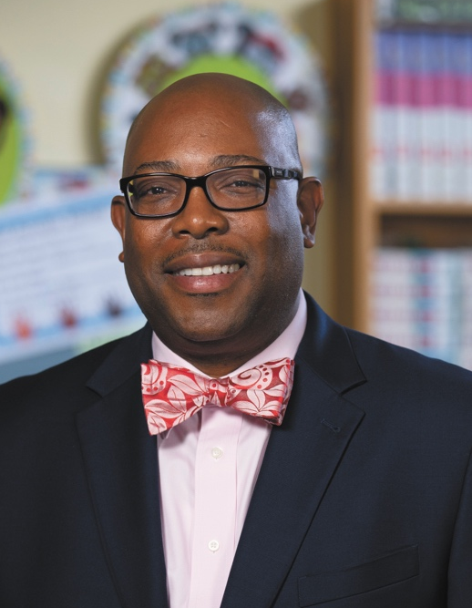
SUPERINTENDENT’S WELCOME
Dear Pittsburgh Public Schools Parents, Students, and Families,
Welcome to the 2026-2027 school year! Whether you are joining Pittsburgh Public Schools for the first time or returning for another exciting year, I am honored to welcome you to a community committed to helping every student learn, grow, and thrive.
At Pittsburgh Public Schools, we believe every student deserves access to a high-quality education in a safe, supportive, and inclusive learning environment. Our dedicated educators and staff are committed to preparing students for success in college, career, and life by fostering curiosity, creativity, critical thinking, and a lifelong love of learning.
This school handbook is an important resource designed to help you navigate the school year. Inside, you will find valuable information about District policies, school expectations, student supports, attendance, academic programs, extracurricular opportunities, health and safety procedures, and ways to stay connected with your school community. I encourage every family to review this handbook together and refer to it throughout the year.
A successful school year is built on strong partnerships between schools, families, and the community. We know that students achieve more when the adults in their lives work together to support their learning and well-being. We invite you to stay engaged by attending school events, participating in Parent School Community Council (PSCC) meetings, communicating regularly with your child's teachers, and taking advantage of the many opportunities to share your voice and partner with us.
As we continue implementing our PPS Future-Ready Plan, we remain focused on creating learning environments where every student feels welcomed, valued, supported, and inspired to reach their full potential. Together, we are building stronger schools and brighter futures for every child.
Thank you for entrusting Pittsburgh Public Schools with your child's education. We look forward to a school year filled with learning, growth, achievement, and meaningful connections.
On behalf of the Board of Public Education and the entire Pittsburgh Public Schools team, welcome to an outstanding school year!
Yours in Education,
Dr. Wayne N. Walters
Superintendent, Pittsburgh Public Schools


PRINCIPAL’S WELCOME
Welcome!
Welcome to Pittsburgh Schiller 6-8. The purpose of this Student Handbook is to provide students and parents with important information about Pittsburgh Schiller STEAM Academy Middle School. An awareness of these rules and procedures will help our students to be successful and to have a very positive experience at our school. We urge you to read the contents completely and to save this handbook for future reference. The school administration will continue to review the policies provided in this handbook and will revise them as needed. Any changes in school policy will be disseminated to all parents and guardians via “backpack” flyers and the monthly school news. We have also incorporated other ways of communicating such as the Alert Now phone system and Talking Points. Please ensure that you are registered and receiving these important announcements.
We are proud of our school, and we are proud of the many students who work so hard to get the finest education available anywhere. Do your best. Get involved in school activities. You are in control of your destiny. You can have an excellent and rewarding school year!
Pittsburgh Schiller 6-8 is a middle school with a partial Magnet program. Enrollment at Pittsburgh Schiller is open to all students in the Pittsburgh Public Schools who complete the prescribed application process. The Office of Magnet Programs at the Board of Education works with the school administration to maintain a balanced and diverse student body. During the 2016.2017 and 17-18 and 18-19 and now 22-23 school years, Schiller STEAM Academy earned STAR Status through Pittsburgh Public Schools, a very distinguished achievement! We hope to continue to show this type of growth every year.
Participation in the STEAM academy magnet program is an educational option offered by the Pittsburgh School District to those families and children that are seeking an enriched educational environment with an innovative perspective. Continued enrollment at Pittsburgh Schiller 6-8 is offered to all students who maintain the expectations concerning appropriate behavior and an acceptable level of academic achievement, as well as a minimum of 90% attendance in a single school year. Students who do not meet these expectations will be placed on probationary status. If sufficient improvement does not occur before the end of the school year, the student may be returned to their feeder pattern school.
The mission of our school is to educate every child to high standards in a safe, orderly, and caring school environment. We intend to provide our students with a foundation for college and career readiness.
Have a great year!

Sincerely,
Paula M. Heinzman
Principal, Schiller 6-8

SCHOOL INFORMATION
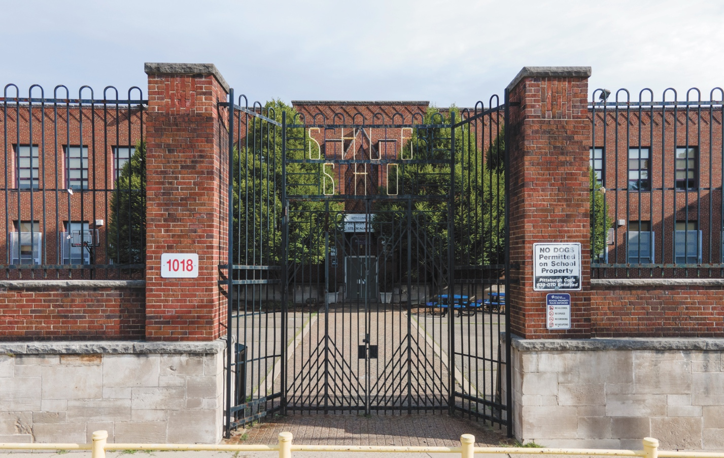

Pittsburgh Schiller 6-8
1018 Peralta St, Pittsburgh, PA 15212  Phone: 412-529-4190  Fax: 412-323-4192  Office Email: schillerms@pghschools.org Website: pghschools.org/schools/6-8/schiller  Schiller 6-8 Staff Directory | School Colors | Navy and Yellow
 | School Mascot | Stallions

VISION AND MISSION

Mission
The mission of Schiller STEAM Academy is to provide all students with world-class educational opportunities in a safe and supportive school environment. Our mission is to prepare all students for life as productive citizens and life-long learners.

Vision
At Schiller STEAM Academy, all stakeholders strive daily to educate the holistic student. Utilizing the engineering design process, we equip children with the 21st century skills needed to surpass the high demand of the college and career fields. Standing with community partners and leading with equity, teachers love our future leaders into learning. Through it all, we will always remain Stallion S.T.R.O.N.G. Yesterday, today, and forever!

COMMUNICATION PROCEDURES

Contacting the School
Please see the previously listed phone number, fax number and office email address to contact our school.
We have also incorporated other ways of communicating such as the Alert Now phone system and Talking Points. Please ensure that you are registered and receiving these important announcements.

Early Dismissals
On rare occasions, a parent may need to request an early dismissal from school for their child (such as for a doctor’s appointment or other important business). The procedure for obtaining an early dismissal is as follows:
- The student must present a note, signed by the parent, requesting the early dismissal. The note should contain the reason for the dismissal, the time of the dismissal, and a phone number where the parent can be reached to confirm the request. The note should be brought to the office before homeroom period.
- Office staff will call to confirm the request.
- The parent is responsible for any transportation needs.
If Early Dismissals become excessive, a citation could be filed at the local magistrate.

Dismissal from School
- Walkers will be dismissed at 3:15p.m. If your child is being picked up, please arrive on Peralta Street at this time. WE CANNOT ACCEPT PHONE CALLS AFTER 3:00P.M. (EMERGENCIES ONLY) ASKING FOR YOUR CHILDS DISMISSAL ARRANGEMENT TO BE CHANGED.
- Children who are assigned to a bus will ride said bus unless other arrangements have been made prior to 3:00p.m.
- If you plan to pick up a child who typically rides a bus, you must be here by 3:15p.m. otherwise, your child will be placed on their bus.

BELL SCHEDULES
Staff Meetings: Tuesday, Wednesday and Thursday 7:45-8:15
Breakfast: Served in Homeroom
When we have a remote day-the bell schedule stays the same.
Daily Schedule
Homeroom | 8:35-8:46
Period 1 | 8:48-9:30
Period 2 | 9:33-10:14
Period 3 | 10:16-10:58
Period 4 | 11:00-11:42
Period 5  First Lunch (11:44-12:14) | 11:44-12:26
Period 6  Second Lunch (12:28-12:58) | 12:16-12:58
Period 7 | 1:00-1:42
Period 8 | 1:44-2:26
Period 9 | 2:28-3:15
Dismissal (Walkers) | 3:15
Dismissal (Busers) | 3:20

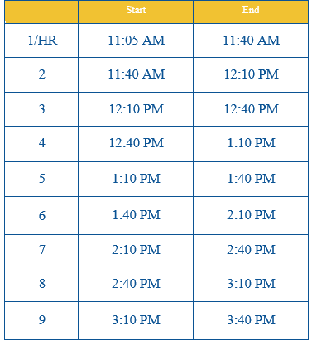
Two-Hour Delay Schedule

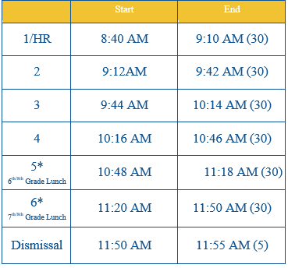
Half Day Schedule

SCHOOL CALENDAR
The 2026-2027 District Calendar can be found HERE.

ATTENDANCE

Strive for 95
Research indicates that there is a positive and statistically significant relationship between student attendance and academic achievement.
At Schiller, our goal is for students to miss 9 days or fewer in a school year, or a 95% attendance rate. Students who miss 10 or more days in a year may show minimal gains throughout their education, which can have lasting effects on college and career readiness.

Incentives/Outcomes
- STRONG points
- Homeroom attendance competition
- Field trips
- Higher GPA's
- Stronger data points
Please contact our school counselor, Ms. Shaftic (lshaftic1@pghschools.org) if you have any questions or concerns.

ACADEMICS
Course Offerings
Grade 6 | Grade 7 | Grade 8
Communications  • IM Math 6  • Science  • Social Studies/Ancient Cultures/Geography  • Physical Ed./Health  • Music Technology, Appreciation and Choral/ Instrumental/Theater Performance  • Art  • STEAM  • Library/Research  • Tech Lab  • Social Emotional Learning | Communications  IM Math 7  Science  Social Studies/World History  Physical Ed. /Health  Music Technology, Appreciation and Choral/ Instrumental/Theater Performance  Art  STEAM  Library/Research  Tech Lab  Social Emotional Learning | Communications  Algebra I  IM Math 8  Science  US History  Physical Ed./Health  Music Technology, Appreciation and Choral/ Instrumental/Theater Performance  Art  STEAM  Tech Lab  Social Emotional Learning
All Pittsburgh Schiller students who meet the criteria for the gifted program attend the Pittsburgh Gifted Center one day per week.
ACADEMIC INTEGRITY
The Board adopts a system-wide policy to promote academic integrity and will not tolerate any form of academic dishonesty, including but not limited to, cheating during examinations or on lab, homework and other assignments; plagiarism; pre-exam access to test forms; and unauthorized use of aids during examinations and assignments. A student shall not engage in, participate in, nor knowingly provide another student with the opportunity to engage in academic dishonesty related to examinations, as well as laboratory, homework and other projects and assignments, whether done during or outside of school hours. Academic dishonesty shall include, but not be limited to, all forms of cheating, plagiarism, pre- exam access to test forms, representing someone else's work as your own, and the unauthorized use of aids during examinations, projects and assignments. Schiller will work with students and families to provide education around the internet, AI and other forms of support students may use to support their learning.

ATHLETICS/EXTRACURRICULAR ACTIVITES

Athletics
Schiller facilitates a variety of sports during different seasons throughout the school year. Feel free to contact the school’s athletic director for more information about Schiller’ interscholastic athletic program:
Ms. Lee Wittman: 412.529.8144 | lwittman1@pghschools.org.
Also, feel free to contact any of our coaches, listed below, for details about any particular sports.

Offerings
SEASON | SPORT | TYPE
Fall | Cross County | Co-ed
Fall | Flag Football | Co-ed
Winter | Basketball | Boys
Winter | Basketball | Girls
Spring | Soccer | Boys
Spring | Soccer | Girls

Sports Eligibility
Any student who has an interest in sports may participate in the sports program. To be eligible:
- A physician must certify that the student is able to take part in the chosen sport before the first practice
- A parent permission slip must be signed
- Compliance with the school district’s academic and attendance standards.
Participation in athletic/extracurricular activities is a privilege and not a right, which may be restricted or withheld per administrative discretion in alignment with applicable district and/or school policies.

Extracurricular Activities
There are many activities that will be available to students, both after school and during the school day, including:
- Interscholastic Sports: In the fall, we have co-ed cross country, and flag football teams. In the winter, we offer basketball, and in the spring, students may participate in soccer. A “C” average is required in order to participate.
- Field Trips and Special Days: Each grade level team plans several activities for students. Some educational field trips are planned that correspond to activities that go on in class. Other trips such as skating parties are meant to reward good behavior and hard work. Only those students who have earned the privilege are invited on these trips.
- In-School Activities: Cheerleaders, yearbook, intramurals, African American History Challenge Bowl, Student Envoys, GSA, lunch-bunch and many more.
- School-wide Activities: In the past, we have planned a Kennywood Day in June. To qualify for this trip, it requires that students have worked hard in school and demonstrated positive behavior. To qualify for the end-of-year trip, students must have:
  - At least a 2.0 grade point average on the most recent report card
  - 90% attendance
  - STRONG Behavior Criteria
  - No serious discipline incidents after the end-of- year letters have been distributed.
At Pittsburgh Schiller, we try to reward those who work hard and do their best!

DRESS CODE
Pittsburgh Schiller adopted a uniform policy in May of 2009. The uniform policy states that all students must wear:
- Navy blue or khaki colored dress pants (absolutely NO JEANS or LEGGINGS will be accepted)
- Plain white or light blue collared shirt (no t-shirts)
- Tennis shoes (no flip-flops, slides or any type of shoe that does not have a secured back strap)
If students do not arrive at school wearing the required uniform, they will be provided with a clean uniform issued by the school administration when available. These borrowed uniforms must be returned to the main office at the end of the day.
Next steps for repeated uniform violation include, but is not limited to:
- Phone call to parents
- Borrowing a school issued uniform.
- Learning Adjustment Center (only if student refuses to change into school issued uniform)

ELECTRONIC DEVICES
Electronic devices are not permitted/All cell phones will be collected at the metal detector and handed back at the end of the school day.

GRADING

Report Cards
The report card is the most familiar way of communicating student progress. Report cards are issued four times during the school year at approximately nine-week intervals. The letter grades A, B, C, D and E are used to indicate academic progress. A citizenship mark is also given for the students’ behavior in each class. Citizenship marks are represented by the letters O for outstanding; S for satisfactory; and U for needs improvement.

Progress Reports
Communication between teachers and parents is absolutely critical, and keeping parents informed of their child’s performance is accomplished in many ways. One of these ways is the use of Interim Progress Reports. At the mid-point of each of the four grading periods, teachers will evaluate student progress. If a child is not working to his or her potential, a progress report is mailed home. If a student’s grade is at risk of dropping two letter grades from the previous grading period, a report is also sent home to inform parents. A conference can be arranged in order to determine the best way to help a child before marks are closed for a particular grading period.

Honor Roll
Students who achieve a grade point average of 3.00 to 3.49 attain Honor Roll status. Those who achieve a grade point average of 3.5 to 4.00 are High Honor Roll students. Students who attain Honor and High Honor Roll will be awarded a certificate and recognized. In addition to the Academic Honor Roll, students who demonstrate respectful and responsible behavior earn Citizenship Honor Roll. A goal of Pittsburgh Public Schools is to produce outstanding citizens; therefore students who achieve all outstanding marks in citizenship will be recognized.

Grading Scale
Percentage Earned | Grade | GPA
90-100% | A | 4.0
80-89% | B | 3.0
70-79% | C | 2.0
60-69% | D | 1.0
50-59% | E | 0.0

HOMEWORK PROCEDURES
Studies have shown that in order to truly remember what is taught in class, it is necessary to spend some time practicing that skill at home. Therefore, homework will be assigned to all Pittsburgh Schiller 6-8 students. Some assignments will be due the next day, and others will be longer-term projects (like a science project). Students are expected to complete all homework assignments, and if they are absent, to find out what they missed and how they can make it up. To do well and to get good grades, it is most important that students complete all homework on time. Please refer to individual teacher letters for their homework policies.

HEALTH SERVICES
The Office of Health Services' goals are to provide quality services that promote, maintain, protect and improve student, employee and community health. We provide services to students that address disease prevention, health promotion, and mandated service provision through the Department of Health.
Schiller is lucky to have Ms. Clayton as our school nurse. Her phone number is 412-529-4196 and her email is mclayton1@pghschools.org.
We strive to ensure that all students have equal access to quality health services, prevention of education and early intervention, and support to help them achieve academic success. Students enrolled in our public, private and parochial schools within City limits receive school health physicals, screenings, and related services that support health and wellness.

Objectives
- To deliver quality services that adhere to all federal, state and local regulations while remaining cognizant of emerging needs.
- To promote, protect and improve the health and safety of all students through policies and best practices that safeguard our students, staff and community.
- To maintain, strengthen and develop partnerships that improve health and academic success.
- To support and join in planning worksite wellness initiatives that promote good health and prevention practices.

INFORMATION TECHNOLOGY/ACCEPTABLE USE
We are pleased to offer our students at Pittsburgh Public Schools (PPS) a safe, stable, relevant, and productive technical experience with the use of all district technologies. The district aims to provide a rich set of technical capabilities that are unique to each learning community among our full portfolio of schools. These capabilities include but are not limited to 1-to-1 laptop, tablet or BYOT (Bring your own technology) environments, the use of classroom laptops, desktops or tablets, and the use of labs for productivity and testing purposes. Technologies also include access to wired and wireless internet, and district printers, scanners and other related peripherals. Students and their families must follow the guidelines established for appropriate care and use of all district technologies. Misuse of PPS equipment may result in the withdrawal of this privilege at the school’s discretion. Intentional or neglectful disregard for equipment resulting in damage or loss will be the responsibility of the student and their family and will be handled on a case-by-case basis where financial penalty is only applied when mutually agreed upon by the district and family. Inappropriate use may result in cancellation of permission to use district equipment which could have academic repercussions. We ask that each student and family take the use of district equipment seriously as the benefits of a contemporary learning environment have a wide range of benefits for the learner, as well as the learner’s family and school community.
Every student in PPS will have access to the district computer network resources, electronic mail and the Internet. To use these resources, all students must sign and return this form to acknowledge the PPS Acceptable Use Policy. Parents, please read and complete this document carefully, review its contents with your son/daughter, and sign where appropriate. Any questions or concerns about this permission form, or any aspect of the computer network, should be referred to your school’s administration.
A copy of the related technology policies can be found in the Boards 900 series that includes related topics such as our Student Code of Ethics, Internet Safety Guidelines, Network Use Guidelines and Mobile Computing Guidelines.

Information Tech Rules (District)
- Do not change the local configuration of the desktop, laptop, or tablet.
- Do not deface or change the physical appearance of any district device.
- Do not use any login or password other than your User Account
- Users are not allowed to do the following unless given permission by an administrator:
  - Store and/or install files on the laptop including Freeware, shareware, public domain, or any other software
  - Install and / or play personal music, videos, or games
  - Use unauthorized programs installed on the laptop.
- Report any damage – accidental or not, immediately.
- Do not attempt to bypass PPS security or content filtering at any time.
- Do not consume food or drink near or on devices.

STUDENT SUPPORT SERVICES
The mission of the Student Services Department is to provide a comprehensive program that addresses the lifelong development of the social/emotional, academic, and career growth of each pupil. It assures equal access and equity to all students by providing them with the skills and tools necessary to succeed in life and to become productive members of society. Pupils may access the Student Services office via staff permission and/or a valid hall pass.

Staff and Services
School Counselor: The school counselor helps students address their academic, emotional, personal, and social needs. Services provided include, but are not limited to, general guidance, individual/group counseling, crisis counseling, home/school communications, student scheduling, student records/transcripts maintenance, career/post-secondary exploration, and restorative practice. The school counselor may also address lower-level disciplinary infractions.
School Social Worker: The school social worker helps students with their social, emotional, and personal needs, so that they can get the most from school. The social worker also helps students and families maintain good attendance, as well. Services provided include, but are not limited to, individual/group counseling, connecting at-risk youth with helpful resources, attendance improvement, and home visits. The school social worker also leads the Student Assistance Program (SAP).
Student Services Assistant: The student services assistant works with the principal, school counselor, and social worker to ensure that students receive the support they need to be successful. The student services assistant also regularly monitors student behaviors, addresses lower-level disciplinary infractions, conducts mediation/restorative practice circles, and coordinates functions with the school’s PBIS and Discipline committees.

Key Student Services Programs:
Student Assistance Program (SAP): The primary goal of the Student Assistance Program is to help students overcome these barriers so that they may achieve, advance, and remain in school. Services provided include in-school support groups, in-school therapy, mentoring, the peer helper program, teen parent advocate services, mental health evaluations, and drug and alcohol evaluations. Various community agencies come into the school to provide man these services to the students. Please feel free to contact the school social worker or school counselor for more information.
Positive Behavior Interventions & Support (PBIS): The school’s PBIS program provides students with incentives for being the best they can be while in school. PBIS include, but are not limited to the following:
- Engaging and rigorous instruction
- Mentoring
- Assemblies
- Class meetings, activities, classroom store options
- Student PBIS rewards prizes/gifts and activities
- A student services department focused on whole learners
- A highly involved and vested SAP core team

MTSS
The Multi-Tiered System of Supports (MTSS) helps schools identify students’ strengths and needs—academic, behavioral, and social-emotional—and provide the right level of support. At Schiller, Student Services offers personalized help to ensure all students can succeed, with support tailored to each student’s level of need.

Education of Children and Youth Experience Homelessness (ECYEH)
The McKinney-Vento Homeless Assistance Act was established in 1987 and amended by the Every Student Succeeds Act of 2015. The Act defines the term “homeless children and youths” as individuals who lack a fixed, regular, and adequate nighttime residence.
The federal mandate ensures that homeless children and youth have access to the same free and appropriate public education as other children. Children who are homeless may qualify for assistance with school lunch, school supplies, tutoring and transportation so that they can remain in their school of origin.
If you believe that your child may qualify for this service, please contact Lisa Arnett, McKinney Vento Program Assistant: (412) 529-5889.

STUDENT EXPECTATIONS/PROCEDURES

School Expectations
Students at Pittsburgh Schiller are expected to be Stallion S.T.R.O.N.G. STRONG is an acronym for students to follow and to remember:
Self-Disciplined | Team-Oriented | Respectful | On Task | Nice | Growing Daily

Rewards and Incentive Program
Students at Pittsburgh Schiller STEAM Academy are expected to work hard in school. Therefore, the Schiller staff and administration have implemented a rewards and incentive program for students that follow the rules and put forth their best effort in their classes. Any questions regarding the PBIS rewards and incentive program should be directed to your child’s homeroom teacher. The rewards and incentive program include:
- STRONG Points (Token Economy): Students can earn these points by following the rules, completing homework, participating in class, achieving honor roll, having perfect attendance, and many others. Students can then cash their points in at the school store.
- Lucky A’s (academic Incentive): These tickets are given to students when the receive an A test/ exam. Students are expected to put their name on the ticket and turn it into the office for a weekly raffle.
- Lucky B’s (Behavioral Incentive): These tickets are given to students that exemplify excellent behavior both in and out of the classrooms. Students may receive these tickets at any time during the day when they are “caught being good.”
- Weekly Drawings: On Fridays during the end of the day announcements, students are called to the office via the PA system if their names are chosen for Lucky A’s, Lucky B’s, or agenda Book numbers. Upon arriving to the office, students are permitted to select a reward from the prize box.
- Bucket-Fillers: At Schiller, staff and students promote treating each other with respect and kindness. Through the Bucket-Fillers Incentive Program, students have the opportunity to “Shout-out” their peers when they are caught “Filling someone’s bucket.” Ask your student for more details about this program

VISITORS
Parents and guardians are welcome at Pittsburgh Schiller 6-8 STEAM Academy. All visitors must report to the main office, identify themselves, and sign the visitor's register. All visitors will be issued and must display a visitor’s pass while in the school building.
Parents wishing to observe their child’s class must first obtain the permission of the principal. Parents should not expect to confer with teachers during class time. All parent-teacher conferences should be scheduled in advance.
Families will not be permitted to enter the building in the morning during student arrival. Please call the main office to schedule all necessary appointments in advance.

APPENDIX
Policy 115 – Homework
This policy establishes expectations for meaningful, purposeful homework aligned to instructional goals. Homework should reinforce learning, be developmentally appropriate, and not excessive.
Policy 119 – Athletics & Extracurricular Activities
This policy governs student participation in athletics and extracurricular activities, including eligibility, academic expectations, conduct standards, and equitable access to programs.
Policy 204 – Attendance
Students are required to attend school regularly in accordance with Pennsylvania law. The policy outlines excused and unexcused absences, documentation, and procedures to support consistent attendance.
Policy 206 – Health Services
Outlines school health services including screenings, medical support, and procedures that ensure student health, safety, and readiness to learn.
Policy 209 – Grading and Reporting
Defines how student performance is assessed and communicated, including grading practices, report cards, and expectations for fairness and consistency.
Policy 211 – Graduation Requirements
Specifies the credit requirements and criteria students must meet to earn a diploma, aligned with state regulations.
Policy 212 – Student Code of Conduct
Establishes behavioral expectations and outlines disciplinary procedures to maintain a safe and respectful learning environment.
Policy 215 – Anti-Bullying
Prohibits bullying and harassment and outlines reporting, investigation, and intervention procedures to protect students.
Policy 216 – Electronic Devices
Governs student use of electronic devices. Devices may be used for educational purposes but are restricted during the school day to maintain a focused learning environment.
Policy 221 – Dress Code
Ensures student dress supports a safe, respectful, and inclusive environment while allowing appropriate self-expression.
Policy 226 – Academic Integrity
Prohibits cheating, plagiarism, and other forms of academic dishonesty, reinforcing ethical academic behavior.
Policy 231 – Homeless Students
Ensures educational stability and access for students experiencing homelessness in alignment with the McKinney-Vento Act. The policy outlines rights related to enrollment, transportation, and support services.
Policy 1004 – School Visitors
This policy outlines procedures for visitors entering school buildings, including sign-in requirements, identification, and approval processes to ensure a safe and secure environment for students and staff.
Annual Child Find Notice
Pittsburgh Public Schools conducts ongoing 'Child Find' activities to identify, locate, and evaluate children who may be eligible for special education services under the Individuals with Disabilities Education Act (IDEA). This includes children ages 3–21, including those who are homeless, wards of the state, or attending private schools. Families can request an evaluation if they suspect a disability impacting learning.

Pittsburgh Public Schools (PPS) does not discriminate on the basis of race, color, national origin, sex, disability or age in its programs, activities or employment and provides equal access to the Boy Scouts and other designated youth groups. It is the policy of the Pittsburgh School District to make all services, programs and activities available and to provide reasonable accommodations to persons with disabilities. Please make requests for accommodations at least 72 hours before the scheduled event. For more information regarding accommodations, civil rights grievance procedures, please contact: Rachel Beers, Office of Employee Relations rbeers1@pghschools.org | 341 S. Bellefield Ave, Pittsburgh, PA 15213 | 412-529-HELP (4357

