First Grade Syllabus Outline First Semester

Mrs. Cassaday, Mrs. Grizzard, Ms. Hill, Ms. Salmons - Corinth Elementary School

Fall 2026
Dear Parents and Guardians,
Welcome to First Grade at Corinth Elementary! This syllabus outlines what your child will learn this semester and how you can support their success. As required by Texas law (Senate Bill 12), this document serves as the instructional plan and is available for your review. We are excited to partner with you for a great semester!

What Your Child Will Learn
This semester, we’ll focus on building skills in the following subjects, based on Texas state standards (TEKS). This is the instructional plan for your child’s class:
- Reading & Language Arts
  - Unit 1: Sharing Stories
    - Learning objectives: This unit will introduce students to stories in the form of fables, folktales, and parables that have delighted generations of people. By listening to these classics, students will increase their vocabulary and reading comprehension skills, learn valuable lessons about ethics and behavior, become familiar with the key elements and parts of a story, and acquire cultural literacy.
  - Unit 2: The Human Body
    - Learning objectives: Using an interactive approach, the first half of this domain will introduce students to the vital network of body systems known as organs. Through rhymes within the Read-Aloud, students will learn the fundamental parts and functions of five body systems: skeletal, muscular, digestive, circulatory, and nervous. The second half of this domain focuses on care and maintenance of the human body, including the five keys to good health: a well-balanced diet, exercise, sleep, keeping clean, and getting regular checkups.
  - Unit 3: Early American Civilizations: Aztecs, Maya, Incas
    - Learning objectives: This unit includes a study of the Maya, Aztec, and Inca civilizations. Students will examine the fundamental features of the Maya, Aztec, and Inca, including farming and the establishment of cities and government. Students will be encouraged to compare and contrast each of these societies and their elements. Specifically, students will learn about the ancient Mayan city of Baakal and about the Mayan king, Pakal II. Students will also learn about Moctezuma, the Aztec ruler, and the Aztec city of Tenochtitlan. For the Inca, students will hear about the city of Machu Picchu. Last, students will learn that much of what we know about the Maya, the Aztec, and the Inca today is due to the work of archaeologists.
  - Unit 4 Astronomy: Space Exploration
    - Learning objectives: In this introduction to the solar system, students will expand their understanding of the universe and learn that Earth is just one of many different celestial bodies within the solar system. Students will learn how the sun, stars, moon, and other planets relate to the Earth, how the Earth orbits the sun, how the sun is a source of light, heat, and energy, and how the Earth’s own rotation on its axis leads to the phenomenon of day and night. In the second half of this domain, students will study the history of space exploration and the missions to the moon, NASA, the Space Race, the Apollo missions, and what it takes to be an astronaut.
  - Unit 5: This Planet Rocks
    - Learning objectives: In this unit, students will learn about the geographical features of the Earth’s surface. They will also learn about the inside of the Earth and characteristics of its various layers.
- Math
  - Module 1: Sums and Differences to 10
    - Learning objectives: This module bundles student expectations that address composing and decomposing numbers and representing and solving addition and subtraction situations by applying basic fact strategies and properties of operations.
  - Module 2: Introduction to Place Value Through Addition and Subtraction Within 20
    - Learning objectives: This module bundles student expectations that address laying the foundation for the role of place value units in addition and subtraction by connecting composing and decomposing ten to addition and subtraction within 20. Three-dimensional objects.
  - Module 3: Ordering and Comparing Length Measurements as Numbers
    - Learning objectives: This module bundles student expectations that address linear measurement and data analysis.
- Science
  - Unit 1: Investigating Properties of Objects
    - Learning objectives: Students will classify objects based on observable physical properties (shape, color, and texture) and attributes based on relative size and weight. Students will also demonstrate that a whole object can be made up of parts that can be taken apart and reassembled.
  - Unit 2: Investigating Pushes and Pulls
    - Learning objectives: Students will explain how pushes and pulls affect the motion of an object. Then, they can plan and conduct their own investigation about the effects of pushes and pulls on the motion of an object.
  - Unit 3: Investigating Heating and Cooling
    - Learning objectives: The student expectations ask students to explain and predict changes in materials caused by heating and cooling and identify if the changes are reversible or not. They will investigate and describe everyday applications of heat
  - Unit 4: Investigating Weather and Seasons
    - Learning objectives: Data about weather will be recorded and organized using pictures, numbers, and words. Seasons of the year have repeating patterns and can be identified by their characteristics.
- Social Studies
  - Unit 1: Communities
    - Learning objectives: This unit bundles student expectations that address students' roles and responsibilities within the classroom, school, and community. Students explore the characteristics of communities, the purpose of rules and laws, and the responsibilities of authority figures and public officials. Students identify characteristics of good citizenship, including responsibility, respect, truthfulness, justice, and participation, and practice using democratic procedures and problem-solving skills to make decisions and contribute positively to their communities.
  - Unit 2: Government and Citizens
    - Learning objectives: This unit bundles student expectations that address the customs, celebrations, symbols, and individuals that contribute to the identity of Texas and the United States. Students explore the origins and significance of patriotic holidays and identify important state and national symbols, anthems, mottoes, and pledges. Students examine the contributions of historical figures who influenced Texas and the nation and consider how their actions demonstrate leadership and good citizenship.
  - Unit 3: Geography
    - Learning objectives: This unit bundles student expectations that address relative location, geographic tools, and the physical and human characteristics of places. Students use spatial terms and cardinal directions to describe locations and create and use simple maps of the home, classroom, school, and community. Students locate their community, Texas, and the United States on maps and globes and explore how landforms, bodies of water, natural resources, weather, and geographic location influence the ways people live.
Thank you for partnering with us to make this semester successful for your child! If you have any questions, feel free to reach out.
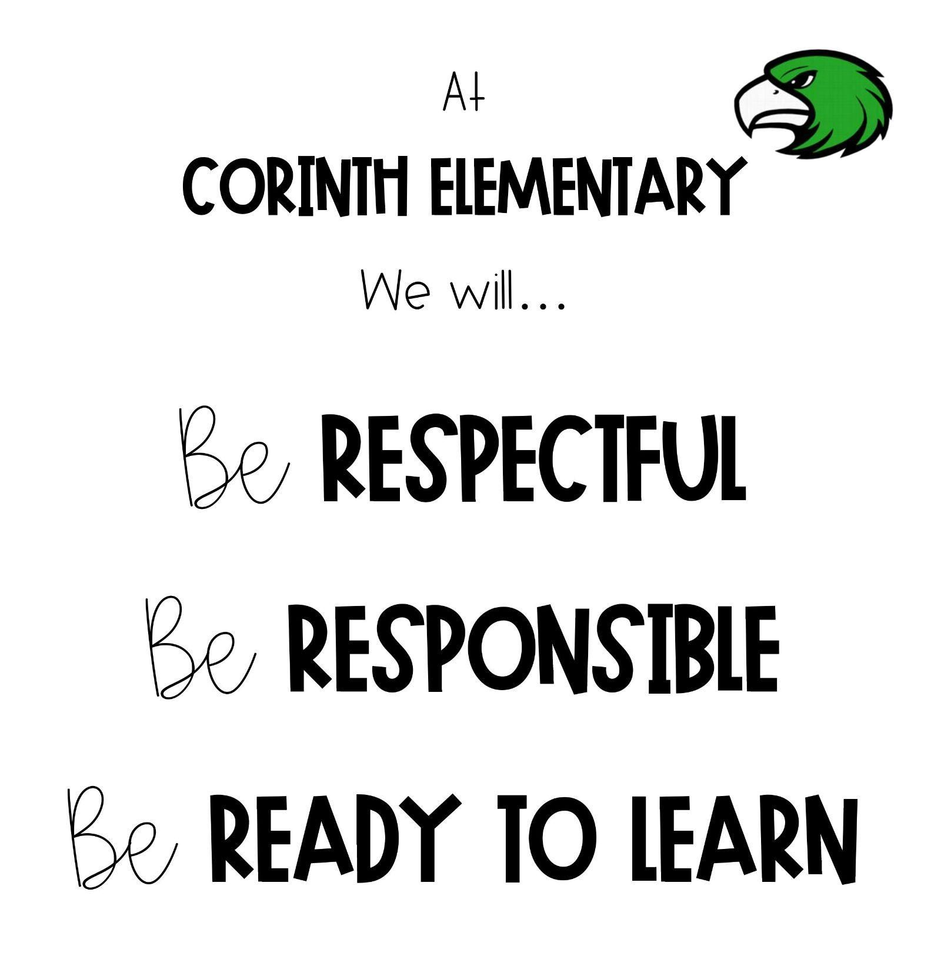
Sincerely,
Mrs. Cassaday, Mrs. Grizzard, Ms. Hill, Ms. Salmons

PBIS
PBIS is a decision-making framework
PBIS Goal: to enhance the capacity of schools to educate
ALL students
4 Elements of PBIS:
  - Outcomes
  - Systems
  - Data
  - Practice
Create a school culture of:
  - Predictability
  - Positivity
  - Safety
  - Consistency
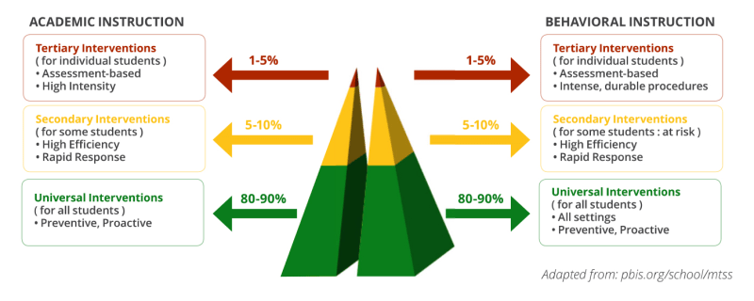
3-tiered model

Leader In Me
At Corinth Elementary, we focus on the 7 Habits of Happy Kids.

