Ceramics 2 Syllabus Outline
Mrs. Murray – Lake Dallas High School
Spring 2027

Contact Information
- Teacher: Mrs. Jeanette Murray
- Email: jmurray@ldisd.net
- Phone: 940-497-4031
- Conference Time: 10:50AM - 12:30 PM, Monday–Friday
- Best Way to Reach Me: Email or call the school office. I’ll respond within 24 hours on school days.
____________________________________________________________________________________

Dear Parents and Guardians,

Welcome to Ceramics 2 at Lake Dallas High School! This syllabus outlines the course plan for your child’s
class this semester, including key topics, expectations, and how you can support their success. As required by Texas law (Senate Bill 12), this document serves as the instructional plan and is available for your review. I look forward to working with you and your child!
The main goal of this course is that you will be able to create as well as appreciate expressive, beautiful three dimensional clay forms. You will have an understanding of other cultures and periods of human expression in clay and finally you will begin to be proficient at forming clay objects yourself.
The main emphasis will be on your work, your growth in the medium, your ability to create expressive, unified and cohesive three dimensional forms in clay.

Supplies:
- Sketchbook (bring it to class daily)
- Optional - Beginning pottery or ceramics tool set (from Hobby Lobby or Michael’s, see below)

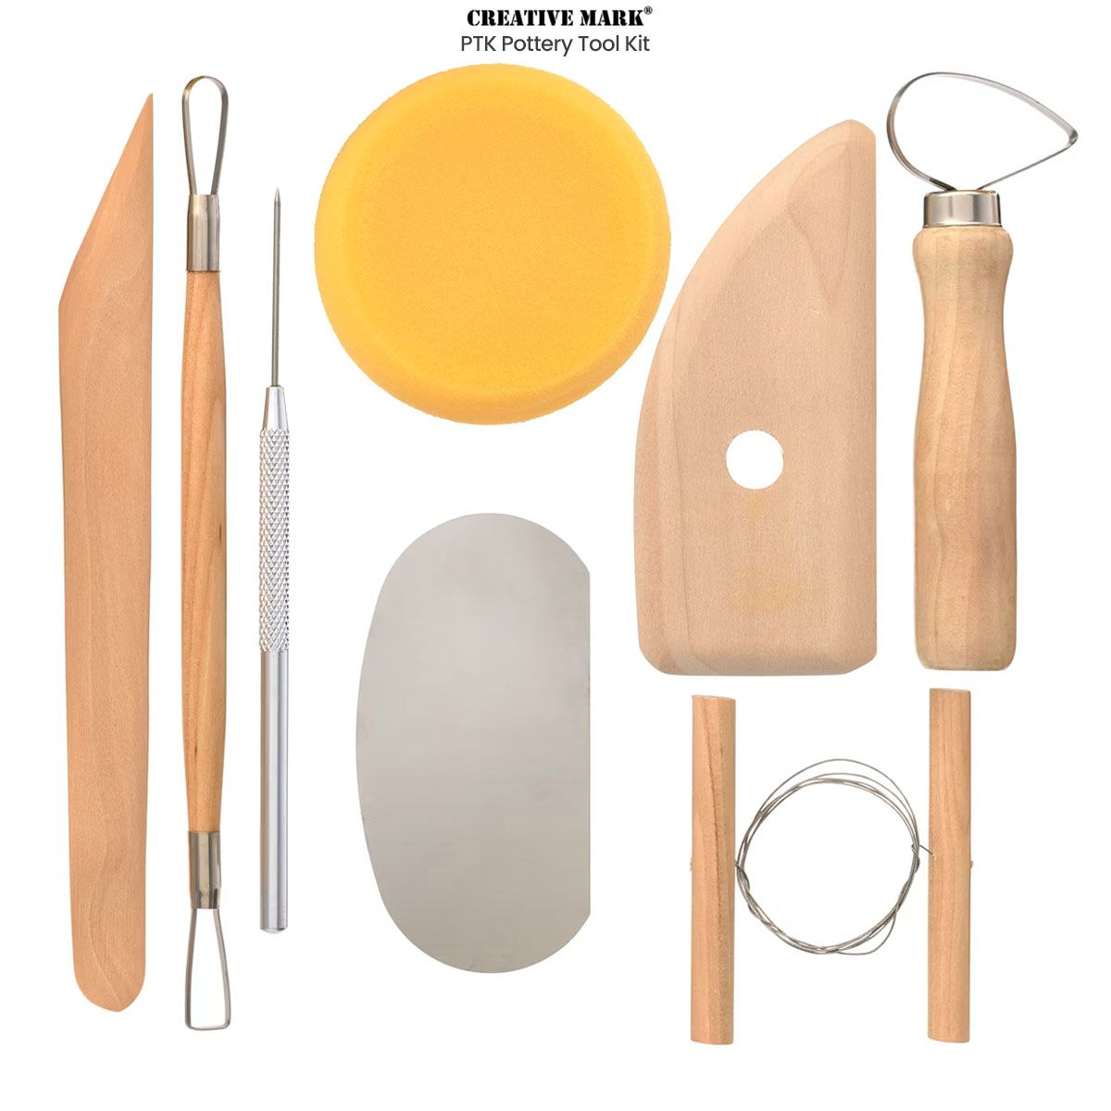
Please email me with any questions regarding required supplies. Parents- if your family has a financial need, please email me for assistance.

Behavior Expectations:
Students in this course have elected to pursue knowledge in visual art. This signifies motivation to spend time developing art skills and solving creative problems, therefore behaviors which do not foster a safe and innovative environment will not be tolerated. It will be expected that students spend time working outside of class on planning, brainstorming, researching, and sketching for their work. Students with tardies and absences should consider attending tutorials as needed.

Assignments:
Regular sketchbook assignments and notes targeted at reinforcing skills will be given before studio projects. Sketches will be required for all Studio Projects - you are expected to do independent research for these pieces! Progress check grades will be given to help pace studio projects and to provide formative assessment opportunities. Projects must be submitted on the due date, and presented for class critique.

Grading Policy:
- 60% Minor Grades - Thumbnails, Sketchbook Assignments, Progress Checks, Daily Assignments
- 40% Major Grades - Quizzes/Tests, Studio Projects, Critiques

Late/Incomplete Policy:
Projects are due on the due date or Critique day, complete or not. Students should always turn in work when it is due EVEN if they think it is incomplete. A partial grade will always be better than a zero. Students who miss critique for school functions or planned appointments are expected to turn in their work BEFORE class is missed. Students should attend morning tutorials the day they return to school to turn in work for unexpected absences on Critique days. Once the project has been graded, a student may continue to work, and resubmit it by the end of the 9 weeks to earn a higher grade.

Opportunities:
Students will have opportunities to enter their work into local and state-wide art competitions (VASE, TVAA, UNT Health and Science Center, and the Congressional Art Competition) in the Spring Semester. Other opportunities will be announced as we are informed of them. We are a competitive department, and encourage student participation in art competitions. Work may be held for inclusion in competitions and exhibitions until the end of the school year. All work will be sent home before the end of the Spring Semester.
____________________________________________________________________________________
Course Overview (Instructional Plan)
This semester, your child will study the following topics in Ceramics 2, based on Texas state standards (TEKS):
- Slab building techniques: soft slab, slab press mold, drape mold, etc, slab vessels
- Functional ceramics: dish sets and teapots
- Armatures and ceramics: portrait busts
- Wheel throwing

Thank you for supporting your child’s education! Feel free to contact me with questions.

Sincerely,
Jeanette Murray

