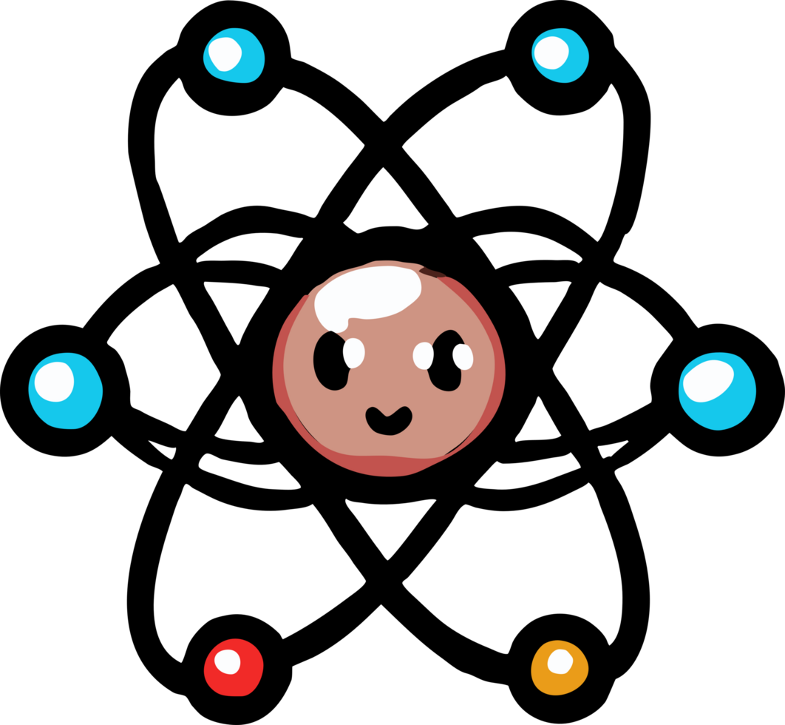Welcome to Chemistry!

2026-2027 Semester I Syllabus

Welcome Note

Get ready to explore the building blocks of everything! In this course, we’ll uncover what matter is made of, how atoms behave, and why chemical reactions happen (spoiler: things might fizz, pop, or glow ✨). You’ll learn to read the periodic table like a pro, mix up some safe chemical reactions, and see how chemistry is connected to cooking, cleaning, space travel, and even your favorite snacks. Whether you're dreaming of being a scientist or just want to know what’s in your soda, this class will open your eyes to the hidden science of the world around you!

Contact Information

Email: fcorcoran@ldisd.net
Phone: 940-497-4031
Conference Period: 4th Period, 12:35-1:20pm
Best Way to Reach Me: Email is by far the easiest and quickest way to reach me!

Course Description

The Chemistry course is designed for students to conduct laboratory investigations, apply scientific methods, and use critical thinking and problem-solving skills to make informed decisions. Students in Chemistry will study a variety of topics, including but not limited to the properties of matter, atomic structure, the periodic table, chemical bonding, chemical reactions, stoichiometry, gas laws, solutions, and energy changes in chemical processes.

Class Expectations

- Safe - be safe by following classroom and lab procedures
- Ownership - take ownership of your actions
- Attitude - remain positive by having a good attitude
- Responsible - be responsible for your education and surrounding
- Respectful - be respectful to yourself and others

Classroom Supplies

Most of the supplies that you will need for this course will be available in the classroom. However, you will need to bring a pencil or pen to each class as well as something to take notes on. A dedicated notebook or binder for chemistry will work best.

Grading Policy

In compliance with the updated grading policy for 25-26,

Minor Grades - 60% of grade
(Class Activities, Labs, Practice Work)
Major Grades - 40% of grade
(Exams, Portfolios, Projects)
Please refer to the student handbook for information regarding late work, missed work, and retesting policies.

Daily Work & Homework

There will be various daily activities entered into skyward as Minor Grades, which account for 60% of your overall grade. This includes class activities, labs, worksheets, quizzes, homework and any other assignments assigned.

IMPORTANT: If you happen to turn in late work, you must email me to let me know that you have turned it in. This is how I will grade it in a timely manner. If you do not email me, I will not be notified that you completed it. This is YOUR responsibility.

Exams & Projects

Major grades will be a mixture of exams and projects that will be administered during each unit. Exams will consist of 75% multiple choice questions and 25% free response questions. Exams and projects will account for 40% of your overall grade, as per the LDISD grading policy. Exams are open-note. You must use your own hand-written notes during each exam.

Open-note exam corrections will be allowed after each exam, but may ONLY be completed during my tutorials (NOT during my class period!). Exams will not be returned to you to keep, and will only be returned for you to review during my tutorials. Your graded exam and corrections will not leave my classroom, and you will not be permitted to use your phone while working on exam corrections. Exam corrections will earn 50% of the missed points back (so, for example, if you earned a raw score of 60 on the test and submit corrections for missed questions, you may earn an amended exam score of 80). There is no minimum or maximum requirement for exam corrections. If you received a raw 95 and want to amend to 97.5-98, you are free to do so. Exam corrections must be completed within 10 days of when the grade is posted in Skyward.

IMPORTANT: If you miss a scheduled exam, you MUST email me to schedule a time to come in (preferably after school so that you may have your fully allotted 45 minute test time) to make up the exam.

Labs

We are very proud of our school. In an effort to maintain safety, lab quality and classroom decorum I will not tolerate horseplay, vandalism, equipment abuse or tampering with emergency equipment. This also includes any tampering with the school’s issued iPad. Science equipment or material use is purposefully determined by the teacher and is not allowed outside of the classroom. A fee or full replacement of damaged, broken, or missing equipment may result along with an office referral.

**Any fighting, purposeful harm to a student or inappropriate behavior that causes a safety concern will result in immediate removal from the lab, which results in a referral and possible loss of participation in upcoming labs.

Academic Dishonesty

Cheating undermines both the cheater and class morale. Avoid doing yourself this disservice: it carries heavy consequences. Please see the Student Handbook to find more information about academic dishonesty.

Cell Phone, Smart Watches, & Airpods

Per HB1481, use of cell phones and all other personal communication devices are prohibited during the course of the school day. This includes airpods. The district’s and state’s policy regarding cell phones, smart watches, and airpods will be followed in my classroom.

Semester 1 Overview

 | Topics Covered | TEKS | Overview
Unit 0 | The Process of Science | 1.A, 1.B, 1.H, 1.G, 2.A, 2.B, 2.D, 3.C, 3.D, 4.A, 4.B | Students define science and scientific inquiry and learn how scientific investigations have changed over time. They will distinguish between scientific hypothesis and theory. They use science and engineering practices used to design investigations or design solutions.
Unit 1 | Intro to Science | 1.E, 1.F, 1.G, 2.B, 2.C | Collect, organize, analyze quantitative and qualitative data. Use lab reports, diagrams, charts and other statistical features to recognize patterns, sources of error and limitations.
Unit 2 | The Nature of Matter | 5.A, 8.C, 9.A, 10.A, 11.B | Explain development of the Periodic Table over time using physical and chemical properties. Calculate percent composition of compounds. Interpret, write and balance chemical equations. Distinguish between reactions, mixtures and solutions.
Unit 3 | Structure of the Atom | 6.A, 6.B, 6D | Construct models that show the development of modern atomic theory over time using scientific discoveries from famous scientists: Dalton, Thomson, Rutherford, and Bohr. Describe the structure of the atom and calculate atomic mass using isotopic composition.
Unit 4 | Electrons | 6.A, 6.B, 6.C, 6.E | Describe structure of atoms, ions including masses, electric charges, protons, neutrons and electrons. Express arrangement of electrons using electron configuration and Lewis Dot. investigate EM Spectrum and relate i t to quantization of energy in emission.
Unit 5 | The Periodic Table | 5.A, 5.B, 5.C | Explain development of Periodic Table. Predict properties of the different chemical families. Analyze and interpret elemental data, including atomic radius, mass, electronegativity, ionization and reactivity trends.
Unit 6 | Ionic Compounds | 7.A, 7.B, 7.D | Name and write the chemical formulas for ionic and covalent compounds. Analyze the properties of ionic, covalent and metallic substances.
Unit 7 | Covalent Bonding | 6.E, 7.A, 7.B, 7.C, 7.D, 12.A | Explain how covalent bonds form. Determine bonds and structure in a compound from its name. Determine the shape of molecules by structure including polar and nonpolar.

PLEASE RETURN THIS SHEET SIGNED, VERIFYING YOU HAVE READ THE SYLLABUS FOR 2026-2027 SCHOOL YEAR .

Name Student (print): _________________________________ Class Period: _____
Student Signature: ____________________________________ Date: ___________
Parent/Guardian Signature: ____________________________ Date: ___________
(This page is worth 50% of your first grade.)

