Practicum in Agriculture  COURSE SYLLABUS  Lake Dallas High School | Lee Blanton, Ag Science Teacher  Email: Lblanton@ldisd.net | Formal Parent Communication: ParentSquare  Course Length: Full Year | Grade Levels: 10–12  Work-Based Learning: 15 hours/week per approved schedule | 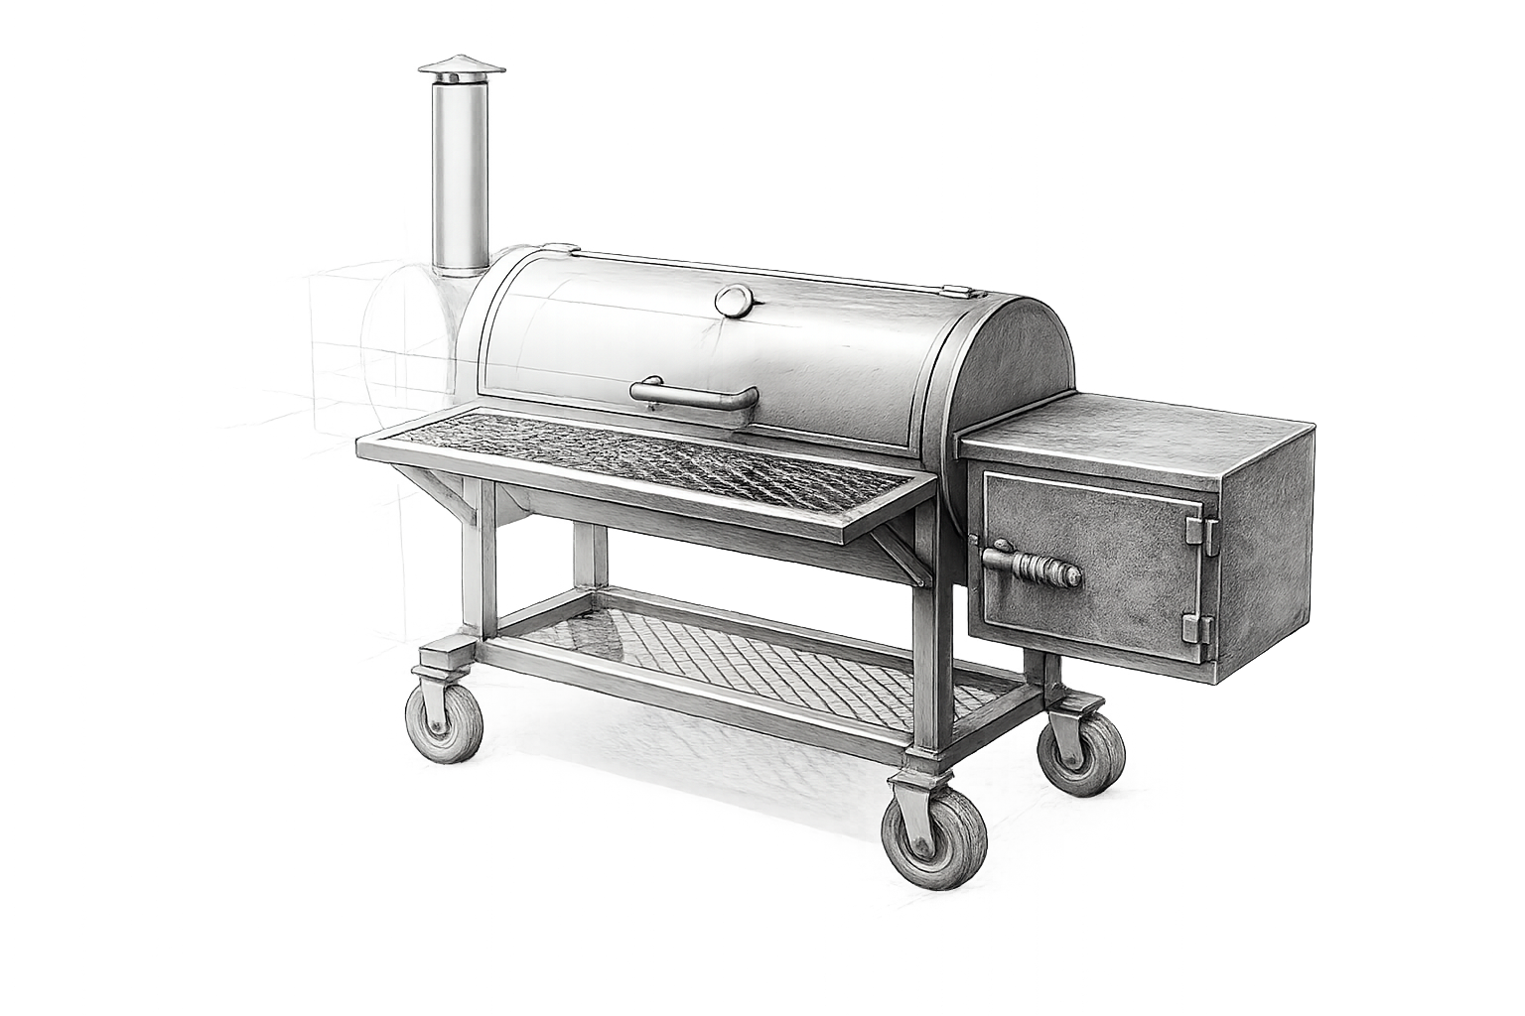
Course Description
Practicum in Agriculture is an advanced work-based and project-based course that connects agricultural knowledge to supervised industry experience, independent project work, technical skill development, SAE recordkeeping, and career preparation. Students may participate in approved paid or unpaid placements, school-based practicum work, industry job shadowing, advanced fabrication, and portfolio development.
Students are expected to become more independent as the year progresses. They are not expected to know every process on the first day; they are expected to work safely, be dependable, communicate professionally, accept correction, solve problems, document their work accurately, and improve with experience.
Without a process there is no progress.
Course Content
Instruction includes work-based learning expectations and safety; SAE planning and AET recordkeeping; career exploration and professional communication; advanced GMAW and SMAW; weld inspection; project proposals, CAD, material planning, and approval; independent fabrication; industry placement and job shadowing; finishing, testing, and quality control; project presentation; portfolio development; and FFA career and leadership connections.
Year at a Glance
Weeks | Unit
1–2 | Course, FFA, SAE, and Practicum Foundations
3–4 | Work-Based Learning Foundations and Safety
5 | SAE Planning and Documentation
6 | Career Exploration and Industry Connections
7–9 | Advanced Welding Skills Development
10–12 | Independent Project Planning and Approval
13–18 | Practicum Project Execution — Phase 1
19–22 | Industry Placement and Job Shadowing
23–27 | Practicum Project Execution — Phase 2
28–32 | Project Completion, Finishing, and Testing
33–34 | Project Presentation and Industry Evaluation
35–36 | Careers, Portfolio, Final Assessment, and Wrap-Up
The pacing guide may be adjusted for school schedules, placement availability, student progress, equipment availability, projects, or instructional needs.
Grading
Lake Dallas ISD grading categories are Major Grades — 40% and Minor Grades — 60%.
Major Grades — 40%: Major practicum projects, practical skill assessments, project phase reviews, project presentations and demonstrations, portfolio assessments, industry-based evaluations when assigned, and semester/final assessments may be used as Major grades.
Minor Grades — 60%: Weekly work logs and timecards, AET/SAE records, weekly supervisor evaluations, quizzes, resumes and career assignments, project proposals and checkpoints, technical drawings, material lists, safety assignments, skill practice, and other formative work may be used as Minor grades.
Practicum Placement and Work-Based Learning Requirements
- Placements must be agriculture-related and approved by the Ag Science teacher before the student begins work. Placements may be paid or unpaid.
- Students are expected to complete 15 hours per week according to an individually approved schedule.
- Teacher-approved safety training and site orientation are required before practicum work begins.
- Each week, students must maintain AET records, an employer-verified timecard, and the required Google Form work log.
- A formal supervisor evaluation is completed weekly and addresses attendance/punctuality, quality/productivity, safety/rules, and professionalism/communication.
- Students and parents/guardians are responsible for practicum transportation.
- An absence or late arrival must be reported to the placement supervisor and Ag Science teacher as soon as reasonably possible.
- A safety incident, injury, unsafe condition, or significant workplace concern must be reported immediately to the placement supervisor and Ag Science teacher.
- Students must follow both school and placement requirements. When requirements differ, the stricter safety or conduct standard applies.
- The practicum agreement must be completed with required student, parent/guardian, placement supervisor, and Ag Science teacher signatures before placement participation.
Shop and Workplace Safety
Safety is a condition of participation. Before any hands-on shop or fabrication work, every student must complete required safety instruction, pass the required safety examination with a 100% score, demonstrate the ability to follow procedures, wear required clothing and PPE, and follow instructor directions. Passing the written test does not remove the daily safety requirement.
For school shop work, the Agriculture Science program provides safety glasses, welding hoods, and welding gloves. Students must arrive with boots, full-length jeans or other approved shop pants, appropriate non-synthetic shop clothing, and any additional PPE required for the operation. The program does not provide storage for student clothing or boots.
At industry placements, students must follow host-site PPE, equipment, emergency, and authorization requirements in addition to school expectations. Students may only operate equipment for which they have received appropriate instruction and authorization. Unsafe conduct may result in immediate removal from an activity and further disciplinary action.
Professional Conduct and Work Standard
Practicum is performance-based. Students are expected to report as scheduled, be prepared, use time productively, communicate professionally, follow the process, care for equipment and facilities, accept instruction, correct mistakes, and complete required documentation. Simply being present does not demonstrate satisfactory practicum performance.
There is a difference between a reason and an excuse. When a problem occurs, students are expected to communicate it, identify what can be corrected, take responsibility for their part, and move forward. A difficult day can happen; unsafe behavior, poor attitude, dishonesty, or refusal to work cannot become a habit.
Projects, Planning, and Documentation
Independent or school-based practicum projects may require a project proposal and teacher approval before construction. Planning may include purpose and scope, hand-drawn technical drawings, CAD drawings, dimensions, bills of materials, cost estimates, cut lists, timeline, safety plan, work logs, progress photographs, and final inspection documentation. Project changes must be communicated and approved when they materially affect scope, cost, safety, or function.
Workmanship matters. Students should expect to measure, check, correct, grind, refit, redraw, troubleshoot, or redo work when necessary. The standard is the highest level of safe, functional workmanship the student is capable of producing at that point in the course—not “good enough” when improvement is reasonably possible.
Tutoring and Open Shop
Tutoring is available Tuesday from 6:50–7:20 a.m., Wednesday from 3:05–3:35 p.m., and at other times by appointment. Students should ask for help early rather than waiting until an assignment, evaluation, or project deadline.
Beginning in September, Open Shop is available Wednesday from 3:05–5:00 p.m. Open Shop is optional, is not extra credit, and is not a course requirement. It may be used for approved fabrication practice, project work, instructor guidance, and Agricultural Mechanics CDE preparation. All regular safety, clothing, PPE, equipment-use, and behavior expectations apply.
SAE and FFA
SAE is an instructional component of Agricultural Science. Students will maintain appropriate SAE records in AET throughout the year. Approved practicum placement hours, project work, skills, supervisor feedback, and supporting evidence should be documented accurately and honestly.
Agricultural education consists of three interconnected components: Classroom/Laboratory Instruction + SAE + FFA. Students will be introduced to Lake Dallas FFA opportunities including leadership and career development, competitions, degrees, awards, scholarships, and community involvement. Practicum experience may support Agricultural Mechanics CDE, Employment Skills LDE, degree, proficiency, scholarship, and career-readiness goals.
Classroom Movement
No student will leave the classroom during the first 10 minutes or the last 10 minutes of class. Students should take care of restroom, water, locker, and other non-emergency needs outside those times. Exceptions may be made for emergencies or when directed by the teacher or campus staff.
Attendance, Communication, and Missed Work
Regular attendance and dependable placement participation are essential because much of the course involves supervised work that cannot always be recreated. Students are responsible for checking missed assignments, communicating with the instructor and supervisor, completing eligible makeup work, and arranging missed assessments or required project work. Attendance and makeup work follow Lake Dallas ISD policy and the approved practicum agreement.
ParentSquare is the formal communication tool for the Agriculture Science program. Students and parents should monitor ParentSquare for announcements, reminders, schedule changes, FFA information, and course communication. Email may be used for individual questions or concerns. Lee Blanton | Ag Science Teacher | Lblanton@ldisd.net
Student Expectations and The Standard
Students are expected to demonstrate integrity, discipline, hard work, responsibility, respect, coachability, commitment, punctuality, attention to detail, pride in workmanship, professional communication, care for others and equipment, and a willingness to improve.
The goal is bigger than completing hours, welding a project, or earning a grade. The goal is to develop students who can show up prepared, work with purpose, solve problems, communicate effectively, work safely, take responsibility, and produce work they are proud to put their name on.
Do the work correctly. Do it safely. Accept correction. Fix mistakes. Take care of the people and equipment around you. Improve every day.
Without a process there is no progress.
Student/Parent Acknowledgment
By signing below, the student and parent/guardian acknowledge that they have reviewed the course syllabus and understand the course expectations, safety requirements, work-based learning requirements, and procedures.
Student Printed Name: ____________________ | Signature: ________________ Date: _________
Parent/Guardian Printed Name: _____________ | Signature: ________________ Date: _________

