Agricultural Structures Design and Fabrication  COURSE SYLLABUS  Lake Dallas High School | Lee Blanton, Ag Science Teacher  Lblanton@ldisd.net | Formal Parent Communication: ParentSquare  Full Year | Grades 10–12 | 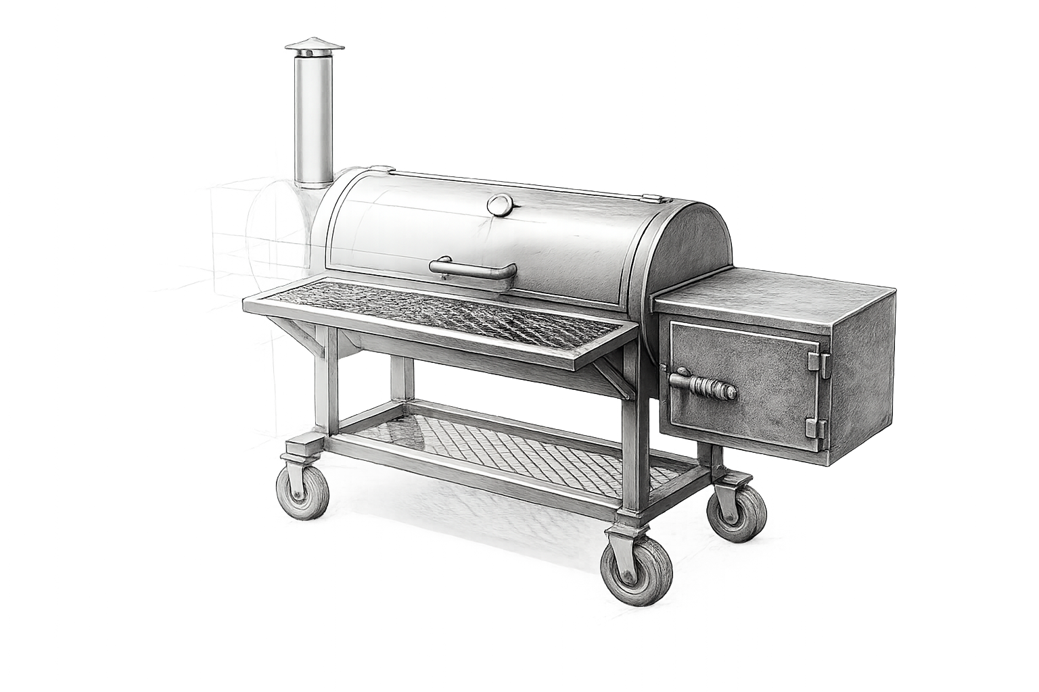
Course Description
Agricultural Structures Design and Fabrication is a project-based course that develops advanced skills in planning, designing, estimating, fabricating, assembling, finishing, and evaluating agricultural structures and equipment. Students apply measurement, blueprint reading, CAD, welding, cutting, material selection, structural design, problem-solving, and project management through progressively more independent work.
Students are not expected to begin the year already knowing every process. They are expected to work safely, follow the process, accept correction, solve problems, document their work, and continually improve the quality of what they produce.
Without a process there is no progress.

Course Content
Instruction includes shop safety and PPE; measurement and blueprint reading; project proposals and cost estimating; CAD using Fusion 360 and/or SolidWorks; structural design and material selection; SMAW, GMAW/MIG, and oxy-fuel cutting; project layout, fit-up, fabrication, assembly, grinding, finishing, painting, quality inspection, project presentation, SAE, and FFA connections.

Year at a Glance

Weeks | Unit
1–2 | Course, FFA, SAE, and Agricultural Structures Foundations
3–5 | Shop Safety and Tool Orientation
6 | Measurement, Blueprint Reading, and Project Proposal
7–9 | CAD Design — Fusion 360 and/or SolidWorks
10 | Welding and Cutting Skills Refresher
11–12 | Project Proposal Finalization and Approval
13–18 | Project Fabrication — Phase 1: Main Frame and Structure
18 | Semester 1 Review and Final Exam
19–26 | Project Fabrication — Phase 2: Components, Details, and Assembly
27–32 | Project Fabrication — Phase 3: Advanced Components and Custom Features
33–34 | Finishing, Paint, and Quality Inspection
35 | Project Presentation and Peer Evaluation
36 | Final Exam, Shop Cleanup, and Course Wrap-Up

The pacing guide may be adjusted for school schedules, student progress, equipment availability, project scope, material availability, or instructional needs.

Grading
Lake Dallas ISD grading categories are Major Grades — 40% and Minor Grades — 60%.

Major Grades — 40%
Major grades may include unit exams, CAD design projects, project proposals, fabrication phase assessments, practical skill assessments, final project quality inspections, presentations, and semester/final assessments. Projects may be evaluated for accuracy, workmanship, safety, process, measurement, planning, documentation, functionality, completion, and finished quality.

Minor Grades — 60%
Minor grades may include weekly shop/process grades, SAE Friday grades, quizzes, technical drawings, material lists, cost estimates, work logs, skill practice, exit tickets, safety checks, project checkpoints, and other formative assignments.

Weekly Process Grade: Monday through Thursday, students may earn 25 points per day for one 100-point Minor grade each week. Students are expected to be prepared, follow directions, work safely, use class time productively, care for equipment, complete assigned work, and participate in cleanup and documentation. Being physically present does not automatically earn full credit.

SAE Friday: Friday is designated for Supervised Agricultural Experience development and recordkeeping. Students are expected to maintain an SAE in AET — The Agricultural Experience Tracker. SAE Friday is a separate 100-point Minor grade from the Monday–Thursday weekly process grade.

Shop Safety and PPE
Safety is a condition of participation. There are no exceptions to established shop safety procedures. Before hands-on shop work, every student must complete required safety instruction, pass the required safety examination with a 100% score, demonstrate the ability to follow shop procedures, wear required clothing and PPE, and follow instructor directions. Passing the written safety test does not remove the daily safety requirement.
The Agriculture Science program will provide safety glasses, welding hoods, and welding gloves. Students are responsible for arriving prepared for shop work and must wear boots, full-length jeans or other approved shop pants, appropriate non-synthetic shop clothing, and any additional PPE required for the operation being performed.
A boot is required. Athletic shoes, sandals, open-toed shoes, Crocs, and other inappropriate footwear are not acceptable for shop participation. The program does not provide storage for clothing or boots. Students who are not properly dressed or equipped will not participate in shop activities that day.
Safety glasses are required in designated active shop areas and whenever directed. Face shields, hearing protection, gloves, and other PPE will be required according to the operation.

Unsafe Conduct, Tools, and Shop Standards
Unsafe behavior will be addressed immediately. Horseplay, unauthorized equipment operation, failure to wear required PPE, distracting someone operating equipment, throwing objects, improper handling of hot metal, misuse of compressed gas equipment, bypassing safety devices, or welding/cutting/grinding without permission are prohibited.
A student may be removed immediately from an activity when the instructor determines that the student's actions create a safety risk. Serious or repeated unsafe conduct may result in formal disciplinary action and removal from shop participation or the Agricultural Mechanics program in accordance with classroom, campus, and district procedures. No project, grade, deadline, or competition is more important than safety.
Students may operate only equipment for which they have received instruction and authorization. They must use the correct tool, inspect tools before use, report damage, never bypass safety devices, return tools, clean equipment, and respect school equipment and materials. “I have used one before” is not authorization to use school equipment.

Projects, Planning, and Workmanship
Projects require planning before fabrication. Depending on the project, students may be required to complete a project proposal, hand-drawn technical drawings, CAD drawings, dimensions and title blocks, bills of materials, cost estimates, cut lists, timelines, safety plans, work logs, progress photographs, and final inspection documentation. Project work may not begin until required planning and approval are complete.
Project Responsibility and Materials: This is a project-based course. Each student is expected to complete an approved fabrication project during the year. Students are responsible for all materials required for their project. If material cost or access is a concern, the student or parent/guardian should contact Mr. Blanton privately so arrangements can be made. A limited number of contracted projects with community members may also be available. These opportunities are first come, first served.
Students should expect to measure, check, correct, grind, refit, redraw, troubleshoot, or redo work when necessary. “Good enough” is not the standard when the student has the ability and opportunity to improve the work. Cleanup is part of the assignment; work is not complete until tools are returned, work areas are cleaned, materials are stored, waste is properly disposed of, equipment is secured, and the shop is ready for the next class.

Tutoring and Open Shop
Tutoring is available Tuesday from 6:50–7:20 a.m., Wednesday from 3:05–3:35 p.m., and at other times by appointment. Students should ask for help early rather than waiting until an assignment, assessment, or project deadline.
Beginning in September, Open Shop is available Wednesday from 3:05–5:00 p.m. Open Shop is optional, is not extra credit, and is not a course requirement. It is provided for additional welding/fabrication practice, approved project work, instructor guidance, and Agricultural Mechanics CDE preparation. Students are not penalized for not attending. All regular safety, PPE, clothing, equipment-use, and behavior expectations apply.

Classroom Movement
No student will leave the classroom during the first 10 minutes or the last 10 minutes of class. Students should take care of restroom, water, locker, and other non-emergency needs outside those times. Exceptions may be made for emergencies or when directed by the teacher or campus staff.

Attendance and Missed Work
Regular attendance is important because much of the course involves demonstrations, supervised fabrication, and project work that cannot always be recreated. Students are responsible for checking missed assignments, communicating with the instructor, completing eligible makeup work, and arranging missed assessments or project work. Attendance and makeup work follow Lake Dallas ISD policy.

SAE and FFA
SAE is an instructional component of Agricultural Science. Students will maintain appropriate SAE records in AET throughout the year. Project planning, fabrication hours, skills developed, photographs, and other appropriate evidence should be documented accurately.
Agricultural education consists of three interconnected components: Classroom/Laboratory Instruction + SAE + FFA. Students will be introduced to Lake Dallas FFA opportunities including leadership and career development, competitions, degrees, awards, scholarships, and community involvement. Students demonstrating interest and proficiency may be encouraged to participate in Agricultural Mechanics Career Development Events and other appropriate FFA activities.

Communication
ParentSquare is the formal communication tool for the Agriculture Science program. Students and parents should monitor ParentSquare for announcements, reminders, schedule changes, FFA information, and course communication. Email may be used for individual questions or concerns.
Lee Blanton | Ag Science Teacher | Lblanton@ldisd.net

Student Expectations and The Standard
Every student can have a difficult day. Students are still expected to respond appropriately to correction and return to the standard. Students should demonstrate integrity, discipline, hard work, responsibility, respect, coachability, commitment, attention to detail, pride in workmanship, care for others and the shop, and a willingness to improve.
The goal is bigger than completing a project or learning to weld. The goal is to develop students who approach work with purpose, solve problems, take responsibility, communicate effectively, work safely, and produce work they are proud to put their name on.
Do the work correctly. Do it safely. Accept correction. Fix mistakes. Take care of the people and equipment around you. Improve every day.
Without a process there is no progress.

Student/Parent Acknowledgment
By signing below, the student and parent/guardian acknowledge that they have reviewed the course syllabus and understand the course expectations, safety requirements, procedures, and responsibilities.

Student Printed Name: ____________________ Signature: ____________________ Date: _________

Parent/Guardian Printed Name: _____________ Signature: ____________________ Date: _________

