Art AP Syllabus Outline

Ms. Rios – Lake Dallas High School

Fall 2026

Contact Information
- Teacher: Ms. Rios
- Email: jrios@ldisd.net
- Phone: 940-497-4031
- Conference Time: 11:05- 12:30, Monday–Friday
- Best Way to Reach Me: Email or call the school office. I’ll respond within 24 hours on school days.
___________________________________________________________________________________
Dear Parents and Guardians,
Welcome to AP Art at Lake Dallas High School! This syllabus outlines the course plan for your child’s class this semester, including key topics, expectations, and how you can support their success. As required by Texas law (Senate Bill 12), this document serves as the instructional plan and is available for your review. I look forward to working with you and your child!
Students will investigate arts practice and design thinking as a means for individual learning, social responsibility, and creative problem solving – mediating ideas and materials toward meaningful and enduring solutions. This course will prepare students to enter upper level drawing and painting courses, ceramics, digital media; and enable students to apply creative skills across disciplines.
Supplies:
A link to a list of supplies is on my Home Page of the class in Canvas or, you may obtain a hard copy from your art teacher.
Please email your art teacher (your child's art teacher) with any questions regarding required supplies.
Parents- if your family has a financial need, please email your child's art teacher for assistance.
Behavior Expectations:
Students in this course have elected to pursue knowledge in visual art. This signifies motivation to spend time developing art skills and solving creative problems, therefore behaviors which do not foster a safe and innovative environment will not be tolerated. It will be expected that students spend time working outside of class on planning, brainstorming, researching, and sketching for their work. Students with tardies and absences should consider attending tutorials as needed.
Assignments:
Regular sketchbook assignments and notes targeted at reinforcing skills will be given before studio projects. Sketches will be required for all Studio Projects - you are expected to do independent research for these pieces! Progress check grades will be given to help pace studio projects and to provide formative assessment opportunities. Projects must be submitted on the due date, and presented for class critique.
Grading Policy:
- 60% Minor Grades - Thumbnails, Sketchbook Assignments, Progress Checks, Daily Assignments
- 40% Major Grades - Quizzes/Tests, Studio Projects, Critiques
Late/Incomplete Policy:
Projects are due on the due date or Critique day, complete or not. Students should always turn in work when it is due EVEN if they think it is incomplete. A partial grade will always be better than a zero. Students who miss Critique for school functions or planned appointments are expected to turn in their work BEFORE class is missed. Students should attend morning tutorials the day they return to school to turn in work for unexpected absences on Critique days. Once the project has been graded, a student may continue to work, and resubmit it by the end of the 9 weeks to earn a higher grade.
Opportunities:
Students will have opportunities to enter their work into local and state-wide art competitions (VASE, TVAA, UNT Health and Science Center, and the Congressional Art Competition) in the Spring Semester. Other opportunities will be announced as we are informed of them. We are a competitive department, and encourage student participation in art competitions. Work may be held for inclusion in competitions and exhibitions until the end of the school year. All work will be sent home before the end of the Spring Semester.

Course Overview (Instructional Plan)
This semester, your child will study the following topics in AP Art, based on Texas state standards (TEKS):
AP 2-D Art and Design
Ms. Rios
jrios@ldisd.net
LDHS 130

Course Description
Welcome to AP (Advanced Placement) 2-D Art Art and Design! This is a program administered by the College Board to provide highly motivated high school students with an opportunity to earn college credit in art with a 2-D Design focus. Students will submit a 2-D Design portfolio to the College Board with work that focuses on the use of two-dimensional (2-D) elements and principles of art and design, including point, line, shape, plane, layer, form, space, texture, color, value, opacity, transparency, time, unity, variety, rhythm, movement, proportion, scale, balance, emphasis, contrast, repetition, figure/ ground relationship, connection, juxtaposition, and hierarchy. AP 2-D Design is not based on a written exam; instead, students submit a portfolio in May to include five selected works (demonstrating drawing skills and synthesis of materials, processes, and ideas) and 15 sustained investigation images (demonstrating drawing skills, practice, experimentation, and revision, as well as synthesis of materials, processes, and ideas) based on an investigation of the student’s choosing. Students should consider how materials, processes, and ideas can be used to make work that exists on a flat surface. Students can work with any materials, processes, and ideas. Graphic design, digital imaging, photography, collage, fabric design, weaving, fashion design, fashion illustration, painting, and printmaking are among the possibilities for submission. Still images from videos or film are accepted. Composite images may be submitted. Students will be encouraged to develop a strong personal artistic voice. The year will culminate with a gallery show. Throughout the year, students will document/photograph and write about their processes and finished work. This year will be about truly becoming an artist in terms of inquiry, the content and quality of your work, your work ethic/practice, and the opportunity to share and sell your work to the public. Let’s make some art!

Portfolio Requirements
The 2-D Design portfolio consists of the following two sections:
- Sustained investigation (60% of portfolio score):
Images:
Fifteen digital images of works of art and process documentation that demonstrate sustained investigation of an idea through practice, experimentation, and revision.
This section will be uploaded to the College Board website.
Writing:
𞠡 Identify the questions that guided your sustained investigation.
𞠡 Describe how your sustained investigation shows evidence of practice, experimentation, and revision guided by your questions (1,200 characters maximum, including spaces, for response to both prompts).
𞠡 For each image:
Materials (100 characters maximum, including spaces)
Processes (100 characters maximum, including spaces)
Size (height x width x depth, in inches, or “NA” for size if documenting process/detail)

- Selected Works (40% of portfolio score):
Five physical works or high-quality printed reproductions of physical works that each demonstrate synthesis of material, processes, and ideas using drawing skills. Works will be shipped to the College Board and will be returned in June.
Writing:
𞠡 For each image:
Idea(s) visually evident (100 characters maximum, including spaces)
Materials (100 characters maximum, including spaces)
Processes (100 characters maximum, including spaces)

May 7, 2021: Final portfolios due. Digital submission must be uploaded to the College Board before this date; five selected works boxed and shipped.

Resources
𞠡 Computers/iPads with Adobe Photoshop digital software
𞠡 Digital projector and screen
𞠡 Standing lights
𞠡 School Wi-Fi connection
𞠡 In-class art library including techniques, art history, and visual references
𞠡 Art magazines in the school library including Art News, Art in America, and Juxtapoz
𞠡 Art supplies, drawing boards
𞠡 Classroom digital cameras for student use
𞠡 Mounting supplies and equipment

Artistic Integrity
Throughout the year, artistic integrity will be stressed. Students will be encouraged to develop a personal artistic voice while researching and exploring the art of others. While not all drawings will require visual sources, when reference material is needed, students are encouraged to use primary sources whenever possible. For example, students can take their own reference photographs or stage/choose scenes to draw from observation. Any work that makes use of (appropriates) photographs, published images, and/or the work of someone else must show substantial and significant development beyond duplication. This is demonstrated through manipulation of the materials, processes, and/or ideas of the source. The student’s individual vision should be clearly evident. It is unethical, constitutes plagiarism, and often violates copyright law simply to copy someone else’s work or imagery (even in another medium) and represent it as one’s own.

Expectations of Students Taking AP Drawing
Work independently.
Show respect for each other, the instructor, the equipment, and the learning environment of the classroom.
Show up on time ready to work.
Attend class regularly.
Bring the following to class every day:
𞠡Sketchbook
𞠡 Current project and materials
𞠡 Your curiosity and awesome creative self

Grading
Grading is based on total points earned using scoring guides that combine the state standards for the arts and the College Board scoring guidelines. Each of the following are awarded points:

Skill Builder: Mini Investigation Projects (5 points per investigation)
These are short projects that will include multiple works investigating a single idea to build drawing skill and the process of investigation in preparation for your chosen sustained investigation.

Sustained Investigation Process (5 points per grade-check)
Once you have begun your chosen sustained investigation, you will document your process weekly via an artist Instagram account. Students are encouraged to follow each other’s accounts and share feedback online. Every grade-check (half-grading period, 9 week report card, and semester), the depth of your investigation will be evaluated via Instagram based on the guidelines of the College Board and the investigation process.
Finished Works (5 points per grade-check)
At each grade-chek, finished work will be curated and displayed by students along with a typed artist statement. Students will participate in an all class critique. Works of art and writing will be evaluated based on synthesis of materials, processes, and ideas, and drawing skill.

Completed AP Portfolio (50 points)
Gallery Exhibit (50 points)

Enrichment Activities (5 points each)
𞠡 Museum/gallery visits
𞠡 VASE competition (required)
𞠡 TVAA competition
𞠡 UNT Health Science Center Show
𞠡 Other art competitions: Scholastic Art Awards, YoungArts, Adobe Youth Voices, etc
𞠡 Artist research
𞠡 National Portfolio Day attendance
𞠡 Service art or other competitions

Year Schedule
Introduction to the AP Portfolio (Week 1)
𞠡 Explanation of each section of the AP Portfolio: Sustained Investigation and Selected Works.
𞠡 Registration on AP website.
𞠡 View sample AP 2-D Art and Design portfolios at AP Central: https://apcentral.collegeboard.org/courses/ap-2-d-art-and-design/portfolio?course=ap-2-d-art-and-design#samples

Evaluation of Past Work (Week 1)
𞠡 Bring in all past work including Summer Assignment.
𞠡 Evaluate past work in terms of design skill, materials, processes, and ideas.
𞠡 What are your strengths? How could you grow as an artist? What materials, processes, and/or ideas are you interested in? What past work could lead to a sustained investigation?
𞠡 Class brainstorm of skill builder/investigation ideas needed as a class before moving on to personal sustained investigation.

Skill Builder: Mini Investigation Projects (September-October)
(5 points each)
These are short projects that will include multiple works or iterations investigating a single idea to build 2-D design skill and model the process of investigation in preparation for your chosen sustained investigation. Each investigation will include all steps on the investigation process handout and will be graded using the sustained investigation grade sheets for finished works. Possible investigations will be designed based on the needs of the current class and may include but are not limited to the following ideas.

𞠡 Color: How can 90 colors be created from seven colors through primary, secondary, and complement mixes/tints/shades? How do color choices affect the mood or perception of a drawn subject? How does colored light affect perception? How does light affect local color?
𞠡 Point / Line / Shape / Plane: How can line be created in three-dimensional space? How can the direction, quantity, and quality of lines affect meaning and mood? How can emotion be communicated through the quality of marks?
𞠡 Composition: How do layers of space, placement on the page, or eye levels affect perception of a subject? What happens to form when part of a subject is cropped out of an image? How can composition communicate ideas?
𞠡 Double Exposure/Blended Imagery: How can altering transparency and opacity of images change the story or affect perception of subject matter? What are ways images can be altered digitally, in physical space, and or both? How can images be placed together to create a contrasting effect?
𞠡 Shape and Space Experimentation: How can images collected from magazines or other analogue sources be recombined into a new unified image? What images emerge when open to discovery and working without a plan? How can drawing be created from or on the newly created work? How do hand-drawn marks interact with collaged imagery? How can one combine imagined and observational drawing?
𞠡 Time / Connection: What is the relationship of artist to viewer/consumer? How do images communicate across cultures and time periods? How can measurable time be incorporated into the art making process to tell a story or deliver a message?
𞠡 Figure/Ground Relationship / Proportion / Scale: How can materials choice, composition, eye level, mark-making, pose, and/or symbolic objects illustrate personal history, identity, and aspects of the self? How can they advertise a message or agenda?
𞠡 Visual Tempo: How can the repetition of lines, shapes, and colors provide a visual path for a viewer? How can curves, chaotic marks, alternating colors, etc. enhance a meaning or mood?
𞠡 Emphasis / Contrast : How can materials act as symbols? What is the effect of using multiples of a chosen object? How can meaning be embedded in the materials?
𞠡 Microcosm / Macrocosm: How can parts and the whole be explored through close-up and overall drawings of visually intriguing or personally relevant objects? How can ordinary objects become abstractions of form through dynamic compositions? How can lighting change perception of objects and affect the mood of a still-life drawing?

Sustained Investigation
This section of the AP Drawing portfolio offers students the opportunity to make and present works of art based on an in-depth investigation of materials, processes, and ideas of their choosing done over time. Sustained investigation is guided by QUESTIONS. It involves practice, experimentation, and revision using materials, processes, and ideas. This section is expected to demonstrate skillful synthesis of materials, processes, and ideas. Visual and written evidence of inquiry are required.

Visual Documentation of Skill Building (5 points)
Quality documentation of finished work and the process of art making will support the final portfolios. Students will learn and demonstrate the ability to do each of the following before moving on to art making in class:
𞠡 Taking quality photos of finished work, works in progress, sketchbook pages, and the art-making process using cell phone cameras and smartphone digital editing software.
𞠡 Editing images for clarity and accuracy on cell phones.
𞠡 Selecting the highest quality images and deleting those that aren’t needed.
𞠡 Creating a Google Drive folder for this class
𞠡 Sharing folder with instructor.
𞠡 Uploading images to Google folder.
𞠡 Renaming images.
𞠡 Sorting images into folders online.
𞠡 Creating an artist Instagram.
𞠡 Posting to and hashtagging/tagging within a post on Instagram.

Brainstorm
Once students have completed the skill-building mini investigation projects, they are ready to investigate an idea of their choosing. Students will be guided through a brainstorm process to generate questions/ideas for an investigation that is compelling to the student. Brainstorm will include reviewing past work, reflecting on personal history, and considering materials, process, and ideas that are of interest. Students will research an artist with a similar focus using the artist/art history research handout at the end of this syllabus.

Independent Work Time
Once an investigation is chosen, students will work independently, with the understanding that the investigation can shift and change as part of the process. Progress will be checked weekly and process and finished works will be graded each grade check (Half-grading period, 9 Weeks Report Card, and Semester) based on the investigation process. The classroom will be open after school for students to be able to work on projects as state and local policies allow in light of the pandemic. See sustained investigation handouts at the end of syllabus for requirements and grading.

Final Portfolio (Last two weeks in April - early May)
(50 points)
Selected Works Section of Portfolio
𞠡 Selection of works: Select the five works that best demonstrate advanced design skill and skillful synthesis of materials, processes, and ideas. The five pieces chosen can come from the sustained investigation, but they don’t have to.
𞠡 Writing: ideas, materials, processes for each piece.
𞠡 Mounting/matting of each piece
𞠡 Meet for final assembly of portfolio where we label and pack your five selected works for shipping.

Digital Submission of Sustained Investigation
𞠡 Selection of photos and finished work that best show the investigation process.
𞠡 Final writing to include investigation question, practice, experimentation, revision, materials, process, and ideas.
𞠡 Dimensions of work

Grading
Evaluation of final portfolio based on College Board scoring guide.

Gallery Exhibit (May - June)
(50 points)
After portfolios are submitted, you will be working on a group gallery exhibit of your work and the work of your fellow AP Art and Design classmates. This will give you an authentic professional artist experience. Work can be for sale. A Virtual Gallery will be held if the event cannot exist in a traditional setting.The following will be included:

𞠡 Typed artist labels and artist statement
𞠡 Professional mounting or preparation of work for display as is appropriate for your work
𞠡 Inventory list
𞠡 Gallery contract
𞠡 Field trip permission slip
𞠡 Attend artist reception
𞠡 Written reflection/Instagram post

Investigation Process
This cycle serves as a guide for sustained investigation. You may expand beyond this guide, but it offers a way of thinking about investigation. Because every artist investigates in their own way and at their own pace, an investigation may start and move in different stages and directions in the cycle. All stages present opportunities for practice, experimentation, and revision (making changes). For an in-depth investigation, explore each stage of the cycle as is appropriate for your investigation while practicing, experimenting, and revising. All stages below are considered part of your PROCESS of investigation, so document each stage with photos and writing for possible inclusion in your final portfolio.

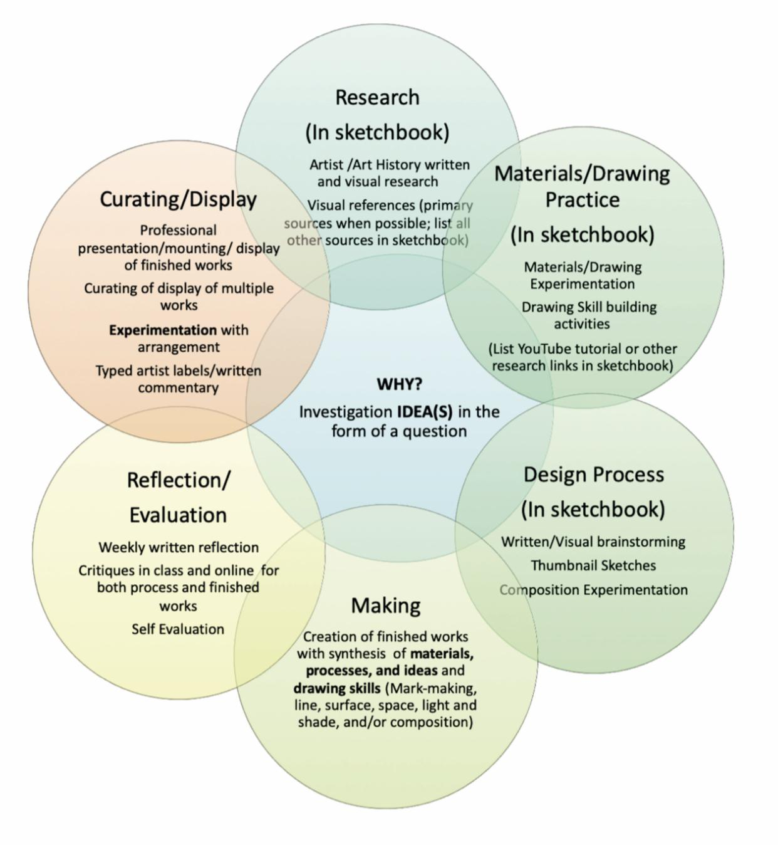
Sustained Investigation Guidelines
Work through the investigation process as is appropriate for your idea(s). Every artist works in their own way and at their own pace. With that in mind, you do not need to explore every stage every week, but you do need to have explored every stage by the end of your investigation. You will score yourself for both process and finished work every half-grading period. You must provide a high-quality mixed-media sketchbook to use to document process, including but not limited to artist/art history research, materials/drawing skill practice/experimentation, experimentation with composition, designing of projects, thumbnail sketches, visual references, inspiration, and drawing practice/experimentation. This sketchbook is a dynamic tool. Images from your sketchbook that document process, practice, experimentation, and revision can be used in your final portfolio.

Process: Instagram Posts Due Every Friday
(5 points per half-grading period)
By the last day of every week, post your investigation process to Instagram. All stages are considered part of your process of investigation, so documenting each stage in your sketchbook and with photos and writing will help you compile your final portfolio in May. Include photos, writing, hashtags, and tags as outlined below:

Photos/Video
𞠡 Photos documenting each stage of your investigation process. Try to avoid cast shadows or unclear photos. Try a variety of types of photos. Look at your entire feed as a gallery wall to curate.
𞠡 Take at least one photo every class period to document your progress/process.
𞠡 Record time-lapse and regular video if you feel this would document your process well. Video can be posted to your stories or as a regular post.
𞠡 Weekly posts can include a stack of multiple photos. Please make sure the top photo is the most engaging.
𞠡 If posting to your story, tag me and save the story to your highlights or it will disappear in 24 hours and you will not get credit.

Written Reflection
Answer each question below in each weekly Instagram post.
- What questions are guiding your sustained investigation? What, if any, new questions have emerged?
- List materials and design skills ( point, line, shape, plane, layer, form, space, texture, color, value, opacity, transparency, time, unity, variety, rhythm, movement, proportion, scale, balance, emphasis, contrast, repetition, figure/ ground relationship, connection, juxtaposition, and hierarchy) you are exploring.
- Describe what you did this week during your investigation process (research, materials/drawing practice, design process, making, and/or curating/display).
- How have you practiced and/or experimented this week?
- What have you revised or changed as you have been working?
- What is working well so far?
- What could you improve?
- What insights, discoveries, or inspiration have you gained?
- What will you do next to further your investigation?
Hashtags and Tags
𞠡 Use #APartwithrios to link to classwork.
𞠡 Tag photo and stories to link to classwork.
𞠡Search the class hashtag and comment on each other’s work.
𞠡 Add hashtags to build your audience. Consider using medium, concept, WIP (work in progress), etc. Suggestions: #drawing #art #painting #mixedmedia #portraits #animalart #natureart #politicalart #installation #color #recycyledart #conceptualart #performanceart #fashion #markmaking

Critique of Finished Works And/Or Works In Progress
Small-group critiques in class. If you are absent for a critique, comment on each class member’s Instagram post for finished works:
𞠡Share your investigation question.
𞠡 Share your materials, process, and ideas.
𞠡 Share your practice, experimentation, and revision
𞠡 Respond to fellow artists’ work.
𞠡 Participate actively and respectfully.
𞠡 Give constructive criticism and positive feedback.
𞠡 Use art vocabulary.
𞠡 Ask questions.
𞠡 Write critique feedback in sketchbook.

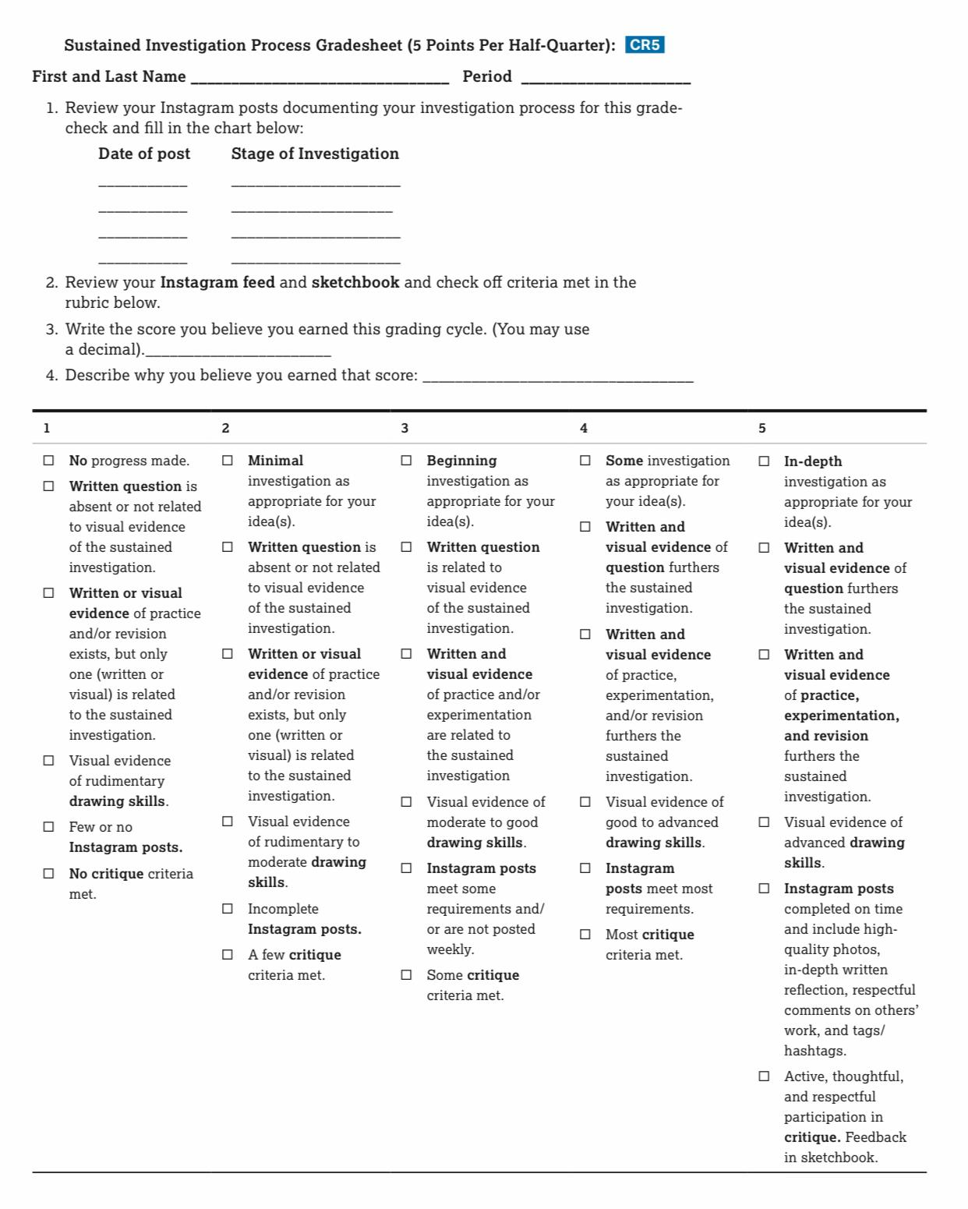

Finished Works Guidelines
You must have finished work by the end of your sustained investigation. There is not a required number of pieces, but within your sustained investigation you are required to eventually have finished work that demonstrates synthesis of materials, processes, and ideas and drawing skill. You are not required to have finished work each half-quarter, but when you DO have finished works at grade-check, follow the steps below. Grading and in-class critiques will happen every half-quarter regardless of the number of finished pieces.

Written Commentary
This commentary will serve to document your investigation in writing and will serve as an artist statement for the public as it will accompany your display of work outside the classroom.

Typed 12pt Times New Roman,
Create a heading: row 1 - centered first and last name; row 2: centered title of your series in italics
Skip a line

Answer the following thoughtfully and accurately, using complete sentences in left-justified paragraphs:
- WHAT questions are guiding your sustained investigation?
- WHY are you interested in investigating this idea?
- WHAT materials, processes, and ideas have you explored in EACH piece? HOW is each piece different from the next?
- WHAT 2-D design skills are you exploring (e.g., point, line, shape, plane, layer, form, space, texture, color, value, opacity, transparency, time, unity, variety, rhythm, movement, proportion, scale, balance, emphasis, contrast, repetition, figure/ ground relationship, connection, juxtaposition, and hierarchy)?
- HOW have you experimented with materials, processes, or ideas?
- HOW have you practiced with materials, processes, or ideas?
- WHAT revisions or changes have you made as you have been working?
- WHAT visual sources have you used in your work? If you’ve used the work of others, list their information here and describe how you have changed the image to show your individual vision.
- WHAT insights, discoveries, or inspiration have you gained as you have been working?
- WHAT materials, processes, or ideas will you explore next to further your sustained investigation?
- WHAT do you hope the viewer will come away with after viewing this work?

Display/Curate Finished Works
Mount or prepare work for display as is appropriate for your work.
Attach an artist label to each work

First Last Name
Title
Medium
Grade
Period
@Instagram handle

CURATE and arrange a display of your works including your typed commentary. Consider relationships of all works to each other, impact of arrangement on perception of your ideas, and relationship to the other artists’ work in the hall.

Instagram Post Of Finished Works
Photograph each finished work using a smartphone. Use even light source (outside in shade or inside with angled lights and no cast shadows). Align edges with the frame when taking your pictures. Crop out the background. Familiarize yourself with the phone’s editing features and adjust the image until color and light look accurate.

Photo of curated display if more than one is complete.
Copy and paste written commentary you used in display into the post.
Tag and hashtag to link it to your classwork and build your audience.

Critique Of Finished Works And/Or Works In Progress
All-class critique. If absent for a critique, comment on each class member’s Instagram post for finished works:
- Share your investigation question.
- Share your materials, process, and ideas.
- Share your practice, experimentation, and revision.
- Respond to fellow artists’ work.
- Participate actively and respectfully
- Give constructive criticism and positive feedback
- Use art vocabulary.
- Ask questions.
- Write critique feedback in sketchbook.
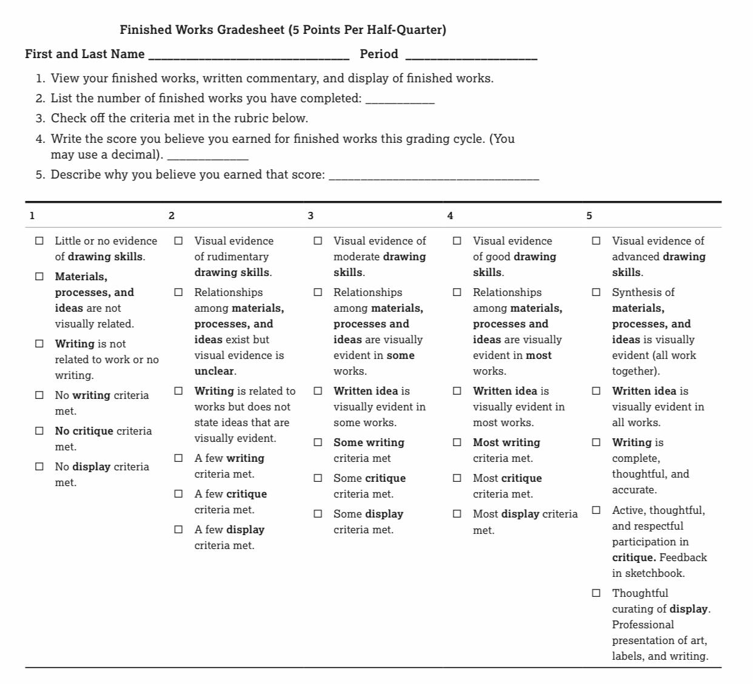

Artist Research
- Research an artist related to the investigation you are starting in class. Search for an artist working with similar materials, processes, and/or ideas. Try searching keywords, the materials you’ll be using, your idea, etc. You may research an artist in a gallery or museum in person. You may use magazines from the library including Art News, Art in America, and Juxtapoz. Go beyond Instagram to find in-depth information on your artist. Here are a few online resources to get you started:
Artsy.net
Metmuseum.org
Art21
Colossal
- Record all research in your sketchbook. Use the questions below to guide your research of an artist or artist collective. Document research in your sketchbook to include the following:
𞠡 Printed and/or sketched images of the artist(s)’ work.
𞠡 Written answers to all questions listed below
𞠡 Sources: website address, name and author of book or magazine article.

- Post research to your artist Instagram:
𞠡 Photograph your artist research pages in your sketchbook
𞠡 Brief description of the artist and what you researched; any insights you want to share with the viewer
𞠡 Hashtag and/or tag the artist
𞠡 Tag and hashtag to link to classwork

Artist Research
- Who:
- When:
- Where is the artist from?
- List aspects of the artist(s)’ identity (race, gender, culture, other?).
- What ideas does the artist investigate in their work?
- What materials did the artist use?
- What was the artist’s process when creating their work? How did they make their work?
- What drawing skills (mark-making, line, surface, space, light and shade, and composition) did the artist use?
- How did the artist use those drawing skills?
- What imagery did the artist use?
- What did the artist use as sources for images?
- How difficult do you think it was to create their work?
- Do you think the artist worked with a plan, no plan as in open to the process, or both?
- Did the artist work from imagination, observation, or both?
- How does the artist(s)’ personal experience, culture, or history inform or influence their work?
- What is your opinion of the artist(s)’ work and why?
- What else do you think is important to note about this artist(s)’ work?
- What questions would you ask the artist(s) if you could talk to them in person?
- How does this artist(s)’ work relate to the project or investigation you are working on in class?

Thank you for supporting your child’s education! Feel free to contact me with questions.
Sincerely,
Jennifer Rios

