Dear Parents and Guardians,

We’d like to introduce you to Overgrad, an online platform that your student is using at their school/organization.

What is Overgrad?

Overgrad is an online platform designed to help students and parents plan for life after high school. Overgrad helps students do the following:

Self Exploration: Take personality and career assessments to discover more about their values and future pathways that align with their passions.

Research Options: Find colleges and career paths that fit their academic strengths and interests.

Understand Requirements: See what’s needed to pursue their chosen colleges and careers.

Track Progress: Keep tabs on their progress toward meeting those requirements over time.

Example student dashboard:
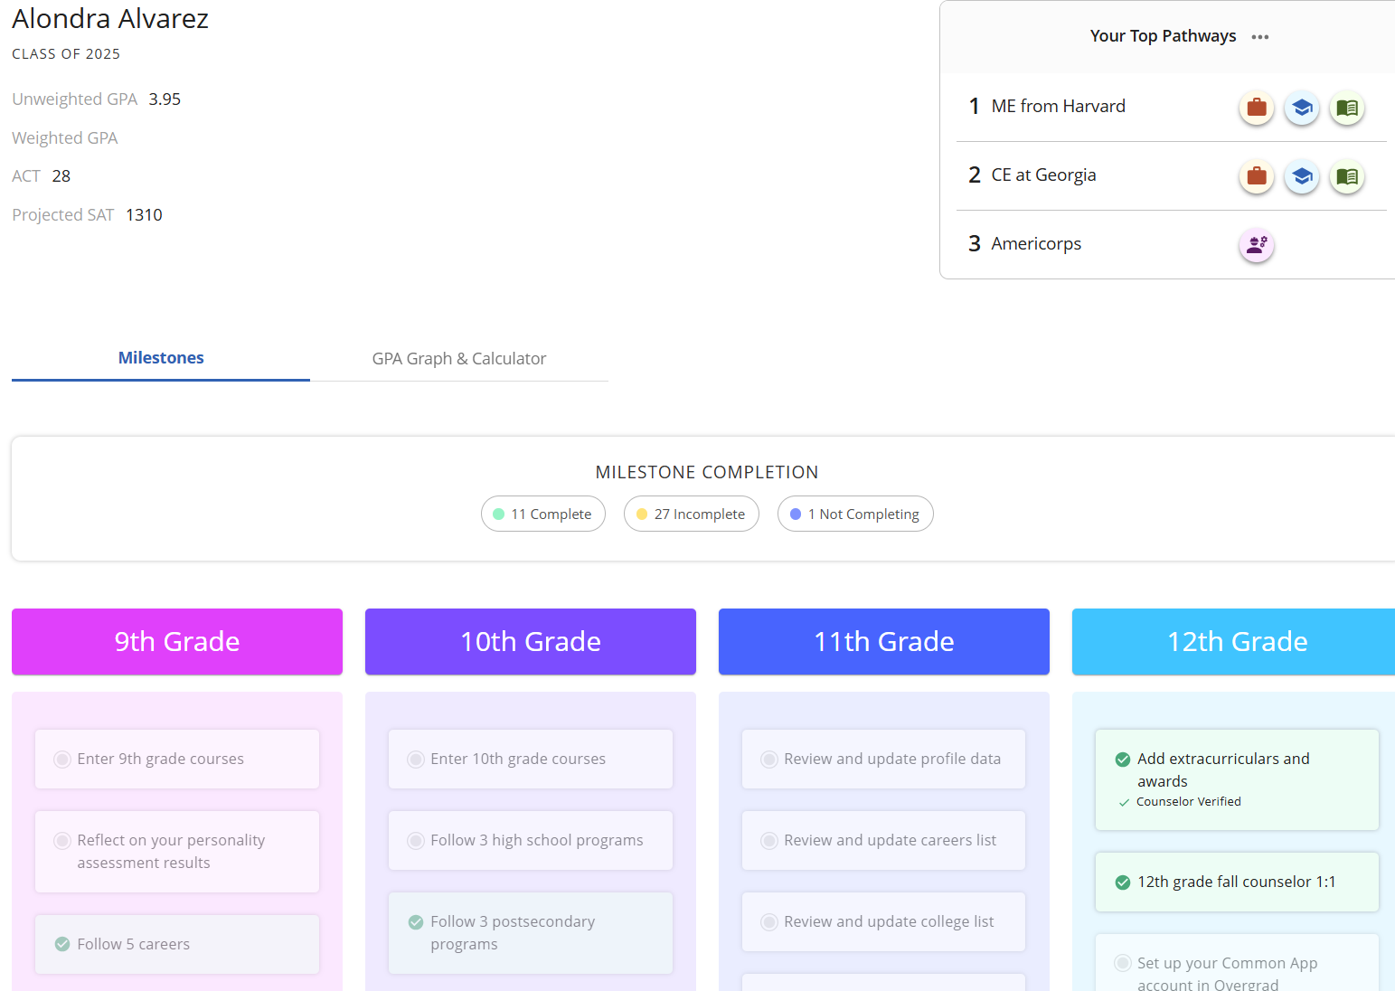

How can my student(s) use Overgrad?
To use Overgrad, your student simply needs to visit overgrad.com and create an account as a student. Or, if they have already gotten started at school, they can simply log in. Students can access Overgrad on any device—including laptops, phones, tablets, and PCs.

How can I use Overgrad?
To access your parent dashboard, you will receive an email from Overgrad inviting you to connect with your student’s account. If you have not received this email, please ask your student’s counselor to resend the invitation and ensure they have the correct contact information.

Once you have accepted your invite you will be able to access the dashboard to track your child’s progress, make suggestions that align with their future goals, and message their counselor.

Example Parent Dashboard:
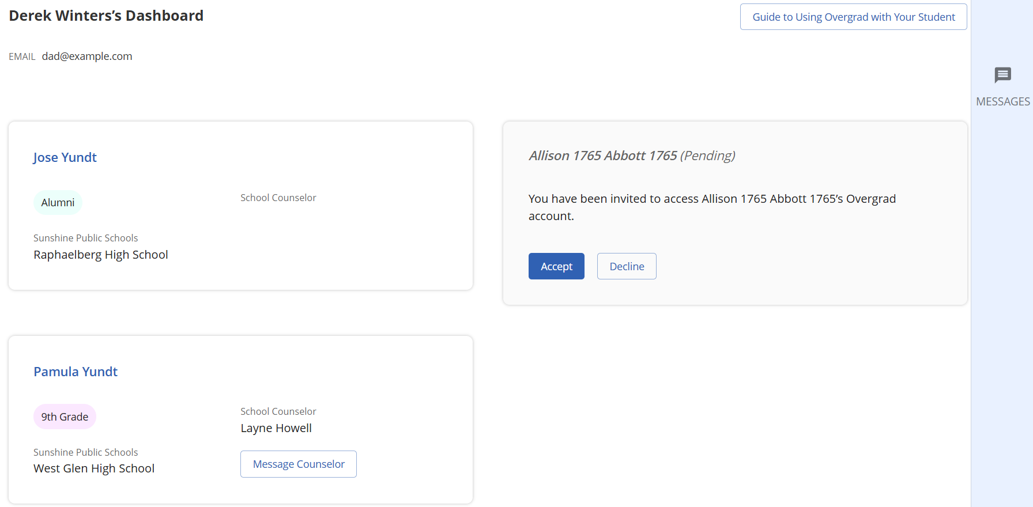

If you have any questions about accessing the site at home please reach out to your student’s school counselor or college and career support team. You may also contact us at support@overgrad.com. Have fun exploring future options with your student!

Sincerely,

The Overgrad Team

