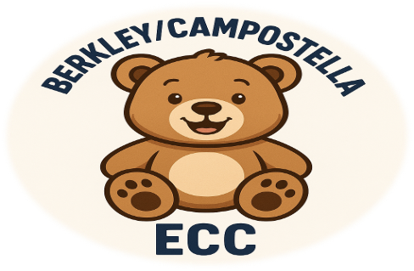

Welcome to the 2026–2027 School Year!
Dear Berkley/Campostella ECC Families,
We are honored to welcome you to the Berkley/Campostella Early Childhood Center (ECC) family! We take our roles as educators seriously and consider it a privilege to support and positively influence your child’s learning, growth, and development.
Our mission at Berkley/Campostella ECC is to provide a positive, safe, and engaging learning environment where every child is valued. We want all students to enjoy learning, build confidence, and achieve their fullest potential.
Throughout the school year, we will work diligently (through strong leadership, effective systems, and a commitment to success) to help our students meet and exceed their end-of-year benchmarks in letter recognition, letter sounds, numeracy, and social-emotional development. Most importantly, we are committed to making a positive and lasting impact on the lives of our students.
We hope to exceed your expectations and are excited to personally welcome your family to Berkley/Campostella ECC and the 2026–2027 school year.

Key Dates and Important Reminders

First Day of School
- School officially begins on Monday, August 24, 2026.

School Hours
- Students may enter the building beginning at 9:10 a.m. Dismissal is at 3:55 p.m.

Drop-Off
- During the first week of school, parents and guardians may walk their children to their classrooms. We kindly ask all parents and guardians to leave the classroom by 9:25 a.m. so that teachers and students can begin their instructional day.

Pick-Up
Parents and guardians will pick up their children from their teacher’s back classroom door. Please ensure that the adult picking up your child is listed on the authorized pickup list, is at least 18 years old, and presents a valid photo ID each day.

- PK3 Families: Enter through the gate near the parking lot behind the cafeteria. Walk over the bridge, down the steps, and through the blue gate to pick up your child.
- PK4 Families: Enter through the blue gate near the community basketball court to pick up your child.

School Supply List
- The school supply list is available in the Student/Parent Handbook and online.
Strong communication between home and school is essential to your child’s success. Please ensure that your phone number and contact information remain current so that your child’s teacher and the school can reach you when needed.
Families may communicate with teachers through email, phone, ClassDojo, or by scheduling a conference
Parents and guardians, I look forward to partnering with you throughout the school year. If you have questions or concerns, please know that I am here to serve you and help ensure that your child’s needs are addressed.
A strong partnership between school and home is vital to student success. Together, we can make the 2026–2027 school year a positive, rewarding, and successful experience for every child.
Welcome to Berkley/Campostella ECC! We are excited to begin this wonderful year of learning and growing together.
Sincerely,

Beverly Ellis
Beverly Ellis
Principal

Cc: Nicole Hughes
Office Manager

Berkley/Campostella Early Childhood Center
1530 Cypress St. Norfolk, VA 23523
School, (757) 494-3870, Fax (757) 494-3290

