2026-2027 McBean Calendar

August
8/3 Open House
8/5 First Day of School
8/28 Building Parent Capacity Training

September: Attendance Awareness Month
9/7 Labor Day Holiday
9/11 Progress Report #1
9/14 Fall Conferences Begin
9/29Annual Title I Meeting

October: Drug Awareness Month
10/8 PowerUp Asynchronous Learning
10/9 Student Holiday/PL Day
10/12-13 Student/Teacher Fall Break
10/24 Fall Carnival
10/30 Progress Report #2
Red Ribbon Week
Bully Prevention and Safety Training

November
11/11 Veterans Day Holiday
School Council Meeting
11/16-11/20 American Education Week
11/23-27 Thanksgiving Holiday

December
First Semester Attendance Party
12/22 End of 1st Semester/Early Release

January
1/6 Student Holiday/PL Day
1/7 Start of 2nd Semester
1/13 Report Cards
1/18 MLK Holiday
100th Day of School

February
2/10 Progress Report
2/11 PowerUp Asynchronous Learning Day
2/12 Student Holiday/PL Day
Feb 15 Student/Teacher Holiday
Feb 16- Spring Parent Conference window begins

March
3/15 Parent conference window ends
3/25 Progress Report
3/26 Student/Teacher Holiday

April
4/5-12 Spring Break

May
Honor’s Day
Field Day
I-Ready Growth Party
Attendance Party
5/26 Last Day of School/Early Release

*Additional Dates to Come! Parents will be notified about any changes in advance. *

The Purpose and Benefit of this Compact
The purpose of this compact is to ensure effective engagement of parents and to support a partnership between our school, parents and the community to improve student academic success.

Communication about Student Learning
McBean Elementary School is committed to two-way communication with families about children’s learning. We embrace an open-door policy. Other ways you can expect us to reach you are: Weekly homework folders, updates on the school website, Infinite Campus Parent Portal, Parent-teacher conferences, Facebook page, Class Dojo/Remind, Letters/Email/Flyers, Quarterly Newsletter, Conferences and PTO. McBean has access to translators and will provide full opportunity for parents with limited English, disabilities, and migrant children. All flyers and information will be available in a language most understood by parents.

Jointly Developed
The parents, students, and staff worked together to share ideas to develop the school-parent compact. Academic goals have been set based on school data, as well as students, faculty and staff feedback. Stakeholders, parents, and students provided feedback with Title I surveys on their needs and strategies they are willing to work on with the school. Meetings are held each school year and feedback is welcomed in the front office.

Sheri Calhoun- Principal
calhosh@boe.richmond.k12.ga.us

Katrina Prophet- Parent Facilitator Designee
prophka@boe.richmond.k12.ga.us

Revised: July 31, 2026
6

“Where We PAWS for Excellence”
School-Parent Compact
2026-2027
McBean Elementary School

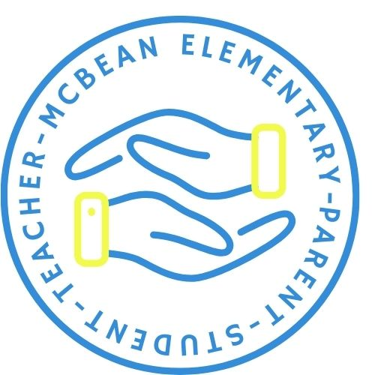
Sheri Calhoun
Principal
Katrina Prophet
Assistant Principal
1165 Hephzibah-McBean Rd.
Hephzibah, GA 30815
706.592.3723
2026-2027 District Goals
- During the 26-27 school year, we will increase content mastery for student groups in tested subject areas on the Georgia Milestones by 3%.
- During the 26-27 school year, we will increase feedback mechanisms by increasing the evaluation completion rate by 3%.
- During the 26-27 school year, we will reduce chronic absenteeism by 3%.
- During the 26-27 school year, we will improve the on-time delivery rate of student transportation services by 5%

2026-2027 School Goals
- By May 2027, we will decrease the number of students with chronic absenteeism by 3% from 17% to 14%.
- By May 2027, increase the number of students performing on grade level in reading by 3% as measured by i-Ready for grades K-2 and Georgia Milestones for grades 3-5.
- By May 2027, increase the number of students performing on grade level in math by 3% as measured by i-Ready for grades K-2 and Georgia Milestones for grades 3-5.

2026-2027 District Goals
- During the 26-27 school year, we will increase content mastery for student groups in tested subject areas on the Georgia Milestones by 3%.
- During the 26-27 school year, we will increase feedback mechanisms by increasing the evaluation completion rate by 3%.
- During the 26-27 school year, we will reduce chronic absenteeism by 3%.
- During the 26-27 school year, we will improve the on-time delivery rate of student transportation services by 5%

2026-2027 School Goals
- By May 2027, we will decrease the number of students with chronic absenteeism by 3% from 17% to 14%.
- By May 2027, increase the number of students performing on grade level in reading by 3% as measured by i-Ready for grades K-2 and Georgia Milestones for grades 3-5.
- By May 2027, increase the number of students performing on grade level in math by 3% as measured by i-Ready for grades K-2 and Georgia Milestones for grades 3-5.

We are partners in educating the children at McBean…
As a school, we promise to…
- Hold Fall and Spring parent-teacher conferences at minimum 4 days of the academic school year.
- Communicate to parents their child’s academic progress and changes in behavior regularly.
- Provide quality customer service and reasonable access to staff and parents.
- Provide parents opportunities to volunteer and participate in school activities and students’ educational experiences.
- Develop reading and math goals based on data and assist students in setting and reaching goals.
- Encourage and Support a positive and Cooperative School environment, where everyone feels safe to learn!
- Foster teacher-student-parent relationships.
- Seek a bond with every child.

As a parent, to help my child or children, I promise to…
- Participate in parent conferences, school meetings, functions and activities.
- Provide the school with updated contact and emergency information and communicate often with the school and/or teacher.
- Always bring child(ren) to school daily, on time, with all materials, ready to learn, and show concern for academics.
- Provide notes for all absences.
- Volunteer when available.
- Review homework assignments nightly and assist my child in meeting set Reading and Math goals.
- Read with or to my child at minimum 5 or more minutes nightly.
- Do not pick up my child(ren) early from school, except for a doctor’s appointment or other major event.
- Recognize your student’s achievements!
- Please dress in modest apparel when entering the school building. For clarity, please see Ms. Calhoun.
As a student, I promise to…

- Discuss what I learned with my parents daily and at conferences.
- Bring home notes, letters and other to my parent(s).
- Be an active participant in setting and achieving academic and behavior goals.
- Complete homework, read daily, and strive to exceed reading and math goals established with my teacher.
- Ask my teacher for help if I do not understand and ALWAYS do my best.
- Try hard to be at school every day, and communicate with my teacher about absences.
- Seek to be a global citizen.
- Keep my area clean and take pride in keeping the school clean.
- Show good character and make good choices when no one is looking.

Community Service Projects
- Toys For Tots
- Pennies for Patients
- Spooky to Be Hungry
- MLK Community Service Project
- Jump Rope for Heart

Parents, please keep this compact in your child or children’s file at home. This compact is a reminder of our, both parents and school, commitment to working together for the successful educating of our children.

