2026-2027
Title I School-Wide Plan

Contents
School Information - 2-
SWP Template Instructions - 3 -
Planning Committee Members - 4 -
SWP/SIP Components - 5 -
1. A comprehensive needs assessment of the entire school, that is based on information which includes the academic achievement of children in relation to the challenging state academic content standards, particularly those children who are failing, or are at risk of failing, to meet the challenging state academic standards and any other factors as determined by the local LEA as described in Section 1114(b)(6). - 5 -
2. School-wide reform strategies that: Sec.1114(b)(7)(A)(i-iii) -21-
3. School-Wide Plan Development: Sec. 1114(b)(1-5) - 44-
4. ESSA Requirements to include in the School-Wide Plan: - 46-
5. Measures to include teachers in the decisions regarding the use of academic assessments in order to provide information on, and to improve, the achievement of individual students and the overall instructional program. - 48-
6. Activities to ensure that students who experience difficulty mastering the proficient or advanced levels of academic achievement standards shall be provided with effective, timely additional assistance, which shall include measures to ensure that students’ difficulties are identified on a timely basis and to provide sufficient information on which to base effective assistance. - 49-
7. Coordination and integration of federal, state, and local services and programs, including programs supported under this Act, violence prevention programs, nutrition programs, housing programs, Head Start, adult education, vocational and technical education, and job training - 50-
8. Description of how individual student assessment results and interpretation will be provided to parents. - 50-
9. Provisions for the collection and disaggregation of data on the achievement and assessment results of students. - 51-
10. Provisions to ensure that disaggregated assessment results for each category are valid and reliable. - 51-

11. Provisions for public reporting of disaggregated data. - 51-

12. Plan is subject to the school improvement provisions - 51-

School Information

SCHOOL-WIDE/SCHOOL IMPROVEMENT PLAN TEMPLATE
School Name: North Hart Elementary |  |  | District Name: Hart
Principal Name: Christina Weir |  |  | School Year: 2026 -2027
School Mailing Address: 124 Ankerich Road, Bowersville, GA 30516
Telephone: 706-856-7369
District Title I Director/Coordinator Name: Lamar Scott
District Title I Director/Coordinator Mailing Address: 284 Campbell Street, Hartwell, GA 30643
Email Address: lamar.scott@hart.k12.ga.us
Telephone: 706-376-5141
Principal’s Signature: |  |  |  | Date:
Title I Director’s Signature: |  |  |  | Date:
Superintendent’s Signature: |  |  |  | Date:
Revision Date: June 5, 2026 | Revision Date: |  |  | Revision Date:

SWP Template Instructions
- All components of the Title I school-wide/School Improvement Plan must be addressed. When using SWP and SIP checklists, all components/elements marked as “Not Met” need additional development.
- Please add your planning committee members on the next page.
- The first 4 components in the template are required components as set forth in Section 1114 of the Elementary and Secondary Education Act of 1965 (ESSA). The additional components are locally required.
- Please submit your School Improvement Plan as an addendum after the header page in this document.

Planning Committee Members
NAME | MEMBER’S SIGNATURE | POSITION/ROLE
Christina Weir |  | Principal/Leader
David Pressley |  | AP/ Title I Coordinator
Nikki Bowers |  | Teacher/Editor
Natalie Barker |  | Teacher/Editor
Erin Pelletier |  | Teacher/Editor
Katie Lukovic |  | Teacher/Editor
Reese Oglesby |  | Parent
Emilee Patrick |  | Parent
Tiffany Bailey |  | Parent
Ryan Gray |  | Parent
Stacy Martin |  | Parent
Missy Vaughn |  | School Social Worker
Lydia Bennett |  | Assistant Superintendent
Brooks Mewborn |  | Associate Superintendent
Jennifer Carter |  | Superintendent

SWP/SIP Components

1. A comprehensive needs assessment of the entire school, that is based on information which includes the academic achievement of children in relation to the challenging state academic content standards, particularly those children who are failing, or are at risk of failing, to meet the challenging state academic standards and any other factors as determined by the local LEA as described in Section 1114(b)(6).
  - We have developed our school-wide plan with the involvement of the community to be served and individuals who will carry out the comprehensive school-wide/school improvement program plan. North Hart Elementary’s comprehensive school-wide improvement plan was developed by a committee of administrators, teachers, parents, and community members. All stakeholders will assist in carrying out the school improvement program plan. Committee members involved were Christina Weir, David Pressley, Erin Pelletier, Katie Lukovic, Natalie Barker, Nikki Bowers, and Missy Vaughn. Parents that participated were Ryan Gray, Stacy Martin, Tiffany Bailey, Reese Oglesby, and Emilee Patrick. The committee met to review the school-wide plan for the 2025-2026 school year. Changes were made to address the needs for the 2026 -2027 school year based on surveys completed by stakeholders, Georgia Milestones results, MAP Data, CCRPI scores, and teacher, parent, and community member input. Christina Weir led the discussions and provided reports and data. The committee made changes to the school-wide plan, parental engagement plan and parent/teacher/student compacts. Erin Pelletier kept minutes throughout the meetings each day. Nikki Bowers typed the revisions into the new template/plan. Natalie Barker edited and made calculations for the data presented. All participants reviewed and analyzed data from MAP and Georgia Milestones to identify the areas of weaknesses for the school so that this information could be used to plan professional development and identify needed resources. All staff and parents were invited to attend Title I planning meetings, as well as give feedback throughout the school year through parent meetings, surveys, emails and leadership meetings.

  - The committee used surveys completed by stakeholders, teachers, parents, and community members to obtain information. Teachers and parents have the opportunity to provide feedback after each Title I event by participating in surveys to communicate with the school about concerns or activities that are working well or need improvement. As that information is collected it is placed into our Title I notebook for viewing by school leadership, school governance team, and committee meetings for Title I and parental involvement. Data from MAP and Georgia Milestones were gathered to identify areas of strength, weakness, trends, and academic gaps. CCRPI data from FY2025 was used to identify areas of strengths and weaknesses. The committee also reviewed diagnostic reports and graphs of student performance. The committee brainstormed ideas and strategies to address the identified needs for the upcoming 2026-2027 school year.

The following assessments and/or data collections will continue to be used as our comprehensive needs assessment tools:
CCRPI* SLDS Georgia Milestones Student Growth Measures
GKIDS Lexiles MAP ESGI Software

DIBELS Exact Path Study Island Wilson Reads

Infinite Campus Amira Learning

FY25 Milestones Targets and Performance by Subgroup
Subgroup | ELA |  | Math |  | Science
Subgroup | Target | Score | Target | Score | Target | Score
All | 68.24 | 74.5 | 83.04 | 91.79 | 63.29 | 86.12
Black | 31.83 | 42.11 | 57.02 | 76.33 | ** | **
Hispanic | 69.67 | 75.01 | 83.54 | 94.74 | ** | **
Mult. Rac. | 64.71 | 65.01 | 77.07 | 73.53 | ** | **
White | 72.09 | 77.91 | 85.42 | 93.51 | 62.82 | 90.72
Ec. Disv. | 58.94 | 74.5 | 73.08 | 91.79 | 57.01 | 86.12
SWD | 37.26 | 47.18 | 55.47 | 65.09 | 18.62 | 44.45
**There are too few students to calculate performance: Asian/Pacific Islander and ELL students did not have the required number of students to be calculated for any subject.
Green = target was met
Yellow = progress was made, but the target was not met
Red= no progress and target not met.
*Due to the Subgroup data for the FY26 school year not being released, this chart reflects the Subgroup data from the FY25 school year.

*Due to the new ELA screener for the district, kindergarten students did not participate in the ELA GKIDS assessment for the 2024-2025 and the 2025-2026 school year. The GKIDS chart below reflects the data from the 2023-2024 school year for ELA. The Mathematics chart reflects the most recent school year of 2024-2025.

GKIDS
Mathematics | 2025-2026  % Demonstrating/Exceeds
Counting & Cardinality | 81%
Count Sequences | 83%
Written Numerals & Comparison of Quantities | 82%
Addition & Subtraction | 76%
Patterns & Passage of Time | 86%
Comparison & Classification of Objects | 87%
Shapes & Positional Language | 87%
MATH TOTAL | 83.14%

FY25 CCRPI Achievement Levels

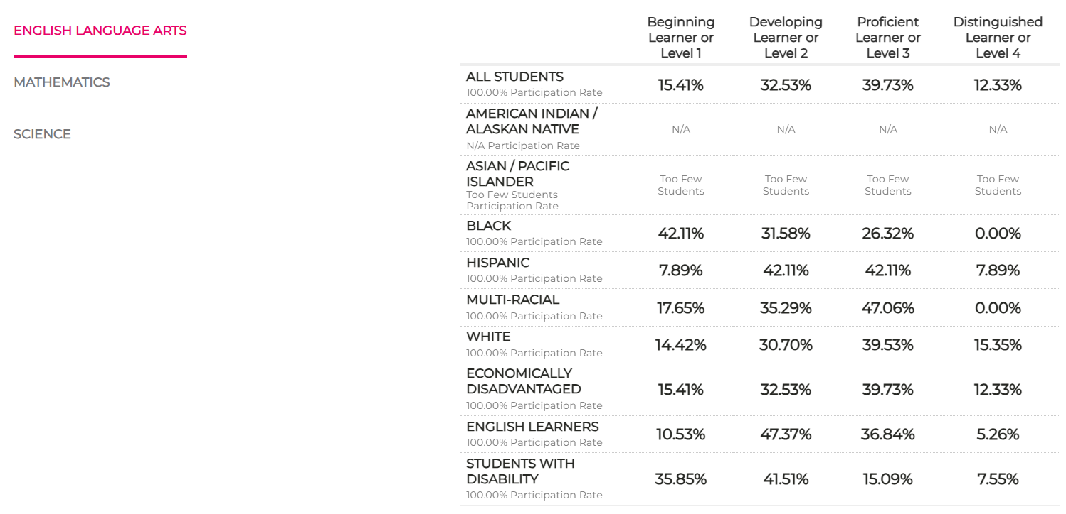

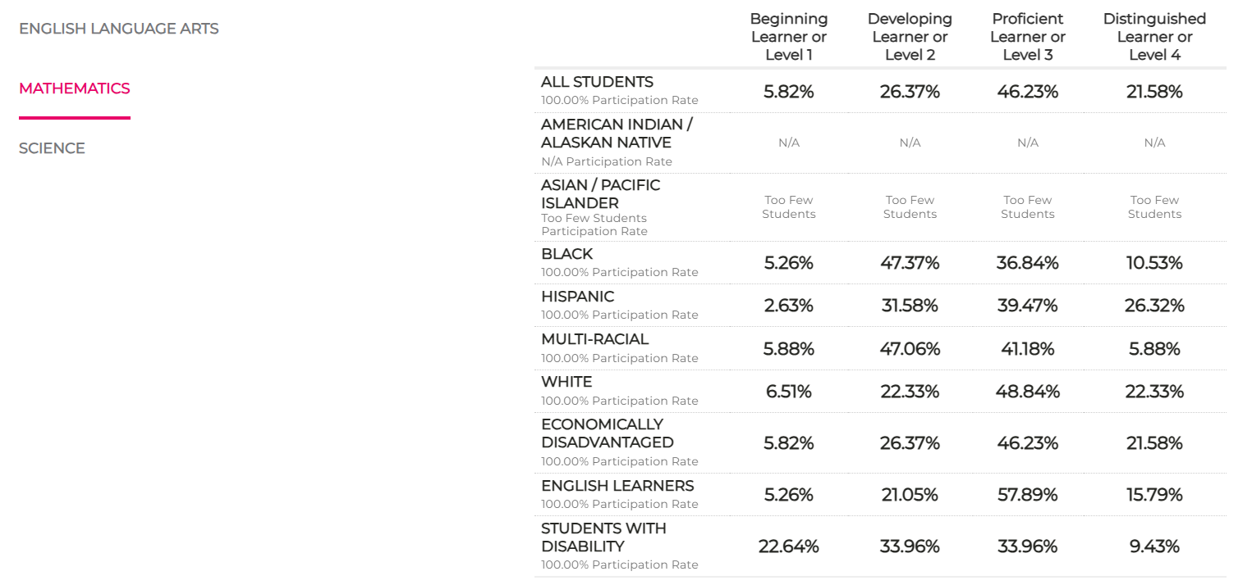
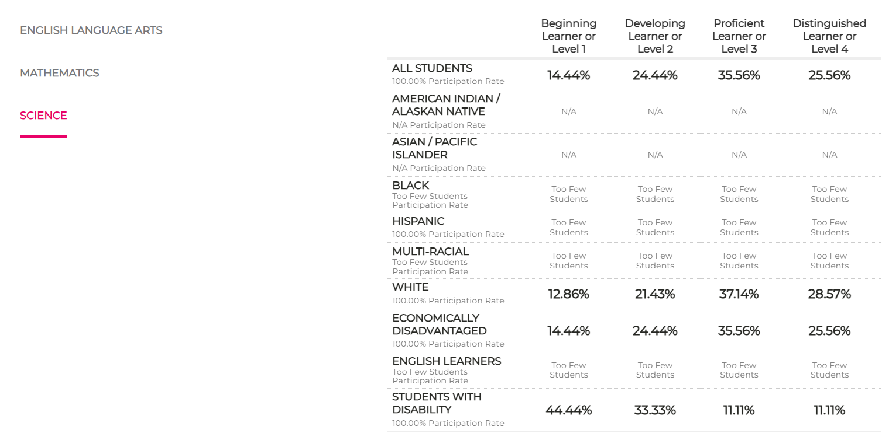

FY25 Subgroup Performance Scores
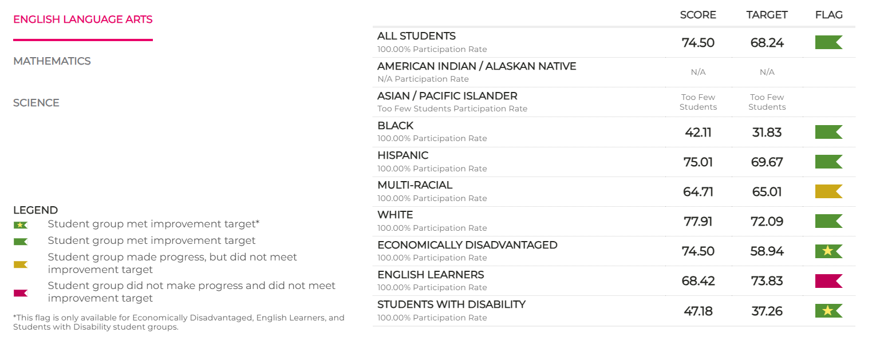

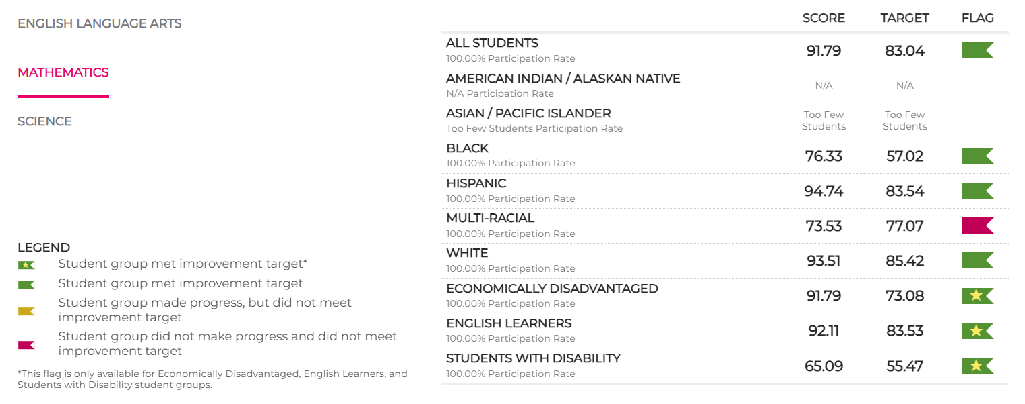

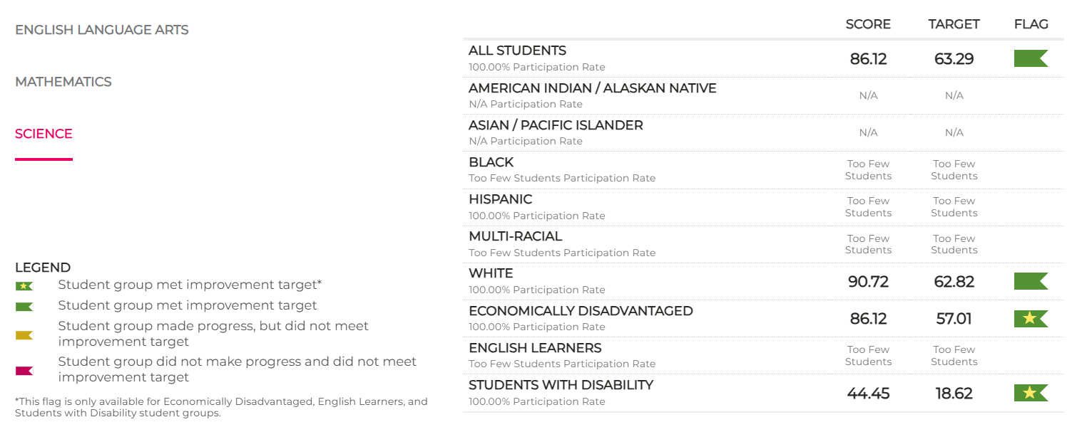

FY25 Performance

3rd Grade ELA

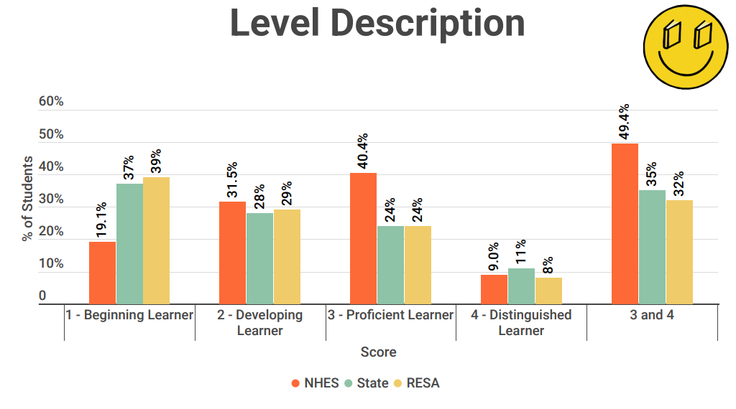

3rd Grade Math
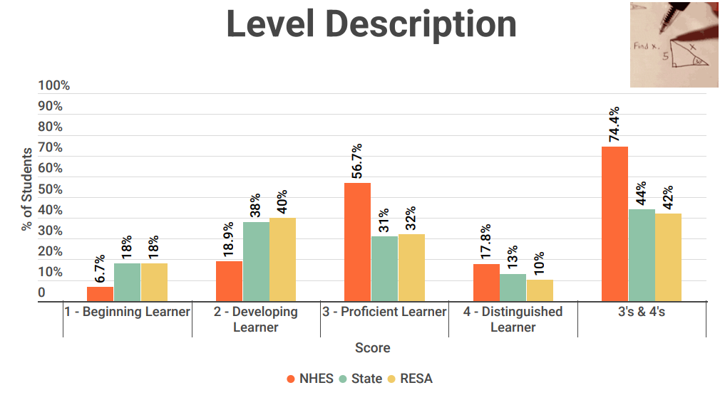

4th Grade ELA
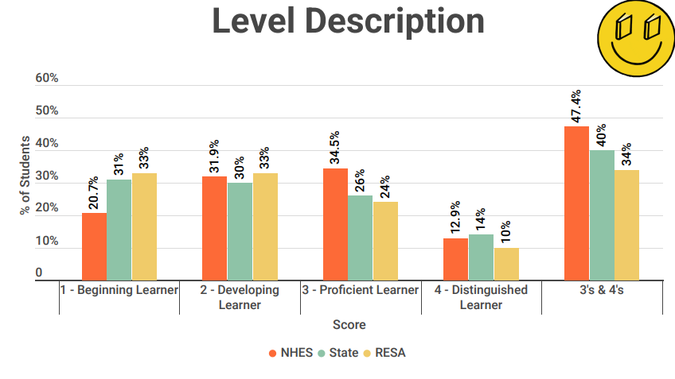
4th Grade Math
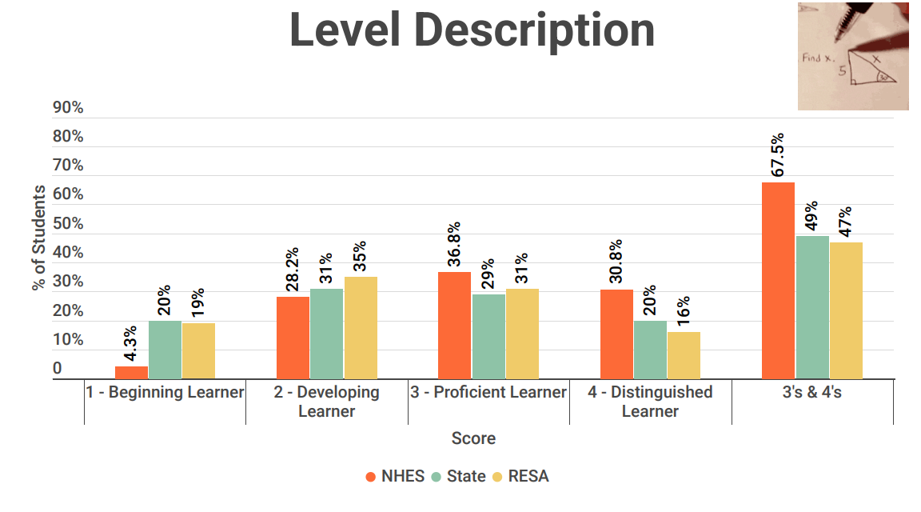

5th Grade ELA
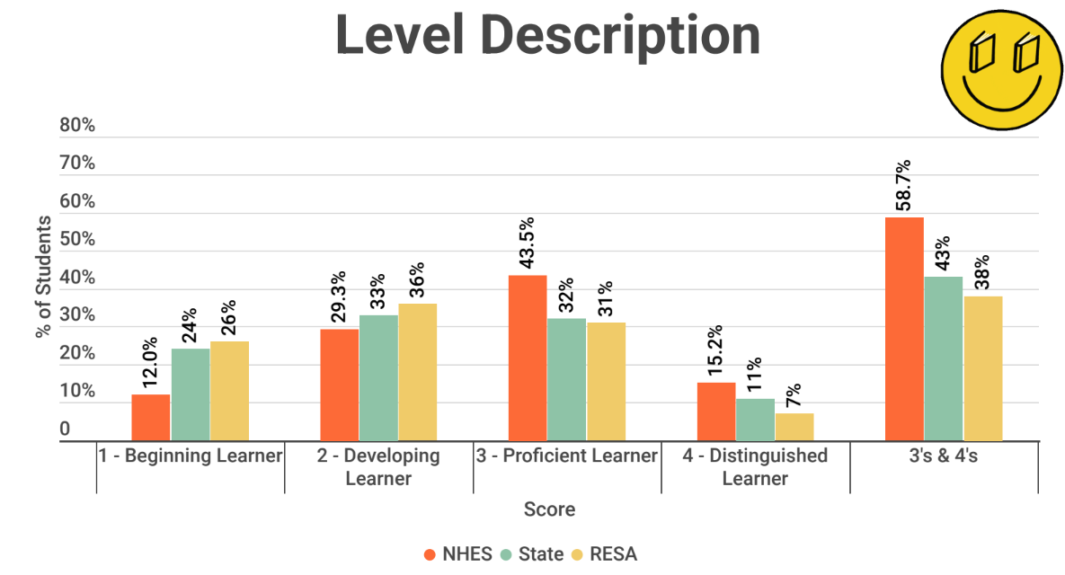
5th Grade Math
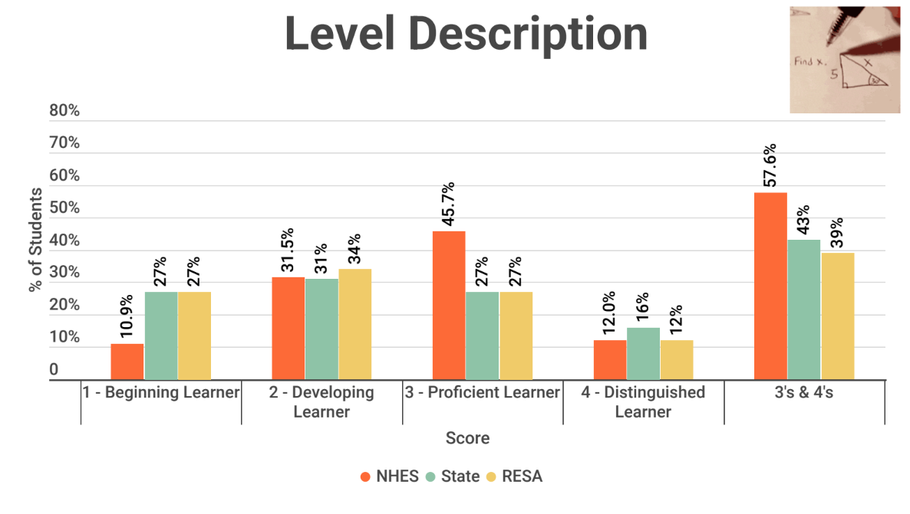

5th Grade Science

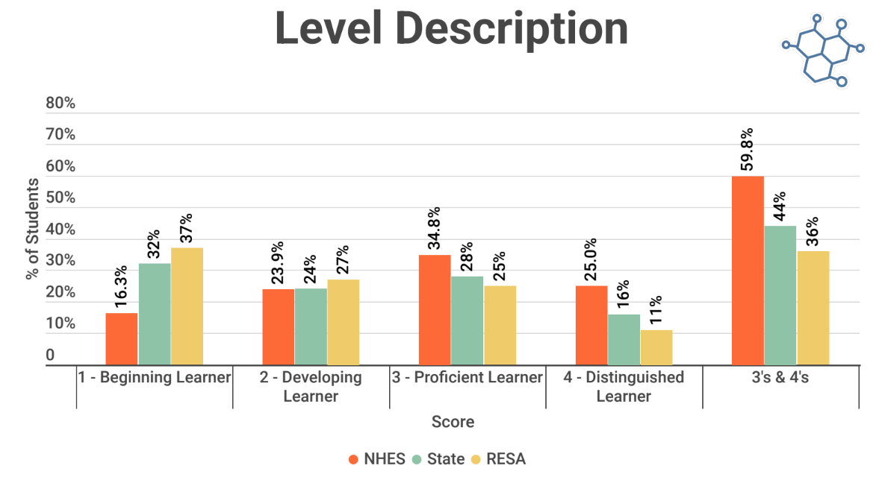
FY25 Projected Performance
Projected Proficiencies:
*GMAS scores are embargoed. These scores are preliminary ELA, math and science scores for the 2025-2026 school year.
*GMAS scores for ELA have not been released for the 2025-2026 school year.
Math Performance Data | Third | Fourth | Fifth | All
Beginning | 9% | 12% | 15% | 12%
Developing | 44% | 21% | 40% | 36%
Proficient | 36% | 52% | 29% | 38%
Distinguished | 11% | 15% | 16% | 14%

Science Performance Data | Third | Fourth | Fifth | All
Beginning |  |  | 37.6% | 37.6%
Developing |  |  | 27.2% | 27.2%
Proficient |  |  | 26.5% | 26.5%
Distinguished |  |  | 8.7% | 8.7%

According to 2025 CCRPI performance flags data, all subgroups made progress, and almost all met their performance targets in English Language Arts and Mathematics with the exception of multi-racial students who made good growth but missed the projected target by 4 points in Math and less than half a point in ELA. Economically disadvantaged, students with disabilities, and ELL students received a star for their outstanding achievement and exceeding their target by 5 points. Math continues to be a strong point for our school with our all student subgroup receiving 91.79. This is 5 points higher than science and 17 points higher than ELA. Science has been a major weakness for North Hart Elementary in the past, but this year all subgroups met their performance targets and two subgroups received stars. Whereas in the 2023-24 school year performance targets were not met by two subgroups.

b. We have identified additional areas that also impact student achievement through the use of surveys and review of quantifiable data, i.e. attendance and discipline data that will help the school understand what improvements need to be made in these areas. For example:

Parental Engagement-
As shown in survey responses, parents have requested a variety of meeting times for events, access to resources when not able to attend, maintain times for parent/teacher conferences, and maintain communication efforts, including email, text, social media, website, School Status app, phone, and paper notifications. We have extended meeting hours on early release conference dates, provided parent/family engagement events at a variety of times, and resource availability for parents/families who are unable to attend. When surveyed throughout the 2025-2026 school year, parents have indicated a desire to attend meetings for reading strategies and math skills. Parents asked for information to be made available through online platforms. North Hart will upload information to Google Classroom and onto the school website to make resources accessible to parents.

PBIS Initiatives-
There was a total of 31 incident resolutions that resulted in bus suspensions. These resolutions came from a total of 18 students. Being suspended from being a bus rider can result in tardies or absences which impact student performance. There was a total of 19 school suspension resolutions for the 2025-2026 school year. These resolutions came from a total of 10 students. These resulted in missed academic learning opportunities for the students involved and in some/most cases these students are the students who need additional academic support, not fewer opportunities. There was a total of 74 In-School Suspensions. These resolutions came from 44 students. There was a total of 246 office referral resolutions with a total of 102 students being referred which resulted in missed classroom time for the students being referred.

Student Attendance-
Twenty-nine percent of the student body missed 10 or more school days during
2025-2026 school year. According to the Georgia Department of Education website, “Data indicates that missing more than five days of school each year, regardless of the cause, begins to impact student academic performance and starts shaping attitudes about school.” Our daily average present was 96.16%.

  - We have based our plan on information about all students in the school and identified students and groups of students who are not yet achieving to the state academic content standards [the Georgia Standards of Excellence (GSE)] and the state student academic achievement standards including:
- Based on preliminary GMAS scores for 3rd through 5th grades, we demonstrated an increase in student performance for students in ELA at all grade levels (ELA and Math scores are currently embargoed.). As a school, we will emphasize the integration of literacy into Social Studies and Science instruction through the use of standard-aligned Studies Weekly/Scholastic News, Generation Genius, IXL, Pebble-Go, Flocabulary, leveled books, hi-low readers, hands-on instructional/learning opportunities, and content-specific literature.
- *The FY26 GMAS data is embargoed, and ELA GMAS scores have not yet been released.
- According to CCRPI data from FY24 to FY25 subgroup performance in ELA showed a decrease in the number of students performing in Level 1 for all subgroups. Subgroup white, economically disadvantaged, and students with disabilities increased the number of Distinguished Level 4s. Subgroup white increased from 12.45% to 15.35%. Economically disadvantaged increased from 5.8% to 12.33%. Students with disabilities increased from 0% to 7.55%.
- The FY26 GMAS data is embargoed, however, based on 2025 GMAS projected performance, the All subgroup in Math demonstrated an increase of students performing in Level 1/Beginning by 5% from 7% in FY25 to 12% in FY26. The number of students in the All subgroups performing at Level 3/Proficient decreased by 7% from 45% to 38%. North Hart decreased the percentage of students in the all subgroup at Level 4 Distinguished from 21% to 14%.
- Based on 2026 GMAS projected performance, the All subgroup in Science showed an increase of students performing in Level 1/Beginning from 15% in FY24 to 37.6% in FY25. of All subgroups in Science showed a decrease in levels 3/Proficient and 4/Distinguished to 26.5% in FY26 from 60% in FY25.
- In order to address these specific subgroups, we will increase our use of hands-on/kinesthetic instruction, vocabulary rich language, and exposure to real-life application. For the 2026-2027 school year, NHES will focus on building vocabulary systematically across the school which will help strengthen the areas of Science and Social Studies. The use of specific supplemental materials will improve the overall daily instruction and practice by utilizing IXL, Study Island, materials for at-home support, and tutoring services provided by certified teachers. Tutoring participants will be selected using multiple-selection criteria. Math and Reading interventions are provided during Intervention/Skills times to address deficits in student progress, in addition to tutoring opportunities. There will be professional learning offered through the Hart County Charter System to target SPED and ESOL needs. The Math and ELA instructional coaches will assist teachers with finding, implementing, and sustaining research-based instructional strategies.
- At the current time, there are two migratory students enrolled at North Hart Elementary School.

Based on data, strategies used with our Hispanic and EL students have been effective. Supplemental services for migratory students are offered during regular school and summer months. These services will continue as new migratory students qualify in order to focus on an increase in student achievement.

NHES will continue to address the various needs of students through Special Education, EIP, ESOL, and Gifted approved instructional models, which are available at all grade levels. The math instructional coach will support math instructional improvement by providing support, modeling strategies, and assist with implementing research-based instructional strategies.

NHES would like to see continued growth in ELA for all subgroups. This growth will be accomplished by focusing more attention on purchasing more nonfiction leveled texts, building classroom libraries, and increasing resources for the media center and teacher resource library. The ELA instructional coach will support ELA instructional improvement by providing support, modeling strategies, and assisting with implementation of research-based instructional strategies. Tier 1 instruction for all students consists of the consistent use of Houghton Mifflin Harcourt, using Heggerty and Secret Stories as supplemental materials. Further support is provided for students with disabilities through co-taught services, small group testing, and resources.

NHES school will implement writing through the Houghton Mifflin Harcourt program that will increase reading and writing across the curriculum. In addition, NHES will implement the tool Writable and the program We Will Write to foster creativity and literacy skills. Professional learning for the support of teacher clarity and implementation will be provided. The ELA instructional coach will assist with improving writing across the curriculum, model strategies, and implement research-based instructional practices. Daily writing practices will ensure that skills are being applied in a timely and relevant manner. Writing supplies (construction/colored paper or cardstock, tape, page protectors, metal binder rings, notebook paper, highlighters, composition notebooks, chart markers, chart paper) will be used during writing instruction to support drafting and publishing of student work.

There was a decrease in Science EOG Assessment from the FY 2025 school year performance at Level 3/Proficient and a slight decrease at Level 4/Distinguished for the All subgroup for the FY26 school year. An increased focus on literacy integration for Science and Social Studies will help reinforce concepts across the curriculum. Social Studies Weekly/Scholastic News will support state standards for each content, which allows application of literacy skills. Generation Genius, Padlet, Screencastify, IXL, and Flocabulary support vocabulary acquisition and hands-on/real-world learning opportunities. These materials also support literacy and content standards at home.

NHES will continue the STEAM program to improve student achievement in the areas of math and science. PBL/STEAM principles will be implemented to maintain and increase sustainability across all grade levels and curriculum. An inquiry based instructional model will be used across all grade levels to provide opportunities for students to develop critical thinking skills while being engaged in learning. Hands-on resources and consumables will be provided for inquiry-based instruction. Training for teachers and resources will be provided for implementation of the GSE for science and inquiry-based instruction as identified through individualized, school, and district goals.

During the 2026-2027 school year an integrative approach will be utilized to teach Social Studies content alongside reading and writing practices to promote retainment and mastery. The ELA instructional coach will assist with improving writing within the Social Studies curriculum, model strategies, and implement research-based instructional strategies. Training for teachers and resources will be provided for implementation of the GSE for Social Studies as identified through individualized, school, and district goals.

Writing continues to be an area that needs improvement for all subgroups. NHES will continue to implement strategies to improve students’ writing. Teaching grammar through writing will improve scores in writing, as well. In addition, the school will continue a program that will increase writing across the curriculum by using writing through Houghton Mifflin Harcourt. The tool Writable and the program We Will Write will also be implemented. The school will collaborate with the ELA instructional coach who will work directly with teachers in grades K-5 to improve instructional strategies. Students will use online research resources, Pebble GO, and Screencastify for age-appropriate research and planning for non-fiction writing.

NHES will continue to implement instructional strategies in the areas of Measurement and Data, Patterning and Algebraic Reasoning, and Geometric and Spatial Reasoning. The school will collaborate with the math instructional coach who will work directly with teachers in grades K-5 to improve instructional strategies. The use of hands-on instructional approaches to build conceptual understanding through the use of various manipulatives will help establish a stronger foundation for mathematical thinking.

During the 2026-2027 school year, Special Education teachers worked with General Education teachers to make all content areas more comprehensible for students with disabilities. In addition, Lexia Core 5, IXL, Flocabulary, Generation Genius, Study Island, Writable, and Exact Path adapts to the students’ levels of performance, builds additional vocabulary knowledge, and links to IEP goals.

Below are subgroup descriptors which support the use of the above-mentioned programs and practices:
    - Economically disadvantaged students may experience lack of opportunities or exposure to a variety of outside learning opportunities.
    - Students from racial and ethnic groups may have diverse ways of acquiring new information.
    - Students with disabilities have Individualized Educational Plans that support the use of the most appropriate instructional strategies. IEPs also include instructional modifications that are necessary to address the students’ learning strengths and weaknesses.
    - Students with limited English proficiency sometimes require instructional accommodations to effectively access the curriculum to gain an understanding of concepts.
  - The data has helped us reach conclusions regarding achievement or other related data.
    - The major strengths we found in our program are:
      - Reading-

  - Vocabulary- K, 1, 2, 3, 5
  - Texts: Context, Structures and Styles- 4
      - Math –
  - Patterning and Algebraic Reasoning - 3, 4
  - Geometric and Spatial Reasoning - K, 1, 2, 3
  - Measurement and Data - 1, 2, 3
  - Numerical Reasoning - K, 4, 5
      - Language –
  - Grammar Conventions- 3, 4, 5
  - Writing Texts- 5

    - The major needs we discovered are:
      - Reading –
  - Reading Texts- 1
  - Vocabulary- 4
  - Writing texts and Grammar Conventions- K
  - Texts: Context, Structures and Styles- 2, 3, 5
  - Texts: Genre Techniques and Elements- 3
      - Math –
  - Geometric and Spatial Reasoning - 4
  - Measurement and Data Reasoning - K, 4
  - Numerical Reasoning - 1, 2, 3
  - Patterning and Algebraic Thinking - K, 1, 2, 5
- Language –
  - Writing Texts- 3, 4

      - The needs we will address are:
      - Black population for ELA
      - Multi-Racial population for ELA, Math
      - All students’ population for ELA, Math, Science
      - ED population for ELA
      - SWD population for ELA, Math, Science

The targeted focus for addressing the specific academic needs of students will be: content vocabulary development for all students in math, ELA, science and social studies, improving reading comprehension skills specifically in nonfiction text, literary text, and historical fiction, poetry book text sets, reader’s theater text sets, expanding reasoning skills in math, drawing conclusions, inferring, analyzing informational text and writing in a variety of genres such as Informational, Persuasive and Narrative writing across the curriculum. Houghton Mifflin Harcourt will be used consistently and systematically across the school. Professional Learning for all content areas will also be provided and implemented throughout the school year by teachers, instructional coaches, and administrators. Individual student academic needs will also be addressed through an online, comprehensive, adaptive program named IXL, and Exact Path. Additional resources such as Reflex Math, Frax Math, Prodigy, Studies Weekly/Scholastic News, Flocabulary, Generation Genius, Screencastify, Lexia Core 5, and Study Island will also be used to address student’s needs. This will support learning for all students, especially ED, Black, Hispanic, and SWD.

The tutorial intervention will continue, which specifically targets these students and helps students set short term and long-term goals in the area of Math and Reading. Due to achievement gaps in MAP and GMAS it is necessary to include reading tutoring to help students who are falling behind. NHES will also continue Lexia Core 5, IXL, Generation Genius, Exact Path, Studies Weekly/Scholastic News, Reflex Math/Frax Math and Study Island, which will allow students to work independently on mastering content specific goals in hopes of raising student achievement.

The FY25 CCRPI report shows areas of achievement gaps mentioned in the dialogue above. Continual efforts in accordance with the school’s SWP will help us progress toward our school goal of a CCRPI meeting or exceeding the district and state average score. See chart below:
2025 CCRPI Score
Content Mastery | Progress Points | Closing Gaps | Readiness | Financial Efficiency Rating | School Climate Rating
83.7 | 92.5 | 100 | 88.5 |  | 
We exceeded the district and state averages in all components apart from Progress Points. North Hart was above the state average on this component, but below the district average.

  - The measurable goals/benchmarks we have established to address the needs were:
    - GMAS- show an increase of 3% or more in all subjects for all subgroups for FY26.
    - MAP- decrease by 3% the percentage of students scoring below 25th percentile in ELA and Math
    - GKIDS- at or above state average for each content area.
    - Parent/Family Engagement- increase the number of participants attending Title I events (tracked through parent/family sign-in sheets)
    - Attendance- decrease the number of students with more than 10 absences from 29% to 25%
    - Behavior- The number of referrals (bus and classroom) decreased for FY26. We will continue to emphasize appropriate bus behavior through PBIS expectations, rewards, and consequences. We plan to maintain or reduce the number of suspensions for FY27. The school counselor will be used to conduct small-group activities to reduce classroom behavior referrals. We decreased out of school suspensions from 31 in FY25 to 19 in FY26. An emphasis has been placed on building relationships with all students with greater emphasis on the students who have five or more behavior referrals. Discipline referrals will be tracked through the SWIS program.

2. School-wide reform strategies that: Sec.1114(b)(7)(A)(i-iii)
The school identified evidenced based strategies that have been effective in addressing
vocabulary acquisition for all subject areas, mathematics, increased reading levels, non-fiction reading skills, writing, and the specific academic needs of individual students identified by both formal and informal assessments identified through classroom and on-line performance. As well as a variety of programs designed to engage students in a manner that will impact their learning and understanding of subjects. Reform strategies that address effective formative assessments and feedback, co-teaching models, differentiation rooted in common assessment data through the implementation of Achievement Teams will also be addressed and strengthened. Data collected and reviewed supports documentation for differentiation and a variety of research-based strategies used to guide daily instruction.

a.i. Provide opportunities for all children, including each of the subgroups of students (economically disadvantaged students, students from major racial and ethnic groups, children with disabilities and English learners [Sec 1111(c)(2)] to meet the challenging state academic standards.
Note: this section also addresses ESSA
4. a. Requirements to include in the school-wide Plan: Define how your interventions are evidence-based; or other effective strategies to improve student achievement. Sec 1111(d)(B)
Interventionists – Strong Evidenced Based Research
Math - One major methodological and practical aspect regarding RTI is the use of research or evidence-based interventions to meet students’ educational needs (Kratochwill, Volpiansky, Clements, & Ball, 2007). Research-based instruction is a cornerstone of effective intervention for students who are at-risk (Denton, Vaughn, & Fletcher, 2003). It includes instructional practices for which original data have been collected to determine their effectiveness, and scientifically based, rigorous research designs have been utilized to evaluate the practices (State Education Research Center, n.d.). For math intervention to be successful in an RTI framework, comprehensive supplemental math interventions must incorporate computation fluency, problem solving, and the use of visual representational all together (Fuchs et al., 2005; Fuchs, Fuchs, & Hollenbeck, 2007; Gersten et al, 2009). Gersten et al (2009) made eight recommendations for math interventions in an RTI model that were as follows: (a) provide screening to all students to identify those at risk for potential mathematics difficulties and provide interventions for those at-risk, (b) instructional materials for students receiving interventions should focus intensely on in depth treatment of whole numbers in kindergarten through Grade 5 and on rational numbers in Grades 4 through 8 (c) intervention should be explicit and systematic, (d) interventions should include instruction on solving word problems that is based on common underlying structures, (e) intervention materials should include opportunities for students to work with visual representations of mathematical ideas and teachers should be proficient in the use of visual representations, (f) interventions at all grade levels should devote about ten minutes in each session to building fluent retrieval of basic arithmetic facts, (g) progress of students receiving supplemental instruction should be monitored, and (h) interventions should include motivational strategies. All recommendations had strong or moderate evidence to support the practice except three (interventions focusing on intensive in-depth treatment of whole numbers, progress monitoring, and motivational strategies). The recommendation of interventions that provide intensive instruction of whole numbers is important for many reasons. It does not take long to realize that along with increased competency in basic addition or subtraction facts, children develop or fail to develop number sense (Gersten & Chard, 1999). Number sense is a developing construct that refers to children’s fluidity and flexibility with numbers, the sense of what numbers mean, and the *Corresponding Author: Vanessa Hinton, vmh0002@tigermail.auburn.edu IJEMST (International Journal of Education in Mathematics, Science and Technology) 191 ability to perform mental mathematics and look at the world and make comparisons (Berch, 1998). Number sense leads to the automatic use of math information and is the key ingredient to solve basic arithmetic computations (Gersten & Chard, 1999). Griffin, Case, and Siegler (1994) suggest number sense is a necessary ingredient for learning formal arithmetic in the early elementary grades. Therefore, the National Council of Teachers of Mathematics (NCTM) Curriculum Focal Points (2006) suggested heavy emphasis on instruction in whole numbers for young elementary students. This position was strengthened by the 2008 report of the National Mathematics Advisory Panel (NMAP), which provided detailed benchmarks and again emphasized in-depth coverage of key topics involving whole numbers as crucial for all students. Milgram and Wu (2005) suggest an intervention curriculum for at-risk students should not be oversimplified and that in-depth coverage of key concepts involving whole numbers is critical for success in mathematics.

Retrieved from: https://files.eric.ed.gov/fulltext/ED548038.pdf

Reading
Identifying best practices
Evidence-based instruction (EBI) is the idea that classroom practices should be based on the best available scientific evidence, rather than personal judgment, tradition, social media trends, or other influences. EBI practices consistently associated with positive learning outcomes.

Success in a MTSS framework hinges on Tier 1 instruction or high-quality general classroom instruction (Marchand-Martella, Ruby, & Martella, 2007). EBI in the general education classroom should provide systematic, explicit, and cumulative instruction in whole-class and targeted small groups for reading. EBI should consider assessed needs of students and target areas of reading identified for best practice:

-oral language
-concepts of print
-alphabet knowledge
-phonemic awareness
-phonics and spelling
-fluency
-morphology
-vocabulary
-reading comprehension
-writing

Grade-level teams may work together to create planning templates for allocating time and topics in whole group and small-group instruction. Using collaborative planning allows grade-level teams to coordinate EBI and determine if instruction is working (Coyne et al, 2016).

Many schools adopt a core reading program to support EBI, since these programs include a scope and sequence, assist with vertical planning across grade levels, and provide suggestions for differentiating for students who are below and above grade level (Leonard, Coyne, Oldham, Burns, & Gillis, 2019). See the next section: Tier 1 Instruction.

For students with reading difficulties in Tiers 2 and 3, Gersten et al (2017) recommend devoting time to decoding and word-level study. The authors examined 20 studies of 11 different types of reading interventions and found the strongest effects for interventions that targeted word and pseudoword reading. For students in grades 2 and 3, there were some positive effects on reading comprehension and passage fluency. Surprisingly, most of the interventions were 1-on-1 and provided support from the intervention provider.

Retrieved from: https://www.readingrockets.org/classroom/evidence-based-instruction/what-is-evidence-based-instruction

Houghton Mifflin Harcourt Into Reading Curriculum - Moderate Evidence-Based Research
Cobblestone Applied Research & Evaluation, Inc. conducted a quasi-experimental design (QED) study to determine the potential impact of the Into Reading program on student reading outcomes. The purpose of this ESSA Tier 3 Promising Evidence study was to answer one key research question: Do schools using Into Reading outperform comparable schools that use another ELA program?

Using variables from a range of relevant data sources, the Cobblestone research team used propensity score matching to find appropriate matches of Into Reading (treatment) and non-Into Reading (control) school sites across the state of Texas, yielding a final sample of 316 schools (140 treatment and 176 control). Utilizing statistical controls for selection bias, outcome analyses were conducted to assess potential differences between treatment and control conditions on the STAAR® reading test. See Table 1 for the mean comparison of key demographic variables of the sample.

The analyses examined (a) the differences between Grade 3 students' pretest scaled reading scores (2020–2021) at the school-level, and their posttest scores (2021–2022, Grade 4); and (b) the differences between Grade 4 pretest scaled reading scores (2020-2021) at the school-level, and their posttest scores (2021–2022, Grade 5). Both comparisons indicated that Into Reading (treatment) schools had slightly higher average scaled scores.
The examination of the Grade 4 (2021–2022) STAAR posttest school-level scaled reading scores across conditions, controlling for Grade 3 pretest (2020–2021) scores, revealed that the Into Reading (treatment) schools had statistically significant higher average scaled scores at posttest (F [1, 184] = 4.81, p = .03; see Table 2] compared to students in the non-Into Reading (control) schools. These findings suggest that the Into Reading program significantly improved students’ reading skills in comparison to other programs.
The Into Reading QED study was designed to determine the potential impact of the Into Reading program on student reading outcomes. Based on the results, the findings suggest that the Into Reading program significantly improved students’ reading skills in comparison to other programs. The study meets the ESSA Tier 3 Promising evidence standards (i.e., well-designed, well-implemented correlational study, with statistically controls for selection bias; and no strong negative findings from experimental or quasi-experimental studies).

Amira - Strong Evidence Based
Powered by artificial intelligence (AI) and evidence-based best practices, Amira Learning is a reliable classroom assistant that assesses oral reading fluency (ORF), screens for dyslexia, and provides reading practice. Amira Learning stems from decades of research and development conducted by scientists at Carnegie Mellon University’s Project LISTEN. In 1997, Project LISTEN researchers first introduced the Reading Tutor, a computer-based instructional program that used artificial intelligence technology to listen to children read aloud, analyze the accuracy and fluency of each student’s reading, and deliver targeted instruction and feedback to each student (Aist & Mostow, 1997; Mostow, 2012). Since the initial introduction of the Reading Tutor, Project LISTEN scientists have collaborated with leading researchers in reading science, speech recognition, and psychometrics to develop Amira Learning. Through decades of rigorous research, Amira Learning has demonstrated Strong levels of evidence—the highest rating under Every Students Succeed Acts (ESSA) criteria—which has been validated by third-party research organizations such as Evidence for ESSA. The effectiveness of Amira Learning has been demonstrated in gold-standard randomized controlled field experiments in real-world classroom settings. Studies have also shown that Amira Learning is effective for multilingual learners
Retrieved from: https://www.hmhco.com/research/amira-learning

IXL- Moderate Evidence Based Research
After practicing IXL Math for one school year, 5th grade students demonstrated larger gains on the NWEA MAP test than students who did not use IXL Math. In a 2017 study, Van Ruler compared NWEA MAP test score growth for two different cohorts of 5th grade students at a school in northwest Iowa. Van Ruler compared the MAP performance of the treatment group to the control group and the national norm of all 5th grade students who took the MAP test in the U.S. From fall to spring, students in the treatment group improved their overall math score by 5.64 percent, compared to 4.20 percent for the control group and 5.08 percent for the national norm. Sixty-five percent of students in the treatment group reached or exceeded normative growth on the MAP test, while only 41 percent of students in the control group met this standard. The analysis of subgroups showed that English language learners and students in special education programs made the most improvement compared to the control group.
Van Ruler, D. (2017). Blended Learning and Math Growth: Investigating the Role of IXL Math in the Growth of 5th Grade Students’ Math Fluency Scores (master’s thesis). Dordt College, Sioux Center, Iowa.
With the support of IXL Math and intervention groups, 4th grade students in a Title I school outperformed their peers and exceeded the district average. A two-year observational study conducted by James (2016) examined how IXL Math and intervention groups helped students improve their math performance on the Smarter Balanced assessment (SBA). At the end of the first year, 74 percent of students in the study group met or exceeded grade-level standards on the SBA. In comparison, only 49 percent of students from the other Title I elementary schools in the same district met or exceeded standards. Only 62 percent of students across all elementary schools in the district met or exceeded standards. The percentage of students exceeding standards in the study group was also much higher than the district’s other Title I schools and the district average.
James, L. (2016). Mathematics Awareness through Technology, Teamwork, Engagement, and Rigor. Journal of Curriculum and Teaching, 5(2), 55.

IXL implementation improves student achievement. Grade cohorts that used IXL performed better on the Georgia Milestones than grade cohorts that did not use IXL. Specifically, the proficiency rate was close to two percentage points higher for IXL Math cohorts and about one and a half points higher for IXL ELA cohorts, relative to cohorts not using IXL.

Higher levels of IXL usage are related to larger achievement gains. Higher IXL usage was associated with better Georgia Milestones performance in both math and ELA.

IXL Math, We found that grade-level cohorts that used IXL Math outperformed comparable non-IXL cohorts on the 2022 Georgia Milestones math assessment. Specifically, the proficiency rate was close to two percentage points higher for IXL Math cohorts relative to cohorts not using IXL (Figure 2). The estimated treatment effect for IXL Math was positive and statistically significant (b = 1.75, p = .02; see Table B1 in Appendix B for full model results). The effect size (Hedges’ g) was 0.09, which corresponds to a percentile gain of four points.

IXL ELA Similar to IXL Math, we found that grade-level cohorts that used IXL ELA outperformed comparable non-IXL cohorts on the 2022 Georgia Milestones ELA assessment. The proficiency rate of IXL ELA cohorts was about one and a half points higher than that of cohorts not using IXL (Figure 3). The estimated treatment effect for IXL ELA was positive and statistically significant (b = 1.43, p = .05; see Table B2 in Appendix B for full modelling results). The effect size (Hedges’ g) was 0.08, which corresponds to a percentage of three points.

Workshop Model – Strong Evidence Based Research
The Workshop Book by Samantha Bennett (2007) frames the workshop model as a system that benefits both students and teachers. Bennett (2007) defines this as “all three parts—mini lesson, worktime, debrief—orchestrated with purposeful reasons in a purposeful manner in order to ‘serve a common purpose’” (p. 14). This can only be possible by adding on the additional layer of the teaching cycle: assessment, planning, and instruction. Another way to consider this is that it is a cycle within a cycle. Not only does each piece of workshop feed into the next, but within each piece, teachers are assessing where students are at, making plans to adjust instruction, and then in fact, implementing those changes through instruction of some kind.

Valerie Brunow (2016) gives real insight from her work in shifting her classroom to a workshop model. Brunow (2016) changed the structure of her classroom to meet the needs of her students, “workshop model blends personal interest with approaches to reading and writing that are differentiated to meet the needs of a variety of learners” (p. 62). The personal interest piece she describes relates back to the idea of student choice, which sits at the heart of the workshop theory. Having students reading different texts also allows readers at different levels to challenge themselves accordingly.

Beyond reading engagement, RWW is meant to entice students to write. According to Brunow (2016), “writing about reading is as important as reading itself” (p.68). To become better readers, students are asked to read constantly. The same applies to students becoming better writers. To do this, she uses reading journals for students to keep track of mini lesson notes, as well as reflection on individual reading and goals (Brunow, 2016, p. 68). In addition, reading journals offer an opportunity for tracking and assessing student progress.

Retrieved from The Power of Workshop by Stephanie Nagl.
https://files.eric.ed.gov/fulltext/EJ1264288.pdf#:~:text=In%20addition%2C%20the%20research%20showed%20the%20workshop,a%20secondary%20classroom%20with%20varying%20class%20times.

Study Island- Strong Evidence Based Research
An investigation regarding the relationship between Study Island achievement and Florida’s end-of-year test scores for students in grades 3 through 8 occurred in this study. Across grade levels and subjects, high correlations were found between student performance on Study Island standards mastery and the Florida Comprehensive Assessment Test in both math and ELA. These results provide quantitative evidence that Study Island content is aligned to state standards across a variety of states and settings.
The evidence presented here supports the use of Study Island both to help students prepare for high-stakes assessments and as a formative assessment tool to measure student progress toward end-of-year achievement. With Study Island, students and teachers can be prepared for increased rigor and high levels of achievement.

Bernard, B.T. (2013). Student achievement and the use of the program Study Island (Unpublished doctoral dissertation). University of Minnesota, Minneapolis.
Dube, P. J. (2011). Attempting to improve standardized test results using Study Island’s Web-based mastery program (Unpublished master’s thesis). Michigan Technological University, Houghton.

Ostroski, T. C. (2012). The impact of Study Island as a formative assessment tool (Unpublished doctoral dissertation). Baker University, Baldwin City, KS.
http://www.edmentum.com/sites/edmentum.com/files/resource/media/0612-34_SI_FCAT_WP.pdf
RTI procedures and the Study Island program provide effective solutions to meet these needs. Study Island gives educators access to both a comprehensive assessment package and a flexible instructional practice system within a single program. Study Island aligns well with the widely used models of RTI, either alone or in combination, and functions efficiently in a multi-tiered service delivery system. Additionally, the versatility and customizable nature of the Study Island program can overcome many of the disadvantages associated with RTI implementation, making its use both suitable and desirable in any RTI environment.

A Foundational Research Study Connecting Response to Intervention Research to the Study Island Program. Magnolia Consulting, LLC. February 13, 2009
https://www.studyisland.com/sites/studyisland.com/files/content/research/pdfs/Study%20Island%20RTI%20Research%20Report.pdf
Exact Path- Promising Evidence Based Research
A national sample of 26 schools within 13 districts were recruited for the field test of the Exact Path assessments and learning paths. The districts were from California, Minnesota, Wisconsin, Idaho, Pennsylvania, New Jersey, Michigan, Florida, and Arizona. This sample consisted of 6,577 unique students in kindergarten through 6th grade who took diagnostic assessments across the 2016–17 academic year and who were placed in learning progressions in midyear.
This paper presents the results of a year-long study of Edmentum’s Exact Path learning platform from a nationwide field test of the K–6 beta product during the 2016–17 school year. Results indicate that use of Edmentum’s Exact Path learning platform is positively associated with student achievement outcomes in math, reading, and language arts. Statistically significant effects were found linking the amount of time spent on the Exact Path learning platform and end-of-year diagnostic scores. The evidence presented here for Exact Path meets the standards for “promising evidence” as an assessment and as an intervention, as laid out by ESSA (U.S. Department of Education, 2016).

Exact Path Research Brief: Effectiveness Study by: Jeff McLeod, PhD Edmentum, Inc. Bloomington, Minnesota (2017).

U.S. Department of Education. (2016). Non-regulatory guidance: Using evidence to strengthen education investments. Retrieved from https://www2.ed.gov/policy/elsec/leg/essa/guidanceuseseinvestment.pdf
http://www.edmentum.com/sites/edmentum.com/files/resource/media/Exact%20Path%20Effectiveness%20Paper%20FINAL_0.pdf

PebbleGo- Promising Evidence Based Research
PebbleGo and Multimodal Literacy--The benefits of multimodal learning

A recent study performed by the Metiri Group, integrating the work of Richard Mayer and Roxanne Moreno, stated that students retain information better through words and pictures rather than through words alone. Students learn better when the corresponding words and pictures are presented near each other, and again if those words and pictures are presented simultaneously. (Mayer, Moreno, 2003). Using computers when learning allows the brain to take in data using the words, sounds, and images at a pace appropriate for the level of learning. This enables the student to learn in their preferred mode (some learn best through seeing, others through hearing) and at their most beneficial tempo.

The National Science Teachers Association encourages teachers to gain full knowledge of the software students use in learning, know how to incorporate the computer into instructional strategies, use computers and software ethically and use computers in a variety of ways. Both the National Science Teachers Association (NSTA) and the American Association of School Librarians (AASL) believe that computers should have a major role in the teaching and learning of science and informational research. It is imperative that the software engages the student in meaningful interactive dialogue and creatively employ graphics, sound and simulations to promote acquisition of facts... and enhance understanding. (NSTA website). Capstone Press, a nationally recognized content-area publisher, is proud to introduce the only database available for the youngest of researchers. Designed to give the emergent reader the opportunity to acquire knowledge by using and developing their multimodal literacy, PebbleGo™ integrates content curriculum, early literacy skills, and information literacy skills.

https://mail.google.com/mail/u/0/#search/peeblego/163b175902cb1a6f?projector=1&messagePartId=0.1

Studies Weekly/Scholastic News- Promising Evidence Based Research
One of the main Common Core Requirements is focused on student use of authentic subject area skills. These skills refer to the type of skills that would be used by professionals in the actual academic field of study. It is therefore important that students use appropriate historical thinking skills in the classroom to attain these skills. The skills being assessed include a student’s ability to read, write, speak, listen, complete research based projects, and appropriately analyze primary and secondary documents to make conclusions as to what has occurred during a historical event. The implementation of instructional techniques that require students to think like a historian are widely supported in the literature and are largely focused on the development of student historical literacy. Implementing primary source analysis in the classroom permits students to engage in historical investigations by analyzing documents from a particular time period in which a historical event has taken place. This analysis offers students a framework for identifying a relationship between historical evidence and the construction of the events that took place in the past (Barton & Levstik, 2003). By engaging students in historical inquiry, they are able to develop appropriate historical thinking skills and are able to understand the underlying essential facts, concepts, and generalizations of historical knowledge (Lee, Doolittle & Hicks, 2006). The exposure to primary sources pushes students to ground their experiences in real world concepts and to realize multiple sources from the same time period can have conflicting accounts of what actually took place (Morgan & Rasinski, 2012). By rooting social studies instruction in the analysis of primary documents, students are required to constantly interrogate documents and their validity (Vansledright, 2004), engaging them in true historical interpretation (Hicks, Doolittle, & Lee, 2004).
Cowgill, Daniel. (2015). Primary Sources in the Social Studies Classroom: Historical Inquiry with Book Backdrops. Social Studies Research and Practice. 10. 65-83.
Primary Sources in the Social Studies... (PDF Download Available). Available from: https://www.researchgate.net/publication/265553381_Primary_Sources_in_the_Social_Studies_Classroom_Historical_Inquiry_with_Book_Backdrops [accessed Jun 01 2018].
It is well known that primary sources are important for teaching historical thinking skills. Many teachers find them useful for engaging students in such tasks as historical interpretation. More frequently, however, documents are used to enrich a textbook account or to help students focus on essential facts and concepts. As a result, school leaders and administrators should seek professional growth activities which not only help history/social studies teachers use primary sources effectively but focus particularly on using Web-based resources.
David Hicks, Peter Doolittle, and John K. Lee, "Social Studies Teachers' Use of Classroom-Based and Web-Based Historical Primary Sources," Theory and Research in Social Education 32, no. 2 (2004), 213-247.
http://teachinghistory.org/issues-and-research/research-brief/23783
Studies Weekly/Scholastic News standards-based curriculum applies a Balanced Literacy approach to education. The combination of printed weekly units and web-based primary source media, audio reader and other features creates a high level of Student Engagement. Teacher-created lesson plans include rigorous and relevant assessment, word study, writing prompts, reading (modeled, shared, guided, and independent) and much more. Our products foster Critical Thinking Skills that help develop a new generation of Responsible Decision Makers. Studies Weekly/Scholastic News online version of the curriculum brings learning to life with primary source videos, audio files, photos and so much more. This media, combined with the attractive print format, creates an emotional engagement that feeds critical thinking skills development.
https://www.studiesweekly.com/about-us/

Flocabulary-Strategies for Vocabulary Development – Strong Evidence-Based Program
Flocabulary is an educational program that uses hip-hop, rhythm, and visual storytelling to teach academic content across a wide range of subjects, including vocabulary, reading, math, science, social studies, and social-emotional learning (SEL). It’s designed to engage students - especially those in upper elementary through high school - by combining multimedia learning with culturally responsive content.
retrieved from: https://www.flocabulary.com/

Brain Pop and Brain Pop Jr.- Promising Evidence-Based Program
The study by SEG Research demonstrates that elementary and middle school students using BrainPOP experience substantial growth compared to students who do not use BrainPOP. Students participating in the treatment group received approximately 16–20 weeks of instruction incorporating BrainPOP, yet the amount of growth achieved was equivalent to between one and two grade levels
retrieved from: http://www.brainpop.com/about/research-related_research/index.weml

Reflex Math- Promising Evidence-Based Program
Use should be made of what is clearly known from rigorous research about how children learn, especially by recognizing…the mutually reinforcing benefits of conceptual understanding, procedural fluency, and automatic (i.e., quick and effortless) recall of facts…
—The Final Report of the National Mathematics Advisory Panel (2008), Principal Messages
http://www.reflexmath.com/research

FraxMath - Promising Evidence-Based Program
Explore Learning Frax—a better way to learn fractions
Frax delivers the latest research-proven instructional strategies in an adaptive game-based learning format to create a better way to learn fractions.
A few of the key factors in Frax that make a difference:
1. In Frax, fractions are numbers first. Each has a specific magnitude (size) and position on the number line alongside whole numbers and other fractions. Students work extensively with length models and number lines to interpret, represent, compare, order, and estimate fractions. In doing so they overcome whole number bias and develop a strong understanding of fraction magnitude.
2. Frax demystifies fraction arithmetic. When students understand fractions as numbers, they also better understand the arithmetic. They learn how to make sense of fractions operations and can draw connections to their work with whole numbers (e.g. the sum of two fractions must be larger than each individual fraction and therefore the sum of 1/2 + 1/3 can't be 2/5).
3. Frax is adaptive and individualized so that students of all ability levels have early and ongoing success. In addition, the Frax online learning system consistently rewards students for both their effort and progress. Students come to understand that if they are willing to put in the work, they really can succeed in learning fractions.
4. Frax is game-based and challenges students to perform a variety of tasks that build their fractions skills in a wide range of engaging scenarios. The math games are supported by brief, just-in-time instruction, allowing students to learn largely by doing rather than by watching and listening.
Generation Genius-Promising Evidence-Research Based
Generation Genius is a classroom tool that helps teachers integrate the Next Generation Science Standards into their classroom through the use of educational science videos. In February 2018, WestEd was funded by Generation Genius to conduct an independent evaluation of their science video, “Collisions and Energy of Moving Objects.” The goal of the evaluation was to examine changes to student engagement in science, perceptions of STEM, and learning after watching a Generation Genius video, and to gather student feedback to improve the videos for future use by teachers and students.

Student responses to these items indicate that the majority of students did feel more engaged in science after watching a Generation Genius science video. Over 80% of students “Strongly Agreed” or “Agreed” that the video made them want to try their own science activities, made them want to learn more about science, made them think that science activities are cool and made them think that science is fun.

Over 85% of students “Strongly Agreed” or “Agreed” that the video made them think that it is important to learn science, and over 70% of students reported that the video made them think that anyone can be a scientist. In addition, over 75% of students “Strongly Disagreed” or “Disagreed” that the video made them think that science is hard. However, only about 25% of students reported that the video made them want to be a scientist when they grew up. Over 90% of students reported that the video helped them learn. Students felt the video helped them learn about energy (93.74%) slightly more so than it helped them learn about collisions (82.26%)

The study recommended that further research would be beneficial in order to take a broader look at the various videos that are available and their impact on student learning.

Tiu, M., Varfolomeeva, M., & Luu, R. (2018) Evaluation of Generation Genius science videos. Wested.org Retrieved from https://www.generationgenius.com/Full_WestEd_Report_on_Generation_Genius.pdf

Academic Tutors in ELA and Math- Strong Evidence-Based Program
- Tutoring programs that incorporate research-based elements produce improvements in reading achievement. A meta-analysis of 29 studies of supplemental, adult-instructed, one-to-one- reading interventions for elementary school students at risk of reading failure was conducted and showed interventions that used trained volunteers or college students, were highly effective [Elbaunz,B., Vaughn, S., Hughes. M. T., and Moody, S, JJ (2000). How effective are one-to-one tutoring programs in reading for elementary students at risk for reading failure? A meta-analysis of the intervention research. Journal of Educational Psychology, 92, 605-6 19.3 A meta-analysis of 65 published studies that used rigorous evaluation methods to evaluate high-quality tutoring programs found positive, though modest, achievement effects across all of the studies. [Cohen, P.A., Kulik, LA., & Kulik, C.L. C . . (1982). Educational outcomes of tutoring: A meta-analysis of findings. American Educational Research Journal, 19, 23 7-248.1] An Oregon tutoring program that included two weekly 30-minute sessions, led to increases in words per minute read aloud from 45 to 61.5 by the end of second grade, and increases from 77 words to 91 words by the end of the third grade. [Gersten and Baker, 2000.1] A British tutoring program involving 2,372 elementary and junior high students who were tutored by trained parents and peers for an average of 8.6 weeks improved their reading comprehension 4.4 times the normal rate and word recognition 3.3 times the normal rate. Four months after the end of tutoring, the average tutee was still improving at twice the normal rate in both comprehension and word recognition. [Topping, K., & Whitley, M. (1990). Participant evaluation of parent-tutored and peer-tutored projects in reading. Educational Research, 32(1), 14-32.] Two tutoring programs in Dade County, Florida, that trained cross-age and adult volunteer tutors to work with elementary school students found that tutors outperformed a randomly assigned control group of students who were not tutored. [Madden, N.A., & Slavin, R.E. (1 989). Effective pull-out programs for students at risk. In Effective Programs for Students At Risk, R.E. Slavin, N. L. Kameit, and N.A. Madden, eds. Boston: Allyn and Bacon.] An after-school tutoring program in which low-achieving second- and third- graders were tutored for one hour twice each week by university students, retirees, and suburban mothers also generated strong improvements in the tutors’ reading skills. Two reading specialists selected the children for tutoring, recruited and trained the tutors, and monitored the tutoring sessions. In each of two years, the tutored group outperformed a closely matched comparison group on word recognition, passage reading accuracy, and spelling. Fifty percent of the tutored children made a full year’s gain in reading while only 20% of the comparison group children did. [Morris, D., Shaw, B., & Perney, J. (1990, November). Helping low readers in Grades 2 and 3: An after-school volunteer tutoring program. Elementary School Journal, 91, 133-1501.] Other studies have shown that carefully crafted peer, cross-age, and adult tutoring services can improve reading achievement among disadvantaged, mildly disabled, and limited-English-proficient students. [Bender, D.S., Giovanis, G., & Mazzoni, M, (1994). After-school tutoring program Paper presented at the Annual Conference of the National Middle School Association; Warger, C. L. (1991). Peer tutoring: When working together it is better than working alone. Reston, VA: Council for Exceptional Children.]
- Tutoring can also lead to improvements in self-confidence about reading, motivation for reading, and behavior, both among tutors and among peer or cross-age tutors. The Partners for Valued Youth employed at-risk middle school students with limited-English-proficiency to tutor low-achieving elementary school students for four hours every week. After participating in the program, tutors had lower dropout and absentee rates and higher self-concept scores than a randomly selected control group. Tutees also experienced improved reading scores, lower absentee rates, and fewer disciplinary referrals. [Robledo, M. clel R. (1990). Partners for valued youth: Dropout prevention strategies for at-risk language minority students. Washington, DC: US Department of Education.] Surveys of targeted groups of students who are tutored in reading have shown positive results for students’ self-confidence as readers, motivation to read, and views of their control over their reading abilities. [Cohen, P.A., Kulik, J.A., & Kulik, C.L. C . (1982). Educational outcomes of tutoring: A meta-analysis of findings. American Educational Research Journal, 19, 23 7-248; Lepper, M.R., & Chabicy, R. W. (1988). Socializing the intelligent tutor: Bringing empathy to computer tutors. New York: Springer- Verlag; Topping, K., & Whitely, M. (1990). Participant evaluation of parent-tutored and peer-tutored projects in reading. Educational Research, 32(1), 14-32; Merrill, D.C., e t al. (1995). Tutoring: Guided learning by doing. Cognition and Instruction, 13(3), 315-3 72.1]

WHAT RESEARCH SAYS ABOUT HIGH-QUALITY IMPLEMENTATION
Researchers who have examined multiple tutoring programs generally agree on the factors that generate the most consistent positive achievement for tutors. Six such factors are:
- Close coordination with the classroom or reading teacher: When tutoring is coordinated with good classroom reading practices, students perform better than when tutoring is unrelated to classroom instruction. [Venezky, R. L., & Jain,R. (1996). Tutoring for reading improvement: A background paper; Reisner, Petry, & Armitage, 1990; Jenkins & Jenkins, 1987).]
- Intensive and ongoing training for tutors: Tutees whose tutors participated in ongoing, intensive training throughout their participation in a Dade County tutoring program outperformed tutors whose tutors did not complete the ongoing training sessions. [Wasik, B. A., & Slavin, R. E. (1993). Preventing early reading failure with one-to-one tutoring: A review of five programs. Reading Research Quarterly, pp. 179-200.1] A review of college-based tutoring programs that recruit college students to tutor younger children concluded that tutor training was a key to project success. [Reisner, E.R., Petry, C. A., & Armitage, M. (1990). A review of programs involving college students as tutors or mentors in grades K-12. Washington, D.C.: US. Department of Education.] The importance of tutor training is reinforced by several other studies, which provide specific advice on the types of training that yield the best results. Jenkins & Jenkins (1985) point to the importance of training in interpersonal skills so tutors do not become impatient with tutors. Warger (1991) says training should include strategies for reinforcing correct responses and properly correcting incorrect responses. [Jenkins, J. R., & Jenkins, L. M. Making peer tutoring work. (1987, March). Educational Leadership, pp. 64-68; Warger, C. L. (1991). Peer tutoring: When working together it is better than working alone. Reston, VA: Council for Exceptional Children.]
- Well-structured tutoring sessions in which the content and delivery of instruction is carefully scripted: In their meta-analysis, Cohen, Kulik, and Kulik found that structured tutorial programs demonstrated higher achievement gains than unstructured programs. Wasik and Slavin (1993) reached similar conclusions when they examined five successful tutoring programs. [Cohen, PA., Kulik, J.A., & Kulik, C.L. C .(1982). Educational outcomes of tutoring: A meta-analysis of findings. American Educational Research Journal, 19, 237-248; Wasik, B. A., & Slavin, R. E. (1993, Spring). Preventing early reading failure with one-to-one tutoring: A review of five programs. Reading Research Quarterly, pp. 1 79-200.1] In a study of the use of tutorial scripts in teaching mathematics, McArthur, Stasz and Zmuidzinas found that the most successful tutors often have well-rehearsed scripts for responding to student errors. The results are general enough to apply to reading also. [McArthur, D., Stasz, C., & Zinuidzinas, M. (1990). Tutoring techniques in algebra. Cognition and Instruction, 7, 197-2441]
- Careful monitoring and reinforcement of progress: A recent study of tutoring for 30 first-graders at risk for reading failure reported that successful tutor-tutee relationships were characterized by strong reinforcement of progress, a high number of reading and writing experiences in which the student moved from being fully supported to working independently, and explicit demonstration of appropriate reading and writing processes. [Juel, C. (I 996). What makes literacy tutoring effective? Reading Research Quarterly, 31 (3), 268-289.1]
- Frequent and regular tutoring sessions, with each session between 10 and 60 minutes daily: More sessions a week result in greater gains. Rigorous evaluations of tutoring programs reported positive results for programs whose tutoring sessions ran from 10 to 60 minutes in length, although longer sessions did not necessarily result in better outcomes. [Brailsford, A. (I 991). Paired Reading: Positive reading practice. Kelowna, British Columbia: Filinwest Associates 1991; Warger, 1991; Robledo, 1990; Jenkins & Jenkins, 19851.] Tutoring programs in which tutors met with tutors at least three times a week were more likely to generate positive achievement for tutees than programs in which tutors and tutees met twice a week. [Reisner, Petry, & Armitage, 19901]
- Specially designed interventions for the 17 to 20 percent of children with severe reading difficulties: The most important strategies for improving early reading instruction and learning have been identified as creating an appreciation of the written work, developing an awareness of printed language and the writing system, teaching the alphabet, developing students’ phonological awareness, developing phonemic awareness, teaching the relationship of sounds and letters, teaching children how to sound out words, teaching children to spell words, and helping children to develop fluent, reflective reading. [Kameenui, Adams, and Lyon (1996). Learning to Read I Reading to Learn (1996). U. S. Department of Education, Washington, D. C. J.] Trained volunteers under careful supervision from reading or resource teachers have proved to be effective instructors for learning disabled and other students with disabilities [Azcoitia, 1989; Madden & Slavin, 19891.]
https://www.gpo.gov/fdsys/pkg/ERIC-ED464343/pdf/ERIC-ED464343.pdf

Lexia Core 5 – Strong Evidence-Based Research
Lexia programs are proven to improve learning outcomes required by federal mandates under the Every Student Succeeds Act (ESSA). Lexia’s rigorous research portfolio of studies published over the past 15 years meets the highest levels of evidence under ESSA needed to evaluate instructional programs.
https://www.lexialearning.com/sites/default/files/resources/Brochure-%20Lexia%20Research%20Brochure.pdf
https://www.lexialearning.com/why-lexia/research-proven

Padlet-Moderate Evidence Based Research In 21st century learning classrooms, students are expected to use educational and instructional technologies to synthesize newly acquired knowledge, collaborate with their peers, solve problems, and make decisions in order to be successful in our current global community. Advancements in technology have helped students to acquire more knowledge and provided the ability to learn at their own pace. It has changed the teaching method by encouraging educators to promote technology integrated teaching modules. Padlet© is an e-learning tool that creates a virtual bulletin board that fosters collaboration between students (https://padlet.com/features). Padlet© provides a free, multimedia friendly wall that supports full-class participation and evaluation in real-time (Fadhilawati, Laksmita, & Mansur, 2020). Padlet© also offers students a platform for teachers and students to share their writing. Padlet© could also be an "exit ticket" or an interactive classroom assessment tool for teachers, rather he or she uses the traditional method in the classroom, for example, writing by using paper and pen.
Researchers noted that students who used Padlet scored better grades in comparison to control groups (Lestari & Kurniawan, 2018). The findings showed participants understood what they have practiced during the Padlet assessment and cultivated learning. Participants also noted that learning through Padlet was fun and engaging, and many found it valuable to be able to collaborate with other learners. Student achievement increased after applying Padlet©. Padlet made the students eager to learn writing procedure text, made them happy to learn writing procedure text, made them interested in the lesson, made them feel comfortable to share their writing of procedure text in Padlet, and made them develop the idea of writing easily. Padlet successfully captured learning objectives as well as managed to assess the 4C competencies of 21st Century Learning Skills: creative, critical thinking, collaboration, and communication.
Fadhilawati, D., Laksmita, D., & Mansur, M. (2020). Using Padlet to Increase The Students’ Procedure Text Writing Achievement. Exposure Journal, 9(02), 158-172.
Lestari, P. Y., & Kurniawan, E. H. (2018). Padlet as media to improve writing mastery of English department students of Uniska 2015-2016. Engl. FRANCA Acad. J. Engl. Lang. Educ. STAIN Curup, vol, 2(1), 12.
Screencastify - Promising Evidence Based Research Screencastify is software through which teachers can record both webcam and screen videos up to 5 minutes in its free version. It helps educators in annotation, trimming videos and exporting videos as an MP4, animated GIF, MP3 (Das, 2021). Quantitative results indicated that teachers and students found face-to-face conferences and Screencastify conferences to be equally effective and easy to use. The qualitative results identified several advantages for each type of conferencing method (Henry, Hinshaw, Al-Bataineh, & Bataineh, 2020). Researchers discovered feedback delivered through screencasts provided more in-depth explanations and created a more personal experience than traditional written comments. The Writer’s Workshop instructional model consists of creating a writing environment that encourages students to engage in the writing process with the support of their peers and their teacher (Henry, et. al., 2020).
Many studies concluded that finding enough time for adequate feedback to occur was a problem. If teachers could find timesaving means of providing quality feedback during a writing conference, it would benefit student achievement. It is possible that technology can be used in such a way as to help alleviate the time-consuming nature of conferencing. Data showed 71% of teachers had a positive perception of the effectiveness of this type of writing workshop conference using Screencastify. Moreover, 72% of teachers had a positive perception of the ease of using Screencastify. Several teachers felt that the feedback they provided on screen casting was generally more thought out and thorough. Since the screen casting was conducted outside of the language arts classroom, teachers found they were able to conduct more conferences overall. Teachers also felt they could be animated and positive in their screencasts, which would help the students feel that the feedback was more positive.
Students felt that the feedback the teachers provided was better feedback and they understood how to use the feedback. Students elaborated by sharing that they felt like the teachers weren’t as rushed on the screencast and that the information they provided was more detailed. In addition, they preferred seeing their own document and having the teacher use the pointer to show exactly where they were providing the feedback. The ability to put on headphones and be the only person to hear feedback from the teacher was also preferred. Several students shared that they enjoyed hearing their teacher’s comments and the tone in the teacher’s voice as they were providing the comments. They felt the tone was positive and helpful. The tone and privacy of the comments made the students feel less intimidated to receive feedback on their writing.
Das, P. (2021) Digital education platforms in the era of crisis. International Journal of Electrical Engineering and Technology. (12)2. DOI: 10.34218/IJEET.12.2.2021.004
Henry, E., Hinshaw, R., Al-Bataineh, A., & Bataineh, M. (2020) Exploring teacher and student perceptions on the use of digital conferencing tools when providing feedback in writing workshops. The Turkish Online Journal of Educational Technology

Heggerty - Promising Evidence-Based Research
The Heggerty curriculum is backed by research and the science of reading.
The National Reading Panel found that phonemic awareness instruction helped children of all levels improve their reading, including:
- Normally developing readers
- Children at risk for future reading problems
- Disabled readers
- Preschoolers, kindergartners, and 1st graders
- 2nd through 6th graders (most of whom were disabled readers)
- Children across various SES levels
- Children learning to read English as well as other languages

Studies have shown that phonemic awareness is a foundational skill, essential for learning to read. As students learn to identify sounds through oral and auditory activities, they become phonemically aware. Engaging in phonemic awareness instruction develops students’ understanding of sounds, and that knowledge directly impacts their spelling and writing.

Phonological awareness difficulties represent the most common source of word-level reading difficulties. First grade phonological awareness continues to develop in typical readers beyond first grade. Reading problems can be prevented if all students are trained in letter-sound skills and phonological awareness, starting in Kindergarten.

Hulme, Bowyer-Crane, Carroll, Duff, & Snowling, 2012; Mel- by-Lervag, Hulme, & Halaas Lyster, 2012; Vellutino et al., 2004
Kilpatrick, 2012a; Lipka et al.,2006; Wagner, Torgesen, Rashotte, & Pearson, 2013
Equipped for Reading Success, Kilpatrick 2016

Secret Stories – Promising Evidence Based Research
The Power of Secret Stories: Constructing Mental Patterns during the Reading-Writing Process Krisell, Meredith; Counsell, Shelly Dimensions of Early Childhood, v45 n1 p24-29 2017
The brain is a complex organ with an intellectual capacity that is unique to humans. For educators, it is wise to study the brain's many attributes and how it functions to help guide, inform, and improve teaching practice. Learners' brains are particularly sensitive to certain kinds of stimuli--that is social, physical, cognitive, and emotional stimuli. Brain development and cognition is further enhanced with continuous exposure to high quality learning activities and methods, particularly those that help children use mental patterns to make sense of their learning. Children's young brains take in information in a totally different way than adult brains. Secret Stories, a new, innovative way to teach children the grammar rules of English in a way that is tailored to their growing minds, is presented in this article.

Descriptors: Writing Processes, Reading Processes, Cognitive Processes, Grammar, English Instruction, Cognitive Psychology, Brain, Visual Perception, Imagery, Emergent Literacy, Early Childhood Education, Educational Practices, Teaching Methods Southern Early Childhood Association. PO Box 8109 Jacksonville, AR 72078. Tel: 501-221-1648. e-mail: info@seca.info; Web site: https:// www.seca.info/dimensions

Writable - Promising Evidence Based Research
Becoming a successful writer is crucial to a student’s overall trajectory in school, work, and citizenship. Learned across a lifetime, the act of writing offers us opportunities to express and to argue, to entertain and to inform. Because writing enables success in all academic areas and prepares students for college, career, and life, it remains one of the most important elements of K–12 education (National Writing Project & Nagin, 2006). Writable scaffolds student learning and builds lifelong writing and reading skills for students in grades 3-12, while saving teachers time on daily instruction and feedback. Writable’s research-backed solution is proven to grow great writers. As students write, cycles of feedback and revision drive them towards improvement and growth. Writable fits district goals with skill-aligned practice and assessments tied to your state or distinct goals.
Retrieved from:https://www.hmhco.com/research/writable-research-evidence-ba,se feedback

We Will Write - Promising Evidence Based Research
We Will Write is based upon research-based strategies such as short bursts writing, think-pair-share, frequent teacher feedback, peer review, inductive learning, and gamification. Our approach aligns with Lev Vygotsky's social constructivism, which emphasizes the importance of social interaction in learning. We fostered a collaborative classroom where students learn faster through quick tasks and frequent feedback from peers and teachers. Utilizing a student-centered approach, we turn students' texts into practical examples, blending theory and practice for deeper understanding and significant learning gains. Peer recognition boosts intrinsic motivation, extending their zone of proximal development, making teaching both easier and more effective.

By engaging in collaborative activities, students and teachers interact on a more personal level, building trust and mutual respect. This, as Parker J. Palmer notes, creates a more dynamic and meaningful learning environment for everyone involved. Inspired by John Dewey's "learning by doing" philosophy, we encourage creativity and flexibility in writing through playful, team-based competition. And by incorporating Jerome Bruner's spiral theory, our approach enables teachers to revisit key concepts in increasing depth, ensuring that students build upon their understanding progressively. This repetition within a playful game framework helps solidify knowledge while keeping the learning experience dynamic and enjoyable. Writing class should be playful for the teacher as well. Inspired teachers who enjoy their work, as Parker J. Palmer discusses in "The Courage to Teach," spread their enthusiasm, creating a contagious and vibrant learning atmosphere. Albert Bandura, Paulo Freire and Carl Rogers all argue that learners are more likely to adopt positive behaviors and engage in the learning process when they feel secure and are not threatened by the possibility of failure or ridicule. By promoting anonymity and team-based competitions, we create a safer space for expressing their ideas, failure, and acceptance of constructive criticism. It’s not just students who need to feel safe — teachers do too. Our advanced filtering and monitoring tools support teachers in maintaining a positive classroom environment, reinforcing good behavior and fostering a sense of safety that encourages openness to learning.
Retrieved from: https://wewillwrite.com/learning

Scholastic’s Storyworks - Promising Evidence Based Research
Scholastic’s Storyworks and Scope provides a library of exemplary shorter texts, including informational texts that aim to support the instruction of the standards. Quality authors write authentic articles on topics of high interest to students and are written in an engaging, age-appropriate style. The program’s online system enables teachers to search for articles according to the standard or skill they plan to teach. The system was also designed for seamless integration with Google Classroom, making it easy for teachers to disseminate the texts and other instructional resources. Educators and administrators who have utilized Storyworks state that Storyworks hit the rigor of the standards in a fun, engaging, and meaningful way. School leaders have stressed the programs’ extensive collection of informational texts aligned to ELA standards, the magazine format that is attractive to non-readers and reluctant readers, and that the magazines and supporting resources provide a “common language of literacy (Scholastic, 2024).
Audubon Public School district conducted a school-wide implementation of Scholastic’s Storyworks. As a result of the implementation, the district saw standardized testing success, with students scoring up to 25% higher than the New Jersey state averages in grades 3 through 6. The district also earned recognition as a National Blue Ribbon School Scholastic Magazines (Scholastic, 2024). The increase in test scores demonstrates the effectiveness of Scholastic's Storyworks in supporting students' acquisition of essential literacy skills.
Retrieved from: https://classroommagazines.scholastic.com/resources/case-studies/audubon-public-school-district.html

Building Fact Fluency - Strong Evidence Based Research
Building Fact Fluency supports conceptual understanding—not just memorization. As students build from what they know to figure out what they don’t yet know, they learn new math facts and develop an understanding of the operations, making connections and noticing relationships along the way. Grounded in current research, Building Fact Fluency: A Toolkit for Multiplication & Division is designed and sequenced so that students will accumulate number facts while developing deep understanding of the operations and their fundamental properties. “The development of procedural fluency, including the learning of basic number combinations and formulas, must begin with and build from a solid foundation of deep conceptual knowledge. This teaching approach is not only essential for developing positive mathematical identities and strong agency but is a necessary prerequisite. The tendency to rush children to prematurely use procedures or memorize facts and formulas without sufficient understanding robs children of opportunities to grow confidence in themselves as mathematical knowers and doers. Procedural fluency develops gradually over many years and must always keep meaning and sense making at the forefront.” National Council of Teachers of Mathematics. 2020. Catalyzing Change in Early Childhood and Elementary Mathematics: Initiating Critical Conversations. Reston, VA: National Council of Teachers of Mathematics. Building Fact Fluency: A Toolkit for Multiplication & Division provides multiple opportunities for students to explore math concepts in different contexts and build connections across ideas. Students relate ideas and build connections as they learn number combinations in and out of contexts, with and without tools, through problem-solving and algebraic reasoning, in abstract practice and metacognitive reflection, and within eleven different routines. “When students learn to represent, discuss, and make connections among mathematical ideas in multiple forms, they demonstrate deeper mathematical understanding and enhanced problem-solving abilities.” National Council of Teachers of Mathematics. 2014. Principles to Actions: Ensuring Mathematical Success for All. Reston, VA: National Council of Teachers of Mathematics. Lesson strings in the Building Fact Fluency toolkit provide interleaved, varied, and spaced activities and tasks to develop students’ ability to learn, apply, and practice different strategies over time. The intentional variety of tasks and thoughtful sequencing are designed to build understanding, maximize retention, and support transfer to future math learning. “The daily practice—the everyday, connected interactions—with numbers, amounts, patterns, and relationships will build your students’ number sense and develop their mathematical understanding. “Shumway, Jessica. 2018. Number Sense Routines: Building Mathematical Understanding Every Day in Grades 3–5. Portland, ME: Stenhouse. Building Fact Fluency is designed to disrupt and replace inequitable practices and support shifts toward more equitable instruction. Traditional fact fluency instruction has served as a gatekeeper—many students are not offered access to rich, challenging mathematics unless and until they have memorized their facts, and these students are often disproportionately from historically excluded communities. Building Fact Fluency is intended to disrupt this structure so that all students engage in rich, challenging, problem-based mathematics right from the outset. “Developing mathematical thinking in the elementary grades puts students on a path to learning mathematics with understanding so that algebra is a gateway to opportunity, not a gate that blocks their way.” Carpenter, Thomas P., Megan Loef Franke, and Linda Levi. 2003. Thinking Mathematically: Integrating Arithmetic & Algebra in Elementary School. 2nd ed. Portsmouth, NH: Heinemann. Building Fact Fluency is built on best practices in the teaching and learning of mathematics. Student discourse, representations, sense making, argumentation, and the rest of the process and practice standards are the center of effective mathematics classrooms. The same can and should be true during fluency work. “Instead of acting as the main source of mathematical information and the evaluator of correctness, the teacher now has the role of selecting and posing appropriate sequences of problems as opportunities for learning, sharing information when it is essential for tackling problems, and facilitating the establishment of a classroom culture in which pupils work on novel problems individually and interactively, and discuss and reflect on their answers and methods. The teacher relies on the reflective and conversational problem-solving activities of the students to drive their learning.” Hiebert, James, Thomas P. Carpenter, Elizabeth Fennema, Karen C. Fuson, Dine Wearne, Hanlie Murray, Alwyn Olivier, and Piet Human. 1997. Making Sense: Teaching and Learning Mathematics with Understanding. Portsmouth, NH: Heinemann.
Retrieved from: https://buildingfactfluency.myzbportal.com/system/files/2021-10/BFFMD_ResearchBase_final.pdf
UFLI
UFLI is a research-based literacy program developed by reading experts at the University of Florida. It is designed to help educators deliver effective reading instruction, especially in foundation skills like phonemic awareness, phonics, decoding, and fluency. UFLI is particularly well-known for its UFLI Foundations program, which supports systematic and explicit reading instruction aligned with the science of reading. Retrieved from: https://ufli.education.ufl.edu/
BrainingCamp- Promising Evidence-Based Research
Braining camp virtual manipulatives are familiar with their physical counterparts, with added convenience and features that will transform how you teach and how your students learn. The use of manipulatives helps students hone their mathematical thinking skills. According to Stein and Bovalino (2001), “Manipulatives can be important tools in helping students to think and reason in more meaningful ways. By giving students concrete ways to compare and operate on quantities, such manipulatives as pattern blocks, tiles, and cubes can contribute to the development of well-grounded, interconnected understandings of mathematical ideas. ”To gain a deep understanding of mathematical ideas, students need to be able to integrate and connect a variety of concepts in many different ways. Clements (1999) calls this type of understanding “Integrated concrete” knowledge. Effectively using manipulatives can help students connect ideas and integrate their knowledge to gain a deep understanding of mathematical concepts. Teachers play a crucial role in helping students use manipulatives successfully so that they move through the three stages of learning and arrive at a deep understanding of mathematical concepts. Research: Braining camp and Math Manipulatives
Clements, D. H. (1999). “Concrete” manipulatives, concrete ideas. 1(1): 45–60.
H Stein, M. K. &amp; Bovalino, J. W. (2001). Manipulatives: One piece of the puzzle. 6(6): 356–360.
Lucky Little Learners - Moderate Evidence-Based Research for Hartwell Elementary
After utilizing Lucky Little Learners (https://luckylittlelearners.com/) for one year through a personally purchased license, first grade students demonstrated larger gains on the NWEA MAP test than students who were in classrooms where the resource was not utilized. In this classroom, nearly 86% of projected MAP Math growth was achieved with 16 out of 21 students scoring at a proficient or distinguished level. In a 2018 MAP study, Nordengren compared instructional strategies to high growth. Nordengren quoted research conducted by Suddan and stated, “proponents of differentiated instruction argue that students with different backgrounds, academic experiences, and proficiencies require different teaching strategies and different content to succeed.” Students receiving instruction on their ability level in the moment reflected greater gains. Utilization of small group resources within the Lucky Little Learners Supplemental resource allows for teachers in first grade to meet those needs as they will expose students to a variety of differentiated, small group activities. Nordengren quotes in his research, “‘Differentiating how students’ access and engage with content can even be necessary to make sure all students are actively engaged in learning instead of sitting as passive participants,’ (McTighe &amp; Brown, 2005).” Nordengren continues to back small group instruction by stating, “Small-group and individual activities can provide students with additional practice, enable the use of digital learning tools, and allow teachers to meet with students one-on-one. Dynamically mixing whole-group, small-group, and individual activities depending on the lesson and students’ learning needs helps high-growth teachers strike the right differentiation balance: providing formative information on where students are, creating opportunities for more small-group attention, and leveraging technology to provide additional opportunities for retrieval practice.” Nordengren specifically notes the importance of connecting standards to gain the most instructional time and to support student understanding and mastery in a more effective way. Number talks and math problems presented in real-world application-based format are included in Lucky Little Learners. Because of this, students engaged with Lucky Little Learners would reflect Nordengren’s research and instructional strategy push for teaching multiple standards at once. He states, “high-growth teachers think carefully about how to ensure equal coverage across essential standards. ” Therefore, the Elementary Instructional Coach is recommending the purchase of this supplemental digital resource for all first-grade teachers to utilize with all first grade students. Lucky Little Learners is a supplemental math resource developed to present math to students by using much above-mentioned research-based practices.
Nordengren, C. (2018). The Transformative Ten: Instructional Strategies Learned from High-Growth Schools. https://www.nwea.org/resource-center/white-paper/69846/The-transformative-ten-instructional-strategies-learne d-from-high-growth-schools_NWEA_white-paper.pdf/
Subban, P. (2006). Differentiated instruction: A research basis. International Education Journal, 7,935–947. https://doi.org/10/bwpm8w

a. ii. Use methods and instructional strategies that strengthen the academic program in the school, increase the amount and quality of learning time, and help provide an enriched and accelerated curriculum, which may include programs, activities, and courses necessary to provide a well-rounded education; Note: this section also addresses ESSA
4. a. Requirements to include in the school-wide Plan: Define how your interventions are evidence-based; or other effective strategies to improve student achievement. Sec 1111(d)(B)
  - The ways in which NHES will address the needs of all students in the school, particularly the needs of students furthest away from demonstrating proficiency related to the state’s academic content and student academic achievement standards, are:
    - Utilizing EIP models based upon student need in each grade level
    - Strategic scheduling, as well as co-taught classrooms, will help minimize class size and maximize human resources. Reducing teacher-student ratio will provide increased opportunities for student support, remediation, and enrichment.
    - Academic tutors in ELA and Math who are certified teachers will be employed with Title I funds throughout the year to work on areas of need. This increase in highly qualified personnel will give greater opportunities for small group intervention to close gaps in academic achievement. This also provides opportunities for students to receive instruction from teachers who specialize in their field.
    - An intervention block will allow for flexible grouping and individualized support as needed in language and math via the use of Chromebooks, chargers, external drives, iPads, and technology accessories (mice/headphones) purchased with Title I funds. The intervention teachers provide greater opportunities for small group intervention to close gaps in academic achievement. Additional academic support should help students retain and apply information. Interventions for students involved in the RTI process will be systematically implemented in the classroom and using an intervention teacher who will conduct tier 2 and 3 interventions using researched based programs and methods. These programs include Words Their Way, U -Fli, Quick Reads, Ready Test, IXL Learning, Exact Path, Reflex Math, Frax Math, Focus Math, Hand 2 Mind, GA Numeracy, Kickstart, Raz Kids, and Early Numeracy Intervention.
    - Students who receive tutoring for ELA and Math will be determined by multiple selection criteria based on academic needs.
    - Expand the use of direct instruction (Heggerty, Wilson Reads, and SRA) programs to increase student achievement, especially for students with disabilities and those who are struggling in reading and/or math.
    - Achievement teams will continue to focus on assessment and instructional strategies aligned to student needs. Achievement teams will identify students who are in need of extra support. Utilizing data on student performance, teachers will adjust instruction based on student needs through flexible grouping. This will maximize instructional time and improve student performance.

    - Teachers utilize best practices/high yield instructional strategies in all subject areas which enhance student engagement and participation. By using high-yield strategies, students will have consistent learning approaches and increased opportunities to deepen their understanding of the content area. Professional learning for the Houghton Mifflin program will be provided to teachers.
    - To meet identified areas through our comprehensive needs assessment in all content areas, Chromebooks and carts, iPads, external drives, and VR glasses will be purchased with Title I funds. This purchase will provide our students with inquiry-based opportunities supporting 21st Century Technology Standards.
    - The Early Intervention Specialist will support teachers who have students with significant academic needs in grades K-5. EIP teachers provide greater opportunities for small group intervention to close gaps in academic achievement. Additional academic support should help students retain and apply information in ELA and Math.
    - Title I Co-Coordinator will assist the School Title I Director with reports and planning.
    - To expand the knowledge of the RTI process and ensure implementation by efficient monitoring. This process will be supported by a district level RTI coordinator which will ensure consistent implementation/practice across our school.
    - Each grade level has a gifted endorsed teacher to provide enrichment to high achieving students. This will allow for advanced students to be taught at a level that is consistently challenging which will maximize instructional time and student achievement. In addition, we have a gifted resource teacher to provide enrichment to the gifted and high achieving students.
    - The Hart County Charter System utilizes PBL/STEAM instruction through embedded instruction practices for all grade levels to build student understanding and comprehension as teachers plan and instruct across the curriculum. Hands-on opportunities will increase student engagement and achievement using PBL in the classroom.

a.iii. Address the needs of all children in the school, but particularly the needs of those at risk of not meeting the challenging state academic standards through activities which may include:
      - counseling, school-based mental health programs, specialized instructional support services, mentoring services, and other strategies to improve students’ skills outside the academic subject areas.
      - preparation for and awareness of opportunities for postsecondary education and the workforce, which may include career and technical education programs and broadening secondary school students’ access to coursework to earn postsecondary credit while in high school (such as Advanced Placement, International Baccalaureate, dual or concurrent enrollment, or early college high school);
      - implementation of a school-wide tiered model to prevent and address problem behavior, and early intervening services, coordinated with similar activities and services carried out the Individuals with Disabilities Education Act (20 U.S.C. 1400 et seq.);
      - professional development and other activities for teachers, paraprofessionals, and other school personnel to improve instruction and use of data from academic assessments, and to recruit and retain effective teachers, particularly in high need subjects.
      - strategies for assisting preschool children in the transition from early childhood education.

a. Counseling, school-based mental health programs, specialized instructional support services, mentoring services, and other strategies to improve students’ skills outside the academic subject areas.
* Preparation for and awareness of opportunities for education, which may include career and technical education programs. The counselor will use Title I funds to purchase resources for classroom guidance and small groups.
*Career Clusters will continue through Ag Day, Career Day, and Fine Arts Day.
*PBIS will be implemented school-wide to reinforce good behavior.
*The counselor will use individual and/or small group counseling to address various needs (grief, divorce, social, academic, attendance)
*Communities In Schools (CIS) is an organization that provides our school with support in terms of providing volunteers, tutors, and mentors. The organization does an excellent job of making sure that the adults coming into our building have background checks and are certified to work with students. The point of contact for our school is our counselor. h

b. Career Clusters will be addressed through various community days- Ag Day, Career Day, and Fine Arts Day. This will help support post-secondary goals.
*Small groups will be pulled and whole class guidance will be provided for career clusters as well.

c. Address implementation of the Response to Intervention/MTSS model as well as implementation of student’s IEPs and 504 plans, including how teachers are made aware of modifications.

*Implementation of a school-wide tiered model to prevent and address problem behavior, and early intervening services, coordinated with similar activities and services carried out under the Individuals with Disabilities Education Act (IDEA)
*Implementation of PBIS behavior plan will be used
*SLDS and Infinite Campus are used to make teachers aware of modifications and accommodations.
*Teachers are given a hard copy of the student’s modifications and accommodations.

d. Identify specific staff development activities/workshops to be attended that will address instructional effectiveness in the area(s) identified as the areas of need or root causes in 1(f)

*At this time, 100% of the teachers and paraprofessionals employed by the Hart County Charter System meet the system’s requirements. The school district monitors all staff certification and reports in-field and out-of-field instruction to the Georgia Department of Education. In addition, the school provides professional learning on an annual basis to support and enhance instruction in the classroom.

*Professional development and other activities for teachers, paraprofessionals, and other school personnel to improve instruction and use of data from academic assessments, and to recruit and retain effective teachers, particularly in high-need subjects will continue during the school year. Professional Learning will be provided to all teachers K-5 through the Georgia Learns Literacy Academy. Additionally, Professional Learning will be provided to teachers in English/Language Arts content areas on the Houghton Mifflin Harcourt program.

*Professional Learning will be provided to teachers in math content areas.

*Professional Learning will be provided to teachers by all instructional coaches in the content areas of Math, ELA, and Science/Social Studies.

e. Transitioning children into the next level of learning
- All preschool children are offered a Kindergarten camp before the start of the school year. This helps the students get to know the routines of school and helps the parents know the curriculum being taught.
- In May of the 2026-2027 school year, NHES will continue “Bridge to Beginnings” kindergarten preparation which is an instructional program to target the lowest performing students as determined by kindergarten readiness test.
- Address how the school will determine if such needs have been met; and
- Are consistent with, and are designed to implement, the state and local improvement plans, if any.

North Hart will determine the effectiveness of the measures taken to identify students who are at risk and provide additional support using:
- MAP scores (Student Growth Report)
- Georgia Milestones Assessment
- Achievement Teams
- Formative Instructional Practices
- District Common Assessments and Benchmark Assessments
- AMIRA

3. School-wide Plan Development: Sec. 1114(b)(1-5
- Is developed during a 1-year period, unless – the school is operating a school-wide program on the day before the date of the enactment of ESSA, in which case such school may continue to operate such program, but shall develop amendments to existing plan during the first year of assistance after the date to reflect the provisions of this section;
- Is developed with the involvement of parents and other members of the community to be served and individuals who carry out such plan, including teachers, principals, other school leaders, paraprofessionals, administrators, the local LEA, to the extent feasible, tribes, & tribal organizations present in the community, and if appropriate, specialized instructional support personnel, technical assistances providers, school staff, if the plan relates to a secondary school, students, and other individuals determined by the schools;
- Remains in effect for the duration of the school’s participation under this part, except that the plan and its implementation shall be regularly monitored and revised as necessary based on student needs to ensure that all students are provided opportunities to meet the challenging state academic standards;
- Is available to the local educational agency, parents, and the public, and the information contained in such a plan shall be in understandable and uniform format and, to the extent practicable, provided in a language that the parents can understand.
a. North Hart Elementary School’s school-wide plan was updated upon completion of the 2025-2026 school year for implementation during the 2026 -2027 school year.

b. We have developed our school-wide plan with the involvement of the community to be served and individuals who will carry out the comprehensive school-wide/school improvement program plan. North Hart Elementary’s comprehensive school-wide improvement plan was developed by a committee of administrators, teachers, parents, and community members. All stakeholders will assist in carrying out the school improvement program plan. Committee members involved were Christina Weir, Katie Lukovic, Erin Pelletier, Natalie Barker, Missy Vaughn, and Nikki Bowers. The committee met to review the school-wide plan from the 2025-2026 school year. Changes were made to address the needs for the 2026-2027 school year based on surveys completed by stakeholders, Georgia Milestones results, MAP Data, CCRPI scores, and teacher, parent, and community member input. Christina Weir and David Pressley led the discussions and provided reports and data. The committee edited and made calculations for the data presented. The committee made changes to the school-wide plan, parental engagement plan and parent/teacher/student compacts. Erin Pelletier kept minutes throughout the meetings each day. Natalie Barker typed the revisions into the new template/plan. All participants reviewed and analyzed data from MAP and Georgia Milestones to identify the areas of weaknesses for the school so that this information could be used to plan professional development and identify needed resources. All staff and parents were invited to attend Title I planning meetings, as well as give feedback throughout the school year through parent meetings, surveys, emails and leadership meetings.

c. The school-wide plan remains effective for the duration of the school’s participation in Title I, Part A. The plan is revised and approved annually with periodic monitoring throughout the year to gauge the effectiveness of the plan. If revisions are necessary prior to the end of the current school year, the plan is revised and submitted to the Title I Director for district level approval.

I. Address the regular monitoring & implementation of, and the results achieved by, the school-wide program, using data from the state's annual assessments and other indicators of academic achievement.

We will plan highly engaging parent-family engagement events focused on addressing the academic deficits and building upon our areas of strength. We will monitor the effectiveness of the SWP by collecting data through parent surveys, teacher feedback, and parent input.

II. Determining whether the school-wide program has been effective in increasing the achievement of students in meeting the challenging state academic standards, particularly for those students who had been far from achieving the standards.

The SWP will be measured using parent feedback forms, Georgia Milestone Data from FY25, and preliminary Georgia Milestone Data from FY26, and parent input to determine the success.

d. Upon approval the school improvement plan and the parental engagement plan will be available to all stakeholders on the school website and in printed form in the front office. A school registration packet contains the school’s parental engagement plan and compact.

At the current time North Hart Elementary School does not have a significant percentage of parents whose primary language is a language other than English. If in the future a significant percentage of parents speak a primary language that is not English, this school-wide plan will be translated into that language.

4. ESSA Requirements to include in the school-wide Plan:
- Define how your interventions are evidence-based; or other effective strategies to improve student achievement. Sec 1111(d)(B)
- Describe how the school will use and implement effective parent and family engagement strategies under Section 1116, Sec 1112(b)(7), and Sec, 1112€(3)(C) for parents of English Learners
- If a middle school or high school, describe how the school will implement strategies to facilitate effective transitions for students from elementary to middle school and middle school to high school, and from high school to postsecondary education including, if applicable –
  - through coordination with institutions of higher learning, employers, and other local partners; and
  - Through increased student access to early college high school or dual or concurrent enrollment opportunities, or career counseling to identify student interest and skills. Sec.1112(b)(10)

a. Evidence-based interventions are addressed in section 2.a.i of this plan.

b. We will use and implement effective parent and family engagement strategies under Section 116, Section 1112(b)(7) and Section 1112(3)(c) for parents of English Learners as follows:
Parents have been invited and participated in the planning, review, and improvement of the comprehensive school-wide program plan by providing opportunities throughout the year for parents to provide feedback through surveys, parent engagement activities, PTO, and School Governance Team. Based on our Title I Parent Engagement Survey, parents prefer evening sessions. They also requested information on homework help, study skills, technology, and reading and math strategies. Parents reported that they were aware of how to communicate with teachers as well as what their child is expected to understand in all subject areas. Parents are also invited to participate and provide input into our annual Title I meeting and development of the parental engagement plan, school-wide plan, and parent/teacher/student compact. Parents will be notified of these opportunities through the local newspaper, The Hartwell Sun. The school-wide plan is a living document and can be revised throughout the school year as needed. The SWP will be updated annually with the revisions in mind. All parents will be invited to participate.

A school registration packet provided to each family contains the school’s parental engagement plan and compact.

We have developed a Parent and Family Engagement Plan included in our appendices that:
- describes events or activities at NHES to increase parental engagement which will strengthen the partnership among all stakeholders to improve academic achievement. A variety of meeting times will be held to accommodate parent work schedules. Funds will be used to cover materials needed for inviting parents as well as building resources for parents to use with their children. The meetings can be found in the following Title I Parent Engagement Plan Meeting Schedule as well as the Parental Engagement Plan.
- In order to help parents better understand the promotion requirements and curriculum, various parent workshops will be provided. Workshops will focus on core content areas, homework help, study skills and technology support. These will include Curriculum Night, Movin’ On Up: Transition meetings, Technology Tips, Spring Assessment Informational Meeting/Student of the Month Recognition, and Reading & Math Homework Tips/Student of the Month Recognitions. Some of these events will be recorded and placed on the North Hart Facebook page and on our website, when possible, for those who are unable to attend Parental Engagement events. In addition, North Hart will work with the school governance team to target and address better ways to educate and meet parent needs.
The governance team and Title I committee will actively participate in a Title I planning meeting to review the data and school goals and objectives and make any necessary decisions in order to improve the school’s targeted needs. Joining any of these groups helps to create open communication, provides important decision-making opportunities, and builds strong partnerships. Parents/guardians are encouraged to become active in the decision-making roles of our school. The Title I Parental Engagement Plan openly states the expectations for parental engagement. The PFEP calendar of events outlines the strategies that will be provided to parents to increase overall student achievement. Because of our strong beliefs in excellence, we acknowledge the immediate and consistent need for parent engagement. North Hart believes that when we work together, EVERYONE achieves more.
- Section 8 of this plan addresses how parents are provided with information regarding assessments and provided the opportunity to understand the information sent to them.
- Posted on the website, copy at the LEA, copy at the front desk/parent center at each school, copies on tables at each PTO meeting, etc.
    - Parent compacts are in the Parental Engagement Notebook
    - The Parent and Family Engagement Plan checklist is located in the Parental Engagement Notebook.

c. Following are our plans for assisting students in the transition between programs.
    - Kindergarten Camp will help students who need exposure to rules, routines, procedures, and academics that will help prepare them to be successful to start their education career.
    - Transition meetings are also conducted for students with disabilities in SKIP and their plans are updated for Kindergarten.
    - During a spring Title I event, transition information is provided, and packets are distributed for students to prepare them for the next grade level.
    - Also included are transition plans for students entering middle school. Fifth graders visit the Hart County Middle School in the month of May and are given an opportunity to attend a 6th grade summer camp in July.
    - Fifth graders who have disabilities are invited to attend a separate 6th grade orientation to address any needs that they may have.
    - Upon registration during the school year, each student receives a school compact, home language survey, and a friendly school tour from our registrar.

5. Measures to include teachers in the decisions regarding the use of academic assessments in order to provide information on, and to improve, the achievement of individual students and the overall instructional program.
  - The ways that we include teachers in decisions regarding use of academic assessment are:

Grade level teachers are provided with common planning time to discuss historical and current data trends based on assessments to guide their daily instruction. This common planning time allows the teachers to make changes in the instructional calendar for pacing purposes based on results of assessments to ensure the success for all students. North Hart Elementary utilizes collaboration, common grade-level planning, Achievement Teams, and vertical team alignment of the curriculum to support all learners in accordance with the school’s mission and vision. Student conferences will be implemented at North Hart Elementary. Conferences are meetings between teachers and students to discuss individual performance and set academic goals. This will help students become self-directed learners and ease the anxiety that often accompanies assessments. NHES includes teachers in decisions regarding use of academic assessment by including them in the analysis of all programs at the school. Teachers’ input regarding decisions about academic programs is obtained throughout the year on the following resources:
    - Achievement Teams meet at least twice per unit of instruction as a grade level.
    - Data analysis meetings with administration monthly
      - DIBELS
      - EasyCBM
      - Georgia Milestones
      - Study Island/ Exact Path
      - AMIRA
      - Writer’s Workshop (HMH)
      - Reader’s Workshop (HMH)
      - Benchmarks (MAP Growth/MAP Fluency)
(9) Lexia Core 5
(10) GKIDS
(11) IXL Learning
(12) Next Step Guided Reading Assessment/Common Reading Assessments
(13) UFLI
(14) Reflex Math
(15) Phonemic Awareness Inventory
(16) Phonic Decoding Assessment
(17) We Will Write
(18) Writable
(19) Building Fact Fluency
(20) Scholastic’s Story Works

6. Activities to ensure that students who experience difficulty mastering the proficient or advanced levels of academic achievement standards shall be provided with effective, timely additional assistance, which shall include measures to ensure that students’ difficulties are identified on a timely basis and to provide sufficient information on which to base effective assistance.
- Activities are provided to ensure that students who experience difficulty mastering proficient or advanced levels of academic achievement standards shall be provided with effective, timely additional assistance. Those activities are AMIRA, Scholastic Next Step Guided Reading Kits, IXL, Lexia Core 5, UFLI, Exact Path, Generation Genius, Flocabulary, Study Island, Reflex Math, Frax Math, Math Intervention Toolkit, Studies Weekly, and MAP benchmarks. Students are monitored through Phonics Decoding Assessment, performance tasks, teacher created assessments and writing assessments. Intervention time will be used to support students’ needs by offering advanced and remediated content and support. Words Their Way assessments will be used for students who need support in phonemic awareness and developmental phonics skills. Reflex Math will be used as intervention for students who are identified needing additional support in Math fact fluency. Assessments will be administered during the first week of school so that students can be identified, and services can be offered. In addition, MAP and Georgia Milestones Assessment scores from the previous year are used to determine needs of students. Scores from each MAP session will be used to modify groups as needed.
- Students identified with significant needs are monitored through the Hart County Response to Intervention/MTSS protocol that is led by the Early Intervention Coordinator.
- Early Intervention teachers are assigned to students identified through this process and monitored on a regular basis. Students identified in this process are monitored by the Early Intervention Coordinator, and quarterly meetings to verify status of a student’s progress are held to ensure specific needs of students are in place and being met.
- Academic tutors in ELA and Math, who are certified teachers, are employed throughout the year to work on writing conventions, word attack skills, fluency, comprehension, and all math areas.
- Continuation of the following researched-based programs will improve instruction and student achievement:
  - Lexia Core 5, Exact Path, UFLI, AMIRA, and IXL to provide individual instruction in the areas of writing conventions, word attack skills, comprehension, reading fluency, numbers and operations, and measurement.
  - Study Island, Social Studies Weekly/Scholastic News, Generation Genius, and Flocabulary to provide resources for teachers and students in the area of Science and Social Studies

7. Coordination and integration of federal, state, and local services and programs, including programs supported under this Act, violence prevention programs, nutrition programs, housing programs, Head Start, adult education, vocational and technical education, and job training staff.
The following chart represents the integration of federal, state, and local services and programs.

Funding Source | Resources provided
FTE | Teachers, paraprofessionals, other staff, instructional materials and supplies, software, transportation
Title I | Interactive instructional boards, instructional materials and supplies, instructional software, leveled readers/novels, tutors, professional learning, organizational supplies for classroom libraries, cases for iPads, Teachers, paraprofessionals, tutors, instructional materials and supplies (On-Grade level reading texts, poetry texts, historical fiction, reader’s theater, non-fiction hi-lo readers, Vocabulary Materials/Resources) , software/online resources (Reflex Math, Frax Math, AMIRA , Exact Path, Lexia Core 5, IXL, Flocabulary, Studies Weekly/Scholastic News, Study Island, Mystery Science, Screencastify, and Generation Genius, Story Works)
Title II | Professional Learning Opportunities
Title III | Specifically for ELL students – instructional materials and supplies, technology, teachers, software
IDEA | Specifically for IDEA students - instructional materials and supplies, technology, teachers, software
SPLOST | Interactive T.V.’s, Interactive instructional boards, iPads, Chromebooks, buildings, parking lot(paved), playground upgrades,
Carl D Perkins | N/A

8. Description of how individual student assessment results and interpretation will be provided to parents.
Parents will receive individual student test results for all assessments. MAP scores will be sent home with students following each testing window. MAP testing will be explained during Curriculum Night in August. Individual student scores are explained during parent conferences. Local assessments such as DIBELS are communicated through parent teacher conferences and/or sent home via progress reports and report cards. For state tests, individual student results are sent to the local school where the results are given to the parents in hard copy with explanation. Interpretation of test results is sent with the student scores. Whenever possible, letters explaining results are translated into the student’s home language. Parent-Teacher conferences will be utilized to review and explain assessment data and student achievement. Translated conferences are provided for a minimum of three times a year. RTI meetings are another opportunity for parents to discuss their students’ achievement with teachers and other professionals. In addition to conferences, teachers communicate with parents on a regular basis through School Status, phone calls, e-mails, and agendas.

9. Provisions for the collection and disaggregation of data on the achievement and assessment results of students.
The state of Georgia collects and disaggregates achievement and assessment data on students in Georgia through the state testing program. Georgia Milestones reports are disaggregated by the state and returned to the school system. These assessment results are returned each spring and analyzed by certified staff. Computer programs are used, including Exact Path, Lexia Core 5, ESGI Software, IXL, Study Island, DIBELS, Reflex Math, AMIRA, and MAP to provide reports which will be useful in the collection and disaggregation of data on the achievement and assessment results of students.

10. Provisions to ensure that disaggregated assessment results for each category are valid and reliable.
The state of Georgia has assured the validity and reliability of the tests used by the Georgia Department of Education. State assessment reports such as Georgia Milestones and ACCESS are disaggregated by the state and returned to the school system. Training is provided to all teachers on the use of the State Longitudinal Data System (SLDS) to analyze provided data, guide instruction, and lesson creation. Research supporting the use of IXL, AMIRA, Lexia Core 5, Academic Tutors for ELA and Math, UFLI, Studies Weekly/Scholastic News, Scholastic Guided Reading Kit, Reflex Math, Exact Path, Study Island, DIBELS, and MAP shows that these are valid and reliable in addition to the testimony from company representatives.

11. Provisions for public reporting of disaggregated data.
The College and Career Ready Performance Index (CCRPI) is a comprehensive school improvement, accountability, and communication platform for all educational stakeholders that will promote college and career readiness for all Georgia public school students. The CCRPI is available to parents and the community on the Georgia Department of Education website (http://www.gadoe.org ). It is also included in the ESSA (Every Student Succeed Act) report which is found on the school website (www.nhes.hart.k12.ga.us). This report includes trends in data and highlights programs that schools are implementing to increase student achievement.

12. Plan is subject to the school improvement provisions
This plan is subject to the provisions of the Every Student Succeeds Act of 2015. The North Hart Elementary School school-wide plan was updated upon completion of the 2025-2026 school year for implementation during the 2026-2027 school year.

