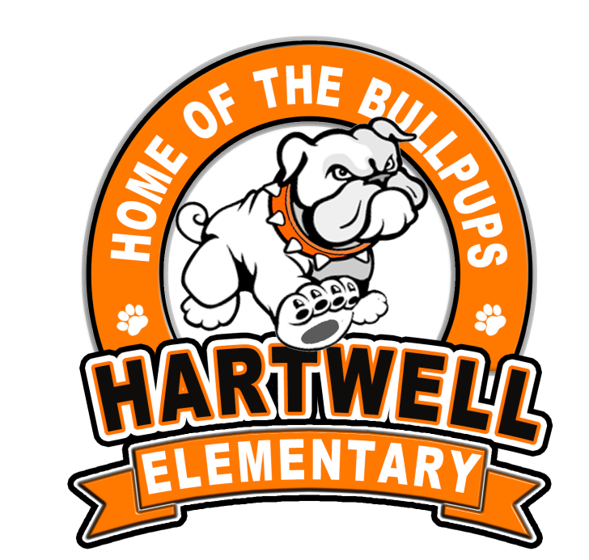
2026-2027

Table of Contents

School Information - Page 4

SWP Template Instructions - Page 4

Planning Committee Members - Page 5

SWP/SIP Components - Page 5

1. A comprehensive needs assessment of the entire school, that is based on information which includes the academic achievement of children in relation to the challenging state academic content standards, particularly those children who are failing, or are at risk of failing, to meet the challenging state academic standards and any other factors as determined by the local LEA as described in Section 1114(b)(6) - Page 6

2. Schoolwide reform strategies: Sec.1114 (b)(7)(A)(i-iii) – Page 26

3. Schoolwide Plan Development: Sec. 1114(b)(1-5) - Page 59

4. ESSA requirements to include in the Schoolwide Plan: - Page 62
5. Measures to include teachers in the decisions regarding the use of academic assessments in order to provide information on, and to improve, the achievement of individual students and the overall instructional program. - Page 65
6. Activities to ensure that students who experience difficulty mastering the proficient or advanced levels of academic achievement standards shall be provided with effective, timely additional assistance, which shall include measures to ensure that students’ difficulties are identified on a timely basis and to provide sufficient information on which to base effective assistance. - Page 65
7. Coordination and integration of federal, state, and local services and programs, including programs supported under this Act, violence prevention programs, nutrition programs, housing programs, Head Start, adult education, vocational and technical education, and job training. - Page 66
8. Description of how individual student assessment results and interpretation will be provided to parents. - Page 67

9. Provisions for the collection and disaggregation of data on the achievement and assessment results of students. - Page 68
10. Provisions to ensure that disaggregated assessment results for each category are valid and reliable. - Page 68
11. Provisions for public reporting of disaggregated data. - Page 69
12. The plan is subject to the school improvement provisions. - Page 70

School Information
SCHOOLWIDE/SCHOOL IMPROVEMENT PLAN TEMPLATE
School Name: Hartwell Elementary School |  |  | District Name: Hart County
Principal Name: Ashley McNeill, Ed.S. |  |  | School Year: 2026-2027
School Mailing Address: 147 S College Ave. Hartwell, GA 30643
Telephone: 706-376-4425
District Title I Director/Coordinator Name: Lamar Scott
District Title I Director/Coordinator Mailing Address: 284 Campbell Dr. Hartwell, GA 30643
Email Address: lamar.scott@hart.k12.ga.us
Telephone: (706) 376-5141
Principal’s Signature: |  |  |  | Date:
Title I Director’s Signature: |  |  |  | Date:
Superintendent’s Signature: |  |  |  | Date:
Revision Date: 6/5/26 | Revision Date: |  |  |  | Revision Date:

SWP Template Instructions
● All components of the Title I Schoolwide/School Improvement Plan must be addressed. When using the SWP and the SIP checklists, all components/elements marked as “Not Met” need additional development.
● Please add your planning committee members on the next page.
● The first 4 components in the template are required components as set forth in Section 1114 of the Elementary and Secondary Education Act of 1965 (ESSA). The additional components are locally required.
● Please submit your School Improvement Plan as an addendum after the header page in this document.

Planning Committee Members
NAME | MEMBER’S SIGNATURE | POSITION/ROLE
Ashley McNeill, Ed. S. |  | Principal
Andrea Gibbs, Ed. S. |  | Assistant Principal/Minutes
Kelsey Allen |  | Teacher/Data Collection
Hannah Jones |  | Teacher/Data Collection
Lauren Brown |  | Teacher/Data Collection
Fran Hershberger |  | Teacher/Data Collection
Brittany Starrett |  | Governance Team Member
Shalisha Lewis |  | Governance Team Member
Bridget Hill |  | Governance Team Member
Tabitha Johnson |  | Parent

SWP/SIP Components
1. A comprehensive needs assessment of the entire school, that is based on information which includes the academic achievement of children in relation to the challenging state academic content standards, particularly those children who are failing, or are at risk of failing, to meet the challenging state academic standards and any other factors as determined by the local LEA as described in Section 1114(b)(6).
A. We have developed our schoolwide plan with the involvement of the community and individuals who will carry out the comprehensive schoolwide/school improvement program plan. Teachers, parents, and School Governance Team Members were invited to attend the Title I Planning Week to review, provide input, and add additional feedback. Those persons involved were Ashley McNeill (Data Collection/Facilitator), Andrea Gibbs (Data Collection/Facilitator), Kelsey Allen (Data Collection), Hannah Jones (Data Collection), Lauren Brown (Data Collection), and Fran Hershberger (Data Collection, Minutes). School Governance team members included Brittany Starrett, Shalisha Lewis, Bridget Hill. Parents included Tabitha Johnson. Community members included Ashley Bowen. The School Governance team members, parent representatives, and stakeholders involved reviewed the gathered data from the Comprehensive Needs Assessment. The team also discussed Title I funds, how funds should be spent to best meet the needs of students and families, and made suggestions to improve our overall school achievement and climate. The planning committee met daily from Monday, June 1, 2026, to Friday, June 5, 2026, to develop our Schoolwide Improvement Plan (SWP), Parental and Family Engagement Plan (PFEP), and our Parent/Student/Teacher Compacts for the 2026-2027 school year. Title 1 Committee members assisted in collecting 2026 data using the SLDS system, EOG data file, and NWEA MAP data to help drive decision-making throughout the creation of these documents. Parents were involved by providing feedback, and were also allowed to help make decisions, to improve school processes at Hartwell Elementary School.
According to 2025 Georgia Department of Education data, Hartwell Elementary School serves grades Pre-K through fifth grades and is one of three elementary schools in the Hart County Charter School System. Hartwell Elementary is home to approximately 567 students, with an ethnicity breakdown of 42.90% White, 38.76% African American, 0% American Indian or Alaskan native, 2.07% Asian or Pacific Islander, 6.70% Hispanic, and 9.57% two or more races. Of our student population, 51% are male, and 49% are female. Approximately 4% of the student body is enrolled in, and receive, 10% gifted education services, and 12.4% receive special education services. The teaching staff consists of 27 homeroom teachers, 14 teachers serving in support roles, and 15 paraprofessionals. The current pupil/teacher ratio is approximately 21:1. The average homeroom class size is 21 students.
The Hart County System Improvement Team provided the guiding force for strategic planning at both the system and school level. Meetings focused on student data and research-based strategies for school improvement and student achievement. A continuous and progressive focus of the team is improving the school, overall, with a determined emphasis on developing and providing a strong standards-based curriculum. In addition, principals met monthly with the district instructional coaches. The instructional coaches and principals continually collaborate with district leadership regarding teaching and learning.
Hartwell Elementary School developed the Schoolwide Plan with the participation of stakeholders. Staff members, School Governance Team members, Leadership Team members, and parents assisted in developing the plan. These stakeholders also helped carry out the comprehensive schoolwide plan. Members of our School Governance Team were involved in the development of the plan and were updated on the direction and progress of the schoolwide improvement plan. Hartwell's parents and other stakeholders were invited to participate in a one-day planning event on June 5, 2026. On this day, the purpose of our schoolwide plan was discussed, our student achievement data was reviewed, and other demographic and attendance data were reviewed. Ideas for improving student achievement, as well as providing a more cohesive educational program, were discussed, and a list of goal areas for Hartwell was established. The group of stakeholders then prioritized a list of action steps and assigned the action steps to the goal areas for our schoolwide improvement plan. Once the goals and action steps were developed, the plan was reviewed by all participants.
B. The following instruments, procedures, or processes were used to obtain this information. Our school improvement process for the 2026-2027 school year began in the Spring of 2026, with data collection in the form of a comprehensive parent survey, a staff professional learning survey, and several brainstorming sessions with data teams, leadership team members, the school governance team, and parent groups. Hartwell Elementary gathered information from many sources to determine schoolwide needs. All staff members, including certified teachers and paraprofessionals, completed a system-level Needs Assessment to help identify areas to be included in professional learning activities. Certified staff members also completed a TKES Self-Assessment that identified individual strengths and areas of need. These areas are then addressed in Professional Learning Communities (PLCs) throughout the school year and in individual professional learning plans.
Hartwell Elementary gathered information from parents through the Title I Parent/Family Engagement Survey and surveys after each Title I Parent Training. Parents were invited to attend the Annual Title I Meeting before Curriculum Night in the fall. Title I Parent/Family Engagement week in late spring offered a platform for parents and guardians to offer suggestions concerning the programs at Hartwell and the use of allocated funds.
The School Leadership Team engaged in collaboration sessions. The team discussed and explored additional ideas for professional learning to improve the instructional programs at Hartwell. Information gathered from these sources, and combined with 2025-2026 MAP data, 2025-2026 Georgia Milestones data, 2025-2026 GKIDS data, 2025 CCRPI data collection, and our students’ overall academic progress, was used to guide the team’s decisions in developing our 2026-2027 plan. Attendance and discipline data were also collected and analyzed. The leadership team met each month and reviewed and adjusted student achievement, whereby the school improvement plan is an ongoing process.
Hartwell Elementary gathered information from a variety of sources to determine student needs, including CCRPI data, Georgia Milestones Assessment data, Achievement Team data from summative and cumulative assessments, Lexile Scores, and MAP data. All of the information obtained was used to drive our schoolwide improvement plan and our district plan. A description of these instruments follows:
College & Career Ready Performance Index (CCRPI)-An Index has been designed around a comprehensive definition of college and career readiness. This is the level of achievement required in order for a student to enroll in two or four-year colleges, universities, and technical colleges without remediation. This means that all students will graduate from high school with both rigorous content knowledge and the ability to apply that knowledge. The CCRPI overall score is made up of three major areas: Achievement, Progress, and Achievement Gap.
Georgia Milestones Assessment- The Georgia Milestones assessment measures how well students have learned the knowledge and skills outlined in the state-adopted content standards in language arts, mathematics, science, and social studies. This assessment is designed to provide students with critical information about their own achievement and their readiness for their next level of learning (e.g., next grade, the next course, or endeavor/college or career).
Lexile Scores-This is a scientific way to match readers with text. Lexile provides a clear way to measure students’ progress toward college and career readiness. Based on common core standards, Lexile scores are represented by grade level ranges and Lexile bands (scores).
Measures of Academic Progress (MAP)-MAP assessments are computer-adaptive achievement tests in Mathematics, Language Usage, and Reading. MAP is a norm-referenced assessment that measures student growth over time. MAP assessments, joined with other data points, provide detailed, actionable data about where each child is on his or her unique learning path. MAP tracks student progress throughout a year and across school years and is linked to software tools (e.g., Exact Path, Study Island), which can assist teachers and administrators in planning instruction.
C C. We have reflected on current achievement data that will help the school understand the subjects and skills in which teaching and learning need to be improved. MAP data was analyzed by grade level, subject, content, and ethnicity. Analysis of the NWEA MAP data reveals several consistent trends across grade levels in both mathematics and reading.
Students demonstrated their strongest performance in numerical reasoning, particularly in kindergarten, fourth grade, and fifth grade. Additionally, geometric and spatial reasoning emerged as a strength in second, third, and fifth grades, while first-grade students performed best in measurement and data. These results suggest that students generally possess strong foundational number sense and are able to reason effectively with numbers, shapes, and spatial concepts. The spring norms data further support these strengths, as every grade level exceeded the national average in mathematics. Kindergarten through fifth grade all performed above the national norm, with particularly strong performance in grades 4 and 5. A clear trend across the school is the need for improvement in patterning and algebraic reasoning, which was identified as the primary area of weakness in kindergarten through third grade. In grades 4 and 5, measurement and data reasoning emerged as the weakest domain. These findings suggest a need for increased emphasis on problem-solving, identifying patterns, algebraic thinking, data analysis, and real-world mathematical applications.
Reading data indicates strong performance in vocabulary, language, and text structure across multiple grade levels. Kindergarten and first grade demonstrated strengths in vocabulary development, while grades 3 through 5 showed strong performance in language, vocabulary, and understanding text structures. Second-grade students excelled in analyzing genre techniques and text elements. Overall reading achievement exceeded national norms at every grade level, indicating that students are generally performing above expectations in literacy. The most common area for improvement in reading involves text analysis and comprehension skills. Kindergarten students need additional support in foundational reading skills, while first-grade students showed weakness in writing texts and grammar conventions. Grades 3 through 5 demonstrated weaknesses related to analyzing genre techniques, text elements, context, structure, and style. Second-grade students showed a need for continued vocabulary development.
Student subgroup data indicate that most demographic groups are performing at or above national norms in both mathematics and reading. However, achievement gaps are evident among some student groups, particularly among Black and Hispanic students in several grade levels. While many of these students still perform near or above national averages, targeted interventions and differentiated instruction may help close achievement gaps and increase overall achievement.
Overall, the NWEA MAP data reflects strong performance in foundational mathematics, numerical reasoning, vocabulary development, and reading achievement. Students consistently outperform national norms across grade levels in both content areas. Areas for continued focus include algebraic reasoning, measurement and data analysis, foundational literacy skills in early grades, and deeper text analysis and comprehension skills in the upper grades. Continued use of differentiated instruction, targeted interventions, and data-driven instructional practices will help strengthen these areas while maintaining the school's strong academic performance.
Throughout the upcoming school year, subgroup deficits will be addressed utilizing differentiation to meet their needs. Parents also need resources to support student learning. We will offer tutoring, as well as summer learning opportunities by certified teachers, to close the gaps in achievement in specific subgroups. We will also address attendance concerns of students and staff. We will target specific discipline concerns and students who have multiple incidents.

D. Below, we’ve listed longitudinal data in each content area and different subgroups.
- GMAS:

 | Mathematics |  |  | % Scoring Levels 2, 3, and 4 on GMAS
 | State Target | System  All Students | School All Students | Black | White | Hispanic | Asian | American Indian | Two or More Races | SWD | LEP | Econ Disadv
18-19 | 63.4% |  | 76% | 72% | 88% | -- | -- | -- | -- | 30% | -- | *
19-20 | No data due to the COVID pandemic.
20-21 | N/A |  | 67% | 67% | 71% | -- | -- | -- | -- | 54% | -- | *
21-22 | N/A | 75% | 60% | 45% | -- | -- | -- | -- | -- | 9% | 17% | *
22-23 | N/A |  | 47% | 42% | – | – | – | – | – | 13% | 50% | *
23-24 | N/A
24-25 | N/A | 74.5% | 61% | 40% | 76% | – | – | – | 46% | 26% | – | 54.8%
25-26 | N/A | 85% | 80.4% | 35% | 80% | - | - | - | - | 40% | - | *
Due to the COVID pandemic and no accountability with CCRPI, there is no data to compare the 2020-2021 data to. In 2025-2026, 100% of our students were considered economically disadvantaged.

 | ELA |  |  | % Scoring Levels 2, 3, and 4 on GMAS
 | State Target | System  All Students | School All Students | Black | White | Hispanic | Asian | American Indian | Two or More Races | SWD | LEP | Econ Disadv
18-19 | 61.2% | 63.5 | 63% | 50% | 81% | -- | -- | -- | -- | 22% | -- | *
19-20 | No data due to the COVID pandemic.
20-21 | N/A | * | 55% | 67% | 64% | -- | -- | -- | -- | 32% | -- | *
21-22 | N/A | 68% | 59% | 45% | -- | -- | -- | -- | -- | 16% | 17% | *
22-23 | N/A |  | 48% | 39% | – | – | – | – | – | 16% | 25% | *
23-24 | N/A |  | 43% | 38% | 64% | – | – | – | 45% | 23% | – | 45%
24-25 | 59.4 | 63.5 | 52.5% | 40% | 65% | – | – | – | 30% | 20% |  | 45.5
25-26 | N/A | N/A | N/A | N/A | N/A | N/A | N/A | N/A | N/A | N/A | N/A | N/A
Due to the COVID pandemic and no accountability with CCRPI, there is no data to compare the 2020-2021 data to. In addition, 2025-2026 ELA GMAS scores will not be released until October 2026.

 | Science |  |  | % Scoring Levels 2, 3, and 4 on GMA
 | State Target | System  All Students | School All Students | Black | White | Hispanic | Asian | American Indian | Two or More Races | SWD | LEP | Econ Disadv
18-19 | 75.9% |  | 76% | 55% | 89% | -- | -- | -- | -- | 44% | -- | *
19-20 | No data due to the COVID pandemic.
20-21 | N/A |  | 61% | 46% | 75% | -- | -- | -- | -- | 75% | -- | *
21-22 | N/A | 77% | 77% | -- | -- | -- | -- | -- | -- | -- | -- | *
22-23 | N/A |  | 43% | – | – | – | – | – | – | – | – | *
23-24 | N/A |  | 59% | 23% | 50% | — | – | – | – | 19% | – | 34%
24-25 | 56.01 | 62.1 | 64.6% | 51.7% | 80% | – | – | – | – | 29% | – | 57.7%
25-26 | N/A | 62.4 | 56% | 14% | 56% | - | - | - | - | 9% | - | 56%
In 2025-2026, 100% of our students are considered economically disadvantaged.

- MAP:
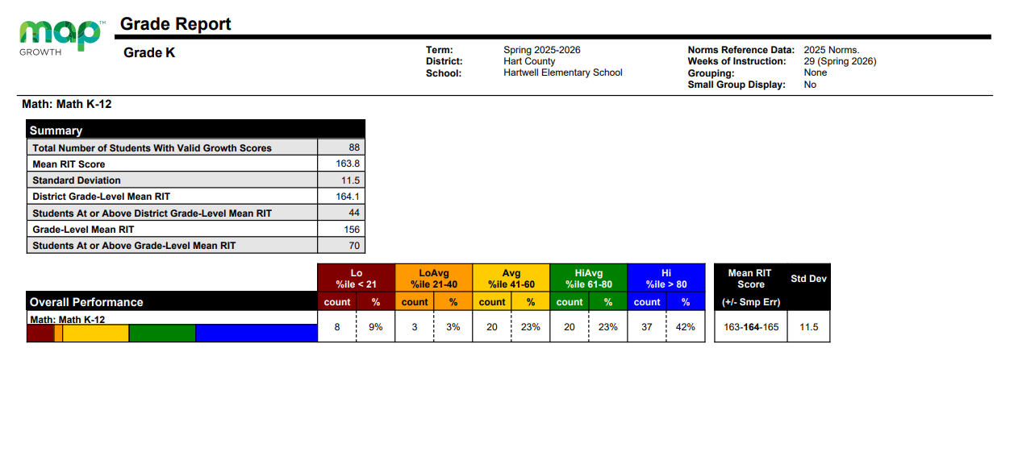
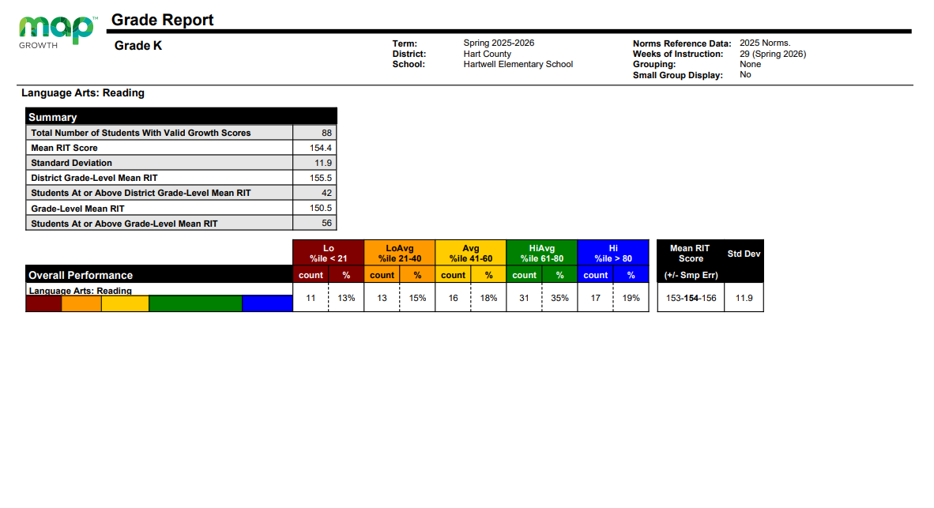
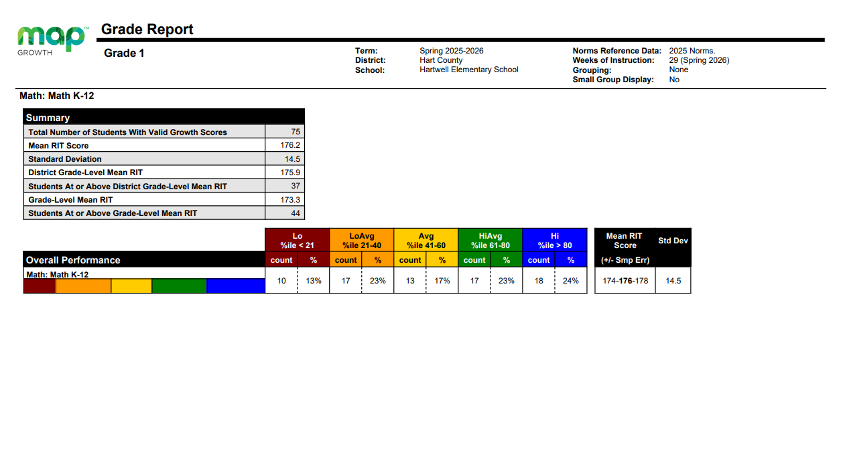
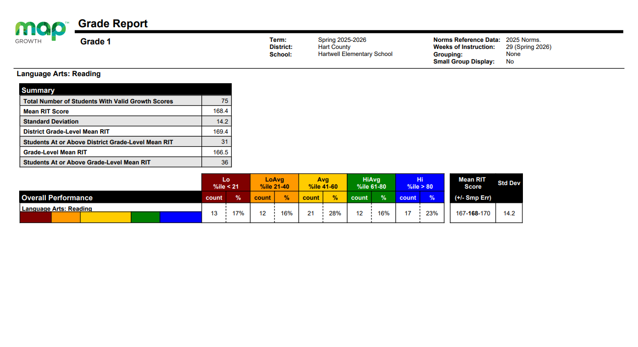
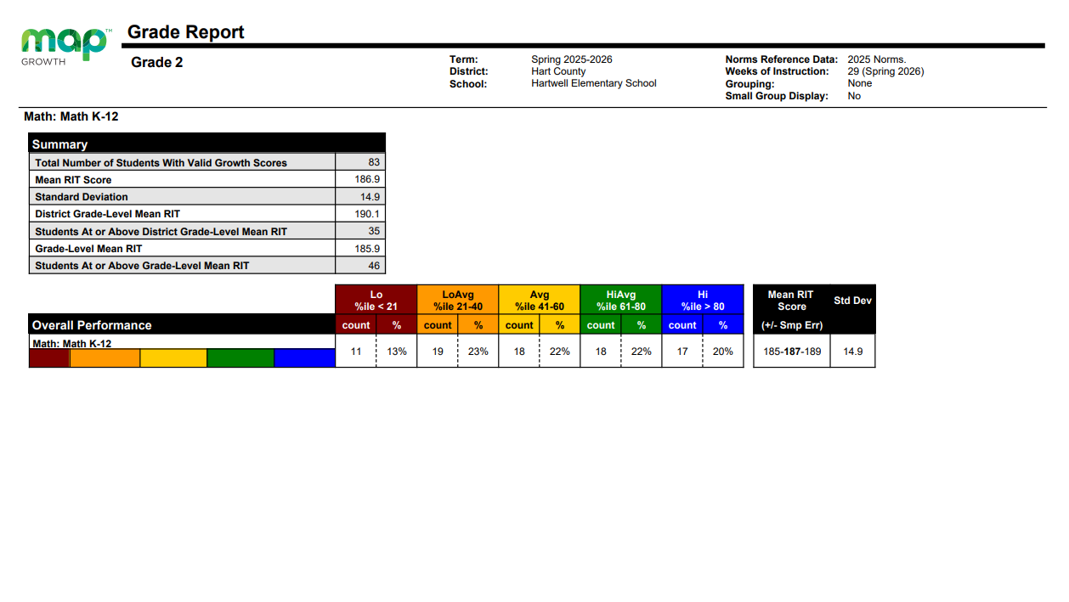
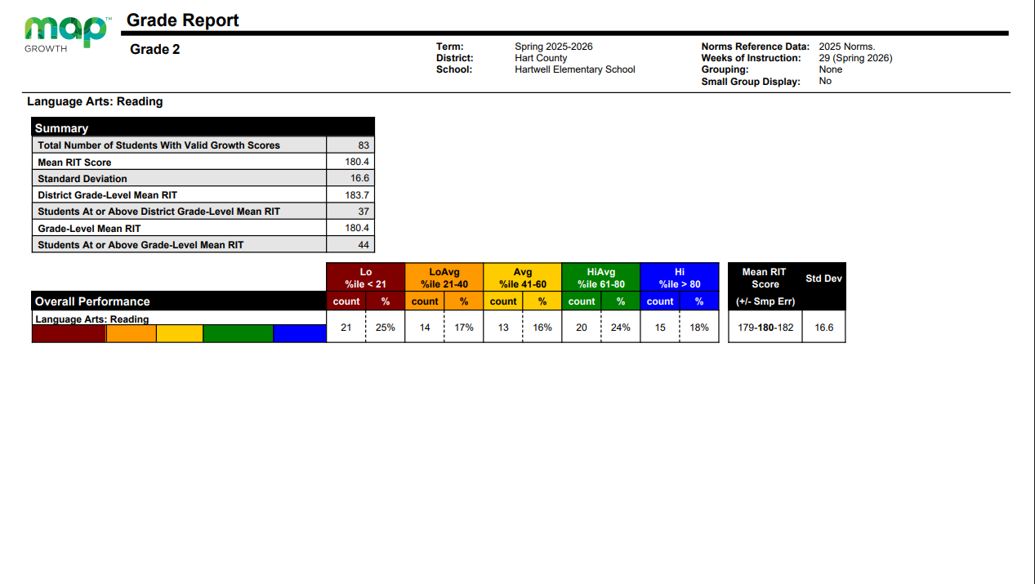

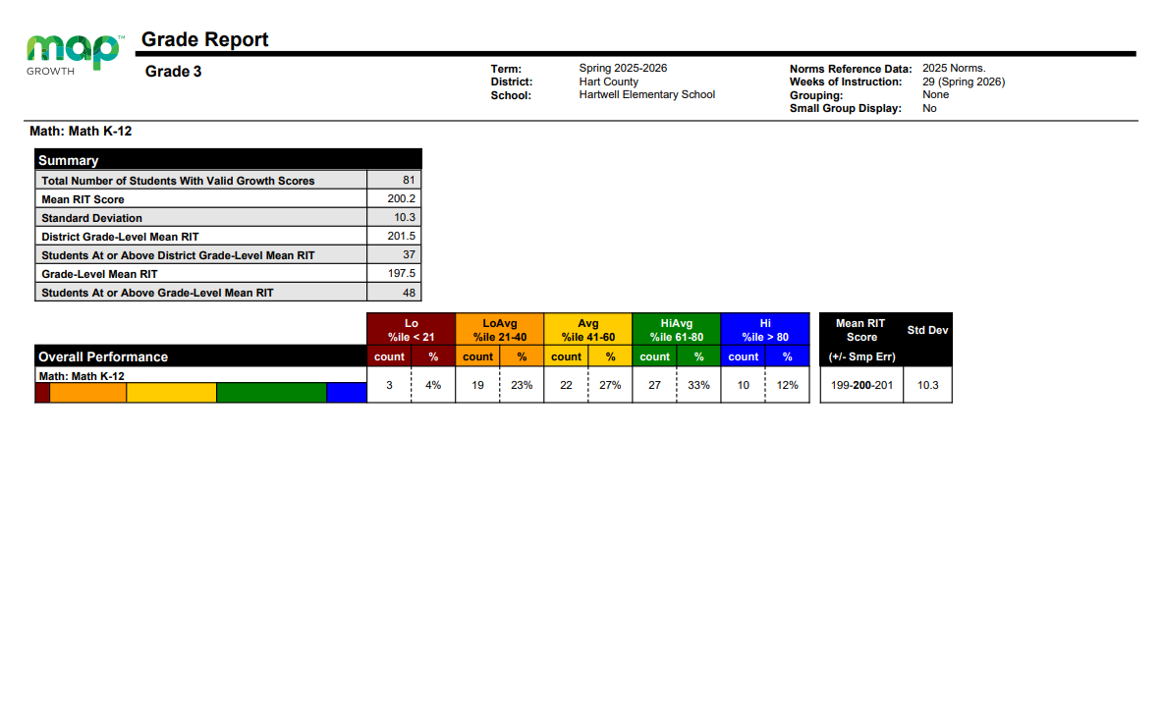

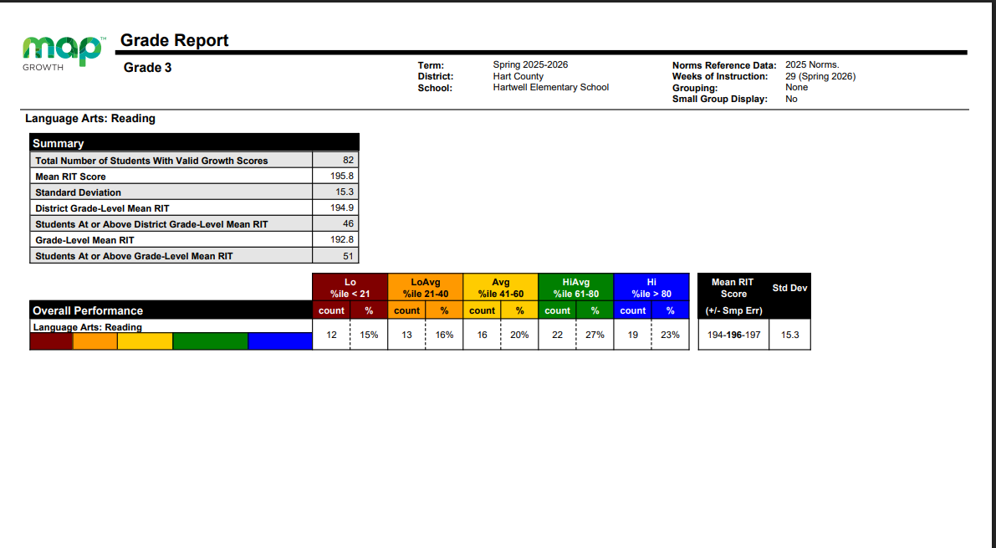

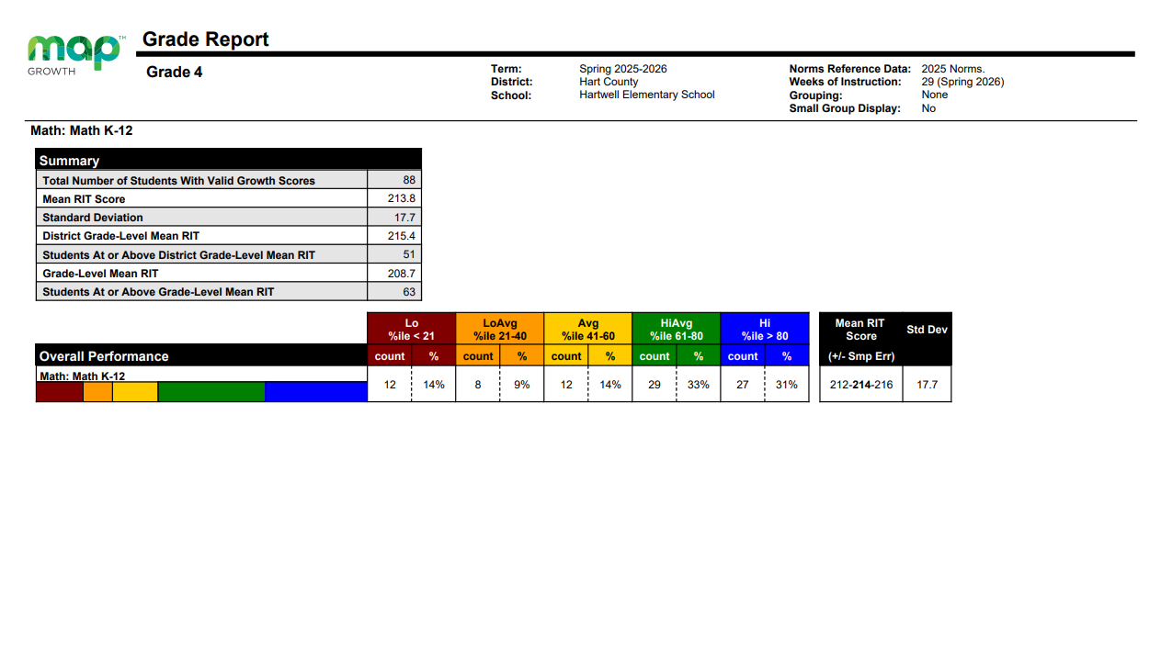

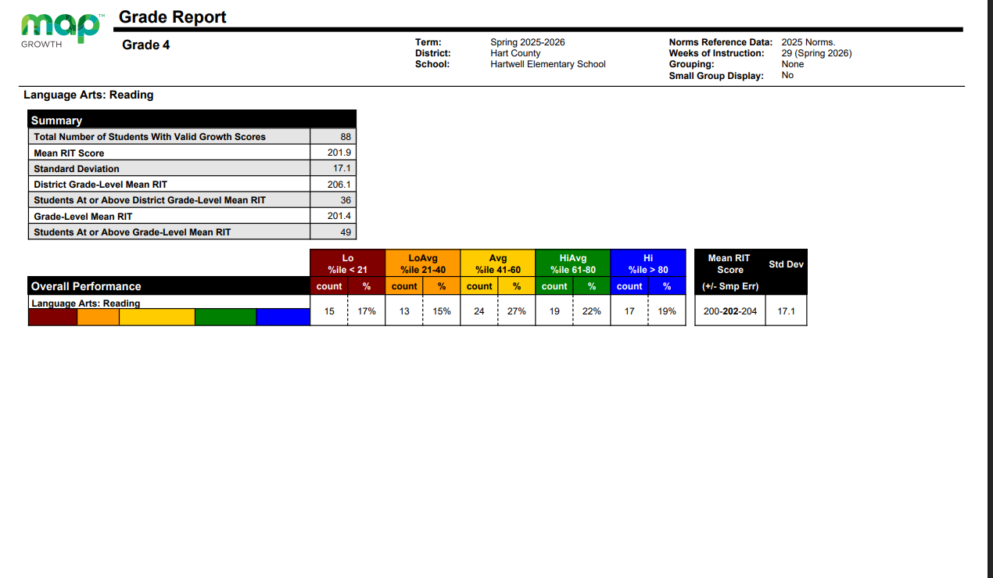

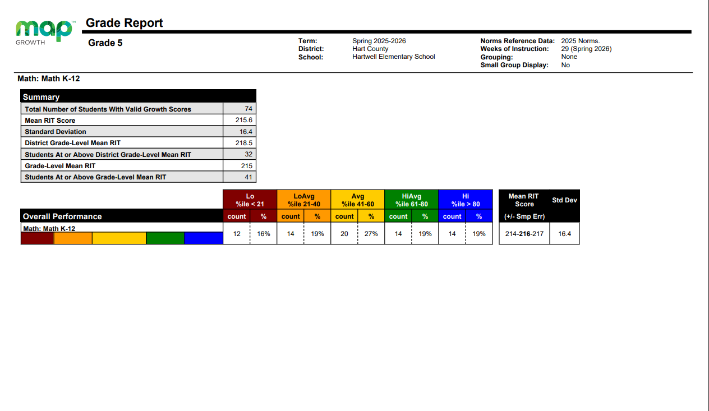

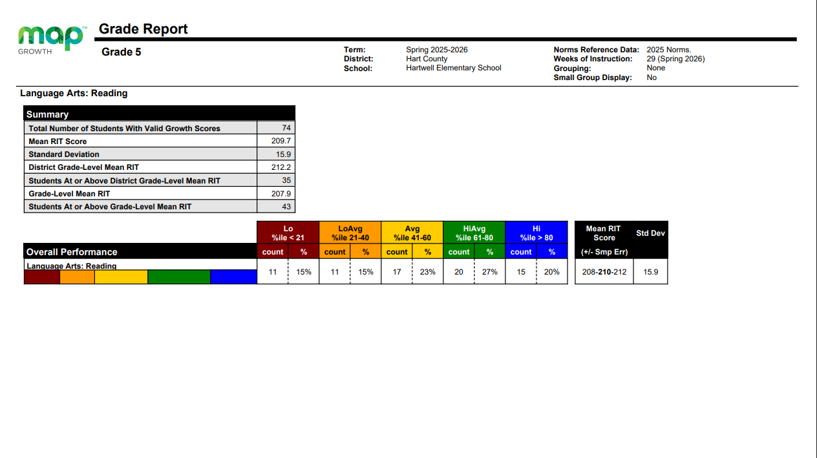

MAP Strengths and Weaknesses by Grade Level

Grade Level | Strength in Math | Weakness in Math | Strength in Reading | Weakness in Reading
K | Numerical Reasoning | Patterning & Algebraic Reasoning | Vocabulary | Foundations
1st | Measurement & Data | Patterning & Algebraic Reasoning | Vocabulary & Reading Texts | Writing Texts & Grammar Conventions
2nd | Geometric and spatial reasoning | Patterning & Algebraic Reasoning | Texts: Genre Techniques and Elements | Vocabulary
3rd | Geometric & Spatial Reasoning | Patterning & Algebraic Reasoning | Language & Vocabulary | Texts: Context, structures, and style
4th | Numeric Reasoning | Measurement & Data Reasoning | Texts: Context, Structures, and Style | Texts: Genre Techniques and Elements
5th | Numerical Reasoning, Geometric & Spatial Reasoning | Measurement & Data Reasoning | Language: Vocabulary, Texts: Context, Structures, and Styles | Texts: Genre Techniques and Elements

Summary of Current MAP findings:
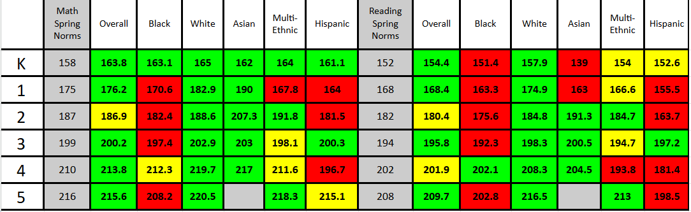
Across grades K–5, students generally met or exceeded national spring norms in both math and reading. Strongest performance trends were observed among White and Multi-Ethnic students, while Black and Hispanic student groups were more likely to score below grade-level norms. Reading performance was strongest in grades 3 and 5, while math performance was strongest in grades 3 and 4. These results suggest continued emphasis on closing subgroup achievement gaps while maintaining strong overall academic growth.
- GKIDS 2.0 DATA:

GKIDS 2.0
English/  Language Arts | 2021-2022  % Meets/  Exceeds | 2022-2023  % Meets/  Exceeds | 2023-2024  %Meets/  Exceeds | 2024-2025  %Meets/  Exceeds | 2025-2026  %Meets/Exceeds
Phonemic Awareness | 55% | 72% | 70% | Not Required | 76%
Phonics | 66% | 72% | 69% | Not Required | 84%
High- Frequency Words | 54% | 52% | 67% | Not Required | N/A
Comprehension | 48% | 55% | 52% | Not Required | N/A
Conventions of Writing | 57% | 59% | 58% | Not Required | N/A
Spelling | 45% | 61% | 69% | Not Required | N/A
Communication of Ideas | 48% | 76% | 67% | Not Required | N/A
Fluency (new 2025-2026) |  |  |  | Not Required | 77%
Concepts of Print (new 2025-2026) |  |  |  | Not Required | 91%
Handwriting (new 2025-2026) |  |  |  | Not Required | 81%
Interpreting Texts (new 2025-2026) |  |  |  | Not Required | 77%
Constructing Texts (new 2025-2026) |  |  |  | Not Required | 76%
Grammar Conventions & Vocabulary (new 2025-2026) |  |  |  | Not Required | 63%
ELA Total | 53% | 83% | 65% | Not Required | 78%
Due to changes in the overall ELA standards in 2024-2025, categories in GKIDS have been updated. The updated categories are highlighted in yellow.

GKIDS 2.0
Mathematics | 2021-2022  % Meets/  Exceeds | 2022-2023  % Meets/  Exceeds | 2023-2024  %Meets/  Exceeds | 2024-2025  %Meets/  Exceeds | 2025-2026  %Meets/Exceeds
Shapes & Positional Language | 68% | 88% | 83% | 82% | 87%
Counting & Cardinality | 75% | 91% | 80% | 85% | 90%
Count Sequences | 75% | 89% | 80% | 87% | 85%
Written Numerals & Comparison of Quantities | 75% | 92% | 87% | 85% | 86%
Addition and Subtraction | 71% | 86% | 77% | 75% | 84%
Patterns & Passage of Time (new 2025-2026) |  |  |  |  | 87%
Comparison & Classification (new 2025-2026) |  |  |  |  | 86%
Math Total | 73% | 89% | 81% | 83% | 86%

GKIDS 2.0
Science | 2021-2022  % Meets/  Exceeds | 2022-2023  % Meets/  Exceeds | 2023-2024  % Meets/  Exceeds | 2024-2025  %  Meets/ Exceeds | 2025-2026  %  Meets/ Exceeds
Physical Attributes | 80% | 88% | 78% | Not required | Not required
Motion | 74% | 91% | 84% | Not required | Not required
Life Science | 82% | 78% | 87% | Not required | Not required
Space Science | 72% | 90% | 81% | Not required | Not required
Earth Materials | 71% | 90% | 75% | Not required | Not required
Science Total | 76% | 87% | 81% | Not required | Not required

GKIDS 2.0
Social Studies | 2021-2022  % Meets/  Exceeds | 2022-2023  % Meets/  Exceeds | 2023-2024  % Meets/  Exceeds | 2024-2025  % Meets/  Exceeds | 2025-2026  % Meets/  Exceeds
Historical Understandings | 79% | 79% | 76% | Not required | Not required
Geographic Understandings | 78% | 85% | 78% | Not required | Not required
Civic Understandings | 78% | 84% | 89% | Not required | Not required
Economic Understandings | 81% | 87% | 82% | Not required | Not required
Social Studies Total | 79% | 84% | 81% | Not required | Not required

d. Attendance Data

We have identified additional areas that also impact student achievement through the use of surveys and review of quantifiable data (i.e., attendance and discipline data) that will help the school understand what improvements need to be made in these areas. For example, we reviewed the school attendance and analyzed the percentage of students who missed 1-5 days, 6-10 days, and more than 10 days for the past eight school years.

School Year | 0 Absences | 1-5 Absences | 6-9 Absences | >10 Absences
2018-2019 | 12.8% | 35.5% | 27.8% | 23.9%
2019-2020 | *No data due to the COVID pandemic. | *No data due to the COVID pandemic. | *No data due to the COVID pandemic. | *No data due to the COVID pandemic.
2020-2021 | 9% | 37% | 28% | 26%
2021-2022 | 21% | 56.2% | 14.9% | 7.9%
2022-2023 | 3% | 26% | 33% | 43%
2023-2024 | 4% | 25% | 26% | 49%
2024-2025 | .3% | 51.2% | 33.3% | 15.2%
2025-2026 | .3% | 41.2% | 29.6% | 33.8%

Attendance data shows that the school made significant progress in reducing chronic absenteeism after the challenges experienced during the 2022–2024 school years. In 2025–2026, 41.2% of students had only 1–5 absences, while 29.6% had 6–9 absences. Although the percentage of students with more than 10 absences increased to 33.8% from 15.2% in 2024–2025, it remained below the peak rates seen in 2022–2024. Overall, attendance remained stronger than historical levels, but continued monitoring and intervention efforts are needed to further reduce chronic absenteeism.

We also analyzed teacher attendance and found that teachers averaged 5.04 days out of the classroom for sick, personal days, and maternity leave. This is an increase from last year due to more maternity leave days.

e. SWIS Behavior Data:

We also analyzed discipline data and noticed that there were a total of 335 incidents involving 104 students. Out of 105 students, 44% had 2 or more write-ups. The students who are consistently being written up need interventions in behavior that include monitoring, mentoring, and counseling support.

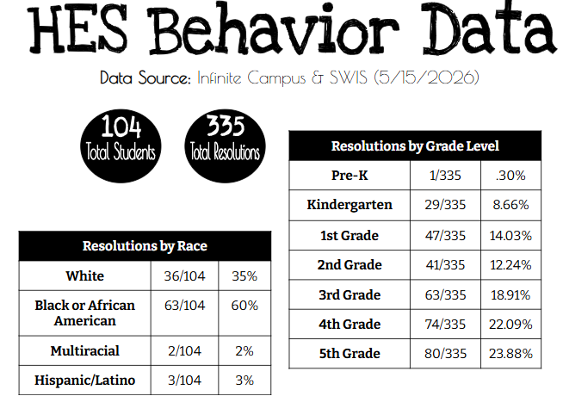

f. The data has helped us reach conclusions regarding achievement and other related data.

- Overall, reading achievement remains a strength across the school, with students consistently performing above MAP national norms in all grade levels. Strong performance in vocabulary, language development, and understanding text structures demonstrates a solid literacy foundation. While these results are encouraging, opportunities for growth remain in foundational reading skills, writing conventions, vocabulary development, and higher-level text analysis. Continued focus on comprehension strategies, author’s craft, text evidence, and critical thinking will help strengthen students’ ability to analyze and interpret increasingly complex texts while sustaining the school’s strong literacy performance.

- Based on the NWEA MAP data, several consistent areas of weakness emerged across grade levels in both mathematics and reading. The most significant mathematics concern is Patterning and Algebraic Reasoning, which was identified as the lowest-performing domain in kindergarten through third grade. In grades four and five, Measurement and Data Reasoning became the primary area of need. In reading, weaknesses centered around foundational literacy skills in kindergarten, writing and grammar conventions in first grade, vocabulary development in second grade, and higher-level text analysis skills in grades three through five, including genre techniques, text elements, context, structure, and style.

The ROOT CAUSES and ACTION PLAN:
- Potential root causes include gaps in students' ability to apply conceptual understanding to unfamiliar problems and transfer skills across contexts. In mathematics, students may have had fewer opportunities to engage in complex problem-solving, identify patterns, justify reasoning, and analyze data through authentic applications. The transition from procedural fluency to conceptual and algebraic thinking appears to be an area requiring additional emphasis.
- In reading, the data suggests a need for increased exposure to rigorous comprehension tasks that require students to analyze the author's craft, compare texts, evaluate text structures, and support responses with evidence. Foundational skill gaps in the primary grades may continue to impact vocabulary acquisition, fluency, and comprehension as students progress through the grade levels. Additionally, writing conventions and language development may not be consistently integrated across content areas, limiting students' ability to effectively communicate their understanding of complex texts.
- Subgroup performance data also indicate achievement gaps among some student populations, particularly Black and Hispanic students in several grade levels. While many students are still performing near or above national norms, these gaps may reflect differences in prior learning experiences, vocabulary exposure, attendance patterns, access to academic support, or the need for more targeted interventions and differentiated instruction.
- To address these weaknesses, instructional efforts should focus on strengthening algebraic reasoning and data analysis in mathematics, increasing opportunities for higher-order reading comprehension and text analysis, providing targeted foundational literacy support in the early grades, and utilizing frequent progress monitoring to identify and address learning gaps before they widen. Continued implementation of data-driven instruction, small-group interventions, and standards-based instructional practices will be essential for improving student outcomes and closing achievement gaps.

g. The measurable goals and benchmarks we have established to address the needs are:

The state targets established for the upcoming Georgia Milestones and Student Growth Measures assessment will be the goals for each of our noted subgroups and all students in ELA. Georgia Milestone data has not yet been released; however, the following plan will remain in place.
- All students and each subgroup will increase 3% of their 2025-2026 score on the Georgia Milestones.
- SWDs will increase 3% of their 2025-2026 score on the Georgia Milestones.
- Percentages of students who have missed more than five days will decrease from 63.4% to 25%. It will be reviewed with all staff in August and monitored during leadership each month.
- Staff attendance will be monitored throughout the year.
- Out of 104 students, 53.8% had 2 or more write-ups. We will reduce this percentage to 25% through the use of mentors, interventions, and counseling, including referrals to outside agencies as needeo. We will also utilize the social worker and resource officer to provide instruction and support related to behavior topics.
- We will increase participation in parent-teacher conferences to at least 75% during October conferences. This will be reviewed during leadership following this date.

2. Schoolwide reform strategies that: Sec.1114(b)(7)(A)(i-iii)
The school identified evidence-based strategies that have been effective in addressing ELA, math, and writing best practices and incorporating project-and problem-based learning.
- a.i. Provide opportunities for all children, including each of the subgroups of students (economically disadvantaged students, students from major racial and ethnic groups, children with disabilities, and English learners [Sec 1111(c)(2)] to meet the challenging state academic standards. Note: this section also addresses ESSA.
- The ways in which we will address the needs of all children in the school, particularly the needs of students furthest away from demonstrating proficiency related to the state’s academic content and student academic achievement standards, include:
- Continuing teaching procedures and strategies for literacy, providing a Balanced Literacy Approach in all classrooms. This BLA will be based on Reader’s and Writer’s Workshop, as well as phonics instruction.
- The Early Intervention Program (EIP) serves students who show poor classroom performance in reading and/or math and qualify based on state and district expectations.
- Provide professional development opportunities for special education support staff who provide supportive instruction in Science and Social Studies.
- Individual instruction is used as a means to re-teach a particular skill to a student. This is done during intervention time by classroom teachers at the same time as small group tutoring.
- Extensive training in math strategies and applications for teachers serving students at all grade levels; daily fluency instruction utilizing kits, number talks, etc.
- An acceleration/Remediation block is provided each day to all students. During this block, students are provided individualized instructional programming based on their individual needs/academic performance. Students are also using Study Island, Reflex Math, Amira, and other computerized reading and math computer-based programs for a portion of the time during the week.
- Positive Behavior Intervention Strategies will be utilized to reduce the misbehaviors and increase attendance throughout the school. A team has been developed and has met to create resources for the school to use to build consistency throughout the school.
- Measurements of Academic Progress (MAP) assessments will be given in August, December, and March/April. Results will be utilized to individualize instruction and support for students, especially during intervention. Also, data from MAP is utilized in individualizing learning paths within Study Island and ExactPath, which provides practice on skills that are specific to their needs.
- Technology resources such as IXL, Reflex Math, Frax Math, Amira, and Study Island will be utilized to support instruction and enhance learning.

4. a. Requirements to include in the Schoolwide Plan
Define how your interventions are evidence-based, or other effective strategies to improve student achievement. Sec 1111(d)(B)
a. ii. Use methods and instructional strategies that strengthen the academic program in the school, increase the amount and quality of learning time, and help provide an enriched and accelerated curriculum, which may include programs, activities, and courses necessary to provide a well-rounded education; Note: this section also addresses ESSA.
A. IXL Math and ELA- Moderate Evidence-Based Research. Through research, IXL schools score as much as 15 percentile points higher in math and 17 percentile points higher in language arts on state assessments. Validity research shows that IXL’s Diagnostic is an accurate measure of student achievement and a strong predictor of performance on standardized assessments, including NWEA MAP, Star, FSA, PSSA, SOL, MCAS, ILEARN, and SC READY. ELLs, SPED students, Title I schools, and urban and rural schools experience similar or even greater gains with IXL.IXL Math offers thousands of hyper-specific “micro-skills” aligned to K-12 state standards, ranging from foundational skills focused on teaching young learners how to count to advanced skills where students solve complex problems (see Bashkov et al., 2021). Skill practice is designed to be an independent activity, so students can work on IXL as part of their assigned homework or live in the classroom along with their peers. Using information from in-skill practice and its diagnostic assessment, IXL provides each student with personalized next steps at the right level of rigor. Thus, the IXL Math intervention is both student- and teacher-driven and can take many forms; however, all IXL usage is captured and summarized in three main usage indicators: time spent, questions answered, and skills proficient. The intervention duration was up to three years, lasting from the fall of 2016 to the spring of 2019. However, given that the assignment and analysis were at the school level, there was no strict intervention intensity cutoff at the individual student level; a student would be considered an IXL user if they answered at least one question on IXL. Instead, a school was considered a treatment school if at least 10% of its students used IXL Math during any of the three school years on average. For example, if 50% of students at a given school used IXL Math during two of the three school years, then the school was still considered a treatment school, as the average user percentage over the three-year period was greater than the 10% threshold. This specific cutoff was chosen in order to exclude from the analysis schools whose students had access to IXL Math but did not use the product, as well as to accommodate a wide range of product usage across schools. Altogether, 45 schools used IXL Math in any one year in the 2016-2019 period, 41 schools used it in any two ESSA Research Report 5 years, and 93 schools used the product in all three years. One- and two-year treatment schools started using IXL later than three-year schools, but had similar levels of weekly IXL usage in the latest invention year (2018-19). Descriptive statistics on IXL Math usage for the treatment group averaged across students and schools are presented in Table 1. The comparison group comprised schools that did not adopt IXL Math at all during any of the three school years.

B. NWEA MAP: In this study, students’ academic achievement in math and reading was assessed using the math and reading sections of the NWEA MAP, respectively. MAP is a collection of computer-based adaptive assessments administered to students in grades Pre-K to 12. Students below 2nd grade take the MAP Growth K-2, students in grades 2 to 5 take the MAP Growth 2-5, and students at or above 6th grade take the MAP Growth 6+. MAP is administered to students three times throughout the school year: August, January, and May. The August 2018 MAP tests were used as the pretest, and the January 2019 MAP tests were used as the posttest in this study. Each MAP test reports a RIT score, which is a Rasch Unit scale score that measures student performance, regardless of age or grade level. The RIT scale scores typically range between 150 and 300. The higher the RIT score, the higher the achievement a student has shown in the subject. In MAP math and reading tests, RIT scores are also reported in different goal areas to show students’ relative strengths and areas of concern. Table 3 shows the goal areas for the MAP math and reading tests.
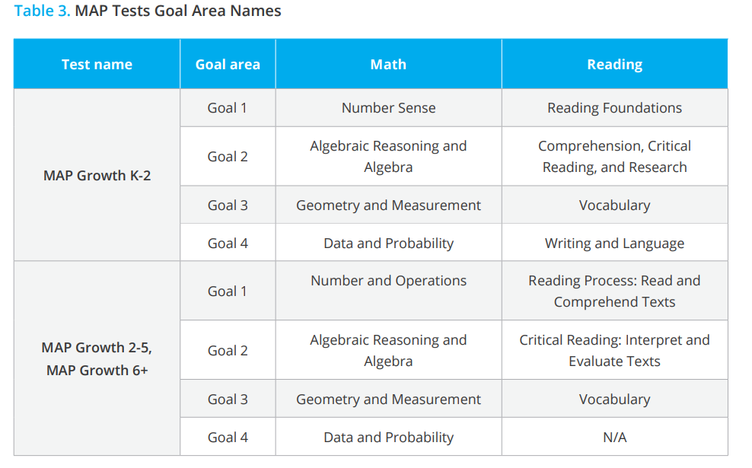
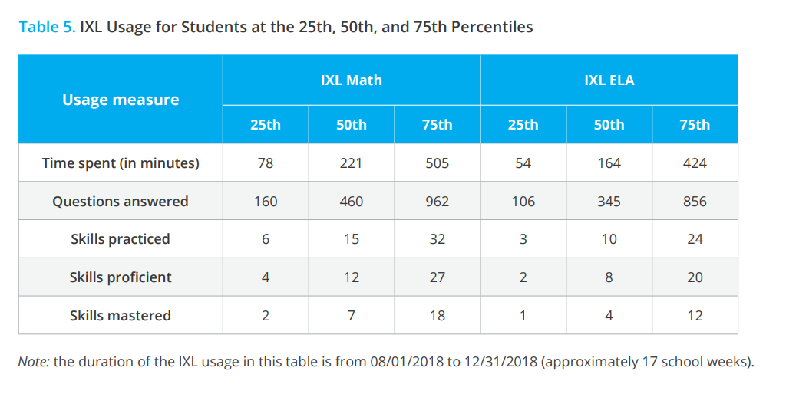
Test name Goal area Math Reading MAP Growth K-2 Goal 1 Number Sense Reading Foundations Goal 2 Algebraic Reasoning and Algebra Comprehension, Critical Reading, and Research Goal 3 Geometry and Measurement Vocabulary Goal 4 Data and Probability Writing and Language MAP Growth 2-5, MAP Growth 6+ Goal 1 Number and Operations Reading Process: Read and Comprehend Texts Goal 2 Algebraic Reasoning and Algebra Critical Reading: Interpret and Evaluate Texts Goal 3 Geometry and Measurement Vocabulary Goal 4 Data and Probability N/A Table 3. MAP Tests Goal Area Names. To measure student growth, MAP reports Met Projected Growth and Conditional Growth Index (CGI). Met Projected Growth indicates whether students met growth projections (Yes) or fell short (No). CGI shows how much individual growth deviates from the student growth norms. CGI is expressed in standard deviation units and can be used to compare students across grades and achievement levels. A CGI of zero means a student showed gains that were equivalent to the growth norms. A CGI of 1.0 indicates that a student’s growth was one standard deviation above the norm, which would represent a high level of growth. By contrast, a CGI of -1.0 indicates that a student’s growth was one standard deviation below the norm. This study used Met Projected Growth and CGI from fall to winter to measure students’ growth during the fall semester of the 2018-2019 school year.

Table 5 shows IXL usage for students at the 25th, 50th, and 75th percentiles from 08/01/2018 to 12/31/2018. An average student (at the 50th percentile) spent 221 minutes on IXL Math and 164 minutes on IXL ELA, which is approximately 13 minutes per week on IXL Math and 10 minutes per week on IXL ELA. On average, students answered approximately 27 questions per week on IXL Math and 20 questions per week on IXL ELA. The majority of the students (75%) achieved mastery of less than one skill per week on IXL Math and IXL ELA, on average.
References:
https://www.ixl.com/materials/us/research/IXL_Math_3-Year_QED_ESSA_Tier_2.pdf
https://www.ixl.com/research/ESSA-Research-Report.pdf

C. Frax Math – Strong Evidence-Based Research
The following summarizes a review of studies on the difficulties with fractions by two leading researchers in the study of learning fractions: Putting Fractions Together. Braithwaite, D. W., & Siegler, R. S. (2020, March 19). Journal of Educational Psychology.
Whole number bias Numerous studies show that many students tend to think of fractions as two separate whole numbers rather than as a single number. This is called whole number bias, and it leads to fundamental errors in comparing fractions, understanding fraction equivalence, and fraction arithmetic. It’s what causes students to claim that 2/9 > 1/2 because 2 > 1 and 9 > 2, that 9/18 is larger than 1/2, or that 3/5 +1/4 = 4/9. These and other difficulties with understanding individual fractions are why 50% of U.S. eighth graders were unable to put 5/9, 2/7, and 1/2 in order from least to greatest on a major national assessment.

The centrality of magnitude, vital to understanding fractions and fraction arithmetic, is the ability to represent or reason about fraction magnitude (size). The previous examples of errors caused by whole number bias, such as 2/9 > 1/2 or 9/18 is larger than 1/2, are also errors in understanding fraction magnitude. An inaccurate understanding of individual fraction size hinders performance on fraction arithmetic by robbing the student of the ability to recognize unreasonable answers. For example, in one recent study, U.S. middle school students asked to estimate sums of pairs of fractions on a number line were no more accurate than if they had simply marked the midpoint on the line for each answer. Even worse, a majority of answers were smaller than the student’s own estimates of one or both of the numbers being summed. These results illustrate that when students don’t understand fraction magnitude, they are unable to do even the most basic reasoning about addition, the simplest of arithmetic operations.

The Integrated Theory of Numerical Development
The Integrated Theory of Numerical Development holds that “numerical development involves increasingly precise representation of the magnitudes of increasing ranges and types of numbers, including whole numbers, fractions, and decimals.” One of the most important predictions of the theory is that understanding numerical magnitudes is closely related to understanding arithmetic. This prediction has been supported by multiple studies showing a strong correlation between understanding magnitude and arithmetic for both whole numbers and fractions. It has been further supported by experimental studies showing that interventions with a strong focus on fraction magnitude improve fraction arithmetic performance compared to traditional methods, even as less instructional time is focused on the learning and practicing of arithmetic.

ExploreLearning Frax—a better way to learn fractions
Frax delivers the latest research-proven instructional strategies in an adaptive game-based learning format to create a better way to learn fractions.
A few of the key factors in Frax that make a difference:
- In Frax, fractions are numbers first. Each has a specific magnitude (size) and position on the number line alongside whole numbers and other fractions. Students work extensively with length models and number lines to interpret, represent, compare, order, and estimate fractions. In doing so, they overcome whole number bias and develop a strong understanding of fraction magnitude.
- Frax demystifies fraction arithmetic. When students understand fractions as numbers they also better understand the arithmetic. They learn how to make sense of fraction operations and can draw connections to their work with whole numbers (e.g., the sum of two fractions must be larger than each individual fraction and therefore the sum of 1/2 + 1/3 can't be 2/5).
- Frax is adaptive and individualized so that students of all ability levels have early and ongoing success. In addition, the Frax online learning system consistently rewards students for both their effort and progress. Students come to understand that if they are willing to put in the work, they really can succeed in learning fractions.
- Frax is game-based and challenges students to perform a variety of tasks that build their fraction skills in a wide range of engaging scenarios. The math games are supported by brief, just-in-time instruction, allowing students to learn largely by doing rather than by watching and listening.

D. Flocabulary-Strong Evidence-Based Research
Flocabulary has a vast body of independent evidence-based research.

Research & Results Student Achievement
Flocabulary is proven to raise scores on state reading tests. Improving Scores on State Tests:

https://www.flocabulary.com/results/
Dr. Roger Farr, former president of the International Reading Association, conducted a study in 2008 and 2009 that determined that The Word Up Project, Flocabulary's multisensory vocabulary program, raised state test scores for middle school students. A total of 1255 students participated in the study in six states.

The results of a 2008-2009 independently conducted study of The Word Up Project show that middle school students who used the program for 7 months had higher scores on their state's reading tests.
Summary of the Results of Phase 2 of The Word Up Project Instructional Efficacy Study

by the Educational Research Institute of America, Flocabulary, an educational publisher, contracted with the Educational Research Institute of America (ERIA) to conduct an instructional validation study of its grades 3 to 8 language arts program, THE WORD UP PROJECT, in eight school sites across the country.
Flocabulary sought to determine the extent to which THE WORD UP PROJECT, a program designed to support students vocabulary development, reading comprehension, and critical thinking skills, improves students language arts skills as measured by state language arts tests.
The study included eight different schools in six different states: Alabama, California, Massachusetts, New York, Pennsylvania, and Texas. All of the students in the study were enrolled in grades 6, 7, or 8. Students began using THE WORD UP PROJECT in September of 2008 and continued until May of 2009. A pretest and posttest designed to measure vocabulary development were administered to students prior to and upon their completion of the program. In addition, student scores on each state's end-of-year language arts test were provided by each school for students using THE WORD UP PROJECT, as well as for a control group in each school.
The results from eight schools provide significant evidence that students who used THE WORD UP PROJECT receive higher scores on state reading and language arts scores than students who did not use the program. The lack of adequate control groups in three of the schools limits the conclusion. However, in those five schools in which adequate control groups were provided, THE WORD UP PROJECT students scored higher in three of the schools and scored the same in the other two, despite the fact that in those schools, the control group seemed to be a slightly higher academic achievement group.
In the three schools in which there was a strong prior academic achievement level for the control group, adjustments were made in the selection of the control group. Under those conditions, THE WORD UP PROJECT schools scored significantly higher in two of the three schools, and in the third school the scores were even.
Raising state test scores is difficult to achieve. These results suggest strongly that THE WORD UP PROJECT can play a significant role in raising state language arts/reading scores.
Read the full report, including data for schools in Texas, New York, Pennsylvania, California, Massachusetts, and Alabama. Or read the research base of The Word Up Project to learn more about effective methods of increasing literacy. The research report is by Roger Farr, Ed.D., Jenny Conner, Ph.D., and the Educational Research Institute of America.
https://www.flocabulary.com/results-achievement-state-tests/

Additional independent studies can be accessed on the following links:
Vocabulary study- https://www.flocabulary.com/results-achievement-vocabulary/
After-school use study- https://www.flocabulary.com/results-achievement-afterschool/

E. Study Island- Strong Evidence-Based Research
An investigation regarding the relationship between Study Island achievement and Florida’s end-of-year test scores for students in grades 3 through 8 occurred in this study. Across grade levels and subjects, high correlations were found between student performance on Study Island standards mastery and the Florida Comprehensive Assessment Test in both math and ELA. These results provide quantitative evidence that Study Island content is aligned to state standards across a variety of states and settings.

The evidence presented here supports the use of Study Island both to help students prepare for high-stakes assessments and as a formative assessment tool to measure student progress toward end-of-year achievement. With Study Island, students and teachers can be prepared for increased rigor and high levels of achievement.

Bernard, B.T. (2013). Student achievement and the use of the program Study Island (Unpublished doctoral dissertation). University of Minnesota, Minneapolis.

Dube, P. J. (2011). Attempting to improve standardized test results using Study Island’s web-based mastery program (Unpublished master’s thesis). Michigan Technological University, Houghton.
Ostroski, T. C. (2012). The impact of Study Island as a formative assessment tool (Unpublished doctoral dissertation). Baker University, Baldwin City, KS.
http://www.edmentum.com/sites/edmentum.com/files/resource/media/0612- 34_SI_FCAT_WP.pdf
RTI procedures and the Study Island program provide effective solutions to meet these needs. Study Island gives educators access to both a comprehensive assessment package and a flexible instructional practice system within a single program. Study Island aligns well with the widely used models of RTI, either alone or in combination, and functions efficiently in a multi-tiered service delivery system. Additionally, the versatility and customizable nature of the Study Island program can overcome many of the disadvantages associated with RTI implementation, making its use both suitable and desirable in any RTI environment.

A Foundational Research Study Connecting Response to Intervention Research to the Study Island Program. Magnolia Consulting, LLC. February 13, 2009
https://www.studyisland.com/sites/studyisland.com/files/content/research/pdfs/Study%20Island% 20RTI%20Research%20Report.pdf
F. Exact Path- Promising Evidence-Based Research

A national sample of 26 schools within 13 districts was recruited for the field test of the Exact Path assessments and learning paths. The districts were from California, Minnesota, Wisconsin, Idaho, Pennsylvania, New Jersey, Michigan, Florida, and Arizona. This sample consisted of 6,577 unique students in kindergarten through 6th grade who took diagnostic assessments across the 2016–17 academic year and who were placed in learning progressions in midyear.

This paper presents the results of a year-long study of Edmentum’s Exact Path learning platform from a nationwide field test of the K–6 beta product during the 2016–17 school year. Results indicate that use of Edmentum’s Exact Path learning platform is positively associated with student achievement outcomes in math, reading, and language arts. Statistically significant effects were found linking the amount of time spent on the Exact Path learning platform and end-of-year diagnostic scores. The evidence presented here for Exact Path meets the standards for “promising evidence” as an assessment and as an intervention, as laid out by ESSA (U.S. Department of Education, 2016).

Exact Path Research Brief: Effectiveness Study by: Jeff McLeod, PhD Edmentum, Inc. Bloomington, Minnesota (2017).

U.S. Department of Education. (2016). Non-regulatory guidance: Using evidence to strengthen education investments. Retrieved from
https://www2.ed.gov/policy/elsec/leg/essa/guidanceuseseinvestment.pdf

http://www.edmentum.com/sites/edmentum.com/files/resource/media/Exact%20Path%20Effectiv eness%20Paper%20FINAL_0.pdf

G. PebbleGo- Promising Evidence-Based Research

PebbleGo and Multimodal Literacy--The benefits of multimodal learning
A recent study performed by the Metiri Group, integrating the work of Richard Mayer and Roxanne Moreno, stated that students retain information better through words and pictures rather than through words alone. Students learn better when the corresponding words and pictures are presented near each other, and again if those words and pictures are presented simultaneously. (Mayer, Moreno, 2003). Using computers when learning allows the brain to take in data using words, sounds, and images at a pace appropriate for the level of learning. This enables the student to learn in their preferred mode (some learn best through seeing, others through hearing) and at their most beneficial tempo.

The National Science Teachers Association encourages teachers to gain full knowledge of the software students use in learning, know how to incorporate the computer into instructional strategies, use computers and software ethically, and use computers in a variety of ways. Both the National Science Teachers Association (NSTA) and the American Association of School Librarians (AASL) believe that computers should have a major role in the teaching and learning of science and informational research. It is imperative that the software engage the student in meaningful interactive dialogue and creatively employ graphics, sound, and simulations to promote the acquisition of facts... and enhance understanding. (NSTA website). Capstone Press, a nationally recognized content-area publisher, is proud to introduce the only database available for the youngest of researchers. Designed to give the emergent reader the opportunity to acquire knowledge by using and developing their multimodal literacy, PebbleGo™ integrates content curriculum, early literacy skills, and information literacy skills.

https://mail.google.com/mail/u/0/#search/peeblego/163b175902cb1a6f?projector=1&messagePart Id=0.1

H. Padlet-Moderate Evidence-Based Research
In 21st-century learning classrooms, students are expected to use educational and instructional technologies to synthesize newly acquired knowledge, collaborate with their peers, solve problems, and make decisions in order to be successful in our current global community. Advancements in technology have helped students to acquire more knowledge and provided the ability to learn at their own pace. It has changed the teaching method by encouraging educators to promote technology-integrated teaching modules. Padlet© is an e-learning tool that creates a virtual bulletin board that fosters collaboration between students (https://padlet.com/features). Padlet© provides a free, multimedia-friendly wall that supports full-class participation and evaluation in real-time (Fadhilawati, Laksmita, & Mansur, 2020). Padlet© also offers students a platform for teachers and students to share their writing. Padlet© could also be an "exit ticket" or an interactive classroom assessment tool for teachers, rather he or she uses the traditional method in the classroom, for example, writing by using paper and pen.

Researchers noted that students who used Padlet scored better grades in comparison to control groups (Lestari & Kurniawan, 2018). The findings showed participants understood what they had practiced during the Padlet assessment and cultivated learning. Participants also noted that learning through Padlet was fun and engaging, and many found it valuable to be able to collaborate with other learners. Student achievement was increased after applying Padlet©. Padlet made the students eager to learn writing procedure text, made them happy to learn writing procedure text, made them interested in the lesson, made them feel comfortable sharing their writing of procedure text in Padlet, and made them develop an idea of writing easily.Padlet© successfully captured learning objectives as well as managed to assess the 4C competencies of 21st Century Learning Skills: creative, critical thinking, collaboration, and communication.

Fadhilawati, D., Laksmita, D., & Mansur, M. (2020). Using Padlet to Increase the Students’ Procedure Text Writing Achievement. Exposure Journal, 9(02), 158-172.
Lestari, P. Y., & Kurniawan, E. H. (2018). Padlet as media to improve the writing mastery of English department students of Uniska 2015-2016. Engl. FRANCA Acad. J. Engl. Lang. Educ. STAIN Curup, vol, 2(1), 12.

I. Tutoring – During and After-School – Strong Evidence
Tutoring will be provided after school. Students needing tutoring will be identified using the tutoring rubric that includes information from Georgia Milestones, Lexile Levels, and MAP percentile scores. Data from the 2022-2023 school year helped shape decisions about certified teacher effectiveness.
Data will be reviewed, and tutors will be evaluated using observations and review of data during each MAP window.
https://www.evidenceforessa.org/programs/reading

J. Instructional Coaches – Teacher Support and Professional Development – Moderate Evidence
Instructional coaches are utilized to support teachers and student learning. They analyze student data as well as teacher feedback on surveys to identify areas of need. Coaches model instructional and assessment strategies in the classroom.
https://www.evidenceforessa.org/programs/reading/elementary/content-focused-coaching-whole class

K. Attendance Incentives – Strong Evidence
School will implement a school-wide attendance incentive program to improve both student and teacher/staff attendance. Attendance percentages will be monitored and discussed monthly during leadership meetings.
https://ies.ed.gov/ncee/edlabs/regions/midwest/askarel/2017/RDR10a_Attendance_June.aspx

L. Summer School – Strong Evidence-Based
Summer school will be provided for 5 weeks during the summer to help prevent summer learning loss. Students needing summer school will be identified using measures that include information from Georgia Milestones, Lexile Levels, and MAP percentile scores. Data from last year helped shape decisions about certified teacher effectiveness. Data will be reviewed, and summer school teachers will be evaluated using observations and review of MAP data from Spring to Fall. Summer learning loss is cumulative; over time, it contributes substantially to the gap in academic achievement between lower- and higher-income students.

Summer counts: Making summer programs part of the learning equation, 2011

https://www.wallacefoundation.org/knowledge-center/Documents/Making-Summer-Count-How-Summer-Programs-Can-Boost-Childrens-Learning.pdf

M. 7 Mindsets – Strong Evidence-Based Research
The 7 Mindsets are based on a 3- year study designed to uncover why so many people seek to have a life of meaning and purpose, happiness and success, yet many don’t reach their full potential. The research proved that the key to discovering your ultimate life is in the power of the mind. There are 7 Mindsets, or ways of thinking, common to the world’s happiest and most successful people. They are rooted in emotion and affect relationships and quality of life. The 7 Mindsets have been designed to promote self-awareness, self-management, social awareness, relationship skills, and responsible decision-making. SELEQUITY™ is the mindset-based approach to SEL immersed in the principles of JEDI (justice, equity, diversity, inclusion) and social justice to be the most comprehensive solution available in PK-12 education. It is the culmination of decades of research and practical application with students and educators around the world.

Retrieved 14 June 2021, from
https://7mindsets.com/

N. PBIS – Strong Evidence-Based Research
Positive Behavioral Interventions and Supports (PBIS) is an evidence-based three-tiered framework to improve and integrate all of the data, systems, and practices affecting student outcomes every day. PBIS creates schools where all students succeed. The tiered process is as follows:
- Tier 1 practices and systems establish a foundation of regular, proactive support while preventing unwanted behaviors. Schools provide these universal supports to all students, school-wide.
- Tier 2 practices and systems support students who are at risk for developing more serious problem behaviors before those behaviors start. These supports help students develop the skills they need to benefit from core programs at the school.
- At Tier 3, students receive more intensive, individualized support to improve their behavioral and academic outcomes. At this level, schools rely on formal assessments to determine a student’s need.
Retrieved 14 June 2021, from
https://www.pbis.org/

O. Heggerty – Promising Evidence-based Research
The Heggerty curriculum is backed by research and the science of reading.

The National Reading Panel found that phonemic awareness instruction helped children of all levels improve their reading, including:
- Normally developing readers
- Children at risk for future reading problems
- Disabled readers
- Preschoolers, kindergartners,
and 1st graders
- 2nd through 6th graders (most of whom were disabled readers)
- Children across various SES levels
- Children learning to read English as well as other languages

Studies have shown that phonemic awareness is a foundational skill, essential for learning to read. As students learn to identify sounds through oral and auditory activities, they become phonemically aware. Engaging in phonemic awareness instruction develops students’ understanding of sounds, and that knowledge directly impacts their spelling and writing.

Phonological awareness difficulties represent the most common source of word-level reading difficulties. First-grade phonological awareness continues to develop in typical readers beyond first grade. Reading problems can be prevented if all students are trained in letter-sound skills and phonological awareness, starting in Kindergarten.

Hulme, Bowyer-Crane, Carroll, Duff, & Snowling, 2012; Mel- by-Lervag, Hulme, & Halaas Lyster, 2012; Vellutino et al., 2004

Kilpatrick, 2012a; Lipka et al.,2006; Wagner, Torgesen, Rashotte, & Pearson, 2013

Equipped for Reading Success, Kilpatrick, 2016

https://heggerty.org/research/

P. Secret Stories – Promising Evidence-Based Research
The Power of Secret Stories: Constructing Mental Patterns during the Reading-Writing Process Krisell, Meredith; Counsell, Shelly Dimensions of Early Childhood, v45 n1 p24-29 2017

The brain is a complex organ with an intellectual capacity that is unique to humans. For educators, it is wise to study the brain's many attributes and how it functions to help guide, inform, and improve teaching practice. Learners' brains are particularly sensitive to certain kinds of stimuli--that is, social, physical, cognitive, and emotional stimuli. Brain development and cognition are further enhanced with continuous exposure to high-quality learning activities and methods, particularly those that help children use mental patterns to make sense of their learning. Children's young brains take in information in a totally different way than adult brains. Secret Stories, a new, innovative way to teach children the grammar rules of English in a way that is tailored to their growing minds, is presented in this article.

Descriptors: Writing Processes, Reading Processes, Cognitive Processes, Grammar, English Instruction, Cognitive Psychology, Brain, Visual Perception, Imagery, Emergent Literacy, Early Childhood Education, Educational Practices, Teaching Methods, Southern Early Childhood Association. PO Box 8109, Jacksonville, AR 72078. Tel: 501-221-1648. e-mail: info@seca.info; Web site: https:// www.seca.info/dimensions

Q. Heggerty Decodables - Promising Evidence-Based Research
A study was done to determine how phonics instruction combined with the use of decodable text can impact fluency development with struggling readers. For six weeks, four third-grade participants met daily for 20 minutes. Each session consisted of a mini-lesson on a specific phonics concept that was then reinforced with a decodable text. There were also weekly fluency lessons to assist further with fluency development. All participants made gains in words correct per minute at a higher rate than expected when compared to grade level norms and growth over time. Student engagement and motivation to read were also higher. The results in this study showed support for the use of explicit phonics instruction in combination with the use of appropriate decodable texts to help fluency development with struggling readers.
Bitney, M. (2021). The Impact of Explicit Phonics Instruction and Decodable Text on Fluency with Third-Grade Students.
R. Tynker - Promising Evidence-Based Research
Tynker is an online platform that easily and successfully teaches students how to code through the activities they already love: games and stories. Students learn the fundamentals of programming and design through Tynker's intuitive visual programming language without the frustrations of traditional syntax.
https://www.tynker.com/school/
Coding is the process of “assigning codes” that allow a machine or a person to act or move (McLennan, 2017). Children frequently experience automated systems with coding-based systems in their daily lives. Due to rapid changes in technology, children are being exposed to these systems more and more, and this exposure naturally promotes their interest in how things perform or move automatically. According to the Partnership for the 21st Century, P21 (2009) skills framework, all students must learn essential skills, including information literacy, media literacy, and information, communications, and technology (ICT) literacy, in order to successfully and actively participate in a digital society. Digital literacy is one of the key skills for people living in the twenty-first century (P21, 2009). As digital literacy is imperative, computer science has become a required curriculum in many states (e.g., Idaho, Ohio, Utah, Virginia, Wisconsin, etc., Lestch 2018) to help all students understand the functions of digital literacy, including coding and programming. Coding is a comparatively new literacy but has become an essential tool for reading, interpreting data, and communicating with others in a digital society (Bers 2018a, b). To respond to the changing society, teachers of young children in the twenty-first century need to know how to introduce this new literacy of coding in the early years (Campbell and Walsh, 2017). All students must become digitally literate to be ready for the twenty-first century (Ananiadou and Claro 2009). It is important to purposefully and systematically help children become familiar with digital literacy from their early years as they develop early emergent skills. Coding is everywhere in children’s lives. The concern is not whether we are exposing children to coding, but how to expose them to coding in a developmentally appropriate manner and in a way that will get them to playfully engage in coding. It is vital to implement unplugged coding with concrete hands-on practices that enable children to manipulate codes. In addition, the intentional use of coding-associated terms in children’s daily lives will help them recognize and understand the terms with accurate meanings of commands (directions and sequences). Connecting coding with children’s daily routine or daily tasks provides meaningful learning contexts.
Lee, J., & Junoh, J. (2019). Implementing unplugged coding activities in early childhood classrooms. Early Childhood Education Journal, 47(6), 709–716. https://doi.org/10.1007/s10643-019-00967-z
Tynker's goal is to provide every child with a solid foundation in STEM (Science, Technology, Engineering, and Math) thinking abilities to prepare them for 21st-century degrees and careers.
S. Lexia Learning- Strong Evidence-Based Research
Equitable learning begins with inclusive and individualized instruction that works for all students. At Lexia, we continually evaluate the efficacy of our products to ensure they have the greatest possible impact on student learning. Lexia is committed to a program of research that helps it meet the shifting needs of a dynamic industry. This helps build customers' confidence in selecting the right instruction or professional learning solutions to meet their goals. Lexia’s mission is to create opportunities for every student through the power of literacy education, so they hold themselves to the highest standards of efficacy research. Lexia's commitment to gold standard outcome studies and peer-reviewed efficacy research is at the forefront of their industry. Lexia products are backed by a diverse and comprehensive body of evidence to help educators take the guesswork out of selecting the right instruction or professional learning solution. Lexia's wide range of research makes it easier for schools and districts to ensure Lexia's programs are assisting students in an ever-changing education climate. Lexia confirms its research is meeting our high-efficacy standards by placing an emphasis on peer-reviewed, published research studies, independent, third-party evaluations, reviews by research organizations, and internal research and reports.
Research efficacy: Lexia. All for Literacy. Because Literacy Can and Should Be for All. (2023, April 3). https://www.lexialearning.com/research/
T. Math Manipulatives-Strong Evidence-Based Research
Over the past four decades, studies done at all different grade levels and in several different countries indicate that mathematics achievement increases when manipulatives are put to good use (Canny, 1984; Clements and Battista, 1990; Clements, 1999; Dienes, 1960; Driscoll, 1981; Fennema, 1972, 1973; Skemp, 1987; Sugiyama, 1987; Suydam, 1984). Additional research shows that use of manipulatives over the long-term provides more benefits than short-term use does (Sowell, 1989).
With long-term use of manipulatives in mathematics, educators have found that students make gains in the following general areas (Heddens and Picciotto, 1998; Sebesta and Martin, 2004):
- verbalizing mathematical thinking
- discussing mathematical ideas and concepts
- relating real-world situations to mathematical symbolism
- working collaboratively
- thinking divergently to find a variety of ways to solve problems
- expressing problems and solutions using a variety of mathematical symbols
- making presentations
- taking ownership of their learning experiences
- gaining confidence in their abilities to find solutions to mathematical problems using methods that they come up with themselves, without relying on directions from the teacher
Studies have shown that students using manipulatives in specific mathematical subjects are more likely to achieve success than students who don’t have the opportunity to work with manipulatives. The following are some specific areas in which research shows manipulatives are especially helpful:
Counting Some children need to use manipulatives to learn to count (Clements, 1999).
Place Value Using manipulatives increases students’ understanding of place value (Phillips, 1989).
Computation Students learning computational skills tend to master and retain these skills more fully when manipulatives are used as part of their instruction (Carroll and Porter, 1997)
Problem Solving Using manipulatives has been shown to help students reduce errors and increase their scores on tests that require them to solve problems (Carroll and Porter, 1997; Clements, 1999; Krach, 1998).
Fractions Students who have appropriate manipulatives to help them learn fractions outperform students who rely only on textbooks when tested on these concepts (Jordan, Miller, and Mercer, 1998; Sebesta and Martin, 2004).
Ratios: Students who have appropriate manipulatives to help them learn fractions also have significantly improved achievement when tested on ratios when compared to students who do not have exposure to these manipulatives (Jordan, Miller, and Mercer, 1998).
Algebraic Abilities Algebraic abilities include the ability to represent algebraic expressions, to interpret such expressions, to make connections between concepts when solving linear equations, and to communicate algebraic concepts. Research indicates that students who used manipulatives in their mathematics classes have higher algebraic abilities than those who did not use manipulatives (Chappell and Strutchens, 2001).
Manipulatives have also been shown to provide a strong foundation for students mastering the following mathematical concepts (The Access Center, October 1, 2004):
- number relations
- measurement
- decimals
- number bases
- percentages
- probability
- statistics
Well-known math educator Marilyn Burns considers manipulatives essential for teaching math to students of all levels. She finds that manipulatives help make math concepts accessible to almost all learners, while at the same time offering ample opportunities to challenge students who catch on quickly to the concepts being taught. Research indicates that using manipulatives is especially useful for teaching low achievers, students with learning disabilities, and English language learners (Marsh and Cooke, 1996; Ruzic and O’Connell, 2001).

Research also indicates that using manipulatives helps improve the environment in math classrooms. When students work with manipulatives and then are given a chance to reflect on their experiences, not only is mathematical learning enhanced, but math anxiety is greatly reduced (Cain-Caston, 1996; Heuser, 2000). Exploring manipulatives, especially self-directed exploration, provides an exciting classroom environment and promotes in students a positive attitude toward learning (Heuser, 1999; Moch, 2001). Among the benefits several researchers found for using manipulatives was that they helped make learning fun (Moch, 2001; Smith et al., 1999).
Research efficacy: Hand2Mind. https://www.hand2mind.com/resources/benefits-of-manipulatives
U. Lucky Little Learners - Moderate Evidence-Based Research for Hartwell Elementary
After utilizing Lucky Little Learners (https://luckylittlelearners.com/ ) for one year through a personally purchased license, first-grade students demonstrated larger gains on the NWEA MAP test than students who were in classrooms where the resource was not utilized. In this particular classroom, nearly 86% of projected MAP Math growth was achieved with 16 out of 21 students scoring at a proficient or distinguished level. In a 2018 MAP study, Nordengren compared instructional strategies to high-growth. Nordengren quoted research conducted by Suddan and stated, “proponents of differentiated instruction argue that students with different backgrounds, academic experiences, and proficiencies require different teaching strategies and different content to succeed.” Students receiving instruction on their ability level in the moment reflected greater gains. Utilization of small group resources within the Lucky Little Learners Supplemental resource allows for teachers in first grade to meet those needs, as they will expose students to a variety of differentiated, small group activities. Nordengren quotes in his research, “‘Differentiating how students access and engage with content can even be necessary to make sure all students are actively engaged in learning instead of sitting as passive participants,’ (McTighe & Brown, 2005).”

Nordengren continues to back small group instruction by stating, “Small-group and individual activities can provide students with additional practice, enable the use of digital learning tools, and allow teachers to meet with students one-on-one. Dynamically mixing whole-group, small-group, and individual activities depending on the lesson and students’ learning needs helps high-growth teachers strike the right differentiation balance: providing formative information on where students are, creating opportunities for more small-group attention, and leveraging technology to provide additional opportunities for retrieval practice.” Nordengren specifically notes the importance of connecting standards to gain the most instructional time and to support student understanding and mastery in a more effective way. Number talks and math problems presented in a real-world application-based format are included in Lucky Little Learners. Because of this, students engaged with Lucky Little Learners would reflect Nordengren’s research and instructional strategy push for teaching multiple standards at once. He states, “high-growth teachers think carefully about how to ensure equal coverage across essential standards.”

Therefore, the Elementary Instructional Coach is recommending the purchase of this supplemental digital resource for all first-grade teachers to utilize with all first-grade students. Lucky Little Learners is a supplemental math resource developed to present math to students by using many of the above-mentioned research-based practices.

Nordengren, C. (2018). The Transformative Ten: Instructional Strategies Learned from High-Growth Schools. https://www.nwea.org/resource-center/white-paper/69846/The-transformative-ten-instructional-strategies-learne d-from-high-growth-schools_NWEA_white-paper.pdf/
Subban, P. (2006). Differentiated instruction: A research basis. International Education Journal, 7, 935–947. https://doi.org/10/bwpm8w

V: Intervention Teachers- MTSS- Moderate Evidence-Based Research Math:
RTI and Mathematics Instruction. One major methodological and practical aspect regarding RTI is the use of research or evidence-based interventions to meet students’ educational needs (Kratochwill, Volpiansky, Clements, & Ball, 2007). Research-based instruction is a cornerstone of effective intervention for students who are at-risk (Denton, Vaughn, & Fletcher, 2003). It includes instructional practices for which original data have been collected to determine their effectiveness, and scientifically-based, rigorous research designs have been utilized to evaluate the practices (State Education Research Center, n.d.). For math intervention to be successful in an RTI framework, comprehensive supplemental math interventions have to incorporate computation fluency, problem solving, and the use of visual representational all together (Fuchs et al., 2005; Fuchs, Fuchs, & Hollenbeck, 2007; Gersten et al, 2009). Gersten et al (2009) made eight recommendations for math interventions in an RTI model that were as follows: (a) provide screening to all students to identify those at risk for potential mathematics difficulties and provide interventions for those at-risk, (b) instructional materials for students receiving interventions should focus intensely on in depth treatment of whole numbers in kindergarten through Grade 5 and on rational numbers in Grades 4 through 8 (c) intervention should be explicit and systematic, (d) interventions should include instruction on solving word problems that is based on common underlying structures, (e) intervention materials should include opportunities for students to work with visual representations of mathematical ideas and teachers should be proficient in the use of visual representations, (f) interventions at all grade levels should devote about ten minutes in each session to building fluent retrieval of basic arithmetic facts, (g) progress of students receiving supplemental instruction should be monitored, and (h) interventions should include motivational strategies. All recommendations had strong or moderate evidence to support the practice except three (interventions focusing on intensive in-depth treatment of whole numbers, progress monitoring, and motivational strategies). The recommendation of interventions that provide intensive instruction of whole numbers is important for many reasons. It does not take long to realize that, along with increased competency in basic addition or subtraction facts, children develop or fail to develop number sense (Gersten & Chard, 1999). Number sense is a developing construct that refers to children’s fluidity and flexibility with numbers, the sense of what numbers mean, and the *Corresponding Author: Vanessa Hinton, vmh0002@tigermail.auburn.edu IJEMST (International Journal of Education in Mathematics, Science and Technology) 191 ability to perform mental mathematics and look at the world and make comparisons (Berch, 1998). Number sense leads to the automatic use of math information and is the key ingredient to solving basic arithmetic computations (Gersten & Chard, 1999). Griffin, Case, and Siegler (1994) suggest that number sense is a necessary ingredient for learning formal arithmetic in the early elementary grades. Therefore, the National Council of Teachers of Mathematics (NCTM) Curriculum Focal Points (2006) suggested heavy emphasis on instruction in whole numbers for young elementary students. This position was strengthened by the 2008 report of the National Mathematics Advisory Panel (NMAP), which provided detailed benchmarks and again emphasized in-depth coverage of key topics involving whole numbers as crucial for all students. Milgram and Wu (2005) suggest that an intervention curriculum for at-risk students should not be oversimplified and that in-depth coverage of key concepts involving whole numbers is critical for success in mathematics.
Retrieved from: chrome-extension://efaidnbmnnnibpcajpcglclefindmkaj/https://files.eric.ed.gov/fulltext/ED548038.pdf

Reading: Identifying best practices
Evidence-based instruction (EBI) is the idea that classroom practices should be based on the best available scientific evidence, rather than personal judgment, tradition, social media trends, or other influences. EBI practices are consistently associated with positive learning outcomes. Evidence-based means that at least one peer-reviewed, high-quality study (hopefully more!) suggests using a specific method, tool, or practice.
Success in an MTSS framework hinges on Tier 1 instruction or high-quality general classroom instruction (Marchand-Martella, Ruby, & Martella, 2007). EBI in the general classroom should provide systematic, explicit, and cumulative instruction in whole-class and targeted small groups for reading. EBI should consider the assessed needs of students and target areas of reading identified for best practice:
- oral language
- concepts of print
- alphabet knowledge
- phonemic awareness
- phonics and spelling
- fluency
- morphology
- vocabulary
- reading comprehension
- writing
Grade-level teams may work together to create planning templates for allocating time and topics in whole and small-group instruction. Using collaborative planning allows grade-level teams to coordinate EBI and determine if instruction is working (Coyne et al, 2016).

Many schools adopt a core reading program to support EBI, since these programs include a scope and sequence, assist with vertical planning across grade levels, and provide suggestions for differentiating for students who are below and above grade level (Leonard, Coyne, Oldham, Burns, & Gillis, 2019). See the next section: Tier 1 Instruction.

For students with reading difficulties in Tiers 2 and 3, Gersten et al (2017) recommend devoting time to decoding and word-level study. The authors examined 20 studies of 11 different types of reading interventions and found the strongest effects for interventions that targeted word and pseudoword reading. For students in grades 2 and 3, there were some positive effects on reading comprehension and passage fluency. Surprisingly, most of the interventions were 1-on-1 and provided support for the intervention provider. Gersten et al (2017) noted that these practices (1:1 and ongoing support) were not typical of most schools.
Retrieved from: https://www.readingrockets.org/classroom/evidence-based-instruction/what-is-evidence-based-instruction

W. Writing Workshop Model & Reading Workshop Model: Strong Evidence-Based Research
Overview: The writing workshop model emphasizes the process of writing through a structured yet flexible approach that includes mini-lessons, independent writing time, and sharing sessions. This model allows students to develop their writing skills in a supportive, student-centered environment.
Key Components:
- Mini-Lesson: A short, focused lesson on a specific aspect of writing.
- Independent Writing: Students write independently, applying the skills taught.
- Conferences: Teachers confer with students individually or in small groups.
- Sharing: Students share their writing with peers or the whole class.
Research Findings:
- Student Engagement: The writing workshop model increases student engagement by providing choice and ownership over writing topics (Atwell, 1998).
- Improved Writing Skills: Students show significant improvement in their writing abilities, particularly in terms of creativity, voice, and coherence (Graves, 1983).
- Differentiation: The model supports differentiated instruction, allowing teachers to meet the diverse needs of students (Calkins, 2003).
Implementation Strategies:
- Classroom Environment: Create a supportive, resource-rich environment that encourages writing.
- Regular Feedback: Provide ongoing, constructive feedback through conferences and peer reviews.
- Professional Development: Teachers should receive continuous training and support to effectively implement the workshop model.

Reading Workshop Model
Overview: The reading workshop model focuses on developing reading skills and fostering a love for reading through a structured approach that includes mini-lessons, independent reading time, and sharing sessions. It promotes student choice and independent reading.
Key Components:
- Mini-Lesson: A brief lesson on a specific reading strategy or skill.
- Independent Reading: Students read self-selected books independently.
- Conferences: Teachers confer with students individually or in small groups about their reading.
- Sharing: Students discuss their reading experiences with peers or the whole class.
Research Findings:
- Increased Reading Achievement: Students participating in reading workshops demonstrate improved reading comprehension and fluency (Fountas & Pinnell, 1996).
- Engagement and Motivation: The model increases students' motivation to read by allowing them to choose their reading materials (Miller, 2002).
- Development of Lifelong Readers: Reading workshops help cultivate a lifelong love of reading (Routman, 2003).
X: Calkins- Strong Evidence-Based Research
Lucy Calkins - There is research evidence that suggests that volume of reading is linked to attaining higher-order literacy proficiencies (Allington, 2012; Brozo et al, 2008; Cipielewski & Stanovich, 1992). Anderson, Wilson, and Fielding (1988) researched the relationship between the amount of reading done and reading achievement. They found that the amount of time reading was the best predictor of reading achievement, including a child’s growth as a reader from the second to the fifth grade. More recently, in her article, Independent Reading and School Achievement, Cullinan (2000) reviewed the research on the effects of independent reading for the purpose of informing policymakers, curriculum developers, parents, teachers, and librarians about the importance of independent reading and programs that support it. The review concludes that independent reading, defined as the reading students choose to do, supports learning and school achievement. Providing students with protected reading time is necessary in order to support their growth in reading.
Y. Houghton Mifflin Into Reading-Moderate Evidence-Based Research
Houghton Mifflin Harcourt Into Reading Curriculum -
Cobblestone Applied Research & Evaluation, Inc. conducted a quasi-experimental design (QED) study to determine the potential impact of the Into Reading program on student reading outcomes. The purpose of this ESSA Tier 3 Promising Evidence study was to answer one key research question: Do schools using Into Reading outperform comparable schools that use another ELA program?
Using variables from a range of relevant data sources, the Cobblestone research team used propensity score matching to find appropriate matches of Into Reading (treatment) and non-Into Reading (control) school sites across the state of Texas, yielding a final sample of 316 schools (140 treatment and 176 control). Utilizing statistical controls for selection bias, outcome analyses were conducted to assess potential differences between treatment and control conditions on the STAAR® reading test. See Table 1 for the mean comparison of key demographic variables of the sample.
The analyses examined (a) the differences between Grade 3 students' pretest scaled reading scores (2020–2021) at the school-level, and their posttest scores (2021–2022, Grade 4); and (b) the differences between Grade 4 pretest scaled reading scores (2020-2021) at the school-level, and their posttest scores (2021–2022, Grade 5). Both comparisons indicated that Into Reading (treatment) schools had slightly higher average scaled scores.
The examination of the Grade 4 (2021–2022) STAAR posttest school-level scaled reading scores across conditions, controlling for Grade 3 pretest (2020–2021 ) scores, revealed that the Into Reading (treatment) schools had statistically significant higher average scaled scores at posttest (F [1, 184] = 4.81, p = .03; see Table 2] compared to students in the non-Into Reading (control) schools. These findings suggest that the Into Reading program significantly improved students’ reading skills in comparison to other programs.
The Into Reading QED study was designed to determine the potential impact of the Into Reading program on student reading outcomes. Based on the results, the findings suggest that the Into Reading program significantly improved students’ reading skills in comparison to other programs. The study meets the ESSA Tier 3 Promising evidence standards (i.e., well-designed, well-implemented correlational study, with statistical controls for selection bias; and no strong negative findings from experimental or quasi-experimental studies).

Z. Guided Phonics and Beyond Curriculum Science of Reading- Strong Evidence-Based Research
Tara West's Guided Phonics + Beyond is a comprehensive phonics curriculum rooted in the Science of Reading (SOR) principles. It is designed to support educators in delivering systematic and explicit phonics instruction, covering a wide range of essential literacy skills. Here are some key features and components of the program:
- Structured Units: The curriculum is divided into six units, each focusing on different phonics skills. These units progress from basic letter sounds and phonemic awareness to more complex skills such as digraphs, blends, silent e words, r-controlled vowels, and vowel teams​ (Little Minds at Work)​​ (Little Minds at Work)​.
- Comprehensive Materials: Each unit includes a variety of materials to support teaching and learning. These include editable lesson plans, sound and mouth articulation cards, instructional mats, decodable readers, fluency strips, and handwriting mats. These resources are designed to engage students in multiple ways, supporting both whole-group and small-group instruction​ (Little Minds at Work)​.
- Phonological Awareness: The program emphasizes phonological awareness with built-in routines that follow an "I do, we do, you do" model. This approach ensures that students receive guided practice before moving to independent work​ (Little Minds at Work)​.
- Multisensory Learning: The curriculum incorporates multisensory techniques, which are crucial for effective phonics instruction. These include visual aids, tactile activities, and oral phonological awareness routines to help students internalize the sounds and patterns of English​ (Little Minds at Work)​.
- Assessment and Tracking: Guided Phonics + Beyond includes assessment tools and trackers to monitor student progress. This allows educators to tailor instruction to meet the needs of individual students, ensuring that they build confidence and mastery before moving on to more challenging material​ (Little Minds at Work)​.
- Teacher Support: Tara West provides extensive support for educators using the curriculum. This includes professional development courses, community collaboration opportunities, and direct access to West for questions and guidance. These resources help teachers implement the program effectively and stay updated with best practices in phonics instruction​ (Little Minds at Work)​​ (Little Minds at Work)​.
Overall, Guided Phonics + Beyond is designed to provide a thorough, engaging, and effective approach to phonics instruction, leveraging the latest research in literacy education to support student success. For more detailed information and resources, you can visit the Little Minds at Work website​ (Little Minds at Work)​.
AA. Accelerated Reader- Strong Evidence-Based Research
Accelerated Reader (AR) by Renaissance Learning is a widely used program aimed at improving students' reading skills and motivation through personalized reading practice and frequent assessments. Several studies and reviews highlight its effectiveness and the conditions under which it works best.
- Positive Impact on Reading Achievement: Accelerated Reader is designed to motivate students to read more and improve their reading skills through personalized reading goals and immediate feedback. Research shows that it can be particularly effective for certain groups of students. For example, a study by the Education Endowment Foundation found that low-income pupils showed significant improvement in their reading age when using AR, gaining five additional months in reading age over 22 weeks​ (Renaissance Learning)​.
- Targeted Interventions: Accelerated Reader seems to work best as a targeted intervention for struggling readers. The EEF's evaluation found that while the general student population did not show additional progress compared to control groups, students eligible for free school meals who used AR made one month of additional progress in reading in some cases​ (EEF)​.
- Enhanced Engagement and Motivation: AR is effective in improving students' attitudes towards reading. According to a report by the National Literacy Trust, students using AR tend to enjoy reading more, engage in it more frequently, and have more positive attitudes towards reading compared to their peers who do not use the program​ (Renaissance Learning)​.
- Implementation Fidelity: The success of AR can depend on how well it is implemented. Schools that integrate AR thoroughly into their reading curriculum and provide consistent support and encouragement to students tend to see better results. The EEF study noted that while many schools saw no significant difference in reading progress, those with higher implementation fidelity did observe more positive impacts​ (EEF, Renaissance Research)​.
- Evidence-Based Design: AR's design is rooted in research. It has been certified by Digital Promise for its research-based instructional design, indicating that it aligns well with current educational research on how students learn best​ (Renaissance Research)​.
Overall, while Accelerated Reader is not a one-size-fits-all solution, it shows promise, especially for targeted interventions and improving students' engagement and attitudes towards reading. For optimal results, schools should focus on thorough implementation and consider the specific needs of their student populations.
BB. Amira - Strong Evidence-Based Research
1. Alignment with the Science of Reading
Amira Learning is built upon decades of research in reading science, supporting all five pillars of reading: phonemic awareness, phonics, fluency, vocabulary, and comprehension. The program's micro-interventions are aligned with Scarborough’s Reading Rope model, ensuring that instruction targets critical components of skilled reading. hmhco.com+1hmhco.com+1hmhco.com+1hmhco.com+1
2. ESSA Evidence Level
Amira Learning has demonstrated strong levels of evidence under the Every Student Succeeds Act (ESSA) criteria, indicating its effectiveness in improving student reading outcomes. hmhco.com+1hmhco.com+1
3. Efficacy Studies
- Utah Study (2022–2023): An evaluation involving 5,434 elementary students across multiple sites in Utah found that Amira Learning had a moderate evidence level of effectiveness. The study utilized the Acadience Reading assessment to measure outcomes. hmhco.com+1hmhco.com+1
- Savannah-Chatham County Public School System (2020–2021): This study observed that increased usage of Amira Learning was positively associated with literacy development in first and second graders. Notably, Hispanic and Black students showed greater benefits per additional week of Amira usage compared to their peers. hmhco.com

Key Findings
- Effect Size: One study reported an effect size of approximately 0.70 for English-speaking students using Amira Learning, indicating a substantial impact on reading growth.hmhco.com
- Usage and Growth: Students who engaged with Amira Learning more frequently exhibited twice the weekly reading growth compared to those with less frequent usage. hmhco.com+1hmhco.com+1
- Efficiency: Amira's dyslexia screener delivers a valid assessment of students’ dyslexia risk in less than 20 minutes, allowing for timely identification and intervention. hmhco.com+1hmhco.com+1
CC. We Will Write- Moderate Evidence-Based Research
The purpose of the writing program is to create an inclusive, dynamic learning environment where students can develop their writing skills with confidence and curiosity. By incorporating anonymous team competitions, the program removes the pressure of individual judgment, encouraging students to participate more freely and without fear of failure. This structure boosts engagement by fostering a sense of camaraderie and healthy competition while reducing anxiety often associated with traditional classroom settings. (We Will Write)
In addition, peer assessment and structured reflection play a vital role in promoting social learning. Students not only gain insights by evaluating the work of others but also deepen their own understanding through collaborative dialogue and constructive feedback. This process empowers learners to think critically about writing and to view revision as a communal, iterative process. (We Will Write)
Finally, teacher-led analysis complements student-driven activities by offering expert guidance in a playful and interactive format. Through facilitated discussions, students connect theoretical concepts to practical writing decisions, uncovering deeper insights and reinforcing their learning. Altogether, the program is designed to build writing confidence, critical thinking, and a supportive community of learners. (We Will Write)
DD. Generation Genius- Promising Evidence-Based Research
Study Overview: Generation Genius is a classroom tool that helps teachers integrate the Next Generation Science Standards into their classroom through the use of educational science videos. During February 2018, WestEd was funded by Generation Genius to conduct an independent evaluation of their science video, “Collisions and Energy of Moving Objects.” The goal of the evaluation was to examine changes to student engagement in science, perceptions of STEM, and learning after watching a Generation Genius video, and to gather student feedback to improve the videos for future use by teachers and students. Research Questions The research questions that guided this study were: 1. Do students report feeling more engaged in science after watching a Generation Genius science video? 2. Do students report that their perceptions of STEM changed after watching a Generation Genius science video? 3. Do students report that they learned scientific concepts after watching a Generation Genius science video? 4. How can the Generation Genius science videos be improved? Study Activities: WestEd recruited fourth grade teachers and their students to participate in the evaluation of the Generation Genius science video, “Collisions and Energy of Moving Objects,” a 12-minute video aligned to the Next Generation Science Standards PS3.A (Definitions of Energy), PS3.B (Energy Transfer), and PS3.C (Relationship Between Energy and Forces). Participating teachers were asked to show the science video to their students. After watching the video, teachers administered a post-survey on student engagement in science, perceptions of STEM, and learning to their students. At the end of the study, teachers were invited to complete an optional post-survey to provide teacher feedback on the science video. WestEd provided detailed instructions to participating teachers that described the study activities and provided instructions for administering the post-survey to students. Teachers were asked to complete the study activities over the course of one day in their classrooms. Instruments Data for the evaluation consisted of a student post-survey and an optional teacher post-survey. Student Post-Survey After watching the Generation Genius science video, students completed an online survey related to student engagement in science, perceptions of STEM, and learning of scientific concepts presented in the video. In addition, the survey collected student feedback related to the video itself. The survey included 20 items in total, with a mix of four-point Likert items, multiple-choice items, and open-ended response items. Researchers developed four Likert items to address students’ engagement in science; four Likert items to address students’ perceptions of STEM; three Likert items and two multiple choice items to address student learning of science concepts; and four Likert items, one multiple choice item, and two open-ended response items to gather student feedback on the Generation Genius video. The Likert items used a typical four-point scale, with responses of “Strongly agree,” “Agree,” “Disagree,” and “Strongly Disagree.” Data Evaluation of Generation Genius Science Videos 2 was also collected on the students’ gender. The complete student survey is presented in Appendix A. Optional Teacher Post-Survey. At the end of the study, teachers were asked to complete an optional online survey to provide their feedback on the Generation Genius science video. The survey included six items in total, with a mix of six-point Likert items and open-ended response items. Researchers developed four Likert items to gather teachers’ opinions about the Generation Genius video. The Likert items used a six-point scale, with responses of “Strongly agree,” “Agree,” “Neither Agree Nor Disagree,”
“Disagree,” “Strongly Disagree,” and “Not Sure (would need to view more videos).” The complete teacher survey is presented in Appendix B: Data Analysis. Data from the closed-ended items on the student survey were analyzed descriptively using statistical analysis software. In addition, the data from the closed-ended items were analyzed to determine if there were any differences in responses among boys and girls, and among students from Title I and non-Title I schools. These data were analyzed using a crosstab analysis and the chi-square test of independence. Sample Teachers were recruited from public elementary schools in the greater San Francisco Bay Area. A total of 15 fourth-grade teachers and their students (n=439) participated in the Generation Genius study. Teachers were classified as teaching at a Title I school or a non-Title I school based on information publicly available through eddata.gov. The primary goal of Title I schools in the state of California is to “ensure that all students, particularly those who are low-achieving, demonstrate proficient and advanced levels of achievement on State academic achievement standards'' (https://www.cde.ca.gov/sp/sw/rt/index.asp). Generally, Title I schools serve areas where at least 40% of the students in the school are from low-income families.

Tiu, M., Varfolomeeva, M., & Luu, R. (2018). Evaluation of Generation Genius Science Videos. Retrieved 14 June 2021, from https://www.generationgenius.com/Full_WestEd_Report_on_Generation_Genius.pdf

a.iii. address the needs of all children in the school, but particularly the needs of those at risk of not meeting the challenging state academic standards through activities which may include:
a. counseling, school-based mental health programs, specialized instructional support services, mentoring services, and other strategies to improve students’ skills outside the academic subject areas;
b. preparation for and awareness of opportunities for postsecondary education and the workforce, which may include career and technical education programs and broadening secondary school students’ access to coursework to earn postsecondary credit while in high school (such as Advanced Placement, International Baccalaureate, dual or concurrent enrollment, or early college high school);
c. implementation of a schoolwide tiered model to prevent and address problem behavior, and early intervening services, coordinated with similar activities and services carried out the Individuals with Disabilities Education Act (20 U.S.C. 1400 et seq.);
d. professional development and other activities for teachers, paraprofessionals, and other school personnel to improve instruction and use of data from academic assessments, and to recruit and retain effective teachers, particularly in high need subjects;
e. strategies for assisting preschool children in the transition from early childhood education.
A. Counselor will provide routine classroom guidance for all grade levels as well as individual/small group counseling sessions based on student needs.
- Through classroom guidance and small group counseling, the counselor, school social worker, school resource officer, and school staff as a whole will review and implement strategies to address attendance and behavior concerns.
B. The classroom guidance will also include college and career awareness and preparation.
C. Multi-Tiered Systems of Support will continue to be implemented to address the behavior and academic concerns using early intervention. This program will monitor student progress and the effectiveness of interventions used. Students who qualify for a 504 plan and/or an IEP will have up-to-date plans and progress towards goals will be monitored at least annually.
D. Professional development for teachers, paraprofessionals, and staff members will be provided based on the needs identified in the comprehensive needs assessment.
- Social Studies and Science support especially for SpEd students in grades 3-5.
- ELA and math curriculum, serving students with disabilities, technology resources (MAP, ExactPath, IXL, Google Classroom, Reflex Math, Amira, Study Island).
E. Following our plans for assisting preschool children in the transition from early childhood programs. Also included are transition plans for students entering middle school or high school and entering from private schools, plus students entering our school throughout the school year.
- Kindergarten students and parents are asked to come for a day before the start of school to take a glimpse into the kindergarten curriculum and learn hands-on strategies to use at home. Parents will be given tools to help bridge the connection between school and home in reading and math. Flyers will be sent to private day cares, public preschools (Head Start), community services (i.e., YMCA, Hydra, Newspapers, and/or churches) to inform parents of events.
- Hartwell Elementary provides a Kindergarten Orientation specifically for incoming Kindergarten students and parents at the beginning of the school year. The faculty and staff work together to answer any questions or concerns parents have to ensure that all students feel safe and secure and part of the Hartwell Elementary school program.
- Fifth-grade students are given several opportunities to aid in the transition to the middle school, including an on-site visit during school hours to view daily operations, a parent meeting held in the evening to inform families of school expectations, and a summer “6th Grade Transition Camp” to assist in the transition from elementary to middle school.
- New students will be given grade-level compacts upon registration.
- Address how the school will determine if such needs have been met; and are consistent with, and are designed to implement, the state and local improvement plans, if any.
  - Common Assessments
  - MAP
  - Study Island
  - Exact Path
  - Reflex Math
  - Frax Math
  - IXL
  - Amira
  - Georgia Milestones
  - Achievement Teams/Data: Achievement teams meet to monitor student progress and develop flexible groups based on the data.
  - Attendance reports will be run monthly and reviewed at the leadership meetings.
  - Discipline reports will be run monthly and reviewed at PBIS team meetings as well as leadership meetings.
  - Monthly collaborative meetings where teachers and administration review data from unit assessments, universal screeners, formative assessments, and state-mandated tests. Attention will be given to the performance of targeted populations. Data will help form flexible groups and indicate who needs additional support/extended day tutoring.
  - Data from assessments will be used to analyze student performance and develop.
  - Instructional interventions.
  - Progress monitoring data will be kept for students not making progress.
  - Students who are not making progress on instructional interventions will be supported through the RTI process.

3. Schoolwide Plan Development: Sec. 1114(b)(1-5)
a. Is developed during a 1-year period, unless the school is operating a school-wide program on the day before the date of the enactment of ESSA, in which case such school may continue to operate such program, but shall develop amendments to the existing plan during the first year of assistance after the date to reflect the provisions of this section;
b. Is developed with the involvement of parents and other members of the community to be served and individuals who carry out such plan, including teachers, principals, other school leaders, paraprofessionals, administrators, the local LEA, to the extent feasible, tribes, & tribal organizations present in the community, and if appropriate, specialized instructional support personnel, technical assistances providers, school staff, if the plan relates to a secondary school, students, and other individuals determined by the schools;
c. Remains in effect for the duration of the school’s participation under this part, except that the plan and its implementation shall be regularly monitored and revised as necessary based on student needs to ensure that all students are provided opportunities to meet the challenging state academic standards;
d. Is available to the local educational agency, parents, and the public, and the information contained in such plan shall be in an understandable and uniform format and, to the extent practicable, provided in a language that the parents can understand.
  - Hartwell Elementary School developed the school-wide plan during the 2025-2026 school year. A development committee will meet throughout the 2026-2027 school year to monitor the progress of the plan, and updates/changes will be made in the summer following the 2026-2027 school year.
  - We have developed our school-wide plan with the involvement of the community to be served and individuals who will carry out the comprehensive school-wide/school improvement program plan. Those persons involved were Ashley McNeill (Principal), Andrea Gibbs(Assistant Principal, Minutes), Lauren Brown (Data Collection), Hannah Jones (Data Collection), Kelsey Allen (Data Collection), and Fran Hershberger (Data Collection). School Governance team members included Brittany Starrett, Shalisha Lewis, Bridget Hill. Parents included Tabitha Johnson. Community Members include Ashley Bowen. The ways they were involved were reviewing the data that had been gathered by the teachers through the comprehensive needs assessment, discussing Title I funds, how they should be spent to best meet the needs of our families, and making suggestions to improve our overall school achievement and climate. The planning committee met daily between Monday, June 1, 2026, and Friday, June 5, 2026, to develop our School Wide Improvement Plan (SWP), Parental and Family Engagement Plan (PFEP), and our Parent/Student/Teacher Compacts for the 2026-2027 school year. Committee members assisted in collecting 2025-2026 data using the SLDS system, 2025-2026 Data using EOG data file, and MAP data to help drive decision making throughout the creation of the documents. Parents were involved by providing feedback and were also allowed to help make decisions to improve school processes at Hartwell Elementary School. Parents were invited by text message (SchoolStatus), email, and social media to attend the Title I Planning Week to review and provide input and additional feedback.
  - The school-wide plan remains effective for the duration of the school’s participation in Title I, Part A. The plan is revised and approved annually, with periodic monitoring throughout the year to gauge the effectiveness of the plan. If revisions are necessary prior to the end of the current school year, the plan is revised and submitted to the Title I Director for district-level approval. This review will take place at leadership meetings during the months of August, October, January, and March.

- Address the regular monitoring & implementation of, and the results achieved by, the schoolwide program, using data from the state’s annual assessments and other indicators of academic achievement.

At Hartwell Elementary, we will implement the SWP by ensuring that all LEAs, parents, and the public (internet, newspaper, newsletter) are aware of the important information included in our SWP. Also, we will have the plan available for anyone who is interested. We will monitor what is happening throughout the year through observations, assessment data, achievement teams, TKES observations, parent feedback, school leadership meetings, and school governance meetings. We will assess the effectiveness of our plan during the next Title I Planning following the school year of 2026-2027.

- Determining whether the schoolwide program has been effective in increasing the achievement of students in meeting the challenging state academic standards, particularly for those students who have been further from achieving the standards. We will measure the effectiveness of our SWP by observations, assessment data, achievement teams, TKES observations, parent feedback, school leadership meetings, and school governance meetings. To ensure that our students who are further behind, we will use all interventions with validity and utilize our intervention specialist to monitor the progress of the students throughout the year.

  - Hartwell Elementary makes the comprehensible school-wide program plan available to the LEA, parents, and the public (internet, newspaper, newsletters)
- The SWP, PFEP, and Compacts are posted on the school website and available in the school office.
- Availability of the plan for review will be advertised in the local newspaper as well as the school newsletters, callouts, and text messages.
- The Parent and Family Engagement Notebook containing the SWP, PFEP, and Compacts is available in the office as well as shown at all Parent and Family Engagement Activities, with an opportunity for review and feedback.
  - At the current time, Hartwell Elementary does not have a significant percentage of parents whose primary language is a language other than English. If in the future a significant percentage of parents speak a primary language that is not English, this school-wide plan will be translated into that language.
4. ESSA Requirements to include in the School-wide Plan:
a. Define how your interventions are evidence-based, or other effective strategies to improve student achievement. Sec 1111(d)(B)
b. Describe how the school will use and implement effective parent and family engagement strategies under Section 1116, Sec 1112(b)(7), and Sec, 1112€(3)(C) for parents of English Learners
c. If a middle school or high school, describe how the school will implement strategies to facilitate effective transitions for students from elementary to middle school and middle school to high school, and from high school to postsecondary education, including, if applicable –
i. through coordination with institutions of higher learning, employers, and other local partners; and
ii. through increased student access to early college high school or dual or concurrent enrollment opportunities, or career counseling to identify student interests and skills. Sec.1112(b)(10)
a. Evidence-based interventions are addressed in section 2. a.i of this plan

b. We will use and implement effective parent and family engagement strategies under Section 116, Section 1112(b)(7), and Section 1112(3)(c) for parents of English Learners as follows: All parents were invited to participate in the Title I planning week through text message (SchoolStatus), email, and social media reminders. The school-wide plan, Parent and Family Engagement Plan, and compacts are available to parents prior to the final approval date for review and revision. It was announced on Facebook, as well as SchoolStatus messages for parents and community members to review.
We have developed a Parent and Family Engagement Plan included in our appendices that
- Includes strategies to increase parental engagement (such as family literacy services
- Describes how the school will provide individual student academic assessment results, including an interpretation of those results
- Hartwell Elementary provides ongoing assessment of student achievement and assessment results are disseminated to parents through progress reports and report cards. Progress reports are sent home every 4 ½ weeks and report cards go home every 9 weeks.
- Daily student progress information is available to parents through the ‘Parent Portal’ on our school website through Infinite Campus.
- School Status and student agendas are an important part of parent-school communication. Teachers and parents can use School Status and agendas for written communication, to send homework, grades, and work to parents, and as a tool for everyday use.
- PBIS Rewards is used throughout the school to communicate with parents regarding behavior, academics, and school events.
- For students assessed through GAA (Georgia Alternate Assessment), a brochure is given to parents prior to the administration of the assessment to explain why and how it is administered. After results are in, parents receive a detailed report of the results with an explanation of each domain and scoring procedures.
- Standard communication through School Status, phone calls, notes home, as well as monthly newsletters and emails, is also utilized to keep parents informed and involved.
- MAP reports are sent home after each testing session with an explanation of how to read and utilize this report.
- Georgia Milestone data will be shared with parents once this is received.
- Teacher-Student and Teacher-Student-Parent conferences will take place throughout the year to share progress and set goals.
- Makes the comprehensive school-wide program plan available to the LEA, parents, and the public (internet, newspaper, newsletters)
- The SWP, PFEP, and Compacts are posted on the school website and available in the school office and at the Hart County District office.
- The grade-level specific compacts can be found in the Parent and Family Engagement notebook and will be given to new students upon registration.
- Parent and Family Engagement Plan checklist included and can be found in the Parent and Family Engagement Notebook.
Save the Dates!

Hartwell Elementary School will host the following events to build capacity for strong parent and family engagement, supporting a partnership among the school, parents, and the community to improve student academic achievement.

Parents of Migrant Children: We need your voice, scan here:

July 20, 2026, from 8:00 am- 2:00 pm Kindergarten Camp
- Teachers will show parents how to support their children's reading and math skills at home. Additionally, they will provide instructional materials, technology resources, and helpful links for subject areas.

July 31, 2026, from 4:00-6:00 pm, Meet the Teacher Grades 1-5
Pre-K and Kindergarten Orientation from 5:00- 6:00 pm
- Join us to meet your child's teacher(s) and learn everything you need to know for the first day of school!

August 25, 2026, from 6:00-6:30 pm, Title I Annual Meeting
August 26, 2026, 8:00 am, Redelivery
- An overview of the following documents will be provided: School-Wide Title I Plan, Parent and Family Engagement Plan, & Student/Parent/Teacher Compact. Title I requirements will also be explained.

August 25, 2026, from 6:30-7:00 and 7:00-7:30 pm, Curriculum Night (2 sessions)
- Parents will learn about curriculum, assessments, classroom resources, and ways to monitor their child's progress through standards-based report cards and Infinite Campus.

September 10, 2026, from 5:30-7:00 pm, Parent Training on Cyber/Social Media
- Parents can learn everything they need to know about digital citizenship, social media, online safety, and how to monitor their child’s phone/activity online. This will be located at the Agriscience Center and presented by GEMA/GBI.

October 15, 2026, & March 25, 2027, from 1:30-7:30 pm, Early Release/Parent Conferences
- Parents will conference with their child’s teacher about their progress, review MAP test data, and discuss Teacher/Parent/Student Compacts. The teacher will model subject-specific instructional strategies during this time. Conferences will be scheduled from 1:30 to 7:30 pm.

February 12, 2027, at 8:00 am, HMH Reading and Social Studies Workshop
- Parents will be provided with the updated ELA standards and resources to use at home to support their child in ELA and Social Studies.
March 26, 2027, from 8:00- 9:00 am, Spring Parent Input Meeting & Georgia Milestone Informational Meeting
- Parents will provide input on Title I plans and school improvement efforts for 2027–2028 and receive information about Georgia Milestones testing.

April 14, 2027, from 6:00 - 7:30 pm, STEAM (Math/Science) Showcase
- As a Title I initiative, students will work to apply math and science concepts through Project-Based Learning (PBL). At this showcase, parents will learn information about PBL and have an opportunity to be the audience and view students’ projects within the district.
June 2027 Title 1 Parent/Family Engagement Planning Week

c. Following are our plans for assisting students in the transition between programs.
- Kindergarten students and parents are asked to come for a day before the start of school to take a glimpse into the kindergarten curriculum and learn hands-on strategies to use at home. Parents will be given tools to help bridge the connection between school and home in reading and math. Flyers will be sent to private day cares, public preschools (Head Start), community services (i.e., YMCA, Hydra, Newspapers, and/or churches) to inform parents of events.
- Hartwell Elementary provides a Kindergarten Orientation specifically for incoming Kindergarten students and parents at the beginning of the school year. The faculty and staff work together to answer any questions or concerns parents have to ensure that all students feel safe and secure and part of the Hartwell Elementary school program.
- As the school year progresses, the Pre-Kindergarten classes are encouraged to participate in more of the school activities.
- 5th grade students are given several opportunities to aid in the transition to middle school, including an on-site visit during school hours to view daily operations, parent meetings held in the evening to inform families of school expectations, and a summer “Bulldog Transition Camp” to assist in the transition from elementary to middle school.
- New students will be given grade-level compacts upon registration.
5. Measures to include teachers in the decisions regarding the use of academic assessments in order to provide information on, and to improve, the achievement of individual students and the overall instructional program.
- We include teachers in decisions regarding use of academic assessments. These include shared decision making through our leadership team, disaggregation of student data, including achievement and school profile data with our achievement teams, grade level and professional learning meetings, identification of individual, class, and grade level strengths and weaknesses and modification of instruction through differentiation and tier services. In this manner Hartwell Elementary ensures the improvement of the academic performance of individual students and the overall instructional program.
- Our local school governance team meets to share dialogue regarding our school goals, test results, and program planning. The school governance team includes administrators, local community partners, parents, and staff members. Previous years’ GMAS data is reviewed by 3rd, 4th, and 5th grade teachers. Common assessments are utilized by all grade levels. MAP reports will be analyzed by grade-level teachers, leadership team, and administration to identify successful strategies.
6. Activities to ensure that students who experience difficulty mastering the proficient or advanced levels of academic achievement standards shall be provided with effective, timely additional assistance, which shall include measures to ensure that students’ difficulties are identified on a timely basis and to provide sufficient information on which to base effective assistance.
A. We are providing activities to ensure that students who experience difficulty mastering proficient or advanced levels of academic achievement standards shall be provided with effective, timely additional assistance. Students in need of additional assistance are identified through Georgia Milestones Assessment given each April, MAP given in August, November/December, and March/April, Achievement Teams which meet at least monthly, and teacher observation that takes place on an ongoing basis. Those activities given for these students are:
- Small group tutoring for students in grades K-5. Tutoring is available in reading and math, beginning in the fall and continuing through the spring. The tutoring services are contracted with certified individuals and will be offered during after school.
- Early Intervention Program serves students who qualify based on the multiple selection criteria and served using the reduced class model.
- Individual instruction is used as a means to re-teach a particular skill to a student.
- Intervention/Acceleration block is provided each day to all students. During this block, students are provided individualized instructional programming based on their individual needs/academic performance.
- Reading incentives – led by the media specialist and supported by all reading/ELA teachers to encourage interest in reading.
- Co-Teaching is utilized to assist in closing the gap in achievement between the general population and students with disabilities. The general ed teacher and special ed teacher in each co-teaching situation collaborate in analyzing data and working to differentiate instruction to meet the needs of all learners.
- Resource classes are provided for SPED students to receive instruction on skills that will help them reach their IEP goals.
- Read 180 and System 44 will be utilized by SWD to individualize support and instruction to help close the gap and meet the needs of all learners.
- MTSS will be implemented and evaluated through progress monitoring and monthly meetings to analyze student progress and intervention effectiveness.
- Scheduled time within the day for Reader’s and Writer’s Workshop, including the use of Houghton Mifflin to assist with teacher/student conferences.
- Study Island and ExactPath are used in the K-5 instructional classrooms to support instruction on individualized levels based on MAP scores.
7. Coordination and integration of federal, state, and local services and programs, including programs supported under this Act, violence prevention programs, nutrition programs, housing programs, Head Start, adult education, vocational and technical education, and job training.
The following chart represents the integration of federal, state, and local services and programs.
Funding Source | Resources provided
FTE | Teachers, paraprofessionals, other staff, instructional materials and supplies, software, transportation
Title I | Instructional materials- High-interest/low-level books, leveled readers  Supplies- Project/problem-based learning activities, manipulatives for parent use, reader’s folder, bags for books  Instructional software- IXL, NewsELA, Exact Path, Study Island, Reflex Math, Lexia, and Freckle for reading and math, with tutoring opportunities
Title II | Professional Learning Opportunities (Houghton Mifflin)
Title III | Specifically for ELL students – instructional materials, supplies, technology, teachers, software
IDEA | Specifically for IDEA students - instructional materials and supplies, technology, teachers, software
SPLOST | Technology (Update teacher laptops, Chromebooks, and iPads)
Carl D Perkins | N/A

8. Description of how individual student assessment results and interpretation will be provided to parents.
Response:
- Hartwell Elementary provides ongoing assessment of student achievement and assessment results are disseminated to parents through progress reports and report cards. Progress reports are sent home every 4 ½ weeks and report cards go home every 9 weeks.
- Daily student progress information is available to parents through the ‘Parent Portal’ on our school website through Infinite Campus.
- School Status and student agendas are an important part of parent-school communication. Teachers and parents can use School Status and the agenda for written communication, to send homework, grades, and work to parents, and as a tool for everyday use.
- PBIS Rewards will be used throughout the school to communicate with parents regarding behavior, academics, and school events.
- For students assessed through GAA (Georgia Alternate Assessment), a brochure is given to parents prior to the administration of the assessment to explain why and how it is administered. After results are in, parents receive a detailed report of the results with explanation of each domain and scoring procedures.
- Standard communication through School Status, phone calls, notes home, as well as monthly newsletters and emails are also utilized to keep parents informed and involved.
- MAP reports are sent home after each testing session with an explanation of how to read and utilize this report.
- Georgia Milestone data will be shared with parents once this is received by mail and parent conferences. A meeting will be held at school and available online explaining how to interpret scores.
- Teacher-Student-Parent conferences will take place throughout the year to share progress and set goals.
9. Provisions for the collection and disaggregation of data on the achievement and assessment results of students.
The state of Georgia collects and disaggregates achievement and assessment data on students in Georgia through the state testing program
Hartwell Elementary teachers participate in the following to enable them to ensure that data is collected and disaggregated
- In-service/professional learning during pre-planning and additional days throughout the school year as well as flexible professional learning times.
- Professional Learning Communities to discuss data from standardized assessment as well as training in differentiation and other methods to remediate and enhance once the data is assessed.
- Teacher training in how CCRPI designations are determined and the factors regarding second indicators.
- Analysis of data to look for trends, patterns, and weaknesses in the student body as a whole in addition to the students assigned to them for the current school year. Training and practice in the analysis and utilization of data to ensure differentiation in the classroom.
- MAP data is reviewed and analyzed by teachers and administrators after each testing session.
10. Provisions to ensure that disaggregated assessment results for each category are valid and reliable.
The state of Georgia has assured the validity and reliability of the tests used by the Georgia Department of Education. The state mandated Georgia Milestones Assessment meets reliability and validity requirements, and are therefore statistically sound and research-based. Annual results are routinely compared to previous results to identify trends or patterns in the performance data.

The Hart County mandated assessment, MAP (Measures of Academic Progress), is guided by the Standards for Educational and Psychological Testing that were developed jointly by the AERA American Educational Research Association), APA (American Psychological Association), and the NCME (National Council on Measurement in Education).

Benchmark assessments are given throughout the year and the reliability will be reviewed and determined as students take MAP and Georgia Milestone Assessment.

11. Provisions for public reporting of disaggregated data.
The College and Career Ready Performance Index (CCRPI), is a comprehensive school improvement, accountability, and communication platform for all educational stakeholders that will promote college and career readiness for all Georgia public school students. The CCRPI is available to parents and the community on the Georgia Department of Education website (www.doe.k12.ga.us). CCRPI scores are also available to parents through a link shared on the school’s Facebook page. A letter notifying parents of the school’s CCRPI report is sent home with students.
Hartwell Elementary School students and teachers are proud of all assessment scores that show student improvement, regardless of whether the numbers indicate a pass or fail score. The goal is for all students to progress as much as they can with the ability that they possess. Assessment results are communicated to all stakeholders by using a variety of methods which include the following:
- CCRPI reports will be shared and will be analyzed with all stakeholders. Action steps will be developed and implemented to address areas of concern and to improve the overall CCRPI score. The CCRPI report is available to parents and the community on the Georgia Department of Education website (www.doe.k12.ga.us).
- The School website provides parents with information needed to access Georgia Milestones score information and/or other assessment data. In addition, Hartwell Elementary Georgia School Report Card is linked on our website.
- Teachers routinely write individual comments regarding assessment results in student agendas which are given to each student at the beginning of the school year. Student work, along with teacher commentary, is sent home and parents are requested to sign as an indication that the material was reviewed.
- Parents receive a copy of The Georgia Milestones Assessment results and MAP reports.
- The local newspaper eagerly prints pictures and articles about student academic success.
- Various assessment results and updates are shared at all public school meetings including PTO meetings and School Governance meetings.
- Display cases located in the main hallway are used to publicly recognize student success. Student work is frequently displayed for all stakeholders to see.
- Student achievement information is included in the bimonthly reports to the superintendent and the board of education.
- Student assessment results are shared at monthly System Leadership Team meetings.
- Awards Day is a community event held on the last week of school to recognize students for various achievements.
- Fifth Grade students participate in a special recognition program held at the end of the school year to celebrate their achievements for the year and to wish them success as they enter middle school in the fall.
- Infinite Campus is available for parents to review grades, attendance, and student information at any time with a username and password.
- Two early release days for conferences are built into the Hart County Charter System calendar. These days provide teachers and parents with two opportunities to meet to discuss their student’s various achievement results and specific learning needs. Parents can also request a conference at any time to discuss their child’s academic progress.
- School Status is a communication tool that administration, teachers, and parents can stay in constant communication that is documented.
12. The plan is subject to the school improvement provisions
Response
This plan is subject to the provisions of the Every Student Succeeds Act of 2015.

