Marietta City Schools Social Studies Classroom Instructional Framework
MCS Social Studies promotes the knowledge, skills, and tools necessary to solve complex problems and to develop individuals who are contributing members of society.

Standards for Inquiry-Based Instructional Practices
High quality social studies instruction is driven by shared principles:
- Social Studies instruction prepares young people for college, career and civic life.
- Inquiry is the heart of social studies learning.
- Social Studies involves inter-disciplinary application and integration of humanities.
- Social Studies is composed of deep enduring understandings, concepts, and skills from the disciplines and democratic decision making.
- Social studies education must have direct and explicit literacy connections.

Pervasive Lesson Practices
Teachers embed pervasive practices throughout lessons based on instructional focus.

Content Literacy
- Close Reading
- Disciplinary Research
- Map and Globe Skills
- Primary and Secondary Sources
- Information Processing Skills
- Reading to Learn
- Discipline Writing

Assessment
- Ongoing formative tasks and assessment practices
- Standards-based summative tasks and assessment practices
- Rubric-based grading
- Standards-based feedback

Classroom Culture
- Develops informed citizens
- Encourages risk-taking
- Fosters collaboration
- Demonstrates high expectations for discourse and historical inquiry
- Provides opportunities for taking informed action

Lesson Framework Overview
A lesson moves through four phases: Opening, Transition, Work Session, and Closing. The Work Session makes up the largest portion of instructional time; the exact time given to each phase will vary based on instructional focus.
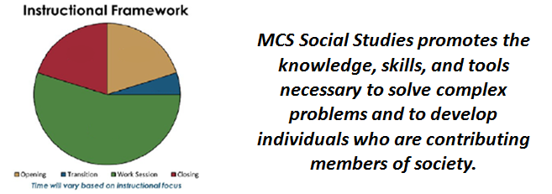

Opening / Transition
Teacher | Student
- Introduces standards and concepts  - Engages students’ prior knowledge  - Provides explicit instruction aligned to standards  - Includes skill development  - Asks challenging questions  - Models and facilitates learning | - Accesses and makes connections to prior knowledge  - Participates in discussions  - Investigates and analyzes thinking  - Asks thought provoking and clarifying questions  - Collaborates with peers

Work Session
Teacher | Student
- Reviews learning standards and concepts  - Purposeful assignment of collaborative groups and differentiated tasks  - Makes decisions based on data  - Facilitates independent and small group work  - Scaffolds learning tasks  - Monitors student progress and provides ongoing standards-based feedback | - Engages in guided practice  - Demonstrates proficiency on skills and concepts related to standards  - Expresses & defends views on current and historic events  - Completes conceptually rich performance tasks and research within readiness levels  - Poses clarifying questions

Closing
Teacher | Student
- Facilitates and provides opportunities for student-led summary sessions  - Formative assessment for student understanding  - Explicitly clarifies misconceptions  - Summarizes and celebrates progress  - Identifies next steps for instruction based on data | - Shares, assesses, and reflects on work using language of the standards  - Provides peer feedback  - Asks thought provoking and clarifying questions  - Summarizes and reflects progress toward mastery of standards

