Guided Goal Development Tool for Teachers

Identify the Need for the Goal | What Do You Want to Achieve? | What is the expected outcome of the goal? | What Action(s) Will You Take?  How Will You Accomplish the Goal? | Why is this Important? | When Do You Hope to Complete This? | Identify Possible Evidence  of Goal Attainment
Rationale | Specific | Measurable | Actionable | Relevant | Time-Bound | How Will You Know?

Goal  (What do you want to achieve?)  Dimension  (What is/are the correlating dimension(s)? | Actions  (How will you accomplish the goal?) | Targeted Completion Date  (When do you anticipate your goal will be met?) | Evidence of Goal Attainment  (How will you know your goal has been met? How will you know whether or not it has impacted instruction and student achievement?)
Goal 1:

Dimension(s):
Translate the goal into the standard GSPD forms >>>

SAMPLE: Guided Goal Development Tool for Teachers

Identify the Need for the Goal | What Do You Want to Achieve? | What is the expected outcome of the goal? | What Action(s) Will You Take?  How Will You Accomplish the Goal? | Why is this Important? | When Do You Hope to Complete This? | Identify Possible Evidence  of Goal Attainment
Rationale | Specific | Measurable | Actionable | Relevant | Time-Bound | How Will You Know?
- Stagnant student scores  - Off-task behavior  - Personal desire to improve my ability to monitor student performance and adjust instruction accordingly | I will improve my abilities to monitor and adjust instruction | resulting in a 10% increase in the STAAR scores for all of my students | through targeted questioning techniques at varied levels of cognition, the use of wait time, and academic feedback to students | to increase time for instruction and reduce student misunderstandings | each quarter during the 2015-16 school year | Increased ability to effectively monitor and adjust instruction as measured through  - Peer and administrator feedback  - Student responses/cognition  - Student performance data, i.e., student work samples, unit assessments, grades, and state assessments

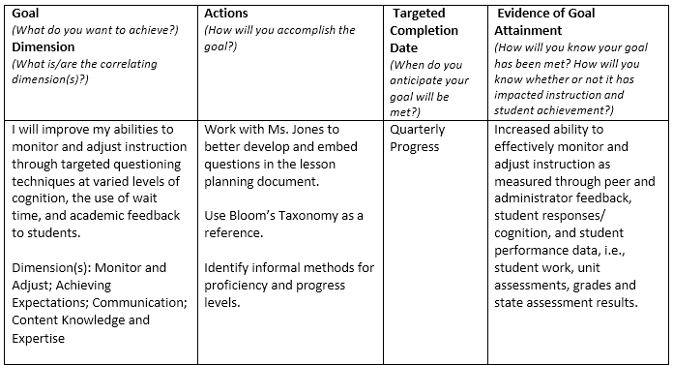
Translate the goal into the standard GSPD forms >>>

