ACADEMIC
RESOURCES
Supporting Student Success

ACADEMIC PROGRAMS
FEV Tutor
Varsity Tutor


The mission of Hephzibah Comprehensive High School is to transform students into caring, open-minded thinkers who will respect themselves as well as others locally, nationally and globally, producing citizens who lead with dignity and integrity. The stakeholders of Hephzibah Comprehensive High School will provide students with an academically challenging and culturally diverse environment that fosters the development of strong character and intellect.

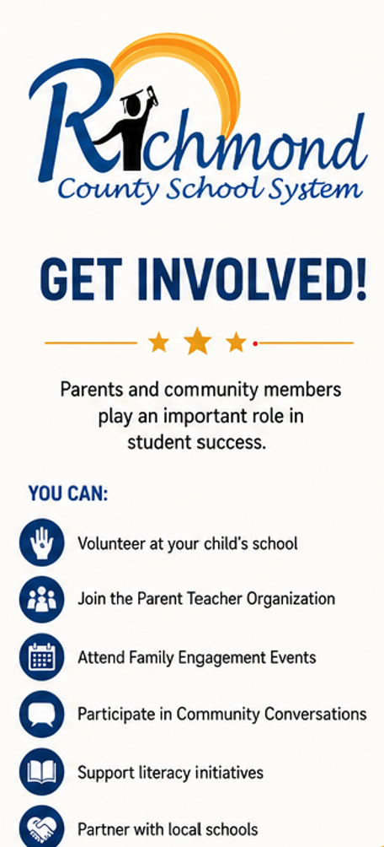
NOTES: ______________________________
_____________________________________
_____________________________________
_____________________________________
_____________________________________
_____________________________________
_____________________________________
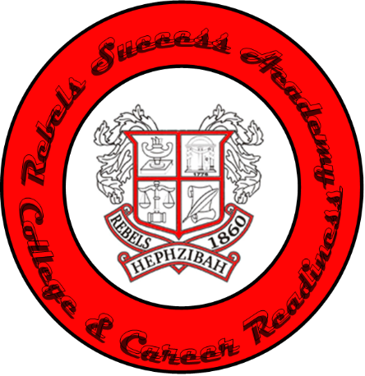

HEPHZIBAH HIGH SCHOOL
FAMILY ENGAGEMENT BROCHURE
Address: 4558 Brothersville Rd. Hephzibah, Ga 30815
CHRISTOPHER NABAHE, PPRICIPAL
Phone Number: 706-592-2089
www.rcboe.org/hhs

SCHOOL/DISTRICT
RESOURCES
Helping Families Stay Connected



FAMILY SERVICES
UNITED WAY
211
RICHMOND TRANSIT
706-821-1497
DEEPLY ROOTED FOR CHANGE
706-426-1869
EQUALITY CLINIC
762-218-2226
PROJECT IMPACT
706-667-4342

STUDENT SERVICES
WHOLE FAMILY, WHOLE CHILD
706-294-5372
CREATIVE FUTURE
706-826-4702

COMMUNITY
RESOURCES

Building Strong Community Partnerships
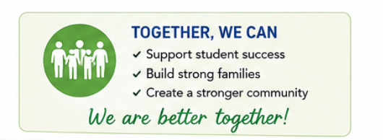

COMMUNITY RESOURCES:
NATIONAL YOUTH ADVOCATE PROGRAM
PATHWAY TO POSSIBILITIES
AUGUSTA DREAM CENTER
HOPE HOUSE
PROJECT LIFE

PARENT FACILITATOR HEPHZIBAH MIDDLE AND HIGH SCHOOL
MRS. TE’ASHA HEARD heardte@boe.richmond.k12.ga.us

OTHER RICHMOND COUNTY
COMMUNITY RESOURCES
