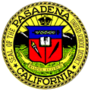

PASADENA UNIFIED SCHOOL DISTRICT

Thurgood Marshall Fundamental Secondary School

Dear Students and Families:

Summer will be here soon! Incoming Seventh Grade students must complete the following assignment. At the beginning of the school year, you will be given an in class assignment on your reading.

Seventh Grade English Required Reading

Please read a book of your choice that is suitable for your grade level.

The Pasadena Public Library has books, ebooks, and audiobooks for checkout.

I ask that you and your parents read this letter. I am looking forward to being your teacher next year!

Sincerely,
Ms. Keith

