Kindergarten Supply List 2026-2027
 | Quantity | Item
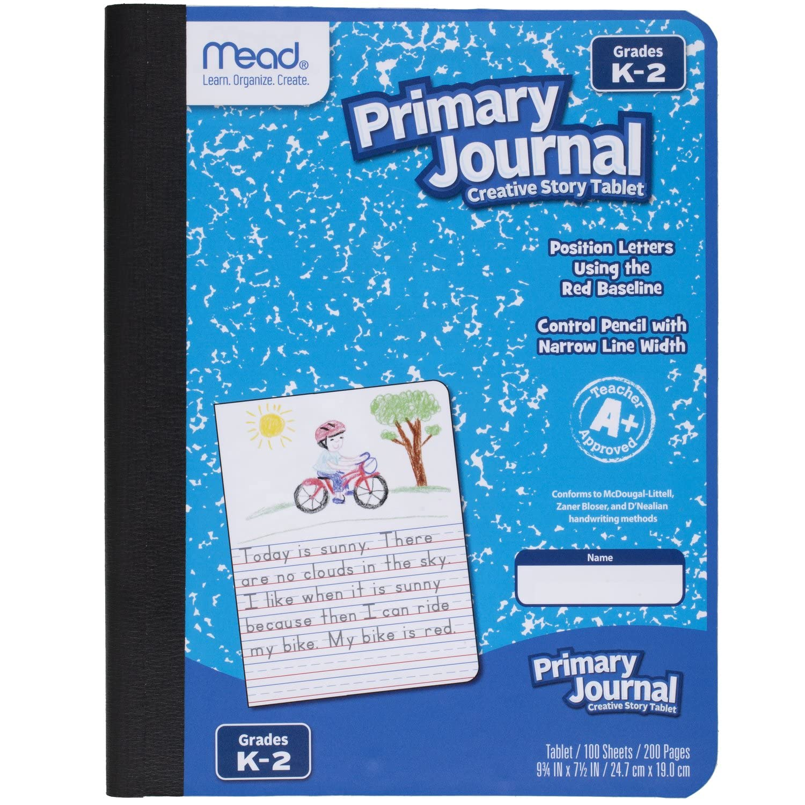 | 2 | Primary Composition Book (there should be space at the top of each page for a picture and writing lines beneath. Any brand will be fine.)
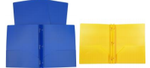 | 2 | Heavy duty PLASTIC 3-prong folders (1 blue and 1 yellow)
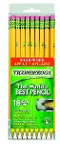 | 1 pack | #2 Ticonderoga pencils (regular, not chubby and pre-sharpened)
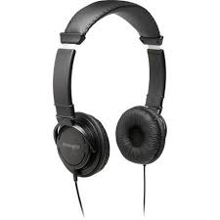 | 1 set | headphones (over the head type, not earbuds, not wireless)
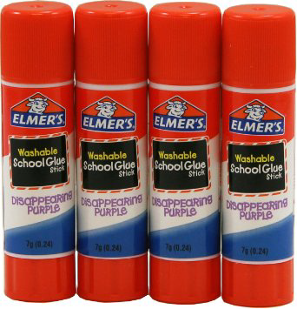 | 4 | jumbo Elmer glue sticks
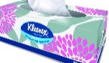 | 1 box | Tissues (family size)
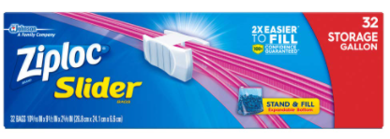 | 1 box | 2.5 gallons
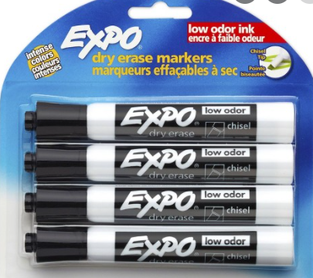 | 3 | 4-packs Expo markers (black only)
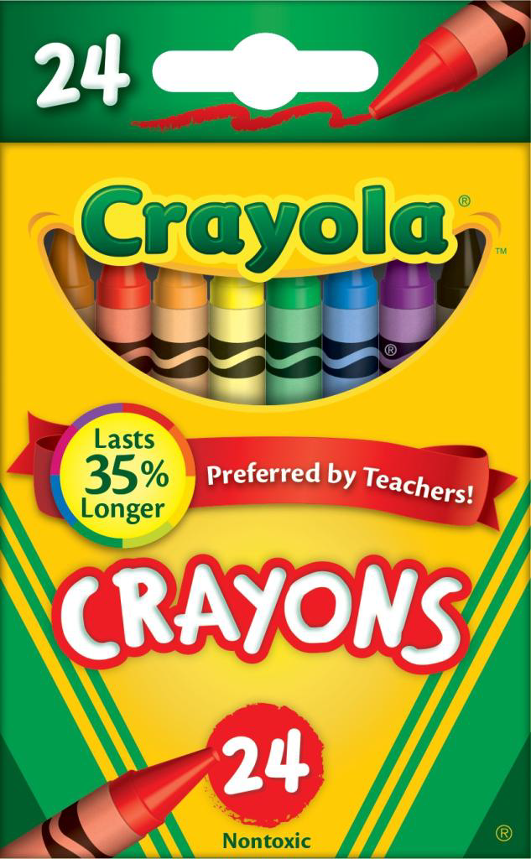 | 3 boxes | Crayola 24 count crayons
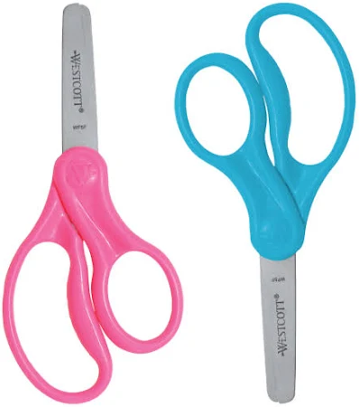 | 1 child scissors | Non pointed style - will be used as a classroom community item. Will not be assigned to individual students and will be kept in a bin.
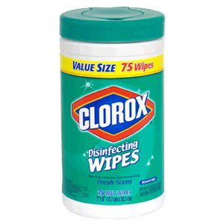 | 1 canister | Clorox/Lysol wipes
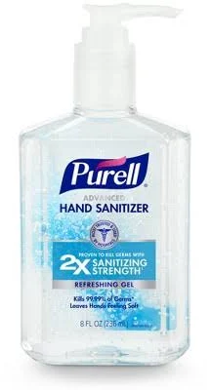 | 1 hand sanitizer | Any brand
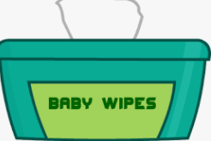 | 1 pack | Baby wipes
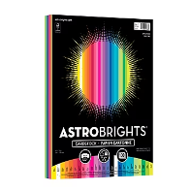 | 1 pack | Multicolor cardstock paper
Students need a regular-sized book bag, change of clothes, including underwear, in a labeled Ziploc bag in their book bag in case of accidental spills.

