MES 4th Grade Supply List 2026-27
 | Quantity | Item
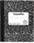 | 4 | Composition Books  (Speckled not Spiral)
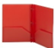 | 3 | 2-Pocket Plastic Folders  (Red, Green, Blue)
 | 36 pack | Pre-Sharpened #2 Pencils  (Ticonderoga Preferred)
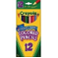 | 1 pack | Colored Pencils OR Crayons  (Crayola Preferred)
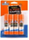 | 4 pack | Glue Sticks  (small)
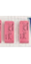 | 1 pack | Erasers  (Cap or Large)
 | 1 pair | Pointed Child Scissors
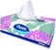 | 3-4 boxes | Kleenex or Puffs Tissues
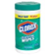 | Boys  1 | Clorox Wipes OR  Baby Wipes  (75 wet wipes or larger)
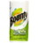 | Girls  2 | Bounty Paper Towels
 | 6 markers | Black Expo Dry Erase Markers
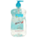 | 1 bottle | Hand Sanitizer
 | 1 | MES Agenda  (Available@ school store)
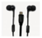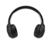 | 1 pair | Earbuds or Headphones
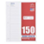 | optional | WIDE-Ruled Paper

