5th MES Supply Order
Please LABEL all items with your child's name!
Item | Quantity | Description
Spiral Notebooks  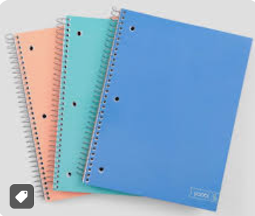 | 1 (math)  1 (science)  2 total | -College Ruled (1 or 3 subject)
Composition Notebooks  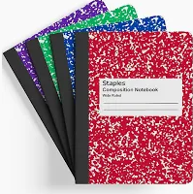 | 1 (reading)  1 (writing)  1 (Social Studies/Misc)
Folders  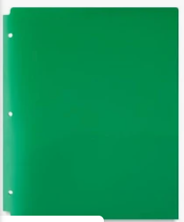 | 1 (Math)  1 (Science)  1 (ELA/SS)  1 (HW/Misc)  1 (Art) | -Plastic with pockets, prongs are not needed  -Try to get one of the following colors red, yellow, blue, green, orange
Pencil Pouch  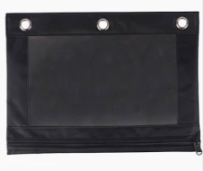 | 1 Pouch | -Prefer pencil pouches, please write name on the outside
Glue Sticks  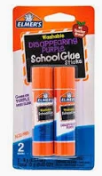 | 1 (2 Pack) | -Prefer Elmers glue sticks
Colored Pencils  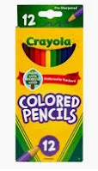 | 1 Pack
Coloring Markers  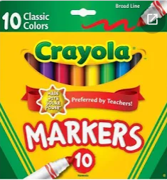 | 1 Pack
Highlighters  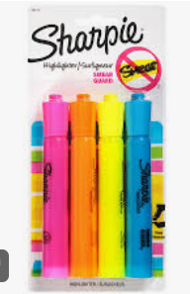 | 1 Assorted Color Pack | -Need yellow, pink, blue, green, and orange
Mechanical Pencils  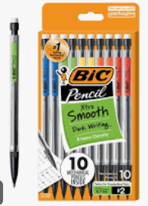 | 1 Pack and Lead | -Mechanical Pencils (pencils and lead)
Scissors   | 1 Pair | -Adult Size, please write your child's name on the blades
Pre-Sharpened Ticonderoga Wood Pencils  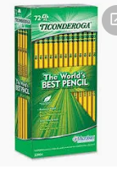 | 1 Pack
Post-It Notes  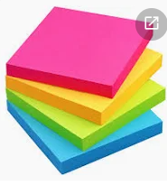  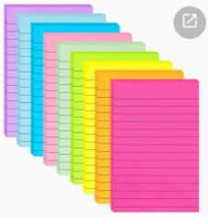 | 1 Pack of Each | -Standard Size unlined (colors student choice)  -Larger Unlined (colors student choice)
Headphones  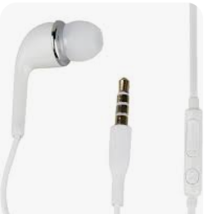 | 2 Pairs | REQUIRED  -2 Pairs with Audio Jack Cable 3.5mm
Pens  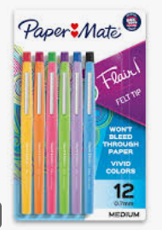 | 1 Pack | -Pens of students choice/color
Expo Markers  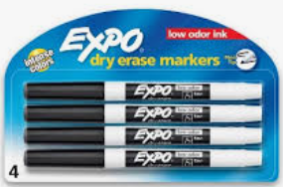 | 1 pack | - 2 or 4 pack of black expo markers
Tissues | 2 Boxes | -If you want to donate more we would love that!
Paper Towels | 1 (2 Pack) | -If you want to donate more than one we would love that!
Clorox Wipes | 1 Container | -If you want to donate more than one we would love that!
Lysol Spray | 1 Container | -If you want to donate more than one we would love that!
Foaming Hand Soap | 1 Container | -Scent of your choice
Ziploc Bags | 1 Box of Each | -Gallon  -Sandwich Bag

Individual Teacher Supply Lists will be provided at Open House

