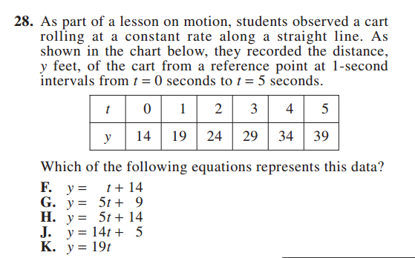
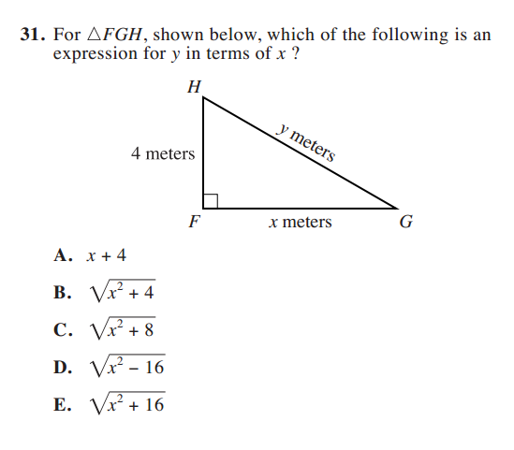
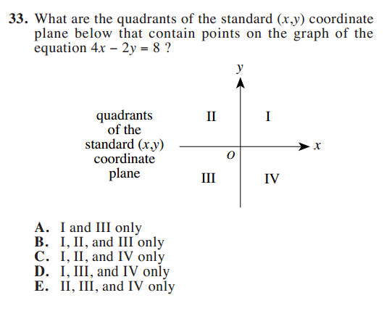
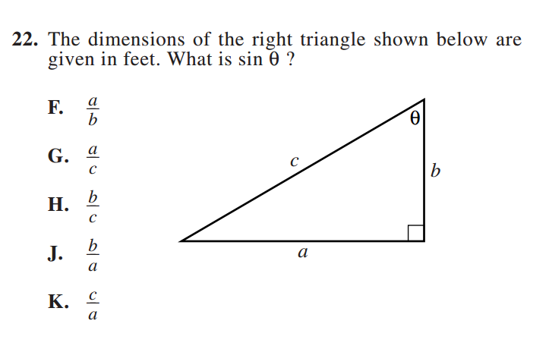
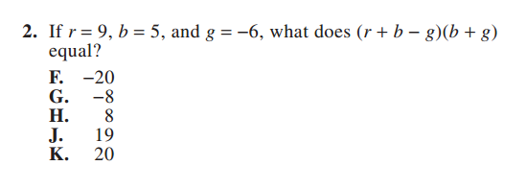
Pre-Algebra
Coordinate Geometry
ACT Math Concepts Tested:
—Pre-algebra (23%) —Elementary algebra (17%) —Intermediate algebra (15%)
—Coordinate geometry (15%) —Plane geometry (23%) —Trigonometry (7%)
Intermediate Algebra
Trigonometry
Elementary Algebra

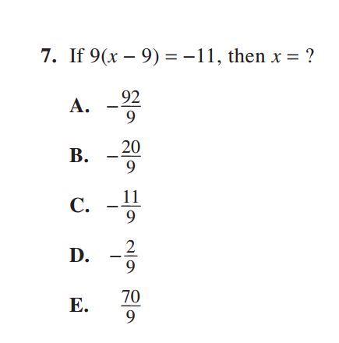

Plane Geometry

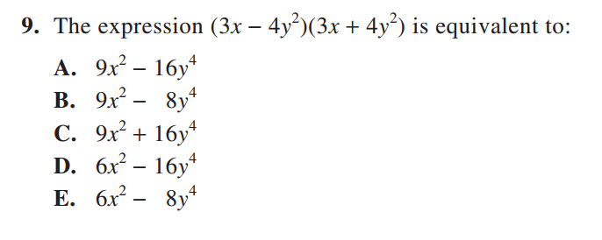

Answer Key + Explanations
2. F
(9 + 5 – (-6)) x (5 + (-6)
(20) x (-1) = -20
7. E
9x – 81 = -11
9x = 70
x = 70/9
9. A
FOIL; recognize that the middle terms will cancel because of the same terms and opposite signs. Make sure to remember exponent rules: when exponents are multiplied, add them.
28. H
Perhaps the fastest way to answer this question is by plugging in the values for t and y to see which equation works. y= 5t + 14 works for all the values in the table.
33. D
Students will need to graph the line, and they can do this easily by putting it in slope-intercept form (y= 2x -4). This line will pass through I, III, and IV.
31. E
Students will need to set up an equation using Pythagorean Theorem (a² + b² = c²). When they do this, they’ll create this equation 4² + x² = y². They then must solve for y, and to do this, they take the square root of both sides, leaving answer E as the correct answer.
22. G
For this trigonometry question, students need to know that sin is opposite over hypothenuse. If they know this, they can easily deduce that the answer is G. It is important to note that students will never have to use the trig functions on their calculators; as the entire test can be done with out one, students are generally asked to set up equations rather than find exact angle measures.

