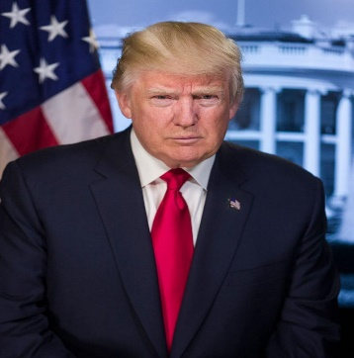
President Donald J. Trump
Commander in Chief

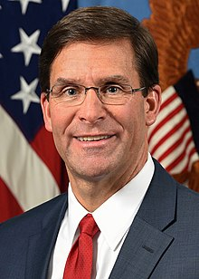

Secretary of Defense
Honorable Mark Esper

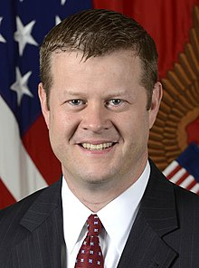

Secretary of the Army
Honorable Ryan McCarthy

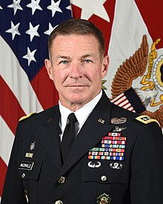
Army Chief of Staff
General James C. McConville

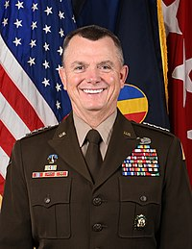

Commander, TRADOC
General Paul E. Funk

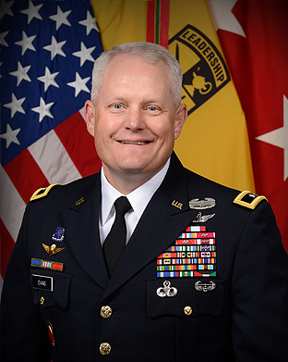

Commander, US Army Cadet Command
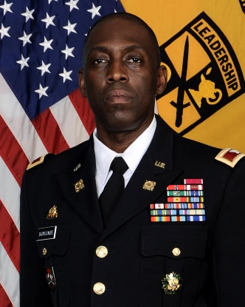
Major General John R. Evans Jr.

4th Brigade Commander, USACC
COL Ferrel J. Duncombe

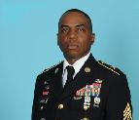
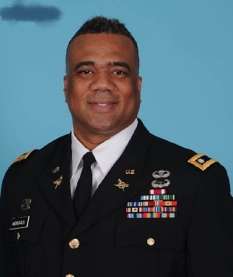

HCHS Senior Army Instructor HCHS Army Instructor
LTC (R) Maurice McDougald 1SG (R) Anthony Cannon

