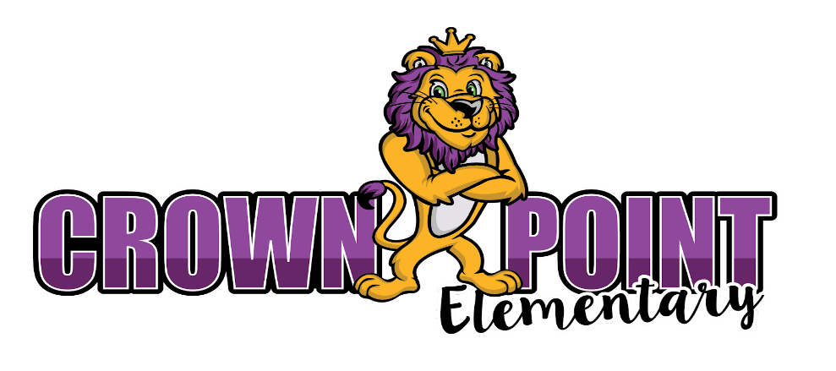
3rd Grade Supply List
2026-2027
- Headphones (mandatory) | - 6 composition marbled books (not spiral bound)
- Scissors | - 3 plastic pocket folder
- 3 packs of white copy paper | - crayons
- 1 pack of index cards | - 2 highlighters
- 3-12 pack of #2 pencils Pre-sharpened preferred | - 8 EXPO (dry erase) markers
- 4 Pink erasers | - 6 boxes of tissues
- ziplock bags (boys- quart; girls- sandwich) | - Clorox Wipes
- band aids | - 2 Hand sanitizer with pump
- 2 rolls of Paper towel | - Bag of nut free candy
- 1 pack of notebook paper | - Recorder (instrument for music)

**SUMMER PRACTICE**
- Memorize addition and subtraction facts; multiplication facts
- Read chapter books of all genres to build stamina, vocabulary, and comprehension

