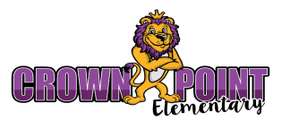
1st Grade Supply List
2026-2027
● Headphones (No Bluetooth or Earbuds) | ● 4 composition notebooks – wide ruled (no spiral)
● 2 - 24 pack of Crayons | ● 1 pair of scissors (blunt tip)
● Index Cards (4x6 or 3x5) | ● 2 packs of dry erase markers and eraser
● 1 - 4 pack Glue sticks | ● 24 pack pencils (pre-sharpened preferred)
● White copy paper | ● 3 Boxes of Kleenex
● Large Erasers | ● 2 - Hand sanitizer
● Plastic Pocket folders: 2 red, 2 blue | ● 2 - Clorox wipes/spray
● 2 boxes Band-Aids (assorted sizes)

**SUMMER PRACTICE**
● Practice letter names and sounds
● Write first and last name
● Count out loud to 100
● Read and write numbers to 20
● Read environmental print (signs, labels, boxes, etc.) and beginner books
- Tying Shoes
- Opening water bottles/lunch containers/milk cartons

