Examples

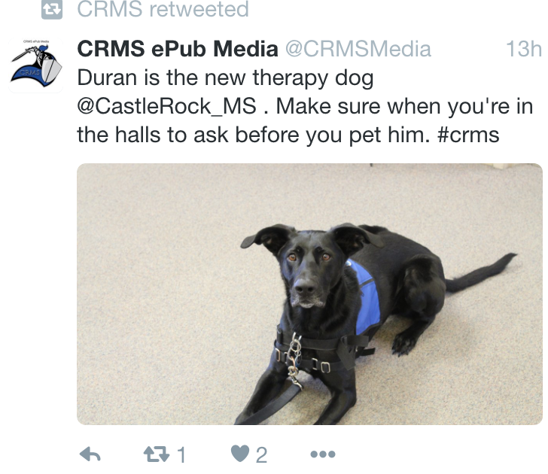

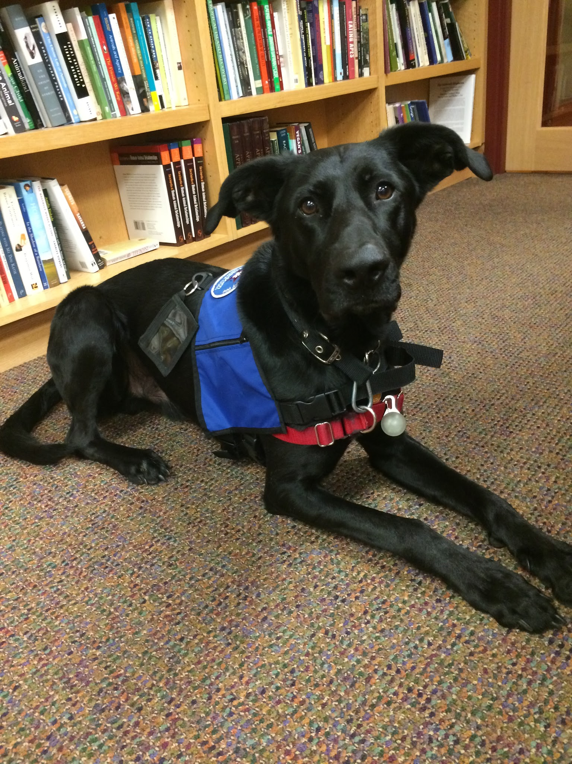
Hello,
my name is Duran!

I am a Professional Therapy Dog.
Please always ask to pet me!
Thank you!!

