Germantown Middle School
School Supply List 2026-2027
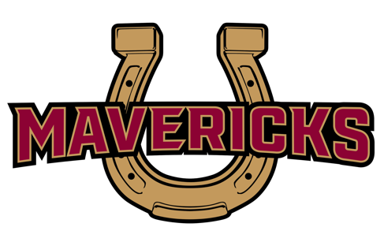
7th Grade

Students will turn in the following items to their 1st block teacher during the first week of school:
- 1 pack of #2 pencils
- 1 pack of notebook paper (college-ruled)

Students will keep the following items in their backpack for their own use:
- 1 Calculator – basic 4 function, not scientific calculator ($1.00-5.00)
- 2- 2” Binders: 1 for ELA & Math to share; 1 for all other subjects
- 2 packs of 8 dividers
- 1 pack of 24 #2 pencils
- 1 pack of assorted color pens
- 1 pack of highlighters
- 1 pack of pencil sharpener (handheld)
- 1 box of colored pencils
- 1 pack of Notebook paper (college-ruled)
- headphones- Standard 3.5 mm wired earbuds that are compatible with Chromebooks (no Bluetooth)

Students will also be responsible for the following:
$25 Chromebook fee payable at myschoolbucks.com
$35 workbook fee payable at myschoolbucks.com
*Some classes may require additional supplies or fees.

