9

California schools are required to check immunization records before school entry. The following immunization requirements must be met before a student can enroll/attend school. These requirements must also be met when a student transfers to a new school, starts Preschool, Transitional Kindergarten, Kindergarten and/or 7th grade.

WHAT YOU NEED:
At registration, you will need an immunization record showing that your child has received all of the required immunizations. The following are acceptable forms of proof:
1. The California Immunization Record
2. Another form of immunization record from your doctor with the date each immunization was given to your child
At minimum, the record must show the month and year of each immunization. You may need to call your doctor or clinic to obtain this documentation.
- Titers do not meet this requirement and therefore cannot be used as proof of immunization.

REQUIRED IMMUNIZATIONS PER STATE LAW:

IMMUNIZATION | DOSE(S) | NOTES
Polio | 4 doses | - Oral poliovirus vaccines (OPV) given on or after April 1, 2016 no longer count toward school requirements.  - 3 doses OK if one was given on or after 4th birthday
DTaP | 5 doses | - Tdap or Td if age 7 years or older  - 4 doses OK if one was given on OR after 4th birthday or for students enrolling in preschool  - 3 doses OK if the last one was given on or after 7th birthday.  - At least one dose must be Tdap or DTaP/DTP given on or after the 7th birthday for all 7th – 12th graders
Hepatitis B | 3 doses | - Not required for 7th grade entry
MMR | 2 doses | - Both doses given on or after 1st birthday  - 1 dose OK for preschool enrollment
Varicella  (Chickenpox) | 2 doses | - History of disease is NOT sufficient to waive this immunization.  - A Permanent Medical Exception for Immunization(s) is required (CAIR-ME)  - 1 dose OK for preschool enrollment
Tdap (For 7th/8th grade) | 1 dose | - Or DTP/DTaP given on or after the 7th birthday
Hib  (For Childcare/Pre-K only) | 1 doses | - One dose to be given on or after the 1st birthday  - Two doses OK if age < 14 months

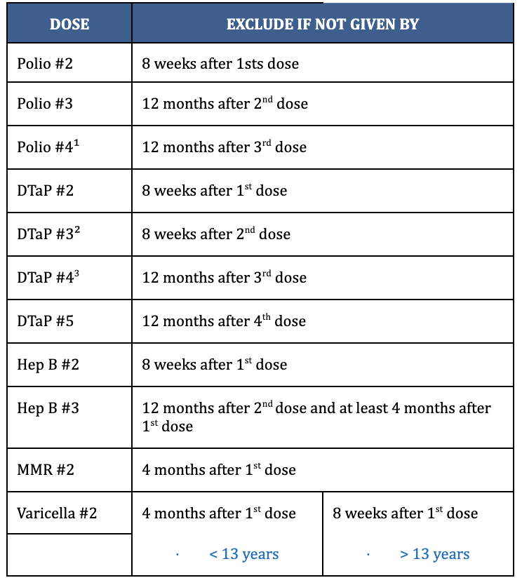 | Has your child received all the required immunizations? If not, please make an appointment with your doctor or the San Diego County Public Health Department’s immunization clinic. Take your records with you to this appointment. If your child’s immunizations are not up to date when school starts, your child, by law, will be excluded from school.  Conditional Admission Schedule for Grades EAK/TK/K-12  Before admission, a child must obtain the first dose of each required vaccine and any subsequent doses that are due within the period of time allowed before exclusion has elapsed.  Personal Belief Exemptions (PBE)  PBE’s are NO longer accepted  Medical Exemptions  A medical exemption (temporary or permanent) issued through CAIR-ME, completed and printed by your child’s physician (MD or DO licensed in California), if any of these immunizations were not given to your child because of medical reasons.  - Temporary medical exemptions shall not exceed twelve calendar months from the date of the licensed physician’s written statement

