Kindergarten Newsletter
May 11-21, 2026
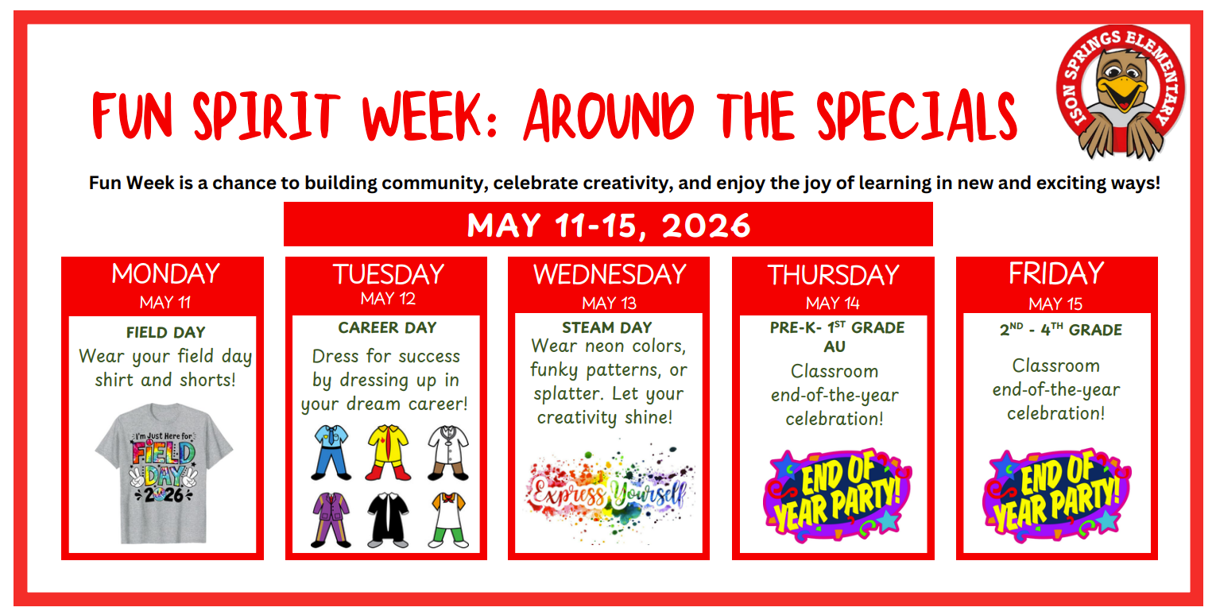
Additional School Information
Please complete the following forms (these may be sent to your email):
- Parent Input Form
- Census
- Intent Form
Goodbye, Kindergarten!
Hello, First Grade!
We have loved having you in kindergarten. We will be sending all supplies, projects, schoolwork and books home starting next week. Please be sure to send all library books back to school and check your lunch accounts for any outstanding balances. Lastly, No backpacks at school on the last day of school, Thursday, May 21, 2026.
We hope you have an AMAZING SUMMER!

