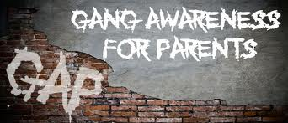

You are invited to join us for
Parent/Guardian Night
Gang Awareness
Where: Kent County Secondary Intensive Learning Center
631 Ridgely Street, Suite 19
Dover, DE 19904
(302) 736-5355
Date: Thursday, February 27, 2020
Time: 5:30 -7:00pm
A light dinner will be provided.
RSVP is requested.

