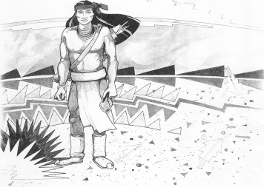
Cochise School District No. 26

5025 N. Bowie Ave.
P.O. Box 1088
Cochise, AZ 85606

(520) 384-2540 (520) 384-4836 Fax
Karl Uterhardt, Superintendent

NOTICE & AGENDA OF GOVERNING BOARD MEETING
COCHISE ELEMENTARY SCHOOL DISTRICT NO. 26

Notice is hereby given that the School District Governing Board will hold a public meeting on
May 6, 2026, at 6:00pm in the Cochise Elementary School Library.
The agenda for the meeting is as follows:

I. Call to Order Time _________

- Pledge of Allegiance to the Flag

- Adoption of Agenda Motion ____/____Vote____

- Call to the Audience (3 minute limit)

- The Governing Board may vote to go into Executive Session under A.R.S. 38-431.03 (A)(3) to receive legal advice either in person or telephonically, on any item on the Consent or Action agenda.

VI. Consent Agenda
- Approve minutes of Regular Meeting of April 1, 2026
- Approve fund balances report for April 2026
- Approve vouchers #21-22 (Payroll) & #2621-2622 (Expense) Motion ____/____Vote____

- Action Agenda
- Approve FY26 Expenditure Budget Revision #1 Motion____/____ Vote____
- Approve Cochise School Financial Audit for Fiscal Year 2025 Motion____/____ Vote____
- Approve policy advisories 917-960 second reading Motion____/____ Vote____
- Approve Classroom Site Fund payment for all eligible teachers
to be paid on May 22, 2026 Motion____/____ Vote____
- Approve superintendent performance pay for FY26 Motion____/____ Vote____
- Approve FY27 St. David Consortium for special services Motion____/____ Vote____

VIII. Summary of reports about current events
A. Superintendent’s Report
1. May calendar of events: May 7th K-8 art show 12-3pm, May 12th 2nd grade wax museum, May 15th Alumni volleyball game, May 19th field day 1230pm, May 20th Kindergarten promotion 1pm, May 21st 8th grade promotion 4pm, May 22nd Last day of school awards ceremony, Cochise School Office will be closed May 25-29.
2. Next Board meetings: June 24, July 8, August 5
B. Governing Board member’s report

IX. Adjourn Motion ____/____Vote____ Time ____

