ENHANCED CONTINUOUS PROVISION AT THE REGENT SCHOOL ABUJA

Rebekkah Lewis
EYFS Coordinator
A

t The Regent School Abuja, continuous provision is not simply a feature of our classrooms; it is the core structure through which teaching, assessment, and learning are delivered. Our approach is distinctive because it is intentionally designed, consistently implemented across classes, and closely aligned to measurable outcomes for children. Continuous provision at Regent is thoughtfully planned with the expectations of our parent community in mind, recognising that families entrust us with both the academic progress and holistic development of their children. We therefore ensure our environment reflects high standards, purposeful learning, and visible progression, providing reassurance that play based learning is both rigorous and impactful.
Purposeful Environment Design: Every learning area is mapped to curriculum goals and developmental progression. Resources are organised, labelled, and accessible so children can independently select, use, and return materials, building executive functioning and responsibility. Enhancements are added daily, when needed, in response to assessment evidence, ensuring that each area provides challenge, extension, and clear learning intention. As Loris Malaguzzi stated, “The environment is the third teacher,” and in our setting this principle is enacted through careful planning rather than decoration. Parents often comment on the clarity and intentionality of our classroom environments, noting how visibly learning is embedded within play.
Skilled Adult Interaction: What makes our provision particularly strong is the quality of adult engagement. Staff are trained to observe first, assess quickly, and intervene purposefully. Interactions focus on extending language, deepening thinking, and modelling strategies rather than directing play. This ensures children remain active agents in their learning while still benefiting from explicit teaching. The consistency of this approach across our department means children experience a shared pedagogy regardless of class, while parents see continuity in expectations and outcomes.

Structured Planning Linked to Assessment: Planning operates as a live cycle: observe → assess → adapt provision → interact → review. Observational assessment informs next steps for individuals and groups, which are then reflected directly in provision enhancements and adult deployment. This tight link between assessment and environment ensures teaching is responsive and personalised. It also provides parents with clear, evidence-based insight into their child’s progress, strengthening home-school partnership and confidence in our approach.
High Expectations and Measurable Outcomes: Our continuous provision model reflects ambitious expectations for every child. Literacy, mathematics, communication, and problem solving are embedded intentionally across all areas rather than taught only in formal sessions. As a result, children demonstrate sustained engagement, independence, collaboration, and confident communication. These observable behaviours provide clear evidence of progress and readiness for the next stage of learning, aligning with both developmental best practice and parental aspirations for strong academic foundations.
A Model for Professional Training: As a training environment, our classrooms also serve as demonstration spaces for best practice. Trainees and visiting educators observe structured provision, intentional interaction, and assessment led planning in real time. Staff articulate their decision-making processes, allowing trainees to see not only what effective practice looks like, but how and why it works. This reflective professional culture positions our setting as a strong contributor to international dialogue on Early Years pedagogy.
In essence, the strength of continuous provision at The Regent School Abuja lies in its clarity, consistency, and shared purpose. It is carefully planned, deliberately taught, and continually refined through reflection and evidence. This collective understanding - shared by staff, children, and families alike - ensures that provision is not simply a choice of activities, but a coherent, high expectation teaching approach that secures strong outcomes while modelling exemplary practice for educators.

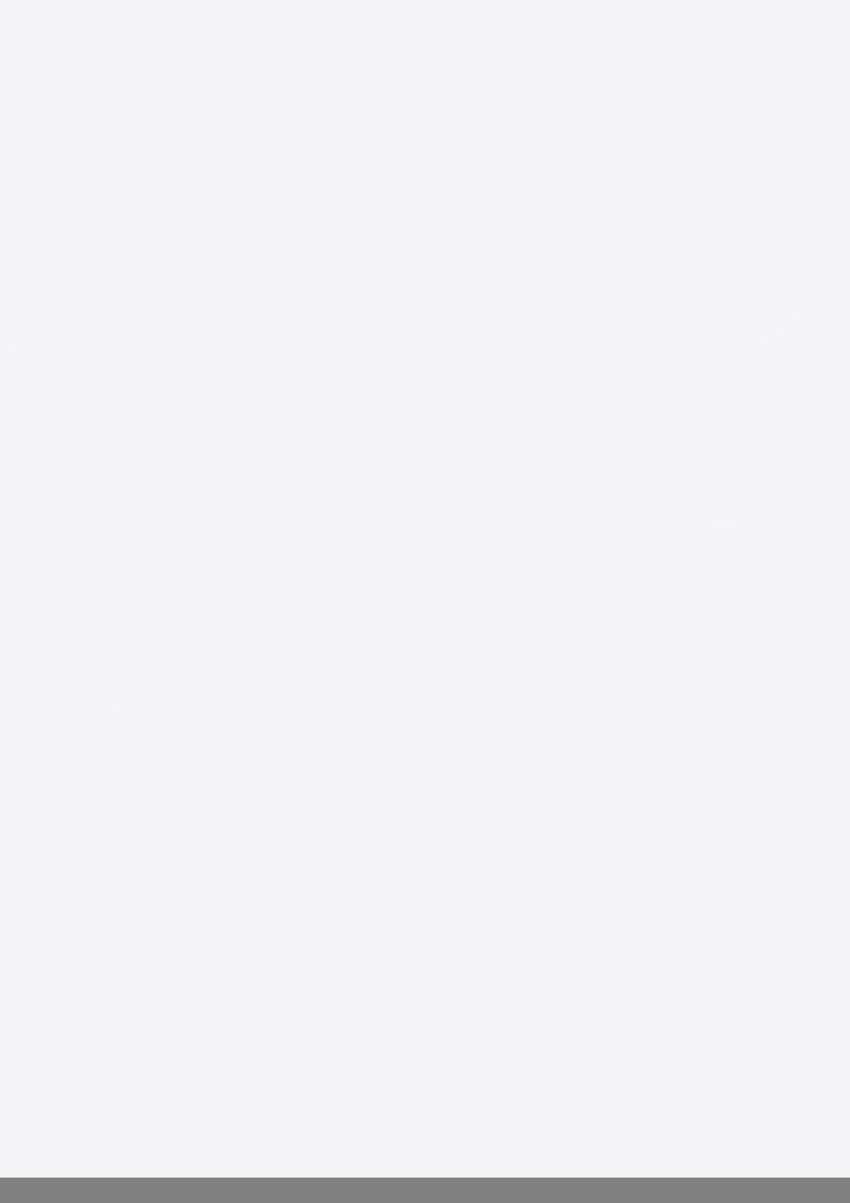

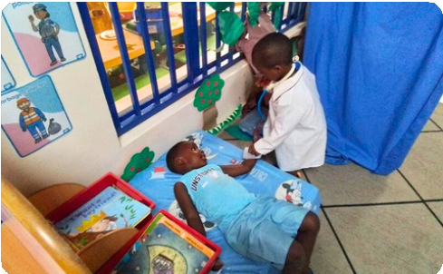
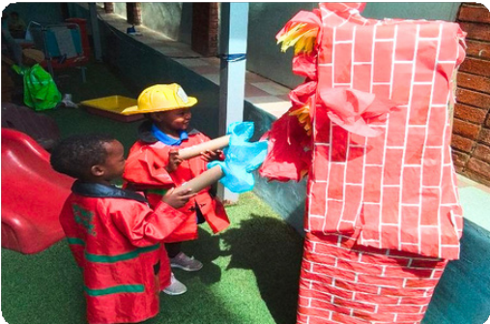

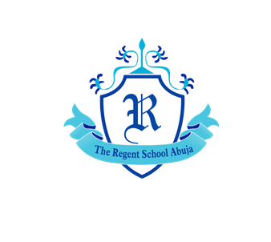
THE REGENT SCHOOL ABUJA

