
Operations & Maintenance Plan
Bioretention / Raingarden, Tree Trench

BMP ID Location
Edison Senior High School

Owner Date
Minneapolis Public Schools xxxxx

Inspector

Metro Blooms

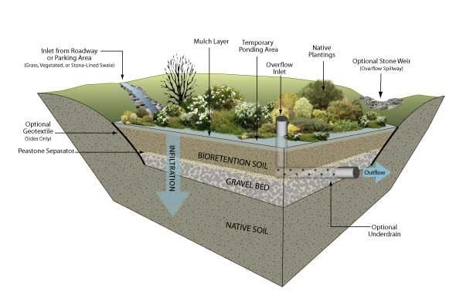

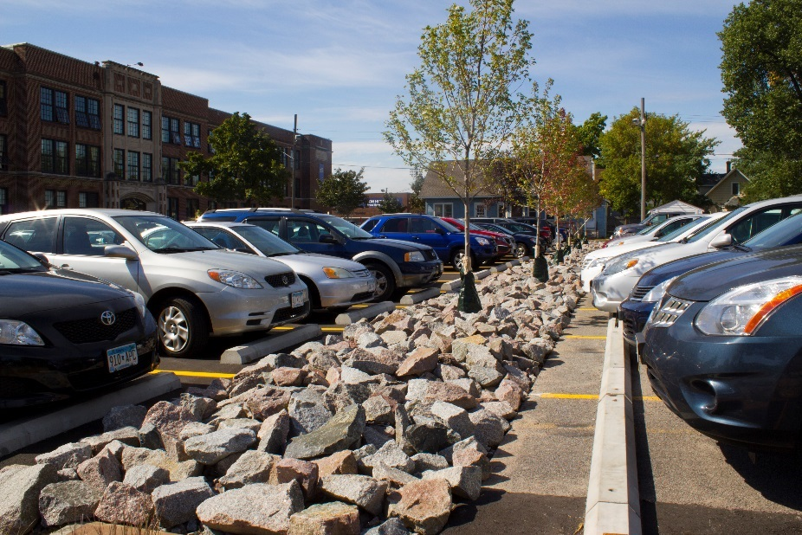

Overview of Bioretention / Raingarden, Tree Trench

Bioretention Operations:

Bioretention works by routing stormwater runoff into shallow, landscaped depressions. These landscaped depressions are designed to hold and remove many of the pollutants in a manner similar to natural ecosystems. During storms, runoff ponds above the surface (mulch, landscape rock) and subgrade (engineered soil/rock mix) in the system. Runoff from larger storms is generally diverted past the facility to the storm drain system. The runoff remaining in the bioretention facility filters through the subgrade. The filtered runoff can either be designed to enhance groundwater infiltration or can be collected in an underdrain and discharged per local stormwater management requirements.

Bioretention Inspection:

Inspection of the rain garden and tree trench are required once per year during the growing season (March - November).
During inspection, the following should be noted on the inspection form:
- Presence of any trash, debris, and soil accumulation
- Presence of weeds
- Presence of invasive plants or weeds (Canada Thistle, Garlic Mustard and any tree seedlings)
- Condition of plants (note any plants that appear to be dead or dying)
- Condition of overflow structure
- Visible indication of clogging or overtopping

Bioretention Maintenance:

Routine maintenance shall be done as prescribed in the approved plan, and when an inspection reveals any of the following conditions:
- Trash, debris and soil accumulation – remove material
- Presence of weeds – remove weeds
- Presence of invasive plants or weeds (Canada Thistle, Garlic Mustard and any tree seedlings) – remove invasive plants
- Dead or dying plants or trees – replace dead or dying plants or trees
- Overflow structure in need of cleaning (e.g., grate covered with grass/leaves) – clean overflow structure
- Damage to the inlet structure – repair inlet

Operations & Maintenance Plan
Permeable Pavers

BMP ID Location
Edison Senior High School

Owner Date
Minneapolis Public Schools xxxxx

Inspector

Metro Blooms

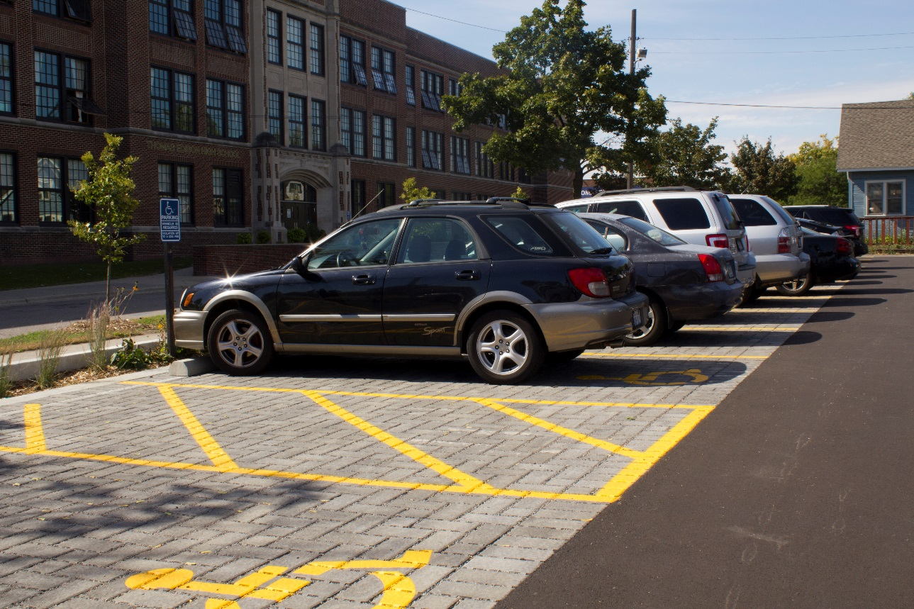

Overview of Permeable Pavers

Permeable Paver Operations:

Permeable pavers are designed to reduce stormwater runoff by allowing water to drain through the spaces between the pavers. Water then moves to a layer of coarse gravel. It is temporarily stored in spaces between rocks underneath the pavers until it moves to the surrounding soil. The soil naturally removes pollutants such as phosphorus, nitrogen, and heavy metals from the water. This helps prevent these and other pollutants from entering our lakes and streams where they can cause unwanted algae and degrade water quality.

Permeable Paver Inspection:

Inspection of the permeable pavers required once per year. During inspection, the following should be noted on the inspection form:
- Presence of weeds growing between the pavers
- Presence of trash, debris, leaf, or sediment accumulation between the pavers
- Damaged pavers
- Loss of fill material between the pavers
- Standing water on or between the pavers 48 hours or more after a rainfall

Permeable Paver Maintenance:

Routine maintenance shall be done as prescribed in the approved plan, and when an inspection reveals any of the following conditions:
- Presence of weeds growing between the pavers – remove weeds by the roots. Do not use herbicide as it may infiltrate into the groundwater.
- Presence of trash, debris, leaf, or sediment accumulation between the pavers – vacuum sweep the pavers to remove the accumulated material. Replace the aggregate fill between the pavers.
- Damaged pavers – repair damage or replace pavers
- Loss of fill material between the pavers – replace the aggregate fill between the pavers.
- Standing water on or between the pavers 48 hours or more after a rainfall – this is an indication that the pavers are not functioning as designed, likely due to a larger problem that will require further study and action
- Annually – vacuum sweep the pavers to remove any accumulated material between the pavers. Replace the aggregate fill between the pavers.

