

Rashida Armstrong
Principal

Shamika Key
8th Grade Assistant Principals

BEAR CREEK MIDDLE SCHOOL
7415 Herndon Road

Fairburn, Georgia 30213

(470) 254-6080 Fax: (470) 254-3584

January 9, 2026
Dear Parents and Guardians,
The final year of middle school is a special time for the Class of 2026, and we’re excited to provide memorable experiences and traditions to make this year unforgettable!
We have several field trips and end-of-year activities planned for our students. To make these events possible, we ask that 8th graders begin making payments.

Payment Information
- Total 8th Grade Dues: $300
- Payment Deadline: April 10, 2026
- Payments must be made through the Online Payment System (OSP).
Before making any payments, please complete the following link to acknowledge the discipline and eligibility requirements:
8th Grade End of the Year Activities Acknowledgement Form – Fill out form
A detailed breakdown of the calendar of events, costs and important notes are listed below.
Important Notes
- Refunds: Refunds are not available for students who become ineligible after payment. However, they will still receive their T-shirt and attend the awards ceremony.
- Discipline Requirements for 8th Grade Activities:
Starting February 1, 2026, any student who receives two or more suspensions (including out-of-school or in-school suspensions) or is expelled prior to the start of activities will not be permitted to attend any 8th Grade activities, with the exception of the Awards Ceremony.

Academic Requirements
- Students must maintain a minimum average of 70% in all classes to participate in activities (except for the awards ceremony).

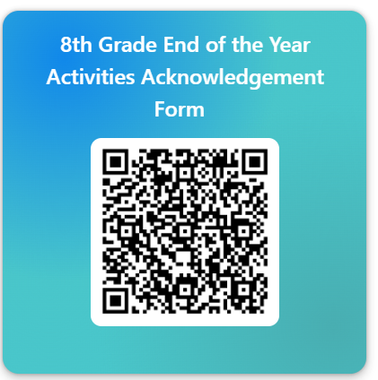
Class Calendar & Fees
- May 8 (Fri): 8th Grade Dance – $50
- May 11 (Mon): 8th Field Day
- May 12 (Tue): Bowling – $30
- May 13 (Wed): Skating – $30
- May 14 (Thu): Six Flags Over Georgia – $80
- May 15 (Fri): Carnival/Cookout – $60
- May 20 (Wed) Graduation: Creekside High School/Stole, Adwards, etc.. – $30
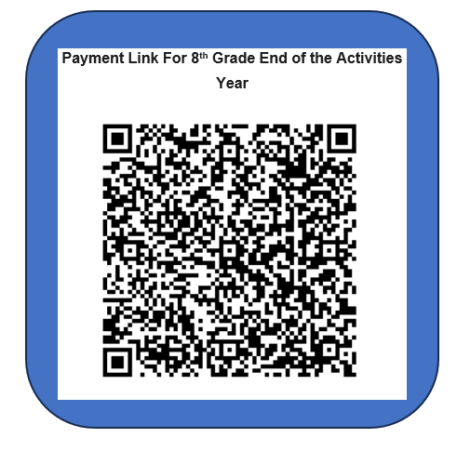
- 2026 Class T-Shirt: $20

On the right are the QR codes for the required form and payments:
- Acknowledgment Form: Complete the form before making any payments.
8th Grade End of the Year Activities Acknowledgement Form – Fill out form

- Online Payment System (OSP): Use this link to submit your payment.
Online Payment System(OSP) 8th Grade Activities

For questions or concerns, please contact Mr. Stallings at stallingsj@fultonschools.org.
Thank you for your support in making this a fantastic year for our 8th graders!
– The 8th Grade Team

