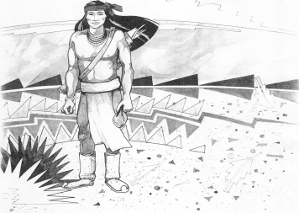
Cochise School District No. 26

5025 N. Bowie Ave.
P.O. Box 1088
Cochise, AZ 85606

(520) 384-2540 (520) 384-4836 Fax
Karl Uterhardt, Superintendent

NOTICE & AGENDA OF GOVERNING BOARD MEETING
COCHISE ELEMENTARY SCHOOL DISTRICT NO. 26

Notice is hereby given that the School District Governing Board will hold a public meeting on
April 1, 2026, at 6:00pm in the Cochise Elementary School Library.
The agenda for the meeting is as follows:

I. Call to Order Time _________

- Pledge of Allegiance to the Flag

- Adoption of Agenda Motion ____/____Vote____

- Call to the Audience (3 minute limit)

- The Governing Board may vote to go into Executive Session under A.R.S. 38-431.03 (A)(3) to receive legal advice either in person or telephonically, on any item on the Consent or Action agenda.

VI. Consent Agenda
- Approve minutes of Regular Meeting of March 4, 2026
- Approve fund balances report for March 2026
- Approve vouchers #19-20 (Payroll) & #2519-2520 (Expense)
- Approve policy advisories 917-960 first reading
- Approve Continuing Resolution to invest County Treasurers Office Motion ____/____Vote____

- Action Agenda
- Approve agreement between Cochise ESD and EHP Essentials Health
Plan for employee wellness benefits Motion____/____ Vote____
- Approve medical insurance contribution amount of $1,650 for FY27 Motion____/____ Vote____
- Approve FY27 contract for Ms. Candy Acuna, Business Manager Motion____/____ Vote____
- Approve FY27 certified teaching contracts for:
Mrs. Aten, Mrs. Martinez, Mrs. White, Mrs. Graham, Ms. Estrella,
Mr. Ochoa, Ms. Hirshouer, Mrs. Mascarenas, & Mrs. Oscar Motion____/____ Vote____
- Approve FY26 non-certified Letters of Intent for:
Ms. Peterson, Mr. D. Brown, Mrs. Williammee, Mr. AJ Brown,
Mrs. Cavey, Mr. C. Ochoa, Mrs. Kauffman, Mrs. Retana, and Ms. Hake Motion____/____ Vote____
- Approve Mrs. Sara Paz, teaching contract for FY27 school year Motion____/____ Vote____

VIII. Summary of reports about current events
A. Superintendent’s Report
1. April calendar of events: AASA testing begins March 30, two track meets 4/9 & 4/30
2. Next Board meetings: May 6, June 24, July 8
B. Governing Board member’s report

IX. Adjourn Motion ____/____Vote____ Time ____

