SCHOOL/DEPARTMENT REPORT TO THE TRSB – APRIL 17, 2014
Atkinson Academy
- Atkinson Academy hosted author Jason Chin a local author from Vermont. He visited the Redwood forest in California and was inspired to write about the redwood trees. He spent the day with all classes talking about how to write a good book.
- On Sunday, April 13th, the school partnered with the Atkinson Lions Club for a delicious pancake breakfast. The student council helped serve along with the staff. A great time was enjoyed by all.
Danville Elementary
- The girls at Danville enjoyed dancing with favorite males at the annual Father/ Daughter dance! The beginning orchestra and band had their concert at the PAC. The Danville Chorus also performed. All of our musicians did a wonderful job!
- Mid-year assessments in reading in math are showing positive growth for the most part. Teachers continue to find creative ways to differentiate the curriculum to meet the needs of every learner. The Annual Academic Fair is April 24 and we invite you to join us between 5:30-7:00 pm.
Pollard School
- April 2nd, as part of Autism Awareness Month, Pollard held our 2nd Annual Acceptance Day. Pollard students and families signed Acceptance Day Pledges. The goal of Acceptance Day is to recognize how special each person is no matter their beliefs, abilities, or other characteristics.
- Congratulations to Derek Coyle, Grade 3 From Dayna Rodriguez’s class. His art work will be featured in the NH Fire Safety 2015 Calendar. There will be a ceremony at the Fire Academy, 6:00-8:00PM on Tuesday, April 22. His Poster was on Generator Safety.
- Elizabeth LaRosa, Kindergarten Teacher at Pollard School was nominated for the 2015 Teacher of the year sponsored by the NHDOE and Hannaford. She was honored, along with 34 other nominees, on April 8th in Concord. She was just informed that she was not a finalist but she is #1 in our book!
- As part of the PTA Auction, Dr. Metzler was bid on and Ms. Foss’ TLC 4 year old class won! Dr. Metzler read to the class and even sang a bit!
- Saturday, April 12th was our second annual Run of the Savages 5K race…over 330 people finished the race and so many local businesses donated in some way to make this happen. We just want to thank everyone that participated.
- Celebrating Art compiles student art work each year. This year we had 7 students make the Fall 2013 edition. Students were in grades 3-5…We have to book tabbed for easy viewing. The seven students were: Diego Robles, Emma Soucy, Kathleen Smith, Trysta Winkowski, Kendall Morrill, Ellie Kennedy, and Annika Smith.
- Pollard held a Safe Routes to Schools LOGO contest. The winner, Michael Hollow-Grade 5 in Mrs. Coyle-Quirk’s class, will have his logo featured on traffic signs around the school.
- 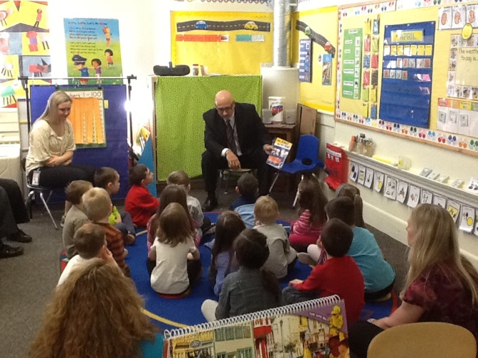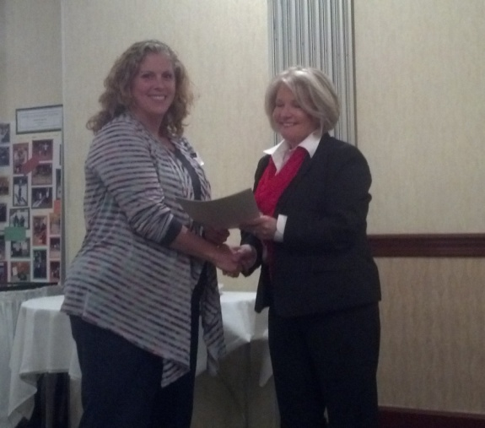
- 
Sandown Central
- All District Elementary Concert Wednesday, April 16th at 7:00PM at the PAC. (Beginning Strings and Band)
- Guidance counselor from TRMS meeting with grade 5 students at Sandown Central April 17th 12:30 – 1:30 to review services for the students at the middle school.
- Arts Night at Sandown Central Music and Displayed Art work from the students April 23rd 6:00- 7:00.
- Grade 5 DARE Graduation – May 15th at 6:00 pm Sandown Central School.
- Grade 5 Freedom Trail Field Trip –May 22
- Distance learning with the middle school students and grade 5 on June 5th 10:00- 10:30.
- Lip Sync – At Sandown Central School June 12th 6:30
- Move Up Day grade 3 from Sandown North to grade 4 Sandown Central and grade 5 to the middle school on June 13th
- Eagle Scout presentation to the School Board on April 17th “New Sign” for Sandown Central School. (Mr. Rolph and Jake Chaput Eagle Scout)

Sandown North
- On Saturday, April 12th, the Sandown PTA Pancake breakfast was held at Sandown Central. It has really become an annual family event with alumni looking forward to seeing each other and reconnecting with those whom they don’t get to see on a regular basis.
- Kindergarten screening has been happening this week, on Tuesday, Wednesday, and Friday. It’s a wonderful opportunity for us to meet our new families and to talk to all parents about their child who will soon be in our school. The energy and excitement about being in the “big school” can be felt in the air.
- On the 16th, our string students participated in the All-District elementary Concert for first year students. It is thrilling for them to be on stage at the PAC and share what they have accomplished with those in the audience. We are so fortunate to have such a fabulous venue to showcase their talents!
- Our Leadership Team has been taking a close look at where we are in achieving our goals and what the most recently collected data is showing us.
- Author/ illustrator David Biedrzycki visited Sandown North on April 16th. Mr. Biedrzycki has written and illustrated “The Ace Lacewing: Bug Detective” series as well as the picture book Me and My Dragon. He has also illustrated several books with author Jerry Pallota including, Dory Story, Who Will Guide My Sleigh Tonight?, The Beetle Alphabet Book, and The Freshwater Alphabet Book. Mr. Biedrzycki presented to kindergarten, first, and second grade students over the course of the day. His presentations captured the students’’ attention. He shared his work with enthusiasm, exciting our students to want to write more.
- Our children practiced bus evacuation with their driver and staff members on Tuesday. They practiced what to do in the case of an emergency so they can exit the bus quickly and be safe.
Middle School
No report submitted.
High School
- April 10 – Career Day - The sophomore class (337) was exposed to career possibilities in Agriculture, Architecture, Arts, Business, Education, Engineering, Finance, Government/Politics, Health Science, Hospitality/Tourism, Human Services, Information Technology, Law/Public Safety, Manufacturing, Marketing, and Science/Technology. Photos can be viewed - http://trsd.phanfare.com/6482895
- April 12 - Project Hope Group led by Meg Guanci was able to raise $15,000 at this year’s event and exceed their goal of $50,000 in 5 years!
- April 19 - Relay for a Cause will take place this Saturday from 12:00pm -8:00pm on the HS track this is a school-wide community service event with the help of the PTSA. Teams will be made up of eight students &/or staff and will be responsible to have one member walking the track every hour. All proceeds to benefit two local food banks and Mealey Meals.
- April 22 - Early College Planning seminar will be held at the PAC 6:30 pm by the guidance department, along with NHHEAF presenter Val Castonguay, presentation for parents of K-8 students. College planning and savings basics will be a main focus of the presentation.
- April 24 – Rho Kappa (formerly Historical Honor Society) puts on a major event in the high school gym, a world’s faire, which highlights global cultures, societies, religions, and historical periods. This year, the theme is myths of societies throughout time and space. We are highlighting the myths and stories of various cultures from the Celts to the Norse to Native Americans, to the Greeks and Romans. Students will experience lessons, games, activities, and food of the cultures being studied.
Athletics
- No report submitted.
Performing Arts
- .

