SCHOOL/DEPARTMENT REPORT TO THE TRSB – JUNE 19, 2014
Atkinson Academy
- Atkinson third graders performed an awesome play, Pirates on Grammar Island, at the PAC on Thursday, June 12. All students participated in the musical under the direction of the third grade teachers, Nicole Shawley, Lynne Ouellette, Karen Bresnahan and Katie Hutchinson. Two other performances were held on Friday.
- Atkinson was proud to honor two PTA scholarship winners, Jordyn Earley and Caroline Casey at the Monday Morning Meeting along with Timberlane graduate Ashley Highim, who volunteered three times a week helping with various clerical tasks.
- An all school field Day was held at the Woodlock Fields on Tuesday with many fun activities culminating in a big kickball game, students against staff.
- Fifth grade celebration will be held on Wednesday night with the final good-bye to our fifth graders at 11:50 am as they take their last walk through the halls before boarding the buses.
- Wishing everyone a great summer vacation.
Danville Elementary
- Danville students ended the year with field days. We were fortunate to have the weather cooperate with us.
- We wish our 5th grade students well at the MS and send them off in something that has become a Danville tradition! The students, parents, and staff rode their bicycles to Adventurelore for a fun day of team building activities. They will hold the Danville family in their hearts as they journey on and make new friends at the MS.
Pollard School
- Pollard School recently had a “Mr. Howie Day” to help celebrate Howie Coomb’s life. Students and staff were asked to wear jeans, grey t-shirts and a mustache. Donations were also accepted for his family. We raised $1085.00!
- We celebrated Flag Day with our students. Mrs. Robichaud’s 5th grade class organized the event, songs were sung and presentations were given to students in K-grade 2 explaining the meaning of the stars and stripes and the history of the flag.
- 5th grade celebration is tonight (Wed). The 5th grade yearbook was dedicated to Nancy Marvin, our grade 3 retiring teacher. The class gift to the school was 3 planting barrels for the main entrance.
- NH DOT Spring Storm water Outreach- 4th and 5th graders participated in the interactive water table experiment as part of the Plaistow wastewater settlement on Monday June 9th.
- Grade 4 Teacher, James Pelletier created a parody of the Harry Potter movie with his Pollard School Harry Potter Lunch Club. The “Harry Pollard and the Year of the Science NECAPS” video premiere was held on Tuesday, June 17th. The video will be posted on VIMEO shortly.
Sandown Central
- 5th grade Volcano Launch June 19th
- 5th grade breakfast celebration June 20th
- Overall a great year for our 4th graders and for our 5th graders as they move on to the middle school and we are excited about our incoming 4th graders next year!
Sandown North
- On Wednesday, June 4th Lindsay and Her Puppets visited Kindergarten and Pre-K. Lindsay has handmade puppets and wonderful stories for each of her characters. She captivates students with her silly stories and voices. Lindsay also teaches social stories with her puppets about the importance of telling the truth, recycling, sharing and other age appropriate topics. Lindsay does a wonderful job and we enjoyed having her entertain our students.
- On May 30th the kindergarten, first and second grade students were treated to the Mad Science Fire and Ice show. Jet Stream Joslyn taught the students the difference between physical and chemical change, and demonstrated flashy exothermic reactions. Students were delighted to “taste a burp” from a test tube and see their teachers get a bubbly dry ice shower.
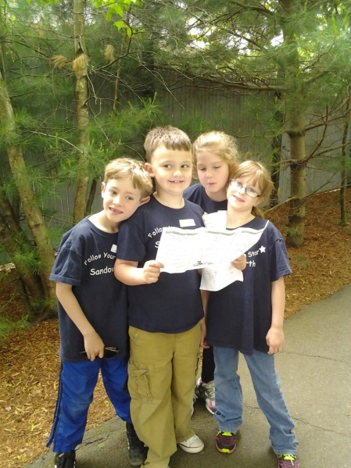
- The First graders went to York’s Wild Kingdom to learn about animals and use their mapping skills to find their way around the park.
- Second Grade students went to the SEE Science Center in Manchester, NH. Students were involved in hands on science exploration. They participated in Slimy Science and created putty while reviewing states of matter. They also learned about conductors and insulators of electricity. Students were introduced to Newton’s Law of motion and each class took home a drawing made by the Harmonograph drawing machine. It was fun day full of science and exploration!
- The third grade field trip to Strawberry Banke provided students to apply what they have learned about New Hampshire history. Students were able to explore a neighborhood that dates back to the 1600s along with seeing how life was in New Hampshire during the 1600s, the 1700s, 1800s, and 1900s.
- As a culminating celebration for all the STAR behaviors we have witnessed throughout the year, we had a one hour celebration outdoors on Tuesday morning. Pam and Don Gaudreu, Sandown residents, performed so the children could join in the festivities by singing and dancing. Chalk, bubbles, and popsicles were provided and much fun was had by all!!!
Middle School
- Friday the 13th we had 5th grade Move-Up Day. We had a guest speaker, Becky Curran, who spoke about to all grades about “differences” living as a little person.
- Grade 8 attended their class trip to Cederdale.
- Grade 8 Celebration Assembly and Dance are Thursday.
High School

Athletics
- The Spring Sports Season has officially ended. The Boys’ Volleyball team finished as Runner Up as they made it to the Finals before losing to Champion Salem 3-1.
- The 2014 Fall Sports sign up process has already begun for Timberlane High School Athletics. WE have over 270 student-athletes registered for Sports, and we anticipate more to come in the next few weeks..
Performing Arts

