SCHOOL/DEPARTMENT REPORT TO THE TRSB – NOVEMBER 21, 2013
- School Updates
Atkinson Academy
- Atkinson partnered with the Kimball Library to host the second annual science fair at the Academy on November 9th. The Mad Scientist Company along with several local scientists held mini workshops demonstrating gravity, prisms, sound, chemical reactions and velocity. About 100 students attended with their parents during the day. The second part of the science fair will be held this Saturday titled "Bubbleology: The Secret World of Bubbles". This is a hands on demonstration of the mystery behind bubbles and the various types of bubbles.
- On Thursday, November 14th, senior citizens along with members of the Atkinson Police Department enjoyed lunch served by the students and after were entertained with lip sync performances by 4th grade students.
- This past Monday, the Superintendent's Leadership Team visited the Academy classrooms for Instructional Rounds. This visit was a chance for our students and staff to show the team the learning that is happening at the Academy.
Danville Elementary
- First grade Junior Scientists are working with their classroom and enrichment teacher on hands on discovery experiments where they learn how common objects can be used as tools to uncover fun facts about water. They are leaning scientific vocabulary and are learning how to make predictions and to record them.
- Third graders are learning about the power of magnets. They are curious and love to experiment as they discover what it means to attract and repel other magnets. The staff and students are looking forward to their upcoming enrichment day!
Pollard School
- Pollard School has been busy putting their school’s Motto into action (What we do today makes a difference tomorrow). November 18-22 is Anti-Bullying week for the state of NH and Pollard is helping by focusing on a different area each day: Monday, Helping Day; Tuesday Encouraging Day; Wednesday, Accepting Others; Thursday, Respect Day; and Friday, Thinking of Others day. Each class has been assigned a Learning Buddy team to do activities with during the week as well as for the rest of the year. Buddy teams worked together this week to create skits/presentations on what they have learned that will be presented Friday the 22nd.
- Thursday, November 14th the Pollard School Title I program hosted an Open house for parents. The tutors were able to review the program goals and technology used with the students. Over 35 parents were in attendance and it was quite the successful night.
- Pollard’s PTA hosted a very successful Bingo for Books night on Friday, November 15th. Both the cafeteria and the gym were filled with Pollard families. Over 800 books were given away but some very happy BINGO players.
- Next Tuesday, November 26th, Pollard will be hosting their 5th annual Grandparents/Special Persons Day. As of Wednesday we have over 680 visitors signed up to come participate. Our guests will be participating in reading and math activities as well as having some classes perform. This is a busy day here at Pollard but one that students, teachers and all of our special guests enjoy. If you have not signed up yet please call the office for specific grade level times.
Sandown Central
- Sandown Central will be holding an assembly December 10th to roll out our new theme as the Sandown Central Eagles with a mascot!
- We will be holding the Service Dog assembly December 2nd at 9:30.
- Please save this date: Sandown PTA Holiday Auction Friday, December 6, 6-9PM at Sandown North elementary school.
- Sandown Central Chorus performances coming up soon. The Sandown Chorus will provide the holiday auction on December 6th with holiday and winter themed songs. The winter concert will be held on Monday, January 13th, 2014 at 7:00 at the Performing Arts Center (PAC) This concert will feature our schools’ performing groups: chorus, strings, and band. Our musical groups are looking forward to performing for the community.
Sandown North
- Instructional Rounds were conducted here on the 14th. Children and staff were pleased to welcome others into their learning. SAU staff observed in classrooms and was able to watch specialists working with children. The atmosphere was abuzz with learning and excitement. Our hope is that the visit served as a learning experience for all involved.
- The Book Fair began on the 20th. Children are so excited to be able to visit it during the day as well as on December 4th in the evening.
- The PTA conducted a food drive. Families were so generous in their donation that, to thank them in a fun way, the children are having a Crazy Hat Day on the 26th.
- Children are so excited by what they are learning in art class that they are working independently on art projects at home. These projects are brought into school and shared with the art teacher who then takes a picture of the artwork and submits it to Mrs. Georgian for inclusion in the Monday Morning Meeting agenda. When projected on the screen, the entire school community can view it and can recognize the child for his/her efforts and talents.
Middle School
- Over 900 cans of food were collected for the food drive.
- Hat Day for Mealey’s Meals will be on Friday, November 22nd.
High School
- November 15 - The Timberlane Student Assistance program brought 25 Middle and 10 High School Students to the “Stand Up to Bullying NH 2013” rally at the UNH Whittemore Center, to be inspired to continue our school climate work and to promote respect and tolerance among our students. They heard inspirational talks from our Governor Hassan, State Senator Martha Fuller Clark, Dr. Malcolm Smith. The highlight of the day was hearing the message of Lizzie Velasquez http://www.aboutlizzie.com/ and Miss NH 2011 Regan Hartley. The students will be bringing back the message to the leadership academy at the Middle school and Student Voice at the High School to continue the work toward improving school climate.
- November 15 - NHIA Advisors, Dessa Landry and Deb St. Germain were contacted by Dr. Jason Holder from Adventurelore to paint a recently constructed 8 foot by 50 foot climbing wall to look like rocks. 14 members of the National Art Honor Society volunteered to participate. On Friday, Nov 15, we gathered at Adventurelore and started the process by sketching in all the boulders with pencil. Next, they applied the darkest value of grey to the cracks between the rocks, then the students dry-brushed the middle grey value over all. Lastly, they sponge painted the shadows and highlights onto the rocks giving the illusion that the rocks were 3-dimensional. It was truly a great experience for all the students involved. Here are the names of the students that participated:
Maggie Bailey, Alissa Bredbenner, Nicole Bruen, Dylan Chiachio, Laura Lingar, Hannah Locke, Alyssa Mulhall, Alicia Ross, Erin Sullivan, Molly Gogas, Teaghan Rooney, Hayley Siemering, Katie Ouellette, and Lauren Hastings.
- November 15 - 150 students and 16 chaperones traveled to NYC for a fun-filled day of learning and bonding. From life lessons to historical connections, students and staff took a great deal away from the day. The journey started off with the whole group visiting the Statue of Liberty. Afterwards, groups broke off and took part in visiting places like Ellis Island, the 9/11 memorial, Times Square, Rockefeller Center, Top of the Rock, the Rockette’s Christmas Spectacular, and of course, imbibed in some of New York’s great food and shopping opportunities! It was a wonderful experience for our students and unearthed a desire for them to travel and see more areas outside of our Timberlane community.
- November 19 - Three representatives of Timberlane’s Peer Outreach Program, Nicole Dill, Corinne Hennessey, and Emma Melanson, attended the Award Ceremony at the NH Transition Community of Practice; Transition Summit VII at which they were awarded the “Transition Student Organization of the Year.”
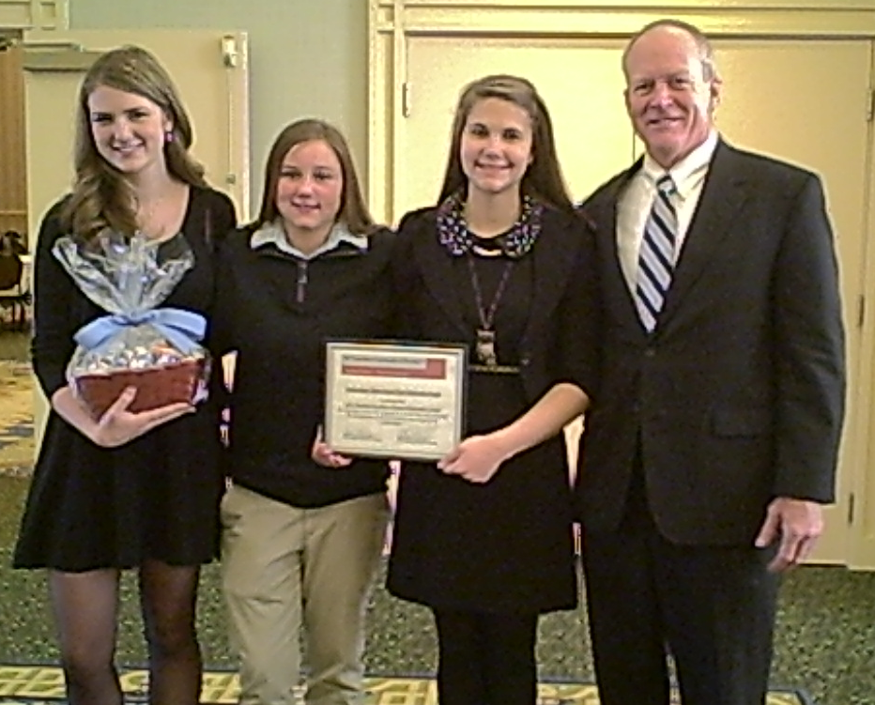
- December 7 – Junior Class Semi Formal 7:00-10:00 High School Cafe
Athletics
- Winter sports is beginning this week with wrestling and swimming, next week with skiing, cheer and hockey, and the following week with boy’s and girl’s basketball and track.
Performing Arts
2013 ALL-STATE
Name |  | Instrument
Danielle | Arena | alto voice
Liam | Arteaga | tenor voice
Hope | Aubrey | clarinet
Quinn | Averill | bassoon
Nicholas | Bealo | bass viol
David | Borrelli | tenor voice
Kyle | Brown | bass voice
Julia | Bruedle | alto voice
Adam | Caezza | tenor voice
Amy | Clark | violin
Sarah | Cole | trumpet
Nicole | Dill | violin
Tyler | Donovan | tuba
Laura | Erickson | clarinet bass
Toby | Esposito | bass voice
Kayla | Gaudet | violin
Anthony | Gentile | tenor voice
Josh | Grambow | cello
Brynn | Grambow | cello
Kathryn | Greenizen | alto voice
Lily | Hevesh | perc II
Mya | Hollins | french horn
Kaitlyn | Jones | soprano voice
Casey | Jones | perc I
Micheala | Kosta | alto voice
Allison | LaPorte | violin
Natalie | Livingston | alto voice
Daniel | Main | perc III
Joseph | Mancinelli | tenor voice
Colin | McCarthy | tenor voice
Brendan | McGuirk | trumpet
Nolan | McGurn | french horn
Braden | McKallagat | tenor voice
Timothy | McLaughlin | tenor voice
Aimee | O'Meara | alto voice
Julia | Perelgut | viola
Matthew | Perry | perc I
Sophia | Rendo | soprano voice
Daniel | Reynolds | perc II
Chris | Robinson | french horn
Siobhan | Sheehan | viola
Aurora | Sidor | violin
Angela | Simmons | bass viol
Elizabeth | Skerry | soprano voice
Jarrod | Solloway | violin
Annie | Steenson | french horn
Joy | Steenson | violin
Harrison | Szczapa | perc I
Madelynne | Torosian | clarinet bass
Jessica | Walsh | viola



