SCHOOL/DEPARTMENT REPORT TO THE TRSB – NOVEMBER 21, 2013
- School Updates
Atkinson Academy
- Atkinson staff enjoyed a Thanksgiving feast on Tuesday hosted by the pre-k students.
Pollard School
- Grandparent’s Day was a HUGE success for Pollard this year. We had over 800 Grandparent’s and Special Persons visiting us throughout our day on the Tuesday before Thanksgiving. Our PTA handed out notepads and pens that said “Someone at Pollard School loves me” and assisted with traffic control, parking and hallway/door monitoring.
- On Tuesday, December 3rd Pollard held our annual Barnes and Noble Night at the Salem store. Children from every grade level read and/or sang to a very crowded audience. All proceeds went to our library program.
- Our PTA will be hosting a Winter Pancake Breakfast here at Pollard School’s Penguin Place (Café) on December 7thh from 8am to 10am. Pollard Staff will be bussing tables and of course making lots of pancakes. Santa will make an appearance, there will be a coloring contest and many raffles.
- Student Council finished their annual food drive, collecting over 550 items for our local food bank.
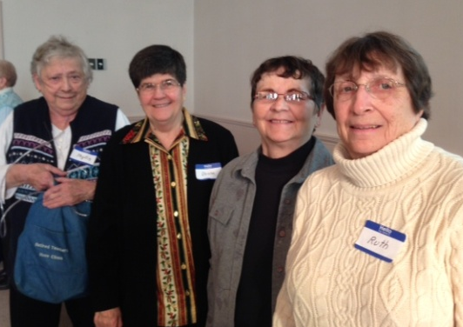
- On Tuesday, December 3rd the 4th and 5th grade chorus entertained the retired teachers during their annual Holiday luncheon at the First Baptist Church. The attached pictures are of the fabulous grade 4 and 5 chorus performance, led by the fabulous Gretchen Bird, and of former Pollard teachers. The teachers are, from left to right, Phyllis Simmons (last grade taught: 4th), Donna DiGennaro (last grade taught: 3rd or 4th), Karen Hoppler (last grade taught: 3rd), and Ruth Shapiro (special education.)
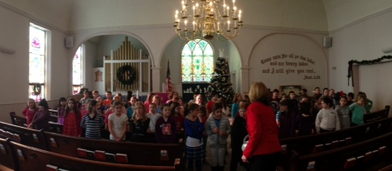
- .

Sandown Central
- Sandown PTA Holiday Auction Friday, December 6, 6-9PM at Sandown North elementary school.
- The Sandown Chorus will provide the holiday auction on December 6th with holiday and winter themed songs.
- The winter concert will be held on Monday, January 13th at 7:00 at the Performing Arts Center (PAC). This concert will feature our schools’ performing groups: chorus, strings, and band. Please mark your calendars. Our musical groups are looking forward to performing for the community!!

Sandown North
- Yesterday the children were treated to a puppet show on Core Democratic values. He engaged the children in moments of history in developmentally appropriate ways. The children were enthralled and actively learning....and laughing.
- Last night was our annual School Literacy Night. Marty Kelly, a well-known author, entertained families. Audience members wore pajamas and slippers and brought blankets and pillows to be comfortable. The night ended with ice cream and family members reading together.
- We're looking forward to the PTA auction tomorrow night. All monies raised go directly to events and happenings for our children. The building is decorated in such a festive way that the spirit of the holidays comes alive.
- Staff members have been working together to administer the Tripod survey to the children. They are doing their best and taking the responsibility seriously.
Middle School
- Senior Tea Saturday sponsored by the Student Senate and the TRMS Music Dept.
- Grades 7 and 8 Band and Chorus concerts performed this week. Orchestra is next week.
High School
- Mealey’s Meal - Student/Staff spare change collection in the first week we have collected over $500.00 for a total of $4000.00 to date.
- Tri-Pod Survey - Students will be taking the survey this week (12/3) Tuesday, Wednesday or Friday.
- Attendance update - At the end of quarter one, we send out letters to families of students with significant attendance issues in one or more classes. After quarter one, 2012 we sent 235 letters home. After quarter one, 2013 we sent 64 letters, using the exact same measurements. This reflects a 72% reduction in the number of students receiving this letter!
- December 3 – Pembroke Academy will be visiting the high school to observe the Algebra Lab and our co-teaching model for Algebra 1.
- December 5 – Professional Development Day will start with guest speaker Dr. Jody Polleck around content literacy and then there will be building level activities including staff taking the Smarter Balance test.
- December 7 - Junior Class Semi Formal 7:00-10:00 High School Café.
- December 10 - College Financial Aid Night is Tuesday Tue, 6:30pm – 8:30pm at TRHS Room 612/614. Night for parents of college bound seniors featuring Val Castonguay from Center for College Planning at the NHHEAF Network Organization.
- December 13 - The Equestrian Team will be holding their first practice next week.
- December 14 - Students of Service (SOS) will be hosting Polar Express Movie Night from 3:00-4:30 in the HS gym.
- December 15 - Student Council will host a ‘Kids Night Out” 1:00-5:00 in the gym and café.

Athletics
- The athletic department has been conducting its Athletic Awareness Nights for those parents and student-athletes that did not participate in a fall sport and attend the fall athletic awareness night. The coaches’ team meetings coincide with the Departments’ Awareness Program. The following message is currently on the Athletics’ HS Web page:
To the Athlete Parents/Guardians:
As the Athletic Director of Timberlane Regional High School, I look forward to presenting our program goals and expectations. We will be hosting our mandatory pre-season meetings for winter sports on the dates listed below.
Please note: If a parent or guardian does not attend this mandatory meeting, the student athlete will be allowed to practice with the team, but will not be allowed to compete until Parent/Guardian contacts Athletic Director and completes the necessary requirements.
Please note that if you and your child attended the Athletic Director portion of the Awareness Night in the Fall Season, you only need to report to the Team Meeting at 7:00 PM.
ATHLETIC DEPARTMENT AWARENESS SESSION
DATE TIME LOCATION SPORT
11/26 6:00PM HS Cafe Wrestling/Swimming
12/3 6:30PM HS Café Hockey/Skiing/Spirit
12/9 6:30PM HS Café Basketball/Track
TEAM MEETINGS WITH COACHES
DATE TIME LOCATION SPORT
11/26 6:30PM HS Room 614 Wrestling
11/26 6:30PM HS Room 613 Swimming
12/3 7:00PM HS Room 614 Hockey
12/3 7:00PM HS Room 613 Spirit
12/3 7:00PM HS Room 615 Skiing
12/9 7:00PM HS Room 614 Boys Basketball
12/9 7:00PM HS Room 613 Girls Basketball
12/9 7:00PM HS Room 615 Track
Performing Arts
- HS Ensemble Concerts will take place on Sunday, December 8th at the Timberlane Performing Arts Center at the following times:
Orchestra at 1:00pm
Band at 2:15pm
Guitar at 3:45pm
Chorus at 4:45pm

