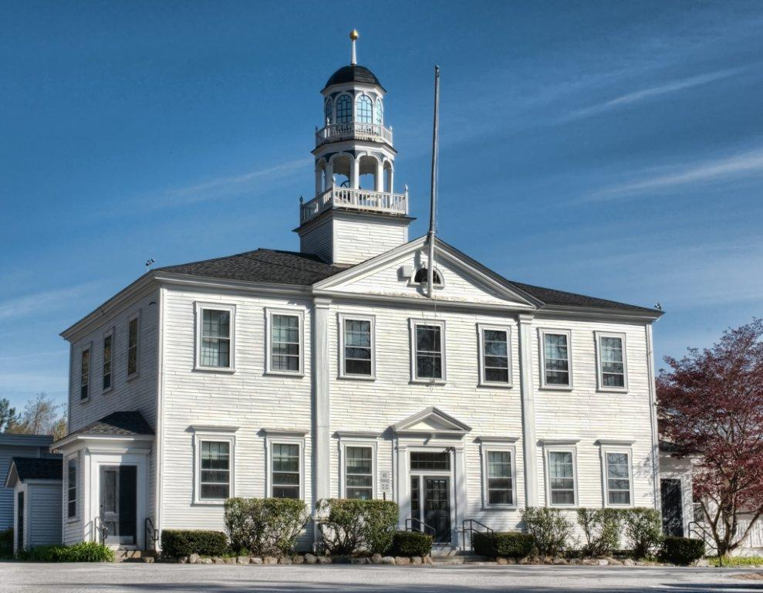

Kathleen Dayotis-Principal
Brian Shawley -Assistant Principal

ATKINSON ACADEMY
School Action Plan
2014-2015

TABLE OF CONTENTS
Mission Statement 3
Principal’s Message 4
Action Plan . 5
A. Goal Statements 5-9
B. Related Professional Development 9
Leadership Team Members…………………………………………………………………..10-14
School Site Assessment………………………………………………………………………15-16
Submisson Page………………………………………………………………………………….17
Appendix…………………………………………………………………………………………18
A. School Security and Safety Plan 19

Mission Statement

Through the process of learning,
We value and build:
Knowledge
Respect
Community

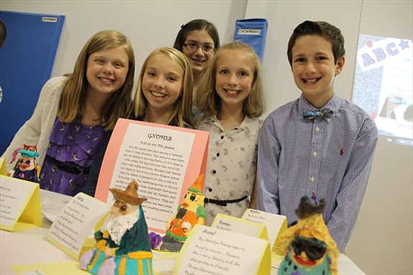

Principal’s Message

Through the process of learning, we value and build knowledge, respect and community. This is a simple motto that we at Atkinson Academy try to base our entire school ideals around.
The Atkinson Academy’s staff works extremely hard instilling strong work ethics in each student. WE value education and have high expectations for our students. From pre-k through fifth grade, we feel that it is important to form strong foundations so that students will go onto Middle, High School and college to be successful.
RTI, or Response To Instruction, was added this year to all grade levels. As we all know, sometimes we might need some information repeated a couple of times to clearly understand a concept or idea. There’s nothing wrong with that! The same with children, repetition, is sometimes needed. Thirty minutes each day was added to the schedule for reading and math. During these times, children are grouped according to their needed, whether it is enrichment, maintaining skills or an extra boost. The flexible groups of 4-5 students change about every 6-8 weeks. Everyone in the school helps deliver services so we can maintain the small group ratio. Classroom teachers, literacy specialists and special educators are responsible to work with re-teaching groups while our media generalist, guidance, enrichment, technology and teaching assistants work differentiating other learning activities revolving around reading units. The same is also repeated for math. We have seen tremendous growth. Small groups allow the children to really shine, explore new concepts and be retaught with success.
We have also adopted the PBIS/ Model of Respect, Responsibility and Right Choices. This is a bullying model that students will continue following at the Middle School. The Atkinson Police Department has trained an officer once again this year to work with our fifth graders using the D.A.R.E. program. This program helps the children learn to JUST SAY NO when faced with difficult decisions or situations.
Community involvement surrounds the Academy almost every day. We are lucky to have strong, involved PTA/Night Owls Dads group. Atkinson partners with many local organizations also. The Atkinson Cub Scouts Pack 95 is responsible to keep our grounds well groomed in the fall and spring. The Atkinson Garden Club involves the children in the Smokey, the Bear Poster contest along with Woodsy Owl Poetry writings. The Atkinson Lions Club along with the King Lion comes into our younger student’s classrooms to read to them. They have donated all the books that are read to the classrooms so the children will have many years of reading enjoyment. The Atkinson Women’s Civic Club is available to take care of daily needs of families whenever I call. Our Fire Department spends a week at school talking to the children about fire safety while the Kimball Library partners with us on yearlong activities. The Police Department is visible this year eating lunch, attending recess and reading to our students. I feel very lucky to have this school involved with so many organizations that care about our students.
AS always, I want to thank everyone for their constant support of Atkinson Academy students and staff. WE strive towards the same goal—to make our students successful in and out of the classroom.
Action Plan
This School Action Plan will be assessed in the spring of 2015.

A. Goal Statements
Goal #1 (Common Elementary Goal) STAR Assessment: Atkinson Academy School will implement Renaissance Learning STAR Assessments for universal screening and progress monitoring during the 2014-15 school year. These assessments will provide actionable data related to the impact of curriculum, program, and pedagogy. In addition, STAR data will be used to monitor growth, group students for instruction and to assess the effectiveness of interventions.
Action Steps/Monitoring Plan
Step# | Strategies/Activities | Timeline | Team/Person Responsible
1 | STAR Champions participate in orientation with the Renaissance Coach to review all aspects of administrating the assessment | August 28th | Champions and school administration
2 | STAR training for school Champion team | Before September 8th | Principal/Assistant Principal/Literacy Specialist
3 | STAR Assessment is administered to all students PreK-5 | September 8– 19th | Classroom Teacher/ Literacy Specialist/ Administration
4 | Champions attend training to understand reporting options | September 22nd & 23rd | Champions
5 | Entire Professional staff will be trained in accessing report data and data analysis protocol | September 29th | Champions
6 | Data from STAR Assessment will be shared/discussed at PLC and grade level teachers will implement a plan using Tier times based on their class/grade level data. | Weeks of September 29th and October 6th | Champions
7 | Data from STAR assessment will define what strengths and weakness will be a focus during RTI for the 2014-2015 school year | October 2014 | Grade level PLC and Champion Team
8 | PLC and Grade level teams will work with the Champions to review data for school wide patterns | October 9th meeting | Classroom teachers/ PLC
9 | Progress monitor struggling students using our new progress monitoring and data management system. | As needed throughout the school year | Classroom Teachers
10 | Mid-year Assessment given to all students PreK-5 | January 5-16th | Champions & Classroom Teachers
11 | End-of-year Assessment given to all students PreK-5 | May 11-21st | Champions & Classroom Teachers
12 | Grade level teams will meet each week during PLCs with a focus on planning reading and math interventions and providing continuous progress monitoring for strategic groups. | September 2014-June 2015 | Grade Level PLC
13 | Review of end-of-year assessments will be done to evaluate the success of the Action Plan Goals #1 & 2. | May 2015 | Champions & grade level PLC teams
14 | School wide Action plan goals will be revised based upon grade level PLC discussions | May 22nd or June 1st staff meeting | Professional staff

Goal #2 (Common Elementary Goal) Guided Reading: In order to improve reading scores and increase student engagement, Atkinson Academy will provide guided reading training to all classroom teachers and interventionists. Teachers will make informed instructional decisions to ensure that students are appropriately matched to engaging texts and grouped effectively according to their instructional reading levels for support.
Action Steps/Monitoring Plan
Step# | Strategies/Activities | Timeline | Team/Person Responsible
1 | Materials received (stamped and inventoried) for all grade levels K-5 | September, 2014 | Literacy specialist
2 | Trainings will be provided for all teachers throughout the year during District Staff Meetings/Early Release days/PD Days | PD-Days in December 11th & January 20th, ER April 24th , & Staff Meetings TBD | Principal/Assistant Principal/Literacy Specialist
3 | Create a system for checking out and checking in all Leveled Guided Reading resources | October 2014 | Literacy Specialist
4 | Scheduling staff/specialists to train in the basics of Guided reading and small group instruction | March -June | Principal/Assistant Principal/Literacy Specialist
5 | Creation of a walk-through/Instructional rounds form that can be used by administration to review the implementation process at Atkinson | Created by March 2015 | Principal/Assistant Principal/Literacy Specialist
6 | Begin utilizing the new walk through/Instructional rounds form during guided reading times at all grade levels. | Spring 2015 | Principal/Assistant Principal/District Administration
7 | Review STAR data to establish the instructional reading levels of all students | May/June 2015 | Entire Staff

Goal #3 – Atkinson Academy will have a systematic math data collection process in place by June 2015 that will provide teachers with accurate and reliable information from which instructional decisions can be made.
Action Steps/Monitoring Plan
Step# | Strategies/Activities | Timeline | Team/Person Responsible
1 | Determine what mathematical data will be collected throughout the school-year. | October 2014 | Principal/Assistant Principal
2 | Identify mandatory assessment timeframe/guidelines. | October 2014 | Assessment Team/Data Team
3 | The school will determine the progress monitoring tools to be used in tier 2 for strategic groups | October 2014 | Staff
4 | Grade level teams will meet in PLCs with a focus on planning math interventions and providing continuous progress monitoring for strategic groups | September-June 2015 | Grade level Teams
5 | All mandatory data collection will be made available three times per year through the comprehensive assessment system. | June 2015 | All Staff

Goal #4 – Atkinson Academy will maintain a systematic behavior management plan designed and implemented during the 2014-2015 school year.
Step# | Strategies/Activities | Timeline | Team/Person Responsible
1 | Determine members of the team. | July 2014 | Staff
2 | Identify basic goals of the team. | September 2014 | Team Members
3 | Continue to use school mascot and themes for rollouts to model behavioral expectations. | October-June | Team Members
4 | Inform staff of common language and procedures to be used by students when accessing the hallway in school setting. | October 2014 | All School Participation
5 | Introduce SWIS (School Wide Information System) as a means to collect data | October-June 2015 | Atkinson Staff
6 | Major and minor behaviors will be collected by staff to be collected by SWIS | October- June | All School Participation
7 | Use the Tripod data to begin brainstorming and creating ways to engage students in promoting a positive school culture | Nov. 2014-March 2015 during staff meetings | Atkinson Staff

Related Professional Development

Dates | Topic Description | Grade(s) | Time | Location | Facilitator | Goal #  (if applicable)
 | STAR Assessment Training | PreK-5th |  | Atkinson | Brian Shawley  Jill Feneberg | 1
 | STAR Data analysis | PreK-5th |  | Atkinson | Brian Shawley  Jill Feneberg | 1 & 2
 | ABC Bears/PBIS | PreK-5th |  | Atkinson | ABC Team | 3
 | Google Chromebook Training | PreK- 5th |  | Atkinson | Lois Paul | 3
 | Google Drive Training | Pre-K- 5th |  | Atkinson | Lois Paul | 3
 | Guided Reading Training | Pre-K- 5th |  | Atkinson | TBD | 2

Atkinson Academy Leadership Team

Chair: Kathleen Dayotis, Principal
Co-Chair: Brian Shawley, Assistant Principal
Teachers: Susan Donnelly, Pre-K
Erin Camire, Grade 2
Lynne Ouellette, Grade 3
Nicole Habib, Grade 5
Staff: Meredith Bastien, Special Education
Pamela DuLong, Enrichment
Claire Culligan, Food Service
Jill Feneberg, Literacy Specialist
Jeff Goddard, Physical Education
Linda Siemering, Special Education Assistant
Christina Wood, Occupational Therapist

Atkinson Academy Assessment & Data Team Members

Chair: Kathleen Dayotis, Principal
Co-Chair: Brian Shawley, Assistant Principal
Teachers: Lindsie Guillermo, Grade 1
Jennifer Spires, Grade 2
Nicole Shawley, Grade 3
Nicole Bailey, Grade 4
Kelly Lennon, Grade 5
Staff: Melissa Oakley, Special Education
Jill Feneberg, Literacy Specialist
Deb Simard-Hill, Speech Pathologist

Atkinson Academy Target Team

Chair: Kathleen Dayotis, Principal
Co-Chair: Brian Shawley, Assistant Principal
Teachers: Nadine MacDougall, Grade 1
Lynn Ouellette, Grade 3
Heather Terrile, Grade 5
Staff: Paula Amante, School Nurse
Jill Feneberg, Literacy Specialist
Melissa Oakley, Special Education
Zachary Champion, Guidance Counselor

Atkinson Academy /PBIS Team

Chair: Kathleen Dayotis, Principal
Co-Chair: Brian Shawley, Assistant Principal
Teachers: Katie Small, Grade 1
Jen Spires, Grade 2
Erin Camire, Grade 2
Erin Lozowski, Grade 4
Staff: Pam Alexander, Art
Diane Geary, Library Assistant
Anna Lizier, Technology Teacher
Beth Fenderson, Special Education
Zachary Champion, Guidance Counselor
Christina Wood, Occupational Therapist

Sunshine Committee

Chair: Jen Toth, Media Generalist
Members: Nicole Habib, Grade 5
Nicole Bailey, Grade 4
Erin Lozowski, Grade 4

Professional Development Committee

Members:
Deb Bell, Kindergarten

Safety Committee

Members: Kathie Dayotis, Principal
Warren Currier, Head Custodian
Sandra McKay, Executive Assistant
Jeff Goddard, Physical Education Teacher
Paula Amante, School Nurse
Claire Culligan, Food Service

School Site Assessment

We believe that our students should have multiple opportunities to demonstrate what they know and are able to do. Assessment is a tool that provides a snapshot of their developmental learning process. The data gathered guides our educational priorities and decisions as it relates to each individual student. The value of the individual and his/her contribution to our global community lies in the manner in which he/she uses intelligence, experience, and creativity in the 21st century.

We give assessments for a variety of reasons, including reporting student progress and achievement; evaluating curriculum and instruction; identifying strengths and weaknesses; comparing Atkinson Academy students with national, state, and other norms; and identifying students who may need some extra help or who may benefit from specialized programs. It is ultimately our way for schools to be accountable to our students, parents and community.
As part of our district Action plan, administrators are currently reviewing our assessments for all students including all three tier levels. At this time our assessments can be summarized in the following way:

Mathematics:
District Summative-Smarter Balanced Assessment 3-5
Universal Assessment-STAR Assessment PreK-5

Tier I- Grade level Authentic Assessments
EDM End of Unit test grades K-5 (optional)
EDM Mid-Year Test grades K-5 (optional)
EDM End of Year test grades K-5 (optional)
Number knowledge baseline grades K-5

Tier II- Number Worlds (placement, exit, end of unit) grades K-5
Star Progress Monitoring

Tier III- SAGES/grades 3-5

Writing:

District Summative-Smarter Balanced Assessment 3-5

Tier I- Writing Prompt (scored against 6 traits rubric) Gr 3
Writing Prompts (scored against 6 traits rubric) Gr 4-5

Reading:

District Summative-STAR Assessment K-5
Universal Assessment- STAR Assessment

Tier I- Weekly vocabulary grades K-5
Fundations Grades K-2
Leveled Literacy Interventions (LLI)
Independent Reading
Guided Reading

Tier II- Lexia (Web based software/game program)
Quick Phonics Screener grades K-3
Fundations Grades K-3
Just Words Grades 4-5
Lively Letters Grades PreK-3
Phonemic Awareness in Young Children Grades K-3
Running Records Grades K-5
Visualizing & Verbalizing Grades K-5
Just Words Grades 4-5
6 Minute Solution grades K-5
Spellography

Tier III- Lexia (Web based software/game program)
Reading Street My Sidewalks grades K-5
Fundations Grades K-3
The WADE (Wilson) Grades K-5
LIPS Grades K-5
Visualizing & Verbalizing Grades K-5
Enrichment: SAGES grades 1-5
Running Records Grades K-5
DIBELS Next Grades K-5
Wilson

Submission Page

Submitted By: Kathleen Dayotis, Principal
Brian Shawley, Assistant Principal

Appendix

School Security and Safety Plan

- Assemble Emergency Response Team
- In case of an emergency exit quickly with emergency bag and go to assigned area and take roll.
- Attendance will be collected and called into secretaries.
- Once attendance is collected principal will instruct staff to move to off-site evacuation.
- Off-Site Evacuation (Atkinson Fire Station)
- Secretaries call for buses to assist students and staff to evacuation site that are unable to walk
- Adults and students that are unable to walk to the off site location, proceed to the “Do Not Enter” sign by the driveway of the 1803 building and wait to be picked up.
- School Nurse and Secretaries are responsible for bringing student emergency contact and health information.
- Students who are in specials stay with that teacher until they are reunited with their classroom teacher at the off site location.
- When students arrive at the off-site location teachers will have designated areas for each grade. Teachers will have students sit quietly in all designated areas and retake attendance.
- While at the Fire Station teachers and staff will wait for instructions from the Incident Commander (Principal).

